SSL/TLS Certificate Measurement Analysis Report

I. Experimental Procedure
1. Data Collection and Processing
1.1 Nmap Active Scanning: Conducted 443 port scanning on target IP lists to extract SSL/TLS certificate information. 1,167 records were detected, covering 1,000 distinct certificate subjects.
1.2 External Data Integration: Imported 3,333 records from external sources (e.g., Certificate Transparency logs). To prevent data skew, a 0.3 ratio sampling was applied, ultimately retaining 350 records.
Dataset Merging:
(1) Balanced Dataset: Nmap data + sampled external data, totaling 1,383 records.
(2) Full Dataset: After deduplication, totaling 4,366 records.
2. Certificate Property Analysis
Conducted exploration, statistics, and analysis on certificate attributes such as Issuer, Signature Algorithm, Public Key Type, Public Key Bits, and certificate validity/expiration status.
3. Certificate Reuse Analysis
Analyzed certificate reuse across different IPs based on certificate fingerprints.
4. Revocation Status Sampling
Performed sampling queries on 100 certificates using the OCSP protocol to check their revocation status.
5. Reproducibility Statement
Provided a complete command-line toolchain and script workflow to ensure the experiment is repeatable.
II. Experimental Results
1. Certificate Issuer Distribution
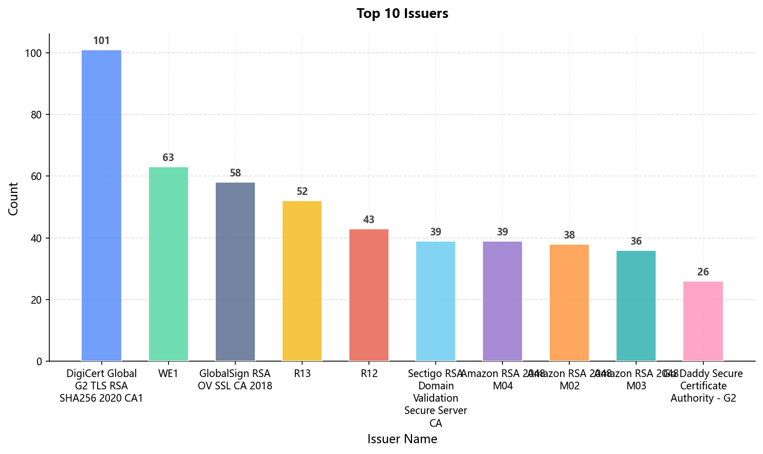
Nmap Data: Primary issuers include DigiCert, WE1, GlobalSign, Sectigo, Amazon, etc.
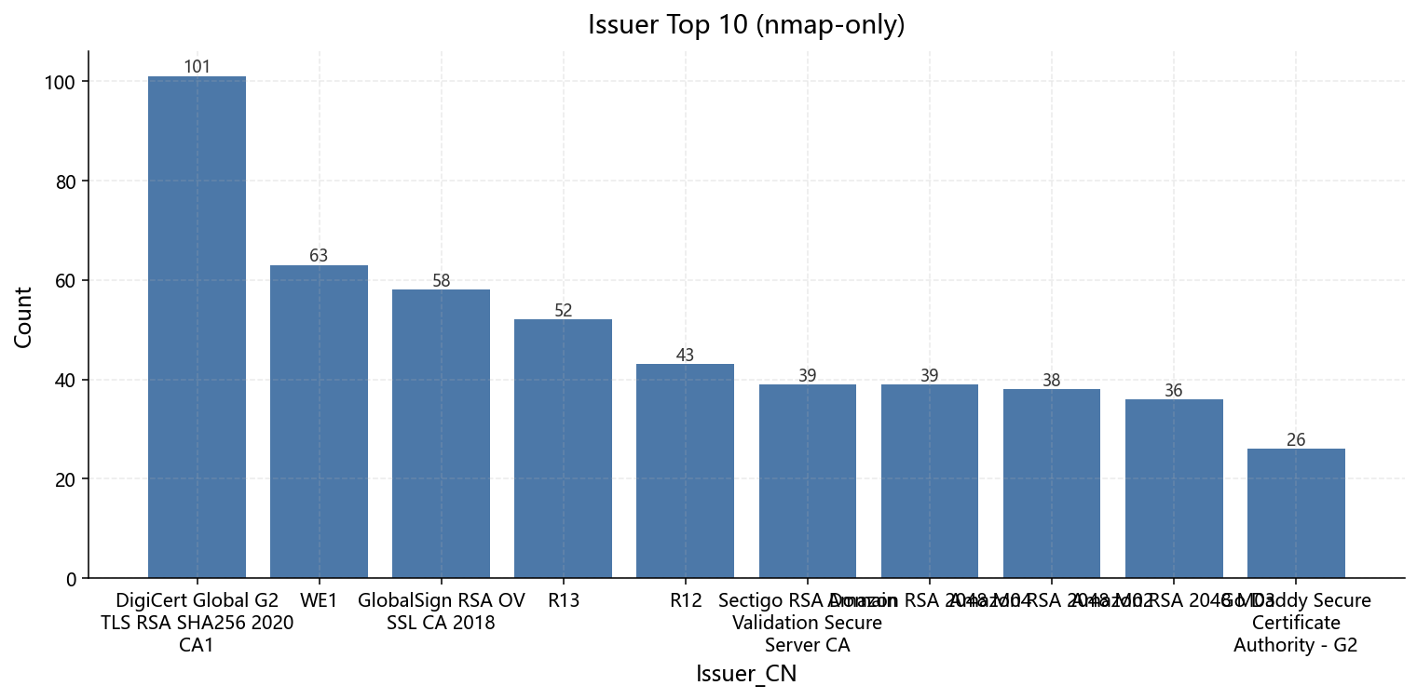
Balanced Dataset: Largely consistent with Nmap data, but includes more traditional CAs (e.g., Thawte, DigiCert High Assurance).
2. Signature Algorithms
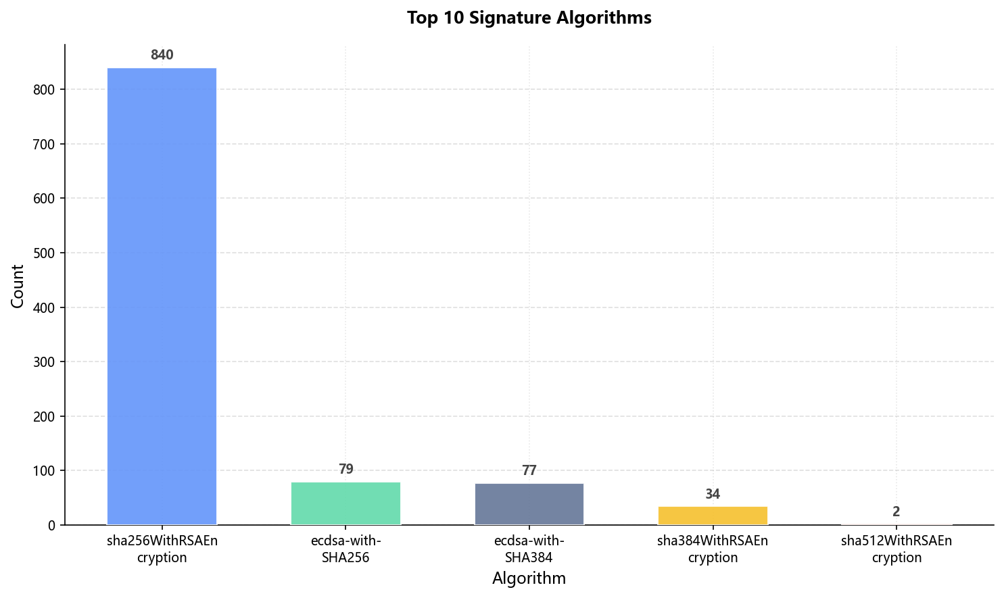
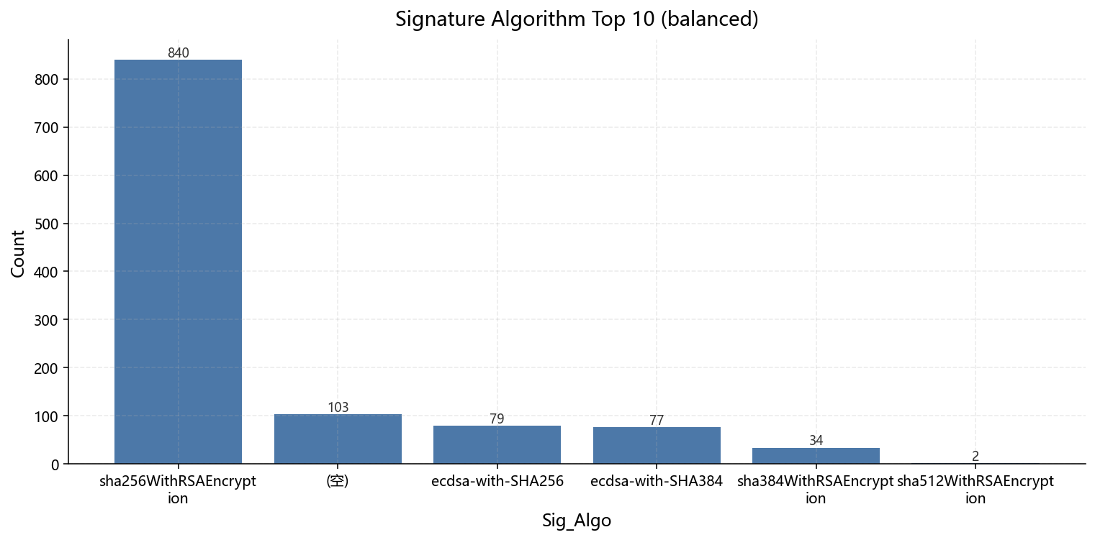
Dominant Algorithm: sha256WithRSAEncryption overwhelmingly dominates (Nmap: 927/1167, Balanced: 841/1383).
ECC Algorithms: ecdsa-with-SHA256 and ecdsa-with-SHA384 are present in smaller proportions, significantly lower than RSA.
3. Public Key Types and Lengths
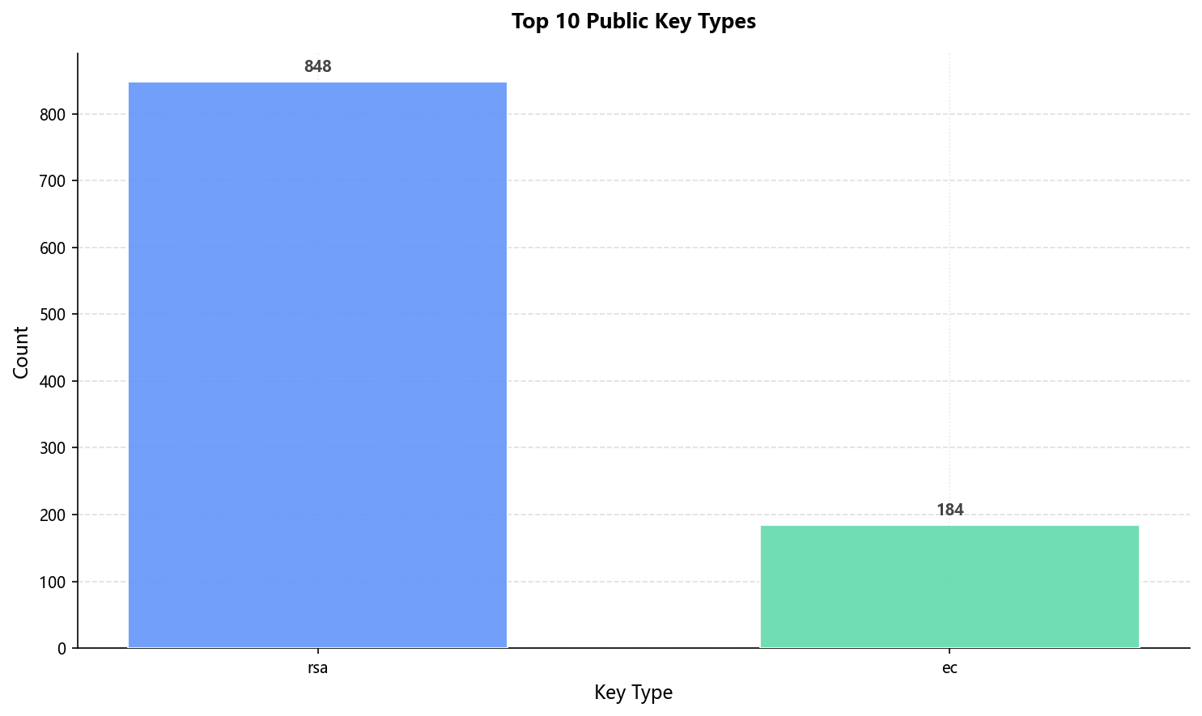
Type: RSA constitutes the vast majority (Nmap: 932/1167, Balanced: 848/1383), followed by ECC.
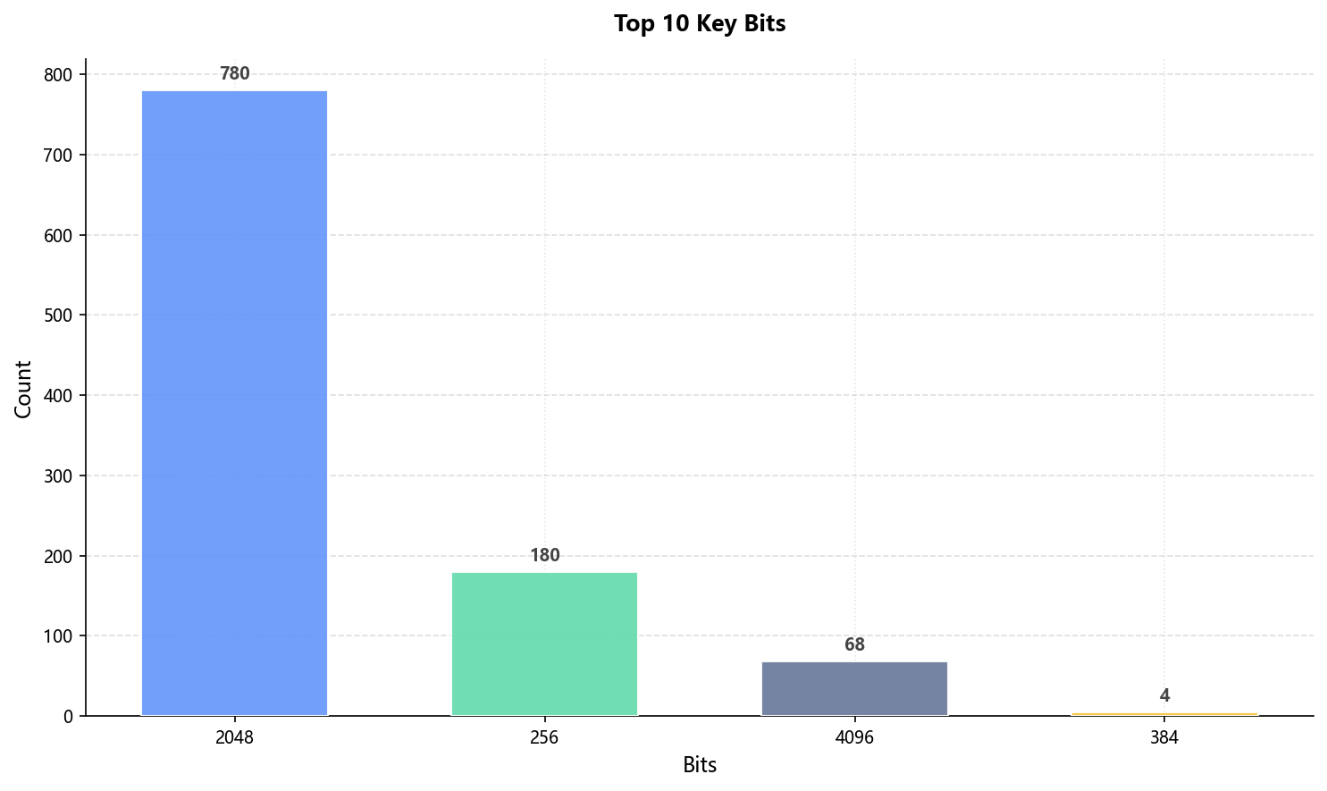
Length: 2048-bit RSA keys are most common (Nmap: 863/1167, Balanced: 780/1383), followed by 256-bit ECC keys.
4. Certificate Validity Status
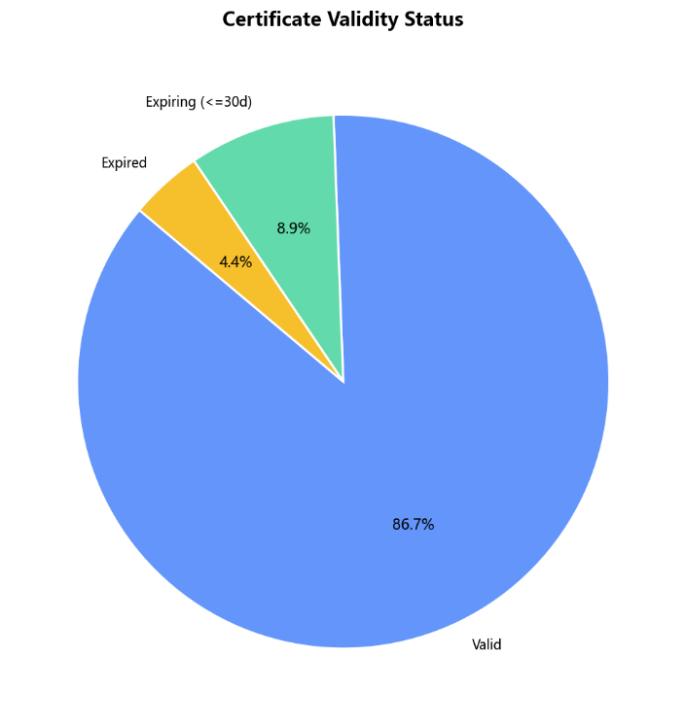
Expired Certificates: 50 (4.4%) in the balanced dataset. Near Expiry (≤30 days): 101 (8.9%). Most certificates are valid (86.7%).
5. Certificate Reuse
The certificate reuse rate is extremely low; the most common certificate fingerprint appears on only 1 IP.
6. Revocation Status Sampling
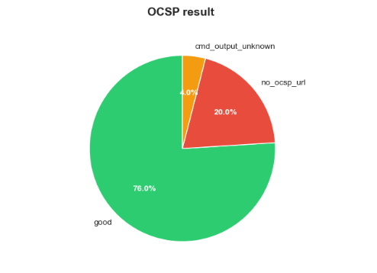
Valid responses constitute the vast majority (76%). Inability to connect/access (no_ocsp_url) also accounts for a significant portion (20%). Command errors (cmd_output_unknown) are very few (4%). No revoked certificates were found (0%).
III. Experimental Conclusions (Updated and Enhanced)
1. Extremely Low Certificate Reuse Indicates Good Security Isolation
Certificate reuse across different services is exceptionally rare; the top 50 most common certificate fingerprints each appear on only 1 IP. This indicates that most services use independent certificates, which is beneficial for security isolation and key management. It also reduces the risk associated with a "single certificate compromise affecting multiple services."
2. Certificate Expiration Issues Concentrated in Specific Services, Including Major Providers
Expired certificates (50) include those from:
- Cloud Service Providers: Cloudflare, AWS, OVH
- Social Media Platforms: Facebook, Instagram, WhatsApp
- Corporate Networks: Huawei, Sony, ESET, Aruba Networks
Expiration issues persist. Upon verification, some expired records originate from the external data source retaining numerous historical expiration records, reflecting the retrospective nature of CT logs. The existence of certificates expired for many years (e.g., pro-web01.dns.pt expired in 2016) suggests the presence of zombie services or configuration legacy issues.
3. OCSP Revocation Checking Suffers from Significant Availability Issues
Based on the 100 samples in this experiment, the following conclusions are drawn:
- Majority Valid Responses: 76%
- No OCSP URL: Constitutes the majority of unknown responses.
- Command Output Unknown: e.g., cmd_output_unknown
- Complete Errors: 4%
Nearly one-quarter of certificates cannot be effectively verified for revocation status via OCSP. OCSP, as a revocation checking mechanism, demonstrates insufficient reliability in practical deployments, impacting the effectiveness of the certificate revocation mechanism.
4. Clear Trends in Algorithm and Key Deployment
RSA-2048 + SHA256 remains the absolute mainstream. ECC usage is concentrated at 256-bit and is more common among emerging or large internet services (e.g., Facebook, WhatsApp). 4096-bit RSA is present in a notable proportion, often seen in enterprise or high-security scenarios.
5. Data Source Differences Highlight Different Perspectives
- Nmap Data: Reflects the current actual deployment status, providing a more realistic view of the state of the network.
- External Data (CT Logs): Contains more historical certificates and records issued by traditional CAs.
- Balanced Dataset: Avoids skew from CT data, offering a more accurate reflection of the current network situation.
Recommendations
- Certificate Lifecycle Management:
Organizations should establish automated certificate monitoring and renewal processes to prevent service disruption due to expired certificates. Implement centralized certificate inventory management and enforce policies for certificates with very short validity periods (e.g., from Let's Encrypt).
- Revocation Checking Mechanisms:
Given OCSP's availability issues, consider supplementing with CRL (Certificate Revocation Lists), Certificate Pinning, or newer mechanisms like CRLite/CRLSet for improved reliability and efficiency. For high-security environments, implement short-lived certificates to reduce reliance on revocation checks, and periodically audit the effectiveness of the chosen revocation method.
- Algorithm Migration:
Although RSA remains dominant, new deployments should prioritize ECC (using approved curves like P-256, P-384) for better performance and stronger security per bit. Actively plan the migration for existing RSA-based services, considering compatibility requirements. Monitor and prepare for the adoption of post-quantum cryptography algorithms as standards mature.
- Security Practices:
The extremely low certificate reuse rate represents good practice and should be maintained. Enhance private key protection measures, such as using Hardware Security Modules (HSMs) for critical systems. Regularly conduct security audits focusing on certificate and key usage.
- Enhancing Measurement and Monitoring:
Establish continuous monitoring for certificate transparency logs relevant to the organization's domains to detect misissued certificates promptly. Utilize tools to track the adoption trends of new cryptographic standards and potential security vulnerabilities.

