Homework #7: Transposing - Supertypes, Subtypes

Due Date: Thursday November 17, 2022__ Must covert this word document to PDF

Note: submissions must be made to the appropriate dropbox in PDF format. This homework is required to be typed, not handwritten.

PART 1: Transposing an E-R Diagram (55 pts)

Transpose the E-R Diagram for RITPO into relations. Use the relational notation: RELNAME( KeyAttr, Attr1, Attr2, FK ). Italicize or dash underline your foreign keys. Be sure to include a reference statement for each foreign key that follows the format :
CURRENT_TABLE(fkattribute(s)) must exist in ORIGINAL_TABLE(pkattribute(s))
Create & submit a PDF file called yourname_HW7.pdf to include all of the resulting relations. SEE NEW CHART passed out in class.

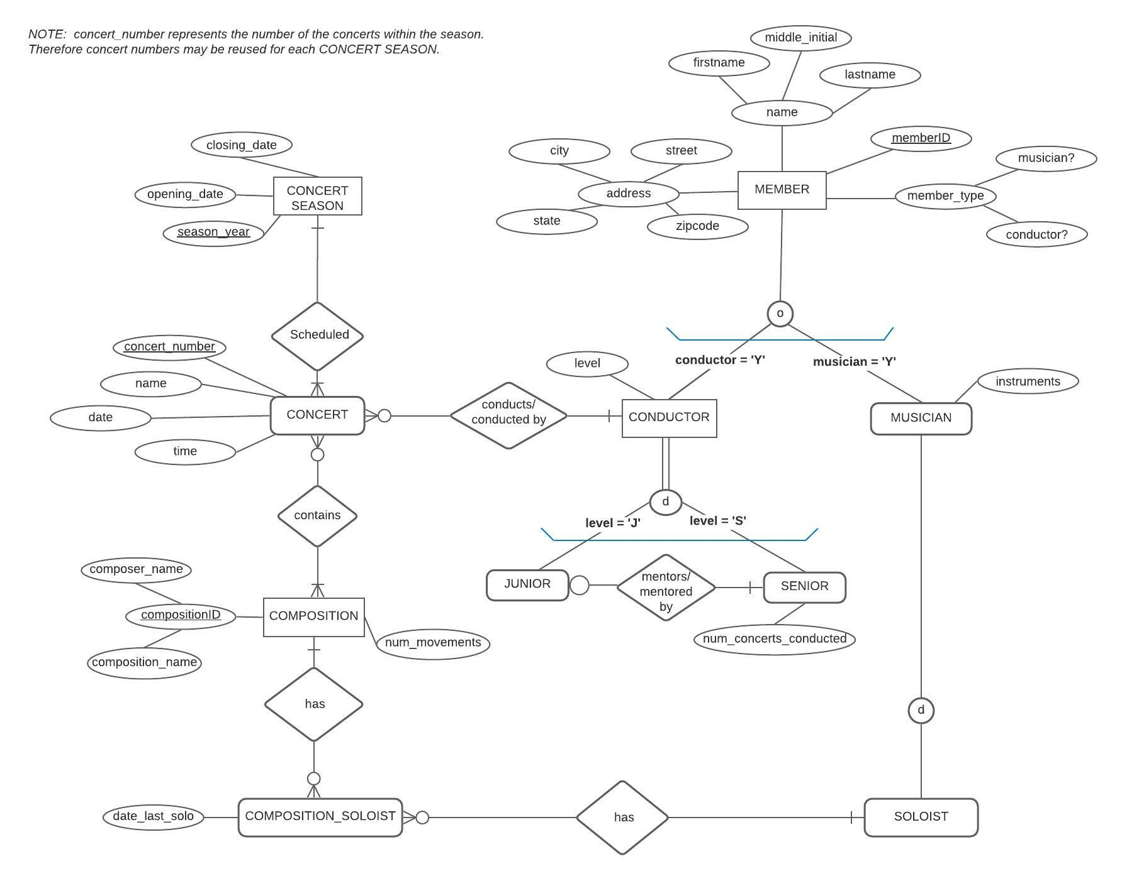

Member(MemberID, firstName, middleName, street, city, zipcode, conductor, musician)
Conductor(memberID, level)
- - - - - - - - -
Conductor(memberID) M.E.I. Member(memberID)

Muscician(memberID,instuments)
- - - - - - - - -
Instuments(MemberID, Instument)
- - - - - - - -
Instruments(MemberID) M.E.I. Muscician(MemberID)

Muscician(MemberID) M.E.I. Member(memberID)

Senior(memberID, num_concert_conducted)
- - -- - - - -
Senior(memberID) M.E.I. Conductor(MemberID)

Junior(memberID, mentor_member_ID)
- - -- - - - - - - - -- - - - - -- - - - - - -
Junior(memberID) M.E.I. Conductor(MemberID)
Junior(mentor_member_ID) M.E.I. Senior(memberID)

Soloist(memberID, instrument)
- -- - - - -- --- - - - - - - - -
Soloist(memberID) M.E.I. Muscian(memberID)
Soloist(instrument) M.E.I. instruments(Instument)

ConcertSeason(SeasonYear, openDate, closeDate)
Concert(ConcertNumber, seasonYear, name, date, time, conductor_memberID)

- - -- - - - - - - -- - - -- - - - - -- - -
Concert(SeasonYear) M.E.I. ConcertSeason(SeasonYear)
Concert(conductor_memberID) M.E.I. Conductor(memberID)

Composition(CompositionID, season_year, composer_name, composition_name, num_movments)
- - - -- - - - - -
Composition(seasonYear) M.E.I. concert(seasonYear)

Compoition_soloist(seasonYear, memberID, date_last_solo)
- - - -- - - - - - - -- - - - - -
Compoition_soloist(seasonYear) M.E.I. composition(seasonYear)
Compoition_soloist(memberID) M.E.I. Soloist(memberID)

