Name: Please put Last name (Lastname, Firstname)____Eng, Chris___________________________ Practice Exercise 5 Posted First week of school

Due Monday October 3, 2022 @ 11:59pm Assignment box PE05
Download this Word file, edit it, upload this document with answers typed in this document. I like PDF files the best, but if you have problems with creating PDF’s then submit a Word Document to the assignment box.
Notice the functional dependencies are provided for you in each question. Study the functional dependencies provided before you attempt your answer for each question.

For each problem below, normalize the relations into the second Normal Form 2nf.
Be sure to use proper relational notation (relational scema):
RELATION(pkattr, attribute1, attribute2, attribute3, fkattr)
Include reference statements for foreign keys (Must Exist In or M.E.I.) statements

Problem #1
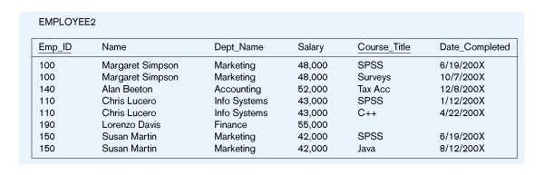
EMPLOYEE2(Emp_ID, Name, Dept_Name, Salary, Course_Title, Date_Completed)
Functional Dependencies:
Emp_ID, Course_Title è Name, Dept_Name, Salary, Date_Completed
EmpID è Name, Dept_Name, Salary
YOUR ANSWER (in relationa scema format) is? What is your M.E.I. statement ?
Employee(EmpID, Name, Dept_Name, Salary)
Course(Emp_ID, Course_title, Date_completed)
- - - - - -
Employee.EmpID == Course.EmpID
Employee.EmpID M.E.I. Course.EmpID
Problem #2
ENGINEER-SERVICE(empID, firstname, lastname, email, serviceID, servicename)

Functional Dependencies:
empID, serviceID è firstname, lastname, email, servicename
empID è firstname, lastname, email
email è empID, firstname, lastname
serviceID è servicename

YOUR ANSWER (in relationa scema format) is? What is your M.E.I. statement
Engineer(empID, firstname, lastname, email)
Service(serviceID, empID ,servicename)
- - -

Engineer.empID = service.empID
Engineer.empID MEI service.empID

Problem #3
Movie
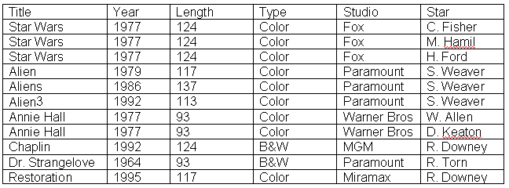

MOVIE(Title, Year, Length, Type, Studio, Star)

Functional Dependencies:
Title, Star è Year, Length, Type Studio
Title è Year, Length, Type, Studio

YOUR ANSWER (in relationa scema format) is? What is your M.E.I. statement?
Movies(Title, year, length, type, studio)
StarsIN(Star, Title )
- - -
Movies.Title MEI starsIN.Title

Problem #4
Is This a relation?_______YES
What is/are the Primary key? ___Supplier ID ProductName_______________________ It appears to have 2 fields (COMPOSTE KEY)
Normalize the folling table. Use Relational Schema! Please include a proper M.E.I. 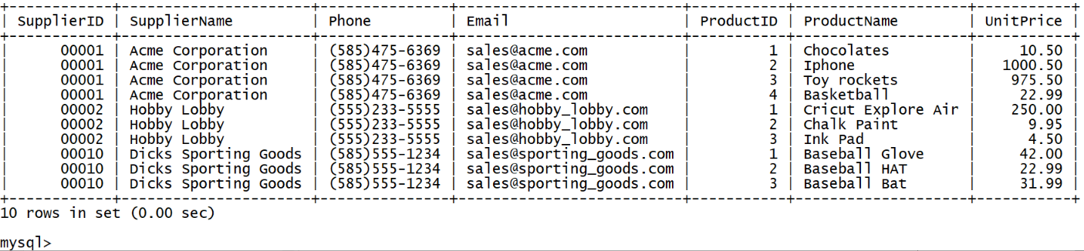
Hobby(SupplierID, SupplierName, phone, email, ProductID, ProductName, unitPrice)
Supplier(SupplierID, SupplierName, phone email)
Product(ProductID, SupplierID, ProductName, UnitPrice)
- - - - - - -

Extra Work Space if needed on page 5 of 5
Extra Work Space if needed below

