Starting with an ERD Entity Relationship Diagram also know as an entity relationship model then create SCRIPT

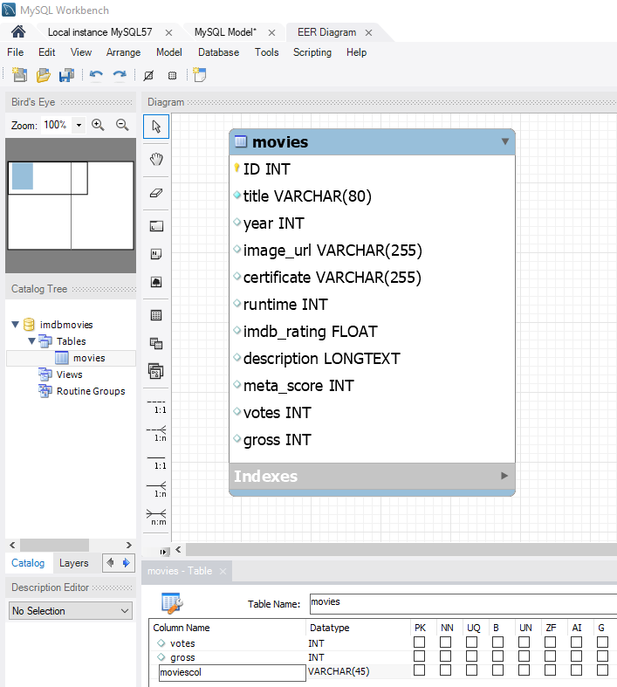

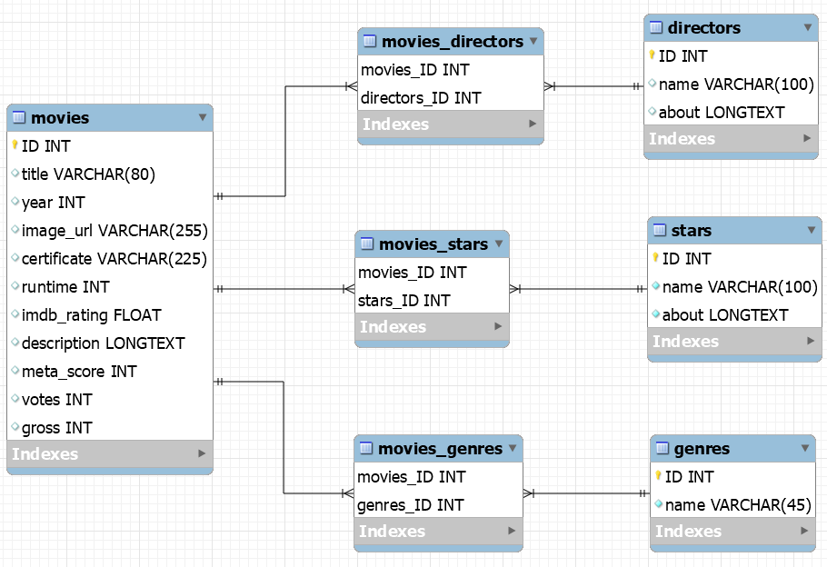
Click Database
Forward Engineer
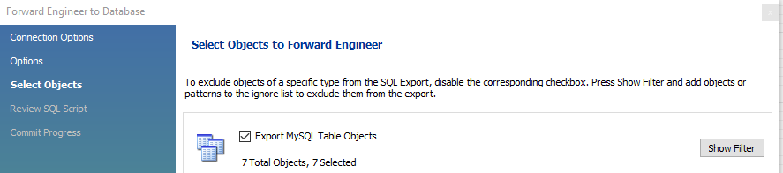

https://www.youtube.com/watch?v=B0aD6yTrT5k

