**Development of ATM system using Python(With screenshots)**

**Login Function**

This function allow user to login bank account using his/her account number and pin number in order to use the ATM services. The procedures are as follows:

1. User enters account number and set up a new 4 digits pin number

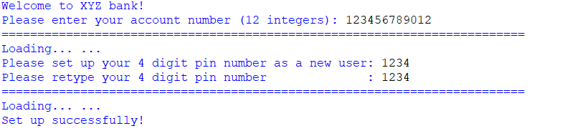

1. After setting up the pin number, the user can now login his/her by using account number and pin number and the user can start using the services offered by the ATM.

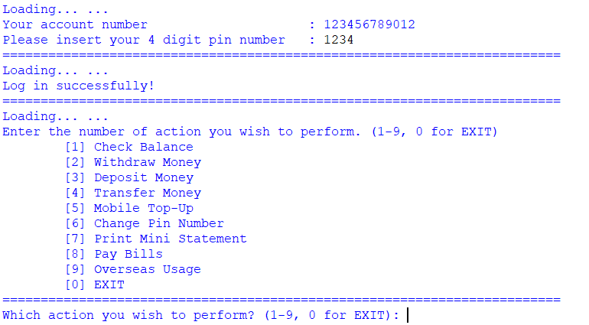

1. If the invalid account number is entered, the atm will prompt user to re-enter the correct account number.

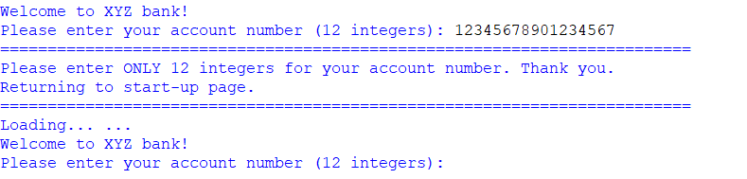

1. If the user enters incorrect pin number which was created, the user will be given another 2 more attempts to retry entering the correct pin number.

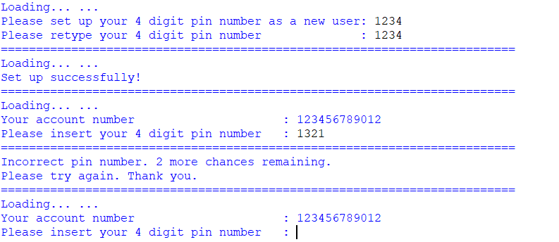

1. Once the user had entered 3 incorrect pin numbers, the ATM will automatically logout the user.

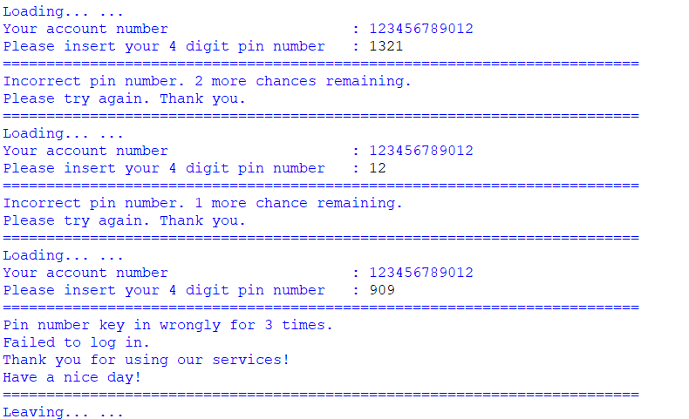

This function also allows the manager to check the login time and date of the customers.

|  |  |  |  |  |
| --- | --- | --- | --- | --- |
| User First Name | User Last Name | User Account Number | Login time | Login date |
| Hailey | Barajas | 123456123078 | 13:34:21 | 12/03/2021 |
| Carleton | Priest | 123564078093 | 12:04:21 | 14/03/2021 |
| Marva | Robb | 154236789096 | 09:21:23 | 16/03/2021 |
| Olivia | Perry | 178452369200 | 12:32:45 | 26/03/2021 |

**Balance function:**

This function will allow the user to their total amount of the money they have in their bank.

If user want to check their balance in bank. They will follow few steps:

1. Insert user account number and the pin number.

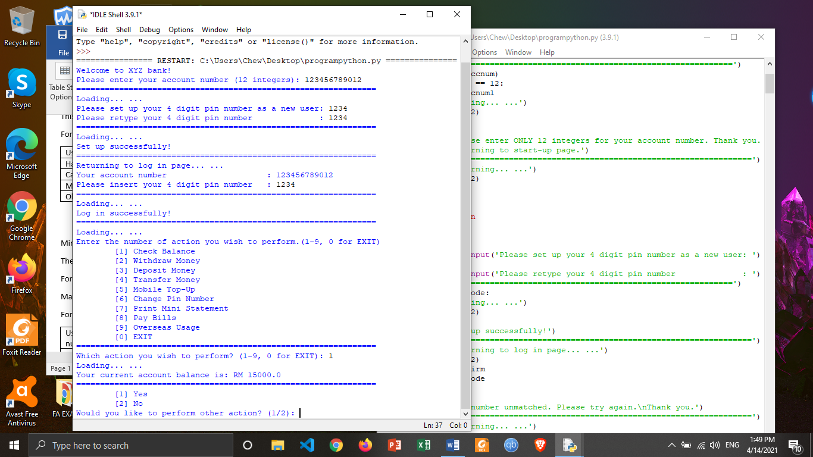

1. 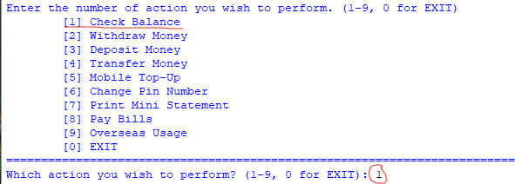Select ‘1’ for checking the balance.
2. After that the system will show out the user’s balance in bank.



This function also allows the manager to check the total amount of the money for their customers.

For example:

|  |  |  |  |
| --- | --- | --- | --- |
| User First Name | User Last Name | User Account Number | User Total Balance (RM) |
| Hailey | Barajas | 123456123078 | 15000 |
| Carleton | Priest | 123564078093 | 25000 |
| Marva | Robb | 154236789096 | 15000 |
| Olivia | Perry | 178452369200 | 30000 |

**Withdraw Money Function:**

This function allows user to withdraw money in the form of cash from his/her bank account balance and displays balance amount of user account after withdrawal.

If a user would like to withdraw money from the ATM, they will have to follow these procedures:

1. 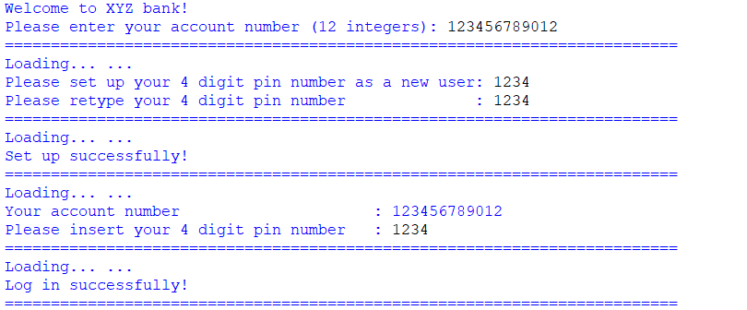Login into user account using account number and pin number.
2. User enters 2 to perform withdraw money function.

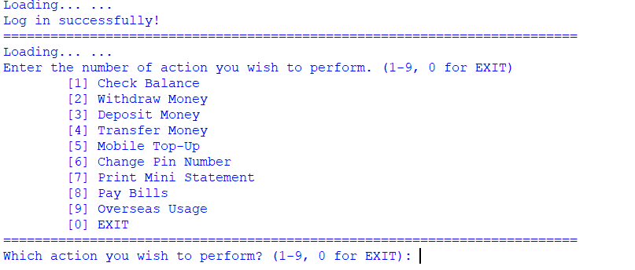

1. User enters the amount he/she wishes to withdraw from his/her account balance.

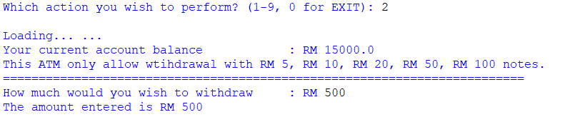

1. User confirms his/her transaction amount where enter 1 to confirm and enter 2 to exit the transaction.

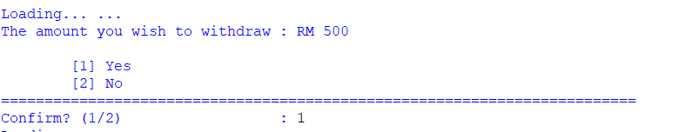

1. After user confirm the transaction by entering 1, the ATM will display transaction made successfully and the balance amount after deduction including date and time of transaction.

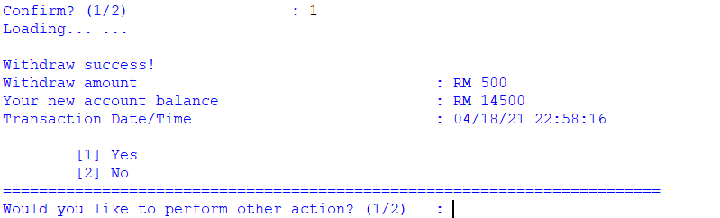

1. If the user enters an amount which exceeds withdrawal limit, it will displays exceed current withdraw limit and ask user if he/she wishes to reset withdrawal limit.

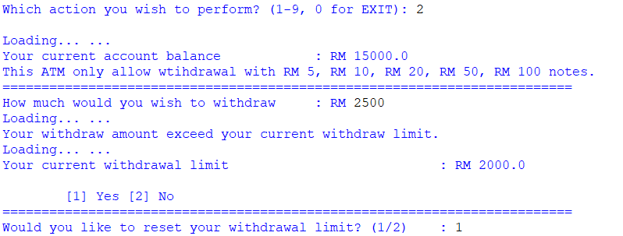

Withdrawal exceed limit

1. If the user enters 1, user can enter a new withdrawal limit where the old withdrawal limit will be reset to new withdrawal limit.

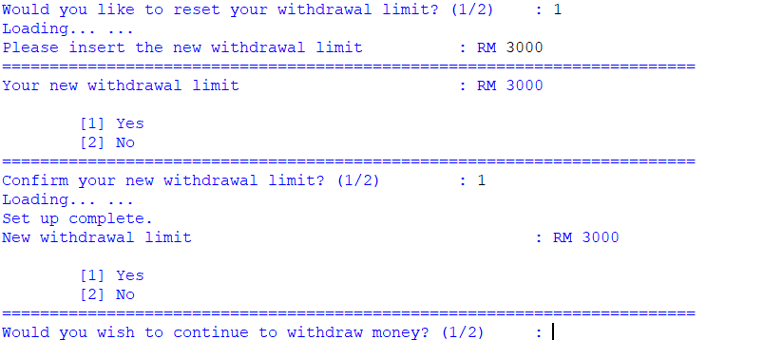

New withdrawal limit

1. As the user had reset the withdrawal limit to RM3000, the user can now withdraw RM2500 from the ATM.

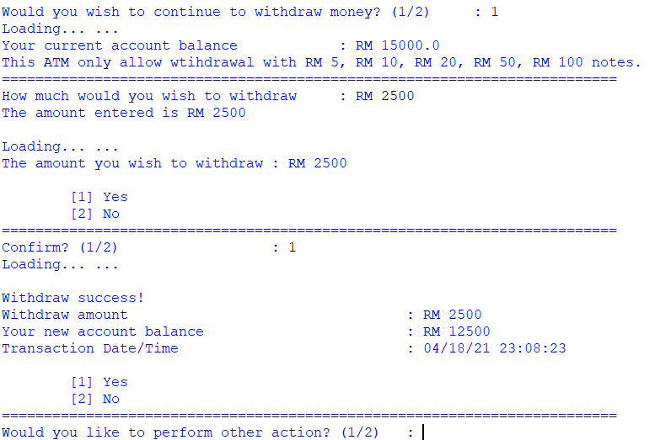

The function also allows manager to check the total amount of money withdraw for the customers.

|  |  |  |  |  |  |  |
| --- | --- | --- | --- | --- | --- | --- |
| User First Name | User Last Name | User Account Number | User Withdraw Amount | User Balance after Withdrawal | Date of Transaction | Time of Transaction |
| John | Russ | 135346789234 | 400 | 14600 | 04/03/2021 | 12:11:01 |
| Charles | Lee | 122437768795 | 300 | 14700 | 25/03/2021 | 03:31:10 |
| Christine | Walt | 154236876435 | 500 | 14500 | 02/02/2021 | 11:45:04 |
| Gregory | Perry | 198568247854 | 200 | 14800 | 03/02/2021 | 10:30:21 |

**Deposit Money Function:**

This function allows user to deposit money in the form of cash from his/her bank account balance and displays balance amount of user account after withdrawal.

If a user would like to deposit money via the ATM, they will have to follow these procedures:

1. 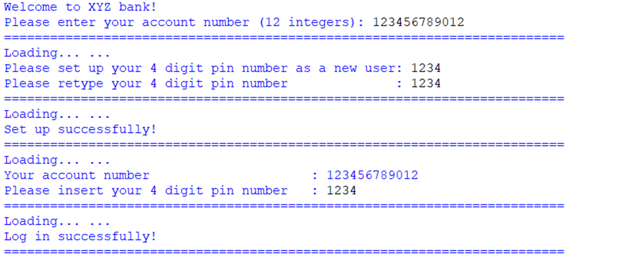Login into user account using account number and pin number.

1. User enters 3 to perform withdraw money function.

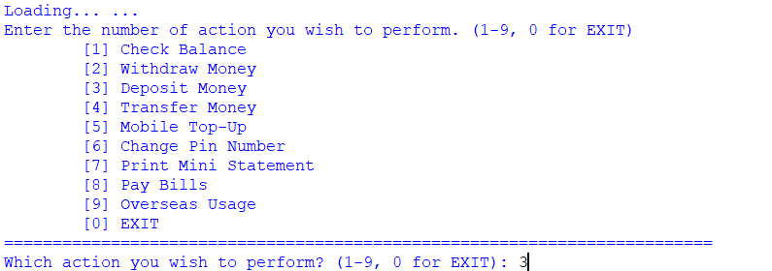

1. User enters the amount he/she wishes to deposit from his/her account balance.

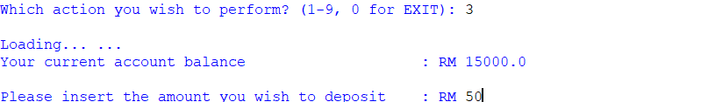

1. User confirms his/her deposit amount where enter 1 to confirm and enter 2 to exit the transaction.

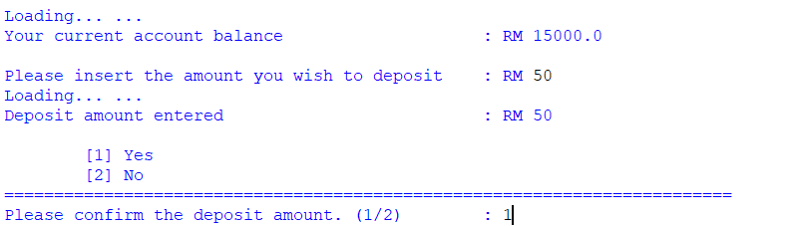

1. After user confirm the deposit amount, the ATM will display deposit made successfully and the balance amount including date and time of deposit.

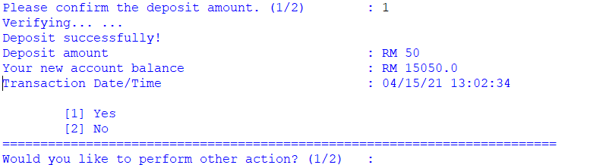

1. If let’s say the user entered RM0, it will display unavailable amount entered and automatically return user to homepage.

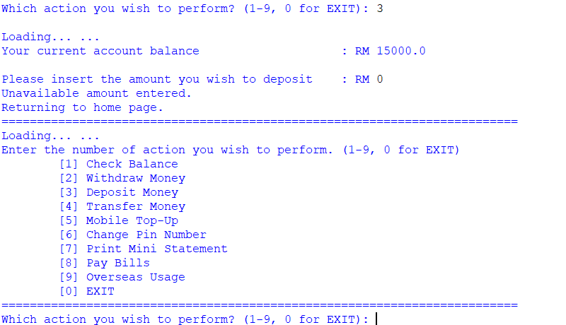

Invalid amount entered

The function also allows manager to check the total amount of money deposited into account for the customers.

|  |  |  |  |  |  |  |
| --- | --- | --- | --- | --- | --- | --- |
| User First Name | User Last Name | User Account Number | User Deposit Amount | User Balance after Deposit | Date of Transaction | Time of Transaction |
| John | Russ | 135346789234 | 200 | 15200 | 24/03/2021 | 10:11:02 |
| Charles | Lee | 122437768795 | 500 | 15500 | 07/03/2021 | 04:23:10 |
| Christine | Walt | 154236876435 | 400 | 15400 | 01/02/2021 | 11:30:04 |
| Gregory | Perry | 198568247854 | 300 | 15300 | 23/02/2021 | 10:30:21 |

**Transfer Money Function:**

This function allows user to transfer money from his/her bank account balance and displays balance amount of user account after withdrawal.

If a user would like to transfer money via the ATM, they will have to follow these procedures:

1. Login into user account using his/her account number and pin number.
2. User enters 4 to perform transfer money function.

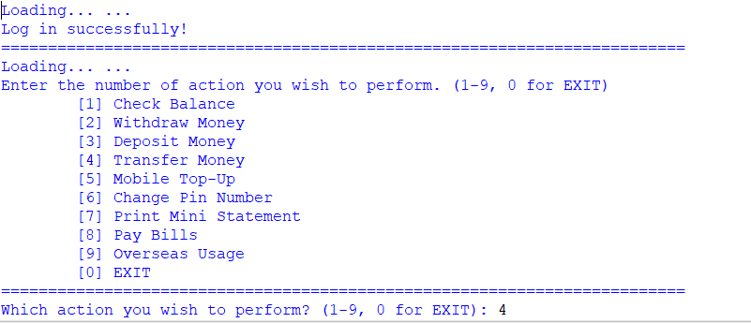

1. User can select which bank he/she wishes to transfer to, where enter 1 to transfer to Alliance bank account and enters 2 to transfer to other bank account.

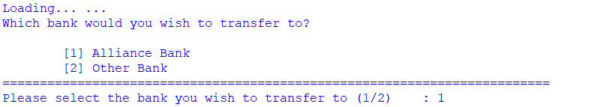

1. The ATM will display the balance amount and current transfer limit. If user wishes to transfer more, he/she can reset the transfer limit by entering 2, else if user wishes to transfer not more than current transfer limit, user can proceed to transfer transaction by entering 1.

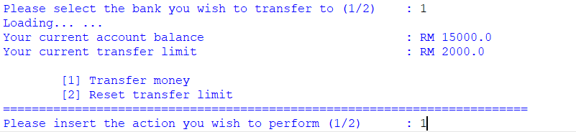

1. User enters the person’s account number he/she wishes to transfer.

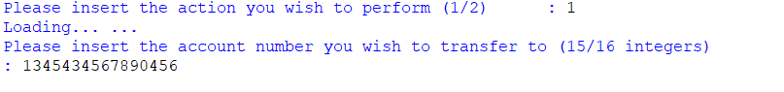

1. User confirms the correct transfer by entering 1 to proceed transaction and enter 2 to exit.

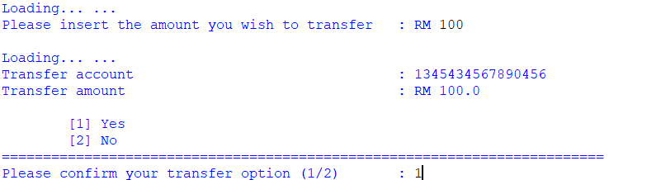

1. The ATM will display transfer successfully to other user’s bank account along with the transaction date and time and balance amount.

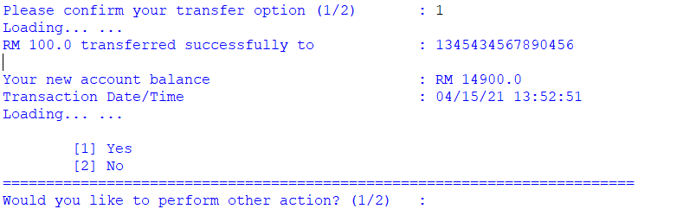

1. If the user enters an invalid selection, the ATM will deny the transaction and display request denied and automatically returns user back to enter the correct selection again.

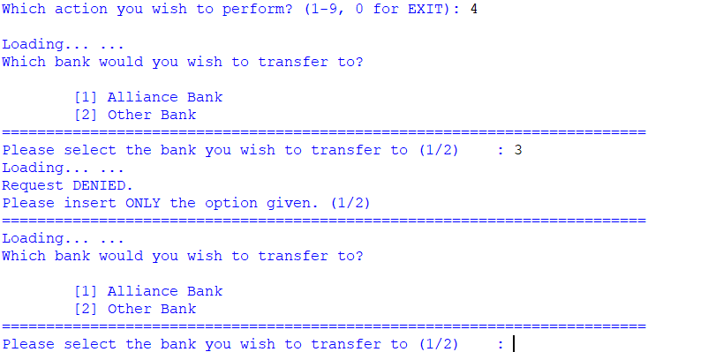

Invalid selection

The function also allows manager to check the amount of money transfer to other user account.

|  |  |  |  |  |  |  |
| --- | --- | --- | --- | --- | --- | --- |
| User First Name | User Last Name | User Account Number | User Transfer Amount | User Balance after Transfer | Date of Transaction | Time of Transaction |
| Missy | Jess | 135346785634 | 200 | 14800 | 24/03/2021 | 06:11:02 |
| Darren | Walson | 123437768795 | 500 | 14500 | 09/03/2021 | 09:23:10 |
| David | Flin | 154267876435 | 400 | 14600 | 21/02/2021 | 03:30:04 |
| Vincent | Carl | 198568247845 | 300 | 14700 | 23/02/2021 | 10:20:20 |

**Mobile Top-Up Function:**

This function allows user to top-up their mobile phone credit from his/her bank account and display the remaining account balance after top-up.

1. Login into bank account using his/her bank account number and pin number.

1. Graphical user interface, text, application

   Description automatically generatedUser will be led to a menu, select 5 to top-up their mobile credit.
2. User are required to insert the phone number that he/she wish to top-up. User is allowing to insert a number with 10 or 11 integers, as a Malaysia mobile number.



1. If user insert a number less than 10 integers or more than 11 integers, a warning message will pop up. User will then be given an option to continue the top-up action.

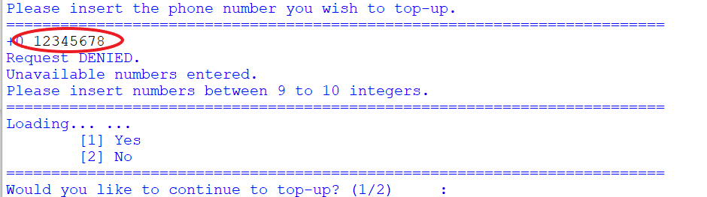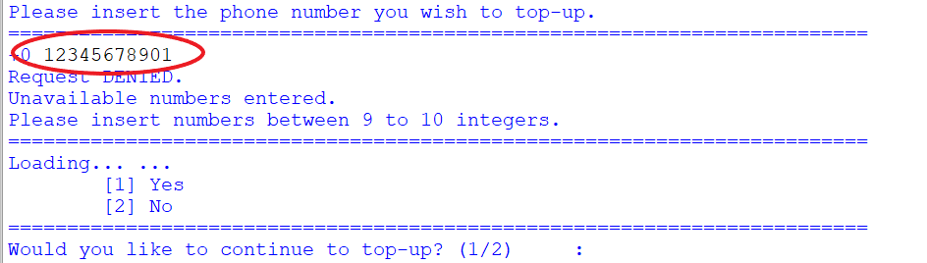

1. Graphical user interface, text, application

   Description automatically generatedUser will be led to a menu and provided option on amount that he/she wish to top-up. Giving example that user wishes to top-up RM xx for the number entered.
2. Graphical user interface

   Description automatically generated with medium confidenceUser will be required to confirm the payment.
3. A printed statement will be shown to user and user are provided an option to continue with other action.

This top-up function also allows manager to check the total amount of customers top-up credit.

|  |  |  |  |  |  |  |
| --- | --- | --- | --- | --- | --- | --- |
| User First Name | User Last Name | User Account Number | User Transaction Amount | User Balance After Transaction | Date of Transaction | Time of Transaction |
| John | Russ | 135346789234 | 10 | 14990 | 30/03/2021 | 17:49:50 |
| Charles | Lee | 122437768795 | 200 | 14800 | 09/03/2021 | 20:01:22 |
| Christine | Walt | 154236876435 | 100 | 14900 | 20/02/2021 | 09:22:49 |
| Gregory | Perry | 198568247854 | 50 | 14950 | 06/02/2021 | 13:28:01 |

**Change Pin Number Function:**

This function allows user to change their 4 digits pin number.

1. A picture containing timeline

   Description automatically generatedLogin into bank account using his/her bank account number and pin number.
2. Graphical user interface, text, application, email

   Description automatically generatedUser will be led to a menu, select 6 to change their pin number.
3. A picture containing text

   Description automatically generatedUser is required to key in the original pin number.
4. Once the pin number entered matched with the original pin number, user will be able to change their 4 digits pin number.



1. Graphical user interface, text

   Description automatically generatedIf the user inserts the new pin number same as the old pin number, a warning message will pop up to inform that the new pin number cannot be same as the old pin number. An option to continue for updating pin number will then be shown.
2. User will be required to retype the new pin number to confirm the changes.
3. Text

   Description automatically generated with medium confidenceA printed statement will be shown to user and user are provided an option to continue with other action.

This function allows the system to record the changes of pin number for users.

|  |  |  |  |  |  |  |
| --- | --- | --- | --- | --- | --- | --- |
| User First Name | User Last Name | User Account Number | Ori Pin | New Pin | Date of Change | Time of Change |
| John | Russ | 135346789234 | 8888 | 0713 | 27/03/2021 | 18:54:18 |
| Charles | Lee | 122437768795 | 5656 | 1314 | 14/03/2021 | 10:05:32 |
| Christine | Walt | 154236876435 | 1234 | 1748 | 22/02/2021 | 21:23:02 |
| Gregory | Perry | 198568247854 | 0000 | 0369 | 10/02/2021 | 15:48:43 |

**Mini Statement:**

The function of this system is to allow the user to check their transaction history

When user want to check their transaction history in bank. They will need to follow few steps:

1. Insert user account number and pin number.



1. Select ‘7’ for the mini statement.

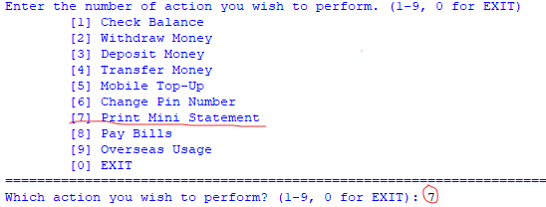

1. After that, system will show the user transaction history.

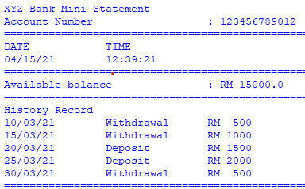

For example:

Manager may use this system to check specific user account transaction history.

For example:

|  |  |  |  |  |
| --- | --- | --- | --- | --- |
| User Account Number | Type Transaction | Amount of Transaction | Transaction Date | Transaction Time |
| 123456789012 | Withdrawal | 500 | 13/03/2021 | 09:30:30 |
| 123456789012 | Withdrawal | 1000 | 15/03/2021 | 09:40:50 |
| 123456789012 | Deposit | 1500 | 20/03/2021 | 10:45:35 |
| 123456789012 | Deposit | 2000 | 25/03/2021 | 13:55:32 |
| 123456789012 | Withdrawal | 500 | 30/03/2021 | 11:45:30 |

**Pay Bills Function:**

This function allows user to pay their bills from his/her bank account and display the remaining account balance after paying the bills.

1. A picture containing timeline

   Description automatically generatedLogin into bank account using his/her bank account number and pin number.
2. Graphical user interface, text, application, email

   Description automatically generatedUser will be led to a menu, select 8 to pay their bills.
3. User will be led to a menu and provided option for bills to pay.

1. Graphical user interface, text, application

   Description automatically generatedIf user inserts an option that are not in between 0 to 4, a warning message will pop up and direct lead the user back to the pay bills menu.
2. User are required to confirm the bill payment after selecting the bills to pay.

1. A printed statement will be shown to user and user are provided an option to continue with other action.

This bill payment function also allows manager to check the total amount of customer paid.

|  |  |  |  |  |  |  |
| --- | --- | --- | --- | --- | --- | --- |
| User First Name | User Last Name | User Account Number | User Transaction Amount | User Amount After Transaction | Date of Transaction | Time of Transaction |
| John | Russ | 135346789234 | 150 | 14850 | 29/03/2021 | 14:11:07 |
| Charles | Lee | 122437768795 | 3560 | 11440 | 03/03/2021 | 09:21:43 |
| Christine | Walt | 154236876435 | 30 | 14970 | 27/02/2021 | 12:58:23 |
| Gregory | Perry | 198568247854 | 250 | 14750 | 04/02/2021 | 19:09:55 |

**Overseas usage setting:**

This function will allow the user to activated or deactivated the overseas usage system

1. User will need insert own account number and pin number.



1. Insert ‘9’ to select the activation of overseas usage system.

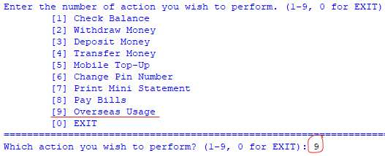

1. 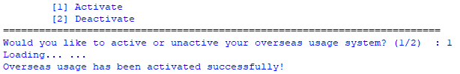Insert ‘1’ to activate the overseas usage system, after that the system will pop up the message to let the user know that the overseas usage function had been activated successfully.
2. After finishing the setting, system will pop-up the if the use wants to change again of their bank overseas usage setting. User will need to ‘1’ to change the setting or insert ‘2’ keep the current setting.
3. 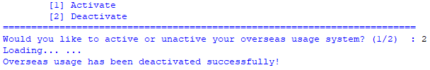If user insert ’1’ they able to go back to the setting page. If user want to deactivate the system, user will need to deactivate the overseas system.
4. 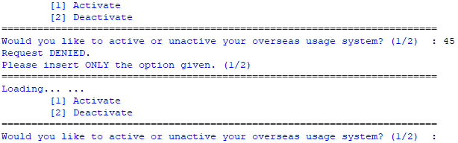If user insert other value than ‘1’ and ‘2’, the system will pop up the message that the value that user insert is wrong and tell the user only insert ‘1’ or ‘2’ only for the process

For the manager this function will allow the manager to check the user current overseas usage status

For example:

|  |  |  |  |
| --- | --- | --- | --- |
| User account number | Current overseas usage status | Setting date | Setting time |
| 123456789012 | Activated | 20/02/2021 | 10:40:25 |
| 124568790457 | Activated | 15/03/2021 | 11:50:44 |
| 123456789012 | Deactivated | 30/03/2021 | 14:25:30 |
| 175894628542 | Deactivated | 01/04/2021 | 09:35:08 |

**Logout Function**

This function allows user to logout his/bank account if he/she had done using the ATM services.

1. User will need to enter his/her password to login his/her bank account.



1. User selects ‘0’ to perform logout from the ATM.

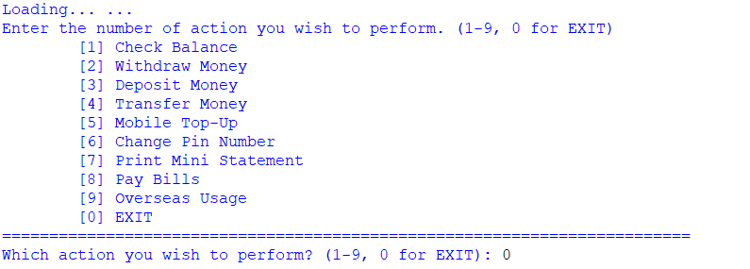

1. The ATM has successfully logout the user’s account.

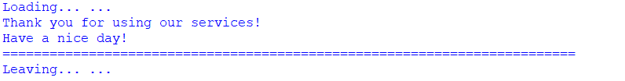

The function also allows the manager to check the logout time and date of customers.

|  |  |  |  |  |
| --- | --- | --- | --- | --- |
| User First Name | User Last Name | User Account Number | Logout time | Logout date |
| Hailey | Barajas | 123456123078 | 14:34:21 | 12/03/2021 |
| Carleton | Priest | 123564078093 | 11:04:21 | 14/03/2021 |
| Marva | Robb | 154236789096 | 08:21:23 | 16/03/2021 |
| Olivia | Perry | 178452369200 | 13:32:45 | 26/03/2021 |