

Bluetooth and Ir

Spring 2018 Final Project



May 17, 2018

California State University Long Beach

**Julie Kim (011963677)**

**CECS 447 Monday, Wednesday 10:00am – 12:15 pm**

**Due Date: May 16, 2018**

**Instructor: John Vu**

**Contents**

**Introduction**: 2

**Operation:** 2

**Hardware:** 2

**Hardware block diagrams** 3

**Part and Components:** 5

**Software Flow Diagram:** 6

# **Introduction**:

The objective of the final project, Bluetooth and IR signal is to use serial communication from Bluetooth to communicate with the microcontroller tm4c123, which send out the command to control the direction: left, right, forward, backward, and speed. The initial setting of the start of the motor is it runs at 50 percent speed with the red led is on, 75 percent speed with the blue led is on and 100 percent with green led is on. When is the motor is driven to a known destination by the command from the Bluetooth terminal, a final command is sent, IR, to send out signal of start + command and address. The IR signal sent out from MCU1 is modulated when sent out to MCU2. When MCU2 receives the demodulated signal, it checks if the signal matches the signal expected to receive. If it matches a confirmation is displayed on the color lcd screen with a predefined picture to confirm the right signal is received.

# **Operation:**

The project includes a smart phone as a terminal to send out a serial command to the microcontroller. The first microcontroller receive signal from smart phone through the Bluetooth module(HC-05) which is a slave to the first microcontroller. A slave means the Bluetooth’s clock rate is determined by the first microcontroller (MCU1). In this project the clock rate is set to 80MHz with the baud rate of 5700bit/second. MCU1 control the movement of the robot which consist of two DC motor. MCU1 control the direction of the two DC motor is the H-bridge, the part number is L9110. At the other end of the is the receiving microcontroller, MCU2. It receives the demodulated signal from the IR receive module which convert demodulate the modulated signal. The MCU2 check the demodulated signal to confirm if it is correct as: Star + 0b10 + 0b1010. The confirmation is display on the color LCD ST7735 module.

The Bluetooth terminal from smart phone need to be configure before used to communicate with the Bluetooth module. The configure command is set by setting the HC-05 to a command mode by pressing the Key button and hold it until the light is blinking one every 2 second. FTDI module is used to set configure the HC-05. Teraterm terminal is used and set the baud rate to 38700bit/second. The command ‘AT’ is sent out from the terminal to FTDI and it send to HC-05.

AT+ RESTET (to reset the Bluetooth)

AT+NAME=JULEKIM_BLUETOOTH (set the Bluetooth name to this name)

AT+ROLE=SLAVE (set the Bluetooth to slave mode)

AT+PSWD=TAHIR (set the Bluetooth password)

AT+UART=5700,1,0 (baud rate of 5700, one stop bit , no parity)

Start to operate by paired the smart phone with the Bluetooth module using the 5700 baud rate, look for Bluetooth name of JULIEKIM_BLUETOOTH, and the password is TAHIR.

During operation, smart phone Bluetooth app have nine signal to send out: ‘A’(turn left), ‘D’(turn right), ‘W’(move forward), ‘S’(move backward), ‘100%’, ‘75%’, ‘50%’ (speed percentage), and the ‘IR1’ is to send out the IR command to MCU2. The command ‘Q’ to stop the motor.

# **Hardware:**

## **Hardware block diagrams**

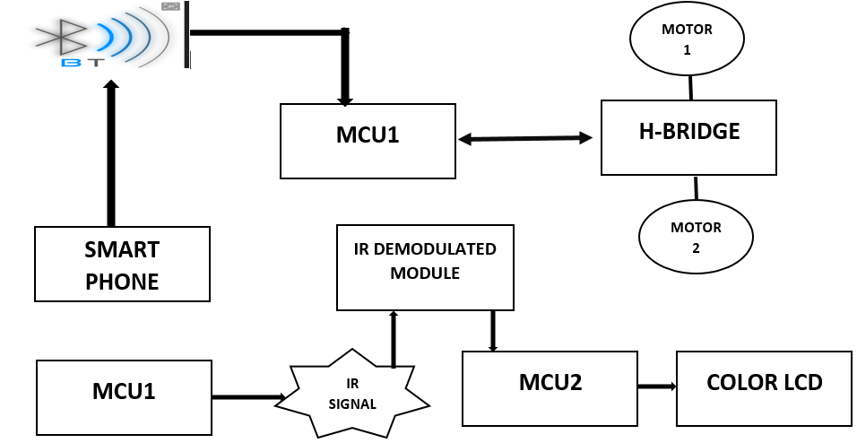

**Schematics:**

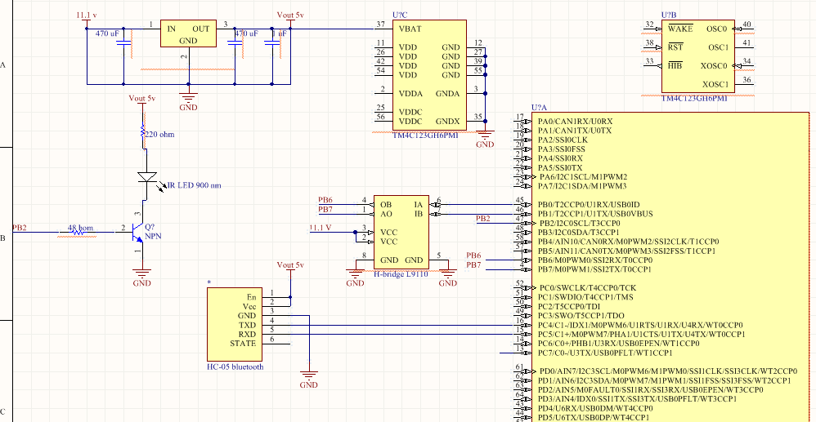

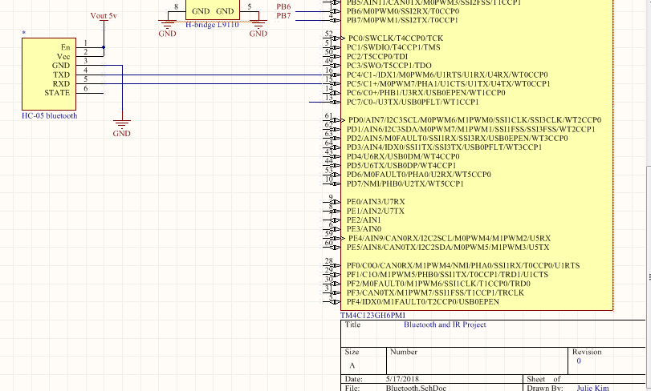

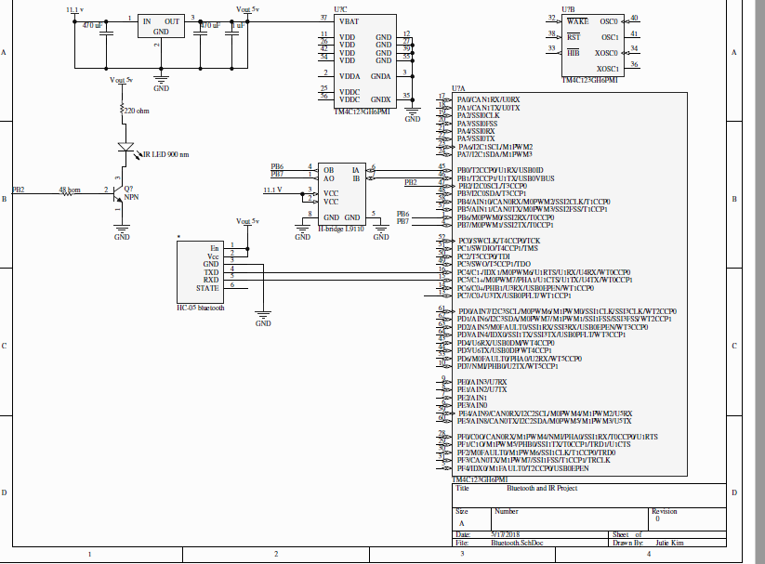

# **Part and Components:**

The required components are two DC motors, one differential platform, HC-05 Bluetooth module, 900 nm IR led, NPN transistor N2222, 48 hom and 100 hom resistor, 38 KHz IR receiver module and ST7735R color LCD. A user interface application (Bluetooth terminal) from a smart phone to send out serial communication signal.

HC-05 Bluetooth module operate at 5v compatible with the tmc123 microcontroller, its tx and rx pin out voltage is 3.3 v compatibles with tm4c 123, which make the designing process easier having to use resistor to create voltage divider to lower the voltage when tm4c receiving signal from the tx of the Bluetooth. 900 nm IR led send out longer rang of signal make it convenient and certain that the receiver module can detect the IR signal. The output pin from tm4c has only 8 mA, it is not enough to drive the IR led. The transistor N2222 can amplify the current up to 1 A to drive the led. N2222 has a base current of about 2mA, a resistor is used to drop down the voltage to the required voltage to drive the transistor. 48 hom resistor produces drop down voltage of 5 volt (a current limiting resistor) to light the IR led.

**Software:**

The program start by running the motor at 50% constant speed and wait for the signal received from the Bluetooth module. There are five case statements for ‘A’, ‘Q’, ‘W’, ‘D’, and ‘S’ to control the direction of the two DC motor. If the these five cases are not met, check for speed and IR command. The MCU2 continuously checking for the signal from IR led, and confirm it with the software hard code signal. With positive respond, the color LCD should update with a predefined screen. The software execute accordingly and go back to the start of the program and continuously execute the program.

To send out the modulated IR signal at 38KHz, the period is 26 us. Using the bus clock of 80MHz, output square wave of 26us based on the command given of Start + 0b10+ 0b1010.

## **Software Flow Diagram:**

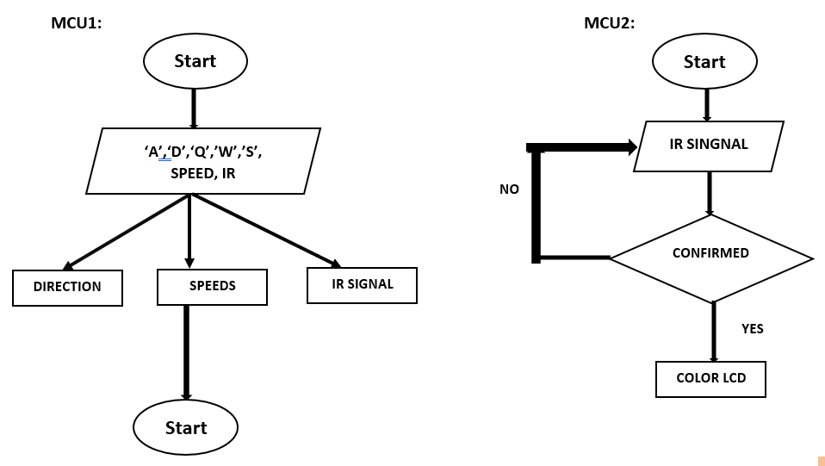**Conclusion:**

This project has been a great learning experience of how to use serial communication in Bluetooth communication through tm4c serial port. The command sends out was successfully control the motor’s movement. The IR signal sent out from MCU1 was successfully modulated and captured by the IR receiving module. There is one major issue while developing the project is the decoding the demodulated IR signal. The IR signal is not properly decoded so no proper command sent to the color LCD to output the on-screen image. This is the major failure as this is the major goal of the project is to create different IR command to control a product. Another issue encounter is the capture of the signal from Bluetooth and the responds of the motor is not instance. There is some delay in the software code to prevent the constant responds of the motor. Over all, there is about 70 percent success of the project. This is minor success is used as a basic understanding of how serial communication work and make better development.