PARENT ABSENCE NOTIFICATION
Software Design Document (SDD)
Enhancement of the SAMS Attendance Module
Prepared in alignment with the Phase-2 (Software Design) guideline
Document Item | Details
Project / System | SAMS – School Attendance Management System
Module | Attendance / Notifications
Document Type | Feature Enhancement Software Design Document
Version | 1.0
Prepared By | Software Design Team
Date | 2 November 2026
Status | Completed Design Baseline - Pending Stakeholder Approval

Table of Contents
1. Document Control 4
1.1 Finalization Baseline and Decisions 4
2. Purpose and Scope 4
2.1 Purpose 4
2.2 In Scope 5
2.3 Out of Scope 5
3. Existing Attendance Feature Overview 5
4. Proposed Feature Enhancements 5
4.1 Functional Requirements 6
5. Interface Design (UI & UX) 6
5.1 Parent – Notification and Reason Form 7
5.2 Parent – Portal 7
5.3 Teacher and Office Staff 7
5.4 Administrator 7
5.5 Baseline Wireframe Specifications 7
6. Architectural Design 8
6.1 Component Responsibilities 8
7. Data Flow Design 9
7.1 Key Data Flows 10
8. Database Design 10
8.1 Proposed Tables / Changes 10
8.2 Field Definitions 11
8.3 Data Integrity and Performance 12
9. Program and API Design 12
9.1 API Contracts 12
9.2 Notification Processing Rules 13
9.3 Pseudocode – Process Notification Events 14
9.4 UML Sequence Diagrams 15
9.4.1 Absence Notification 15
9.4.2 Parent Submits Absence Reason 16
10. Software Report / Analytics Design 16
11. Security, Privacy, and Non-Functional Design 16
11.1 Security & Privacy 16
11.2 Non-Functional Requirements 17
12. Impact Analysis and Migration 17
12.1 Deployment Approach 17
12.2 Rollback Considerations 18
12.3 Deployment Environments and Release Gates 18
13. Test Design 18
13.1 Regression Areas 19
14. Acceptance Criteria 19
15. Requirement-to-Design Traceability 19
16. Finalized Implementation Decisions 20
Appendix A – Completion and Approval Checklist 20
Appendix B – Review and Approval Record 20

1. Document Control
Executive assessment: The Release 1 design covers every Must and Should requirement in the BRD (BR-01 to BR-11) and is traceable to tests. Production approval should depend on cleaning up missing student–parent links, confirming SendGrid sending limits, and naming an owner for the 11:00 follow-up list. Decision requested: approve F-01 to F-08 for implementation, subject to the release gates in Section 12.3. The main delivery risks are incomplete guardian data, email deliverability at the 08:30 peak, and correct handling of corrections made shortly after cut-off.
This document describes the software design for adding parent absence notifications to the existing SAMS attendance module. It combines architectural and detailed design so the enhancement can be reviewed before implementation and maintained after release.
Version | Date | Author | Change
1.0 | 2 November 2026 | Software Design Team | First complete design baseline produced from BRD v1.0 (20 October 2026).

1.1 Finalization Baseline and Decisions
The BRD leaves several design choices open. To make this SDD implementation-ready without presenting those choices as decided facts, this version adopts the following explicit baseline. Any later change must be recorded as a versioned design change before production release.
- Release 1 includes features F-01 to F-08 defined in Section 4. SMS and Telegram remain out of scope (BRD §6).
- Notification processing runs as a scheduled job every minute; the first absence run for a school is at its configured cut-off time (default 08:30, school time zone Asia/Phnom_Penh).
- A correction window of 30 minutes after a notification is sent applies; changing Absent to Present within this window sends one correction message.
- Release 1 channels are email (SendGrid) and in-app (parent portal). Each parent must keep at least one channel enabled.
- Absence-reason links are signed, single-student tokens valid for 72 hours; parents who are logged in can also answer from the portal.
- Attachments for absence reasons are limited to PDF, JPG and PNG up to 5 MB each.
- Notification logs and absence reasons are kept for the current academic year plus 90 days, then deleted; monthly aggregates are kept for 3 years.
- Templates are stored per event type and language (English, Khmer); the parent's preferred language decides which is used, with English as fallback.

2. Purpose and Scope

2.1 Purpose
The purpose of this design is to notify parents promptly when a student is absent or late, let them submit a reason, and give staff a reliable record, without changing how teachers take attendance. It defines the interface, components, data flows, database changes, APIs, security controls and tests needed.

2.2 In Scope
- Automatic absence and late notifications after a configurable cut-off time.
- Correction messages when attendance is changed to Present within the correction window.
- Email and in-app channels, with parent channel preferences.
- Parent absence-reason submission with optional attachment.
- Staff view of reasons and an office follow-up list.
- Administrator configuration of cut-off times, late notifications and bilingual templates.
- Notification log and monthly absence/notification report.

2.3 Out of Scope
- SMS, Telegram or other messaging channels (phase 2).
- Automatic absence prediction or risk scoring.
- Changes to the teacher attendance-taking screens or QR check-in flow.
- Fixing guardian data in source systems beyond the data-quality report in Section 12.

3. Existing Attendance Feature Overview
SAMS already records daily attendance through the web screen and QR-code check-in. All attendance writes go through a single attendance service, which records the source of each change. Office staff currently phone parents manually. The enhancement reuses the attendance service as the trigger point and adds a notification subsystem.
Area | Existing Behavior (Baseline) | Enhancement Impact
Attendance recording | Teachers mark Present/Absent/Late via web or QR; one attendance service writes records. | Attendance service emits an event on every status change; no UI change for teachers.
Parent contact | Office phones parents manually each morning; no record kept. | Automatic email and in-app notifications with a full delivery log.
Parent portal | Parents can sign in and view basic student information. | Adds notification inbox, absence-reason form and channel preferences.
Staff screens | Attendance list per class. | Shows absence reason and response status; new office follow-up list.
Administration | User, class and student management. | Adds notification settings, cut-off times and template editor.
Email | SendGrid used for account emails. | Reused for notifications with delivery-status webhooks.

4. Proposed Feature Enhancements
ID | Feature | Design Intent
F-01 | Absence notification | Notify every linked parent when a student is marked Absent after the cut-off time.
F-02 | Late notification | Optionally notify parents when a student is marked Late (school setting).
F-03 | Correction message | Send a correction when a record changes to Present within the correction window.
F-04 | Absence reason | Parents submit a reason and optional attachment from the notification link or portal.
F-05 | Staff reason view & follow-up | Teachers and office see reasons; office sees unanswered absences after 11:00.
F-06 | Channel preferences | Parents choose email and/or in-app; at least one must stay on.
F-07 | Admin configuration & templates | Admins set cut-off times, enable late notices and edit English/Khmer templates.
F-08 | Notification log & reporting | Log every send and delivery status; monthly report by class.

4.1 Functional Requirements
ID | Requirement
FR-01 | An Absent status that exists at or after the school cut-off time triggers one notification per linked parent per student per day (BR-01).
FR-02 | Late notifications are sent only when the school setting late_notify_enabled is true (BR-02).
FR-03 | Each notification is delivered through every channel the parent has enabled; in-app is always created as the record of the message (BR-03, BR-09).
FR-04 | If a status changes from Absent/Late to Present within 30 minutes of the first notification, exactly one correction message is sent; later changes are logged only (BR-04).
FR-05 | A parent can submit one reason per student per absence date; resubmission replaces the earlier reason and keeps a history (BR-05).
FR-06 | Reasons and response status appear on the teacher class list and the office follow-up list (BR-06, BR-07).
FR-07 | The follow-up list shows absences with no reason and no successful delivery, or no reason by 11:00 school time (BR-07).
FR-08 | Only administrators can change cut-off times, late settings and templates; template changes are versioned (BR-08).
FR-09 | Parents cannot disable all channels; the API rejects a preference update that would leave none enabled (BR-09).
FR-10 | Every send attempt and delivery-status update is stored in the notification log (BR-10).
FR-11 | Students without a linked parent are listed on the follow-up list as "No guardian contact" instead of failing silently.

5. Interface Design (UI & UX)
New screens follow the existing SAMS look and components. Parent screens are mobile-first because most parents open notifications on a phone. Staff screens add information to existing lists rather than creating new navigation where possible.

5.1 Parent – Notification and Reason Form
- Email contains student name, class, date, status (Absent/Late), the school phone number and a "Submit reason" button.
- The reason form opens from the signed link without a password; it shows the student, date and status read-only.
- Reason options: Sick, Family matter, Other; free-text up to 500 characters; optional attachment.
- After submission, a confirmation screen and an in-app confirmation are shown.
- All text is available in English and Khmer according to the parent's language setting.

5.2 Parent – Portal
- Notification inbox listing recent messages with unread markers.
- Notification preferences page with email and in-app toggles; the last enabled toggle cannot be switched off.

5.3 Teacher and Office Staff
- Class attendance list shows a reason icon and response status next to Absent/Late students.
- Office follow-up list filtered by date, class and reason status, with a "Mark contacted" action and note.

5.4 Administrator
- Notification settings per school: cut-off time, late notifications on/off, follow-up time (default 11:00).
- Template editor per event (Absence, Late, Correction) and language, with preview and placeholder list.

5.5 Baseline Wireframe Specifications
Screen | Primary Inputs / Controls | Primary Outputs
Reason Form | Reason type, text, attachment, submit | Confirmation, saved reason
Parent Inbox | Open message, mark read | Message list with status
Preferences | Email toggle, in-app toggle, language | Saved preferences / validation message
Office Follow-up | Date, class, status filters, mark contacted | Paginated list of unanswered absences
Template Editor | Event, language, subject, body | Preview and saved template version

Region | Baseline Layout / Behavior
Reason form header | School name and logo, student name, class, date and status badge.
Reason form body | Radio buttons for reason type, text area with character counter, attachment picker with size hint.
Reason form footer | Submit button full width on mobile; error messages shown above the button.
Follow-up list toolbar | Date picker (default today), class filter, status filter, export CSV.
Follow-up list rows | Student, class, status, parent contacts, delivery status, reason status, actions.
Empty / error states | Explain when there are no unanswered absences or when data could not load, with retry.

6. Architectural Design
The enhancement adds a Notification module inside the existing SAMS backend. The attendance service publishes status-change events to an outbox table in the same transaction as the attendance write. A scheduled Notification Worker reads due events, applies the rules and sends messages through channel adapters. This keeps teacher attendance fast and makes notifications reliable even if email is slow.
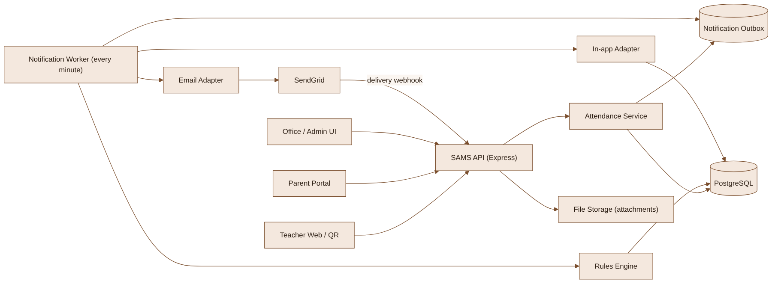
Figure 1. Proposed notification architecture

6.1 Component Responsibilities
Component | Responsibility
Attendance Service | Existing single write path for attendance; now also writes an outbox event on status change.
Notification Outbox | Durable queue table of attendance events waiting to be processed.
Notification Worker | Runs every minute; picks due events with row locking, calls rules, sends and logs.
Rules Engine | Checks cut-off time, late setting, correction window, deduplication and guardian links.
Channel Adapters | Email (SendGrid) and in-app; render templates and return a provider message ID.
Reason Service | Validates signed tokens, stores reasons and attachments, records history.
Follow-up Service | Builds the office follow-up list and records "contacted" actions.
Webhook Endpoint | Receives SendGrid delivery events and updates the notification log.

7. Data Flow Design
The Level-1 data flow below shows how teachers, parents, staff and external email interact with the notification processes and data stores.
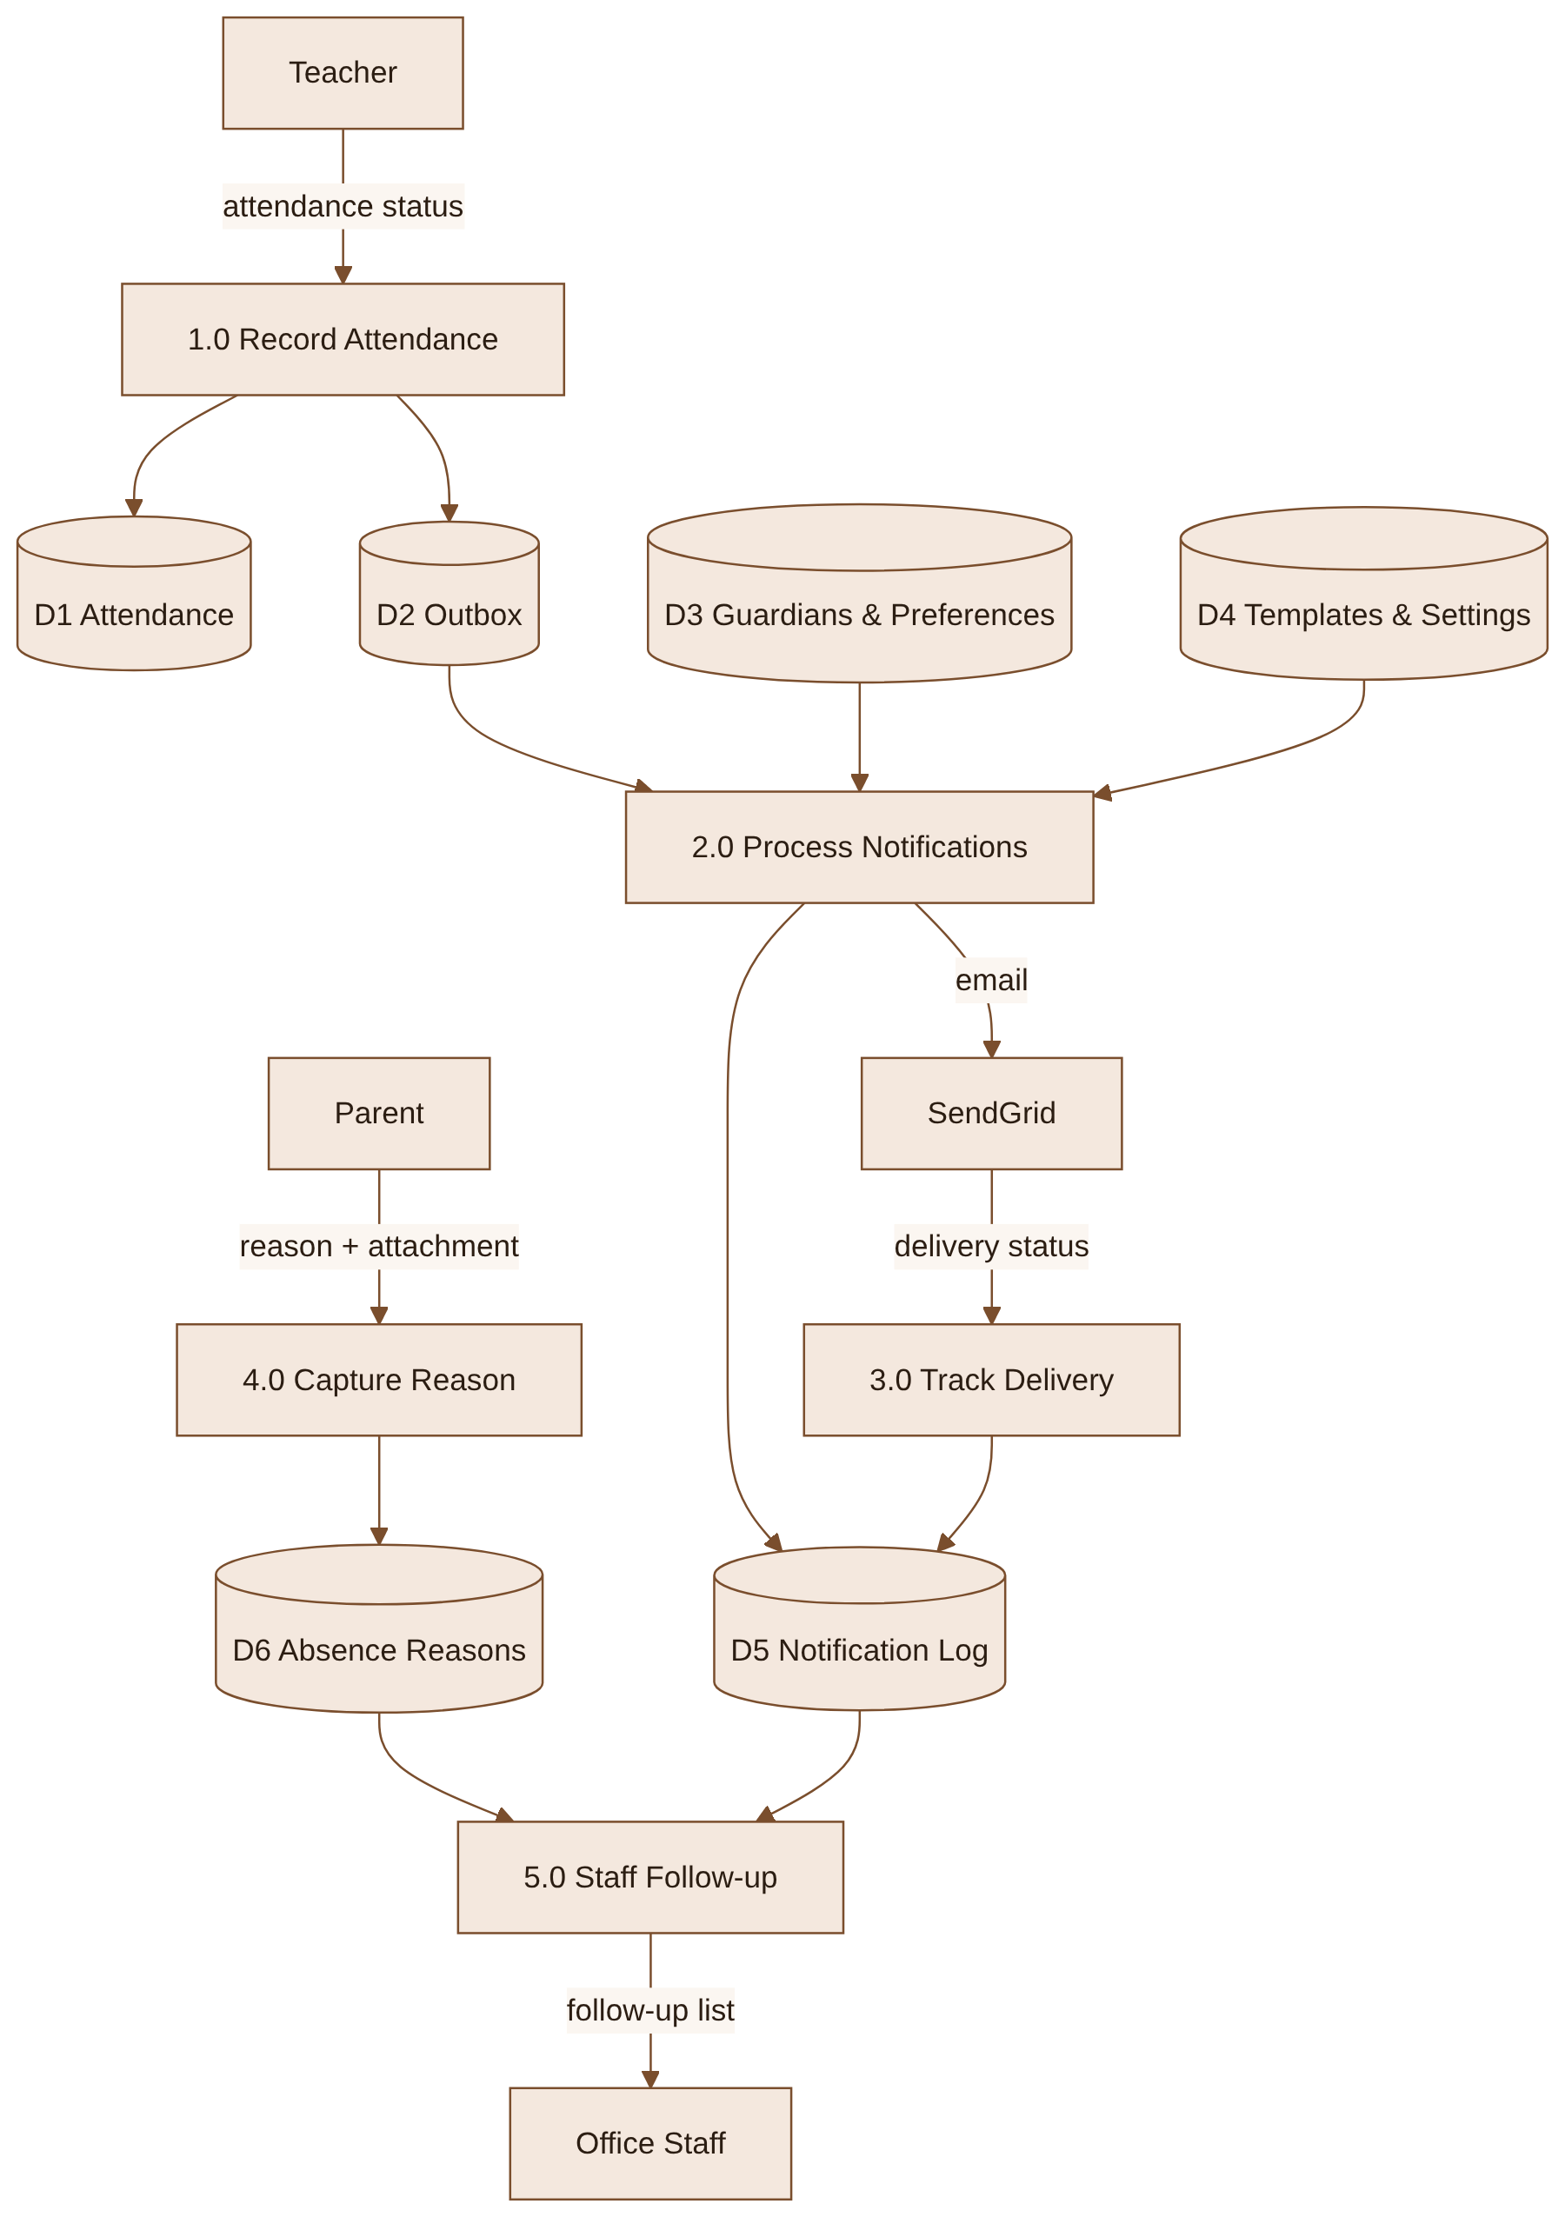
Figure 2. Level-1 Data Flow Diagram for parent absence notifications

7.1 Key Data Flows
- A teacher marks attendance; the attendance service writes the record and an outbox event in one transaction.
- The worker reads due events, loads guardians, preferences, settings and templates, and sends messages.
- SendGrid reports delivered, bounced or dropped status back through the webhook into the notification log.
- A parent opens the signed link, submits a reason, and the reason becomes visible to staff immediately.
- At the follow-up time, the follow-up service combines attendance, log and reason data for the office.

8. Database Design
The design adds tables to the existing PostgreSQL schema and reuses the existing students, classes, users and attendance tables. All new tables use UUID primary keys and timestamps in UTC.
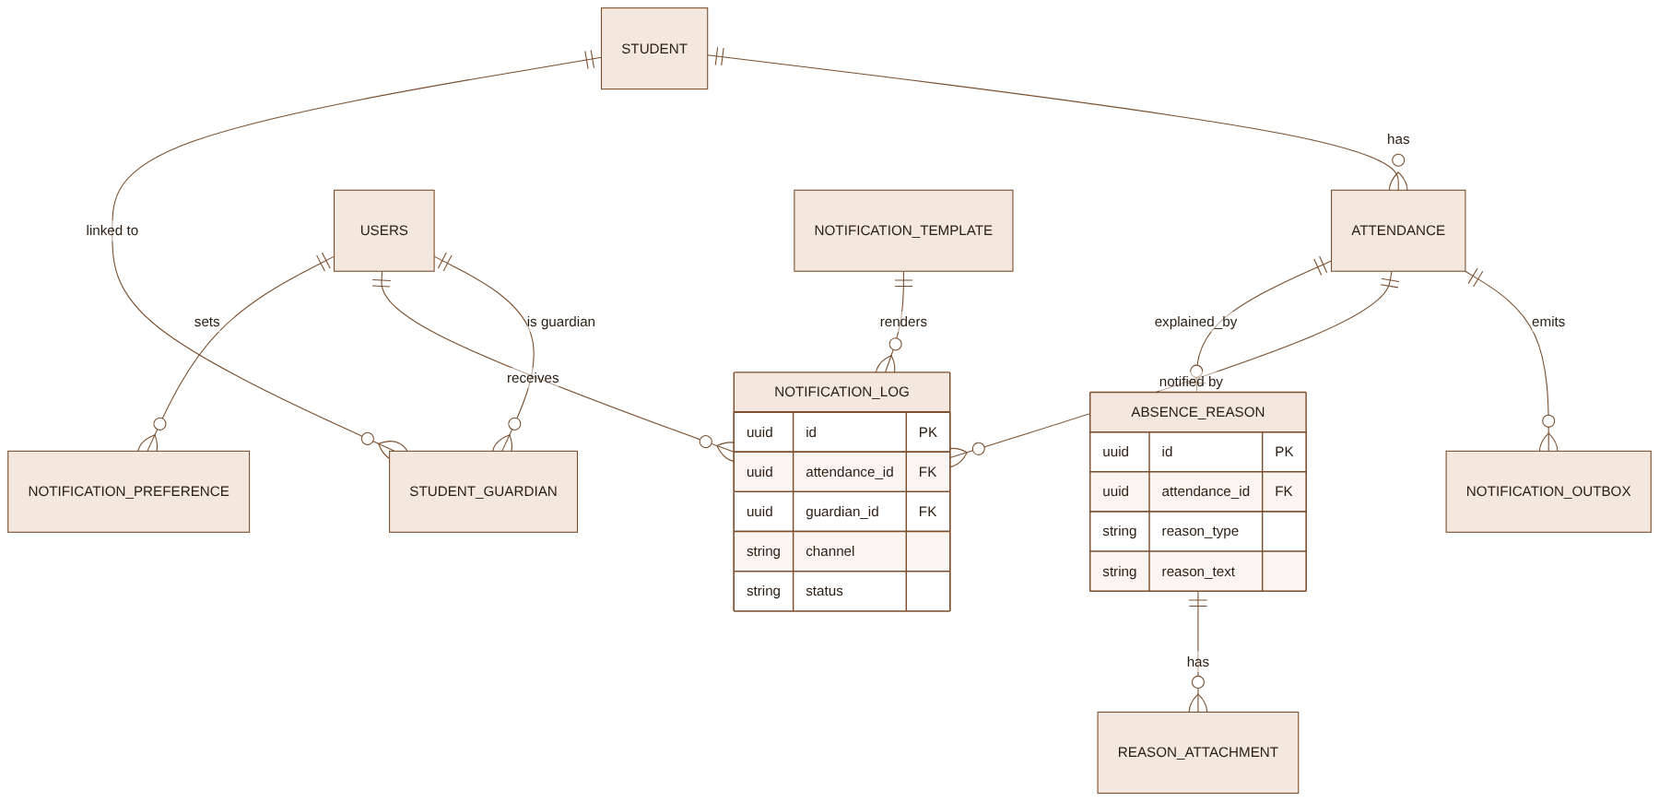
Figure 3. Conceptual Entity Relationship Diagram

8.1 Proposed Tables / Changes
Table | Type | Design Notes
ATTENDANCE | Existing | No column changes; status changes now also insert an outbox row in the same transaction.
STUDENT_GUARDIAN | Existing / Modify | Add is_primary and receives_notifications flags; UNIQUE(student_id, guardian_id).
NOTIFICATION_OUTBOX | New | Pending attendance events with due_at and processed_at; index on (processed_at, due_at).
NOTIFICATION_LOG | New | One row per message per channel per guardian; UNIQUE(attendance_id, guardian_id, event_type, channel).
NOTIFICATION_PREFERENCE | New | One row per guardian: email_enabled, in_app_enabled, language; CHECK at least one channel on.
NOTIFICATION_TEMPLATE | New | Versioned templates by school, event_type and language; only one active version.
NOTIFICATION_SETTING | New | Per school: cutoff_time, late_notify_enabled, followup_time, correction_window_min.
ABSENCE_REASON | New | Current reason per attendance record; history kept in ABSENCE_REASON_HISTORY.
REASON_ATTACHMENT | New | File metadata; files stored outside the database.
FOLLOWUP_ACTION | New | Office "contacted" actions with staff user, time and note.

8.2 Field Definitions
Table | Field | Type | Constraint / Index | Purpose
NOTIFICATION_OUTBOX | id | UUID | PK | Event identifier
NOTIFICATION_OUTBOX | attendance_id | UUID | FK, NOT NULL | Source attendance record
NOTIFICATION_OUTBOX | new_status | VARCHAR(10) | NOT NULL | ABSENT, LATE or PRESENT
NOTIFICATION_OUTBOX | due_at | TIMESTAMPTZ | NOT NULL, indexed | Earliest processing time (cut-off)
NOTIFICATION_OUTBOX | processed_at | TIMESTAMPTZ | NULL, indexed | Set when processed
NOTIFICATION_LOG | event_type | VARCHAR(12) | NOT NULL | ABSENCE, LATE or CORRECTION
NOTIFICATION_LOG | channel | VARCHAR(10) | NOT NULL | EMAIL or IN_APP
NOTIFICATION_LOG | status | VARCHAR(12) | NOT NULL, indexed | QUEUED, SENT, DELIVERED, BOUNCED, FAILED, READ
NOTIFICATION_LOG | provider_message_id | VARCHAR(100) | NULL, indexed | SendGrid message ID for webhooks
NOTIFICATION_LOG | sent_at | TIMESTAMPTZ | NULL | Time the message was sent
NOTIFICATION_PREFERENCE | email_enabled | BOOLEAN | DEFAULT true | Email channel opt-in
NOTIFICATION_PREFERENCE | in_app_enabled | BOOLEAN | DEFAULT true | In-app channel opt-in
NOTIFICATION_PREFERENCE | language | VARCHAR(5) | DEFAULT 'en' | en or km
ABSENCE_REASON | reason_type | VARCHAR(12) | NOT NULL | SICK, FAMILY or OTHER
ABSENCE_REASON | reason_text | VARCHAR(500) | NULL | Parent explanation
NOTIFICATION_SETTING | cutoff_time | TIME | DEFAULT 08:30 | School-local absence cut-off

8.3 Data Integrity and Performance
- Write the attendance change and the outbox event in one database transaction so no event is lost.
- The unique constraint on NOTIFICATION_LOG prevents duplicate notifications if the worker retries.
- The worker selects outbox rows with FOR UPDATE SKIP LOCKED so two worker instances never process the same event.
- Guardian deletion cascades to preferences; notification logs keep the guardian ID but personal contact data is not copied into the log.
- Logs and reasons older than the academic year plus 90 days are deleted by a nightly job after monthly aggregates are stored.

9. Program and API Design
All endpoints are added to the existing Express API, use the existing JWT authentication and role checks, and are documented in Swagger.

9.1 API Contracts
Method | Endpoint | Input | Output / Behavior
GET | /api/parent/notifications | page, pageSize | Parent inbox, newest first; parent role required.
PATCH | /api/parent/notifications/{id}/read | – | Marks an in-app message as read.
GET/PUT | /api/parent/notification-preferences | email_enabled, in_app_enabled, language | Read/update preferences; 422 if no channel enabled.
GET | /api/absence-reasons/form?token= | Signed token | Student, date and status for the reason form; 410 if expired.
POST | /api/absence-reasons | token or session, reason_type, reason_text, attachments | Creates or replaces the reason; returns saved reason.
GET | /api/attendance/{classId}/reasons?date= | Class, date | Reasons and response status for a class; teacher/office role.
GET | /api/office/follow-ups | date, classId, status, page | Unanswered absences; office role.
POST | /api/office/follow-ups/{attendanceId}/contacted | note | Records office contact.
GET/PUT | /api/admin/notification-settings | cutoff_time, late_notify_enabled, followup_time | School settings; admin role.
GET/POST | /api/admin/notification-templates | event_type, language, subject, body | List or create a new template version; admin role.
POST | /api/webhooks/sendgrid | SendGrid event batch (signed) | Updates delivery status; signature verified.
GET | /api/reports/absence-notifications?month= | Month, classId | Monthly report data; admin/head role.

9.2 Notification Processing Rules
- Select outbox events where processed_at is null and due_at <= now, locking rows with SKIP LOCKED (batch of 200).
- Load the current attendance status; if it no longer matches the event, mark the event processed and stop.
- For ABSENT, require that the time is at or after the school cut-off; for LATE, require late_notify_enabled.
- For PRESENT, send a CORRECTION only if an ABSENCE/LATE notification was sent within the correction window.
- Load linked guardians with receives_notifications = true; if none, add the student to the follow-up list as "No guardian contact".
- For each guardian and enabled channel, insert a QUEUED log row (skipping duplicates), render the template and send.
- Update the log with SENT or FAILED; retry FAILED email up to 3 times with 1, 5 and 15 minute back-off.
- Mark the outbox event processed.
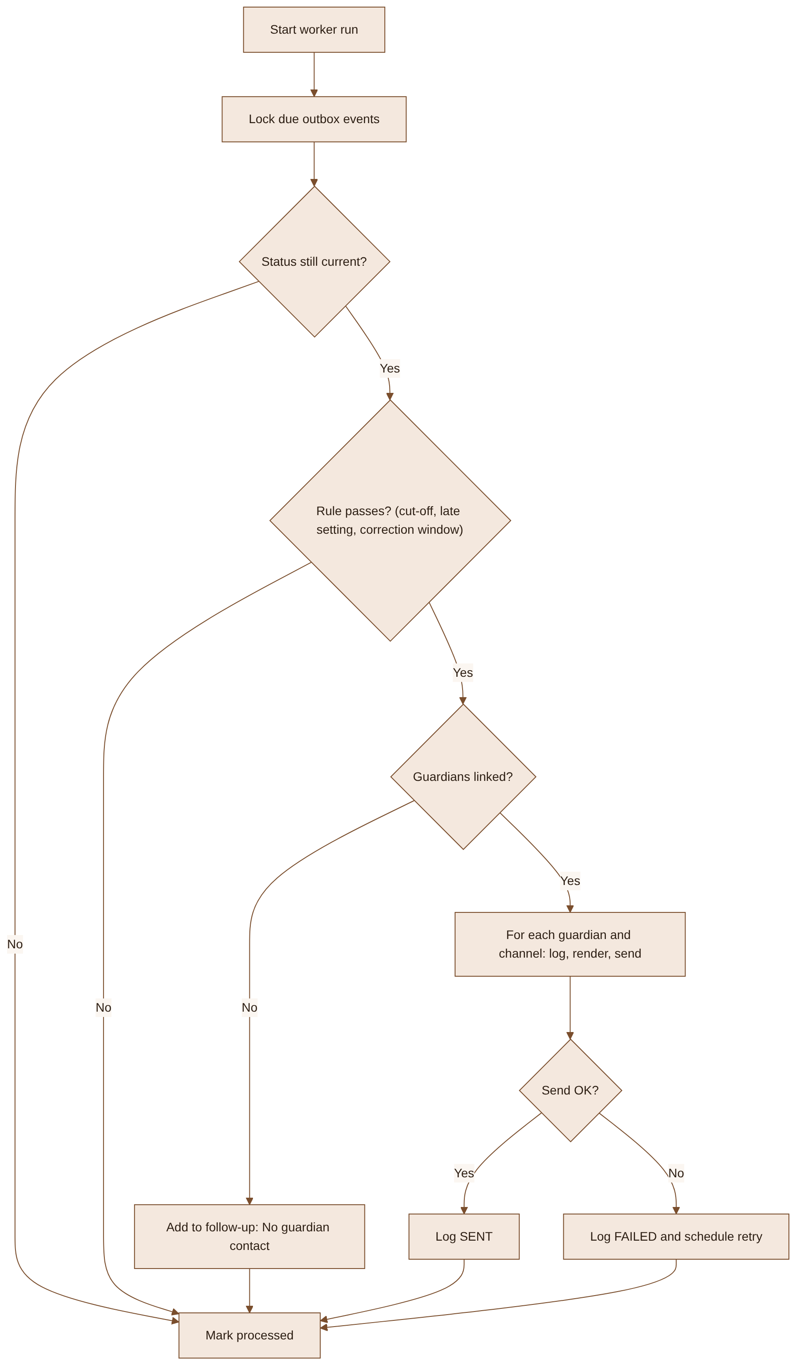
Figure 4. Notification worker program logic

9.3 Pseudocode – Process Notification Events
function processDueEvents(now):
events = outbox.lockDue(now, limit = 200) // FOR UPDATE SKIP LOCKED
for event in events:
record = attendance.get(event.attendanceId)
if record.status != event.newStatus:
outbox.markProcessed(event); continue
settings = settings.forSchool(record.schoolId)
type = rules.eventType(event, record, settings, now) // ABSENCE | LATE | CORRECTION | null
if type is null:
outbox.markProcessed(event); continue
guardians = guardians.forStudent(record.studentId)
if guardians is empty:
followUps.flag(record, "NO_GUARDIAN_CONTACT")
for g in guardians:
for channel in preferences.enabledChannels(g):
if log.insertIfAbsent(record, g, type, channel):
message = templates.render(type, g.language, record)
result = adapters[channel].send(g, message)
log.update(result)
outbox.markProcessed(event)

9.4 UML Sequence Diagrams
The sequence diagrams show the order of calls for the two most important interactions and where authorization and validation happen.

9.4.1 Absence Notification
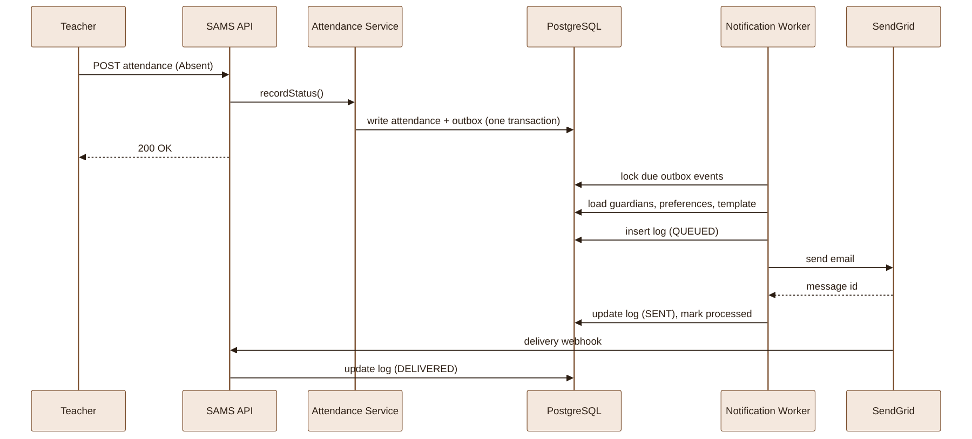
Figure 5. UML sequence diagram – Absence notification
Design note: the teacher request returns as soon as the attendance and outbox rows are written. Email sending happens in the worker, so a slow or failing email provider never blocks attendance taking.

9.4.2 Parent Submits Absence Reason
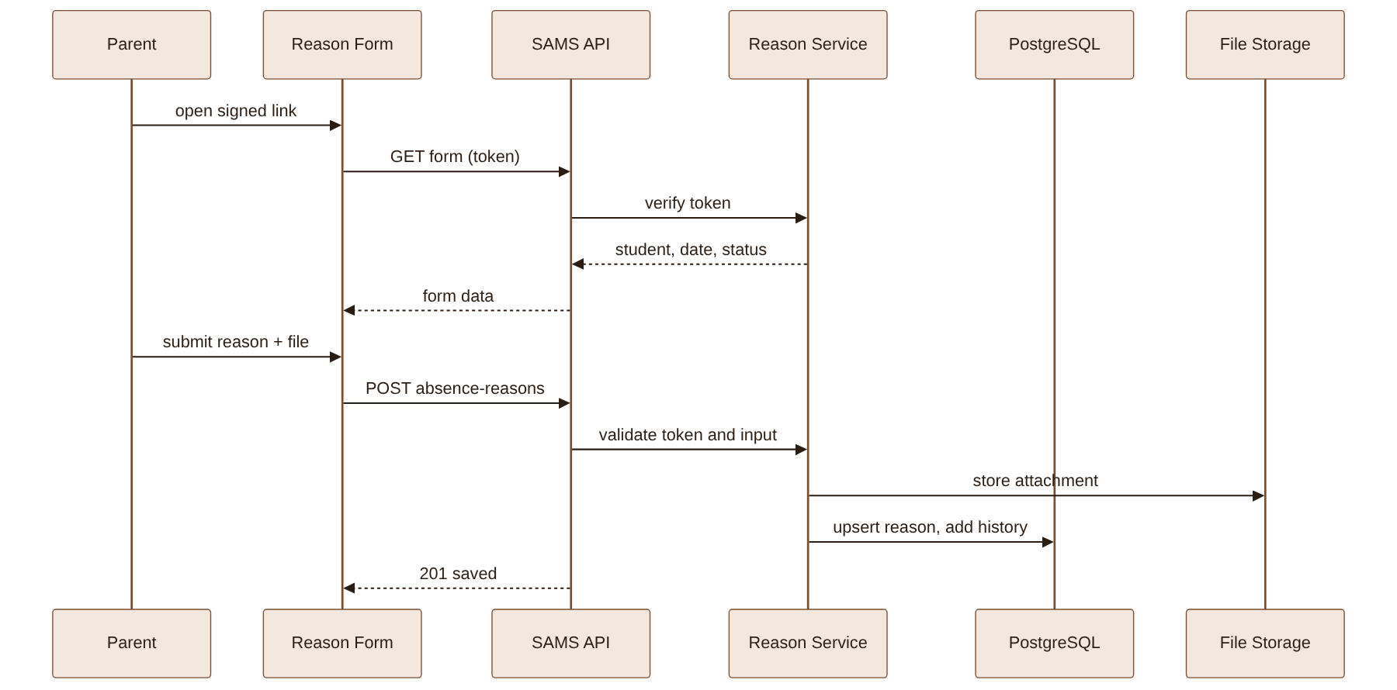
Figure 6. UML sequence diagram – Parent submits absence reason
Design note: the token identifies exactly one student and date and expires after 72 hours. It never grants access to other students or portal data.

10. Software Report / Analytics Design
Reporting supports the success measures in the BRD while keeping personal data to a minimum. Reports use monthly aggregates and are available only to administrators and the Head of Student Affairs.
Metric / Report | Definition | Possible Use
Absence count | Absent and Late records by class and month. | Identify classes with rising absence.
Delivery rate | Delivered ÷ sent notifications by channel. | Check email quality and guardian data.
Time to notify | Minutes from cut-off to SENT (p50, p95). | Measure the 10-minute target.
Parent response rate | Absences with a reason ÷ absences, same day. | Measure the 60% target.
Office follow-ups | Follow-up items and contacted count per day. | Measure reduction in manual calls.

Reports can be viewed on screen or exported as CSV. Exports exclude parent contact details.

11. Security, Privacy, and Non-Functional Design

11.1 Security & Privacy
- All staff and parent endpoints use existing JWT authentication with role checks on the server.
- Parents can only see notifications and students linked to their own account.
- Reason tokens are HMAC-signed, scoped to one student and date, expire after 72 hours and are rate-limited.
- The SendGrid webhook verifies the request signature before updating any record.
- Attachments are type- and size-checked, stored outside the web root and served only through authorized download URLs.
- Logs do not store message bodies or contact details; they reference the guardian by ID.
- Retention follows Section 8.3 and the school data-protection policy.

11.2 Non-Functional Requirements
ID | Area | Requirement
NFR-01 | Timeliness | 95% of absence notifications are SENT within 10 minutes of the cut-off time at a load of 300 absences.
NFR-02 | Performance | Attendance write API p95 increases by no more than 50 ms; parent and staff read APIs p95 ≤ 1.5 s.
NFR-03 | Reliability | No notification is lost if the worker or email provider fails; failed sends retry 3 times.
NFR-04 | Availability | 99.5% monthly availability during school hours (06:00–18:00).
NFR-05 | Usability | Reason form usable on a 360 px wide screen; works in English and Khmer; WCAG 2.1 AA contrast.
NFR-06 | Observability | Alert when failed sends exceed 5% in 15 minutes or the outbox has events older than 15 minutes.

12. Impact Analysis and Migration
Existing Area | Potential Impact | Mitigation
Attendance writes | Extra outbox insert adds load to the write path. | Single indexed insert in the same transaction; measured in staging (NFR-02).
Guardian data | Missing or wrong links mean parents are not notified. | Data-quality report before go-live; FR-11 flags missing links.
SendGrid account | Peak sending may hit rate limits or spam filters. | Confirm plan limits, set up SPF/DKIM, throttle to the account limit.
Teacher behaviour | Late corrections may cause confusing messages. | Correction window and clear correction template.
Office workflow | Staff need to adopt the follow-up list. | Short training and a two-week parallel run.

12.1 Deployment Approach
- Deploy database migrations (new tables and STUDENT_GUARDIAN columns) – additive only.
- Run the guardian data-quality report and fix critical gaps with the school office.
- Deploy backend with the notification worker disabled by a feature flag.
- Enable the worker for one pilot class, then one grade, then the whole school.
- Release parent portal and staff screens after pilot sign-off.
- Monitor delivery rate, time to notify and errors daily for the first two weeks.

12.2 Rollback Considerations
Rollback disables the worker feature flag and hides the new screens. Attendance taking is unaffected. New tables are kept so logs and reasons are not lost; they can be removed only after the observation period agreed with the school.

12.3 Deployment Environments and Release Gates
The same build is promoted through the environments below. Secrets such as the SendGrid key and token signing key are stored in environment configuration, never in code or this document.
Environment | Purpose | Promotion Gate
Development | Developer testing with a SendGrid sandbox. | Build passes; migrations apply cleanly; unit tests pass.
Staging / UAT | Production-like data copy; school staff test. | TC-01 to TC-18 pass; NFR-01/NFR-02 load test passes; rollback rehearsed.
Production | Live use by the school. | Pilot sign-off, approval recorded in Appendix B, monitoring alerts active.

13. Test Design
Tests cover the new behaviour and regression of attendance taking. Test data includes students with none, one and two guardians, both languages, and correction timing edge cases.
ID | Scenario | Expected Result
TC-01 | Student marked Absent before cut-off | Notification sent at cut-off time, not before (FR-01).
TC-02 | Student marked Absent after cut-off | Notification sent within the next worker run (FR-01).
TC-03 | Student with two guardians | Each guardian receives one notification per enabled channel (FR-03).
TC-04 | Late with late notifications off/on | No message when off; Late message when on (FR-02).
TC-05 | Corrected to Present after 10 minutes | Exactly one correction message (FR-04).
TC-06 | Corrected to Present after 45 minutes | No correction message; change is logged (FR-04).
TC-07 | Worker retried / runs twice | No duplicate notifications (FR-10, unique constraint).
TC-08 | Parent submits reason by link | Reason saved and visible to teacher and office (FR-05, FR-06).
TC-09 | Expired or tampered token | Request rejected with 410/401; no data exposed.
TC-10 | Parent resubmits reason | New reason replaces old; history kept (FR-05).
TC-11 | Parent disables last channel | API returns 422; preferences unchanged (FR-09).
TC-12 | No reason by 11:00 | Absence appears on follow-up list (FR-07).
TC-13 | Student without guardian | Listed as "No guardian contact" (FR-11).
TC-14 | Non-admin edits template | Request denied (FR-08).
TC-15 | Khmer-language parent | Khmer template used; English fallback if missing.
TC-16 | SendGrid bounce webhook | Log status becomes BOUNCED; appears in follow-up (FR-10).
TC-17 | Load: 300 absences at cut-off | 95% sent within 10 minutes (NFR-01).
TC-18 | Reason form on mobile, both languages | Usable at 360 px; contrast checks pass (NFR-05).

13.1 Regression Areas
- Teacher web attendance and QR check-in still record correctly and as fast as before.
- Existing attendance reports show the same numbers.
- Existing account emails (password reset, invitations) still send.
- Parent login and existing portal pages still work.

14. Acceptance Criteria
ID | Criterion
AC-01 | F-01 to F-08 work as designed, or deviations are documented and accepted.
AC-02 | TC-01 to TC-18 and the regression areas pass in Staging / UAT.
AC-03 | NFR-01 and NFR-02 thresholds are met in the staging load test.
AC-04 | Pilot class runs for one week with no lost or duplicate notifications.
AC-05 | Guardian data-quality report reviewed and critical gaps fixed.
AC-06 | Rollback rehearsed and stakeholder approval recorded before full release.

15. Requirement-to-Design Traceability
Capability | Feature IDs | Design Sections | Test Coverage
Absence & late notifications (BR-01, BR-02, BR-03) | F-01, F-02 | Sections 6, 7, 8, 9 | TC-01 to TC-04, TC-07, TC-17
Corrections (BR-04) | F-03 | Sections 9.2, 9.3 | TC-05, TC-06
Absence reasons (BR-05, BR-06) | F-04 | Sections 5, 8, 9.4.2, 11 | TC-08 to TC-10, TC-18
Follow-up (BR-07) | F-05 | Sections 5, 9.1 | TC-12, TC-13, TC-16
Channel preferences (BR-09) | F-06 | Sections 5, 8, 9.1 | TC-11
Admin templates & settings (BR-08) | F-07 | Sections 5, 8, 9.1 | TC-14, TC-15
Log & reporting (BR-10, BR-11) | F-08 | Sections 8, 10 | TC-07, TC-16

16. Finalized Implementation Decisions
ID | Finalized Decision | Decision Owner / Basis
OD-01 | Release 1 includes F-01 to F-08; SMS/Telegram in phase 2. | BRD §6; confirm in stakeholder approval.
OD-02 | Transactional outbox plus a one-minute worker, not direct sending from the API. | Reliability (NFR-03) and attendance speed (NFR-02).
OD-03 | Correction window is 30 minutes from the first notification. | BRD BR-04.
OD-04 | Reason links use signed tokens valid for 72 hours. | Usability for parents without portal accounts; security baseline.
OD-05 | Retention: academic year + 90 days for logs and reasons; aggregates 3 years. | BRD §5 data-protection constraint.
OD-06 | Default cut-off 08:30 and follow-up 11:00, configurable per school. | BRD BR-01 and BR-07.

Appendix A – Completion and Approval Checklist
- COMPLETED - Cover and document-control details filled with the design-baseline metadata.
- COMPLETED AS BASELINE - Release 1 scope defined as F-01 to F-08 in Sections 1.1 and 16.
- COMPLETED AS BASELINE - APIs, tables, fields and roles defined and traceable in Sections 8–9.
- COMPLETED AS BASELINE - Architecture, DFD, ERD, flowchart and sequence diagrams included.
- COMPLETED - Measurable performance, timeliness and retention thresholds defined.
- EXTERNAL APPROVAL REQUIRED - Reviewer names and signatures must be recorded by the school before production.

Appendix B – Review and Approval Record
This record is left for real approval. Reviewer names, dates and signatures must be supplied by the responsible people before production release.
Role | Reviewer | Decision | Date | Signature / Record Reference
Business Owner (Head of Student Affairs) | To be recorded | Pending approval | To be recorded | To be recorded
Technical Lead / Architect | To be recorded | Pending approval | To be recorded | To be recorded
Database Owner | To be recorded | Pending approval | To be recorded | To be recorded
Security / Data Protection | To be recorded | Pending approval | To be recorded | To be recorded
QA / Test Lead | To be recorded | Pending approval | To be recorded | To be recorded

