## COVID-19

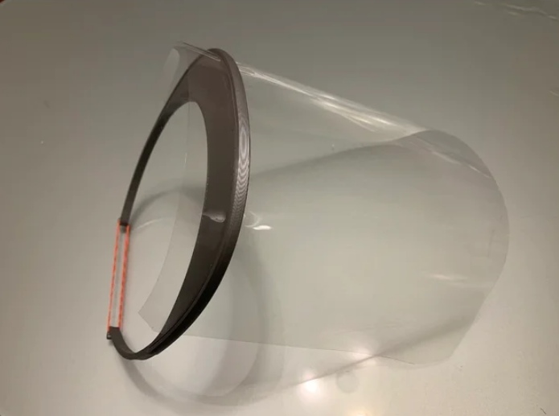

Face Visor Design Printed and Assembled

The 3D Print Club have been monitoring the national (& international) ‘maker’ community response to the past PPE supply crisis relating to the COVID-19 pandemic and have followed closely the designs of protective face visors that [DoESLiverpool](https://doesliverpool.com) have been using for their [PPE Manufacturing effort](https://ppe.doesliverpool.com/).

Early on in the crisis we were passed on a design for a protective face visor that although well intentioned seemed not fit for purpose.

We wanted to contribute and make our own visors, for use in the NMC day to day, so initially we looked at the designs that DoES were making, their community having already gone through lengthy design conversations and decisions, prototypes, wrong turns, success and failure, accommodated a range of issues and problems, before settling on a design they could feasibly and efficiently and safely make.

Their community represents a huge body of amateur and professional knowledge including the persepectives of NHS staff who, although there is no official endorsement from NHS England, have vouched for its usefulness. We think ‘re-inventing the wheel’ ie using a new design will not help anyone, as well meaning as this may be.

So we’ve made a donation to the [DoESLiverpool PPE Manufacturing Project](https://ppe.doesliverpool.com/) and they have provided us with 25 of their face visors which staff are going to use in a deep clean and preperatoin of the centre for limited re-opening.

Meanwhile we are starting to print and test a design by Maker Mike Luaderdale and we’ll be selling them in the NMC or on request alongwith a Surgical Mask Strap Support

|  |  |
| --- | --- |
| Item | Cost |
| 3D Printed Surgical Mask Strap | £1 |
| 3D Printed Face Visor Frame with 1 acetate sheet | £5 |
| Extra clean transparent visor acetate sheet | £1 |

### Design We Use

We reviewed this [comprehensive list and notes](https://github.com/DoESLiverpool/covid19/blob/master/FaceShield.md) before settling on using [Maker Mike Lauderdale’s Design](https://www.thingiverse.com/thing:4253904/) because it’s really easy to print and assemble without needing any additional equipment. It fits a standard elastic band and A4 180 micron thick Acetate sheets. We’ve printed a few and they work really well and are surprisingly comfortable.

### Surgical Mask Strap

Kay has a [design for a Surgical Mask Strap Support](https://www.thingiverse.com/thing:4202906) that supports long term face mask use.

Wearing and removing a face mask can be tricky, you can effectively spray droplets and contaminate yourself and others with the mask contents if worn carelessly and this looks like it might help keep it securely and comfortably in position.

## Supporting Others

There are many ways to support each other in a crisis with or without 3D printing as many of us at the NMC continue to do, so keep in touch with all the NMC news and your friends remember all the hard work they are still doing.

You can still support the [DoES PPE Project here](https://www.gofundme.com/f/get-visors-into-the-hands-of-healthcare-workers) but as PPE supply is now more or less getting to the people who need it most, demand has now slowed down. There are other aid groups out there of course like [Acorn renters union](https://acorntheunion.org.uk/corona/) or [West Cheshire Community Response](https://winsford.gov.uk/3706-2/)

## Prepare

Kay Briggs has setup our 3D printer at home so she’s now our 3D Printing hub! She’s prepared a clean workspace for making the visors and other 3D printing projects.

|  |  |  |
| --- | --- | --- |
| Item | Description | source |
| Hot soapy water | For cleaning down once printed |  |
| Handwash 99% alcohol | General hygeine |  |
| A4 Acetate sheets (approx 180micron thick) | Snap fits into visor frame | [eBay](https://www.ebay.co.uk/itm/Acetate-Sheets-Transparent-Clear-OHP-Craft-Office-Acetate-Film-Assorted-Sizes/131588810542) |
| Clean Workspace for printer and assembly | Isolated from people and traffic inside/outside |  |
| Elastic Bands | For securing the mask to your forehead |  |

### Make

We are using PTGE as a material as it’s most effective for cleaning and sterilising because it is less porous than PLA which we normally use.

[Guidance on printing](https://3dverkstan.se/protective-visor/protective-visor-print-guide/)

Recommended print settings from [Twitter](https://twitter.com/diegotrap/status/1242182168933269516):

* Nozzle: 0.4mm to 0.8mm
* Layer Height : 0.3mm
* Base and top layers 3
* Wall thickness 3
* Infill 20%, triangular
* No support
* Print Speed: Operator to decide

#### Disinfect & pack

This is an overall guide to [cleaning from Prusa](https://help.prusa3d.com/en/article/prusa-face-shield-disinfection_125457) with an overview of all the cleaning techniques.

Do not use pure alcohol or 99%, part diluted to 75% is much more affective, allowing the alcohol in solution, to penetrate the cell wall and lipid layer of the virus and kill it that way. Hot soapy water is also very affective, although it makes drying more porous materials more time consuming

# FAQ

If people have questions please point them to this page or our [Frequently Asked Questions Page](FAQ.md)

### DoES Designs

For further reference here are some other alternative designs

* [DoES version of the 3D Verkstan Face Visor Frame Design](https://github.com/DoESLiverpool/covid19/blob/master/visor-designs/3d-printed/3DVerkstan/DoES_Verkstan.stl)

This design is from [3dVerkstan](https://3dverkstan.se/protective-visor/) * [Verkstan Acetate Cut Design Europe A4](https://github.com/DoESLiverpool/covid19/blob/master/visor-designs/3d-printed/3DVerkstan/Template-shield-EUROPE-4hole.pdf) which can be done by hand with scissors, a scalpel and a standard 4-hole hole punch with help from this [A4 Cut Template](https://github.com/DoESLiverpool/covid19/blob/master/visor-designs/visor-templates/covid19%20Shield%20foil%20-A4%20%20hand%20cutting%20template.STL)