RIT Arm Documentation

("Derek Arm version")

Second release v0.43 July 29 2014

Jascha Wilcox

Paul Richard

[**Jon.Schull@RIT.edu**](mailto:Jon.Schull@RIT.edu)

Disclaimer

License

Overview

The Current Model

Customization for other individuals.

Typical Fabrication and Assembly Procedure

I. Print components

III. Assembly

IV. String it up

V. Fitting

Revisions

## Disclaimer

*By accepting any design, plan, component or assembly related to the so called “RIT Arm”, I understand and agree that any such information or material furnished by any individual associated with the design team is furnished as is without representation or warranties of any kind, express or implied, and is intended to be a gift for the sole purpose of evaluating various design iterations, ideas and modifications. I understand that such improvements are intended to benefit individuals having specific disabilities and are not intended, and shall not be used, for commercial use. I further understand and agree that any individual associated with the e-NABLE organization shall not be liable for any injuries or damages resulting from the use of any of the materials related to the e-NABLE Arm.*

## License

*This arm is licensed for non-commercial use, subject to the disclaimer above.  
Commercial licenses are negotiable.*

*We currently use fingers from Jorge Zuniga's Cyborg beast design, which is subject to it's own non-commercial use license. See http://www.thingiverse.com/thing:261462*

## Overview

The Derek Arm is an elbow-actuated variant of an RIT-developed e-NABLE prosthesis designed to fit Derek, the first user of our arm. As illustrated below and in the video at <http://www.youtube.com/watch?v=T9nngOrdPkg>, bending the elbow causes the fingers to flex by tightening strings descending from the fingers to tensioners in the upper arm.

## The Current Model

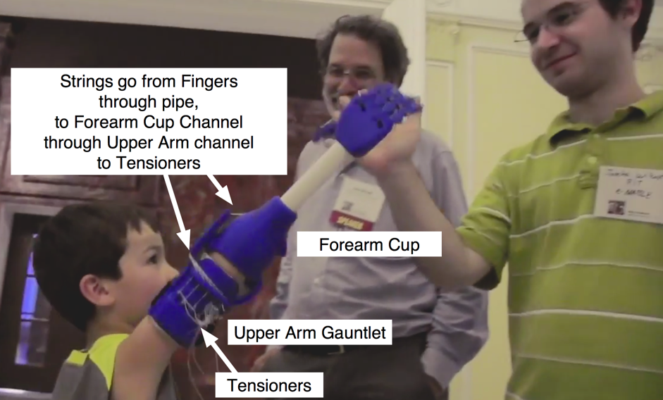

The Derek Arm prosthesis requires more customization than an e-NABLE Hand, because it replaces a portion of the forearm, is larger and more complicated, and is subject to greater forces. Furthermore, the interior of the forearm cup will typically be custom shaped to fit a particular individual.

This is a work in progress and we are aware of the limitations of an elbow-actuated design: because it links arm-bending to hand-closing, it imposes limits on the extent to which the arm can be bent, and it puts additional force on the forearm. We expect that an actuator like a scapular harness will be a more robust solution. (But Derek, our only user, reportedly really likes what he's got!)

We suggest you contact us to check for updates and improvements before proceeding to make an arm for a recipient.

## Customization for other individuals.

You will probably want to ....

* Import the IGS or STP files into a modelling program such as Inventor, Solidworks, or Fusion 360.
* Re-proportion the Upper Arm Gauntlet and Forearm cup to match your recipient.
* Ensure that the interior of the Forearm cup is a good fit for the recipient's Forearm. [see: [Customizing Forearm Cups](https://docs.google.com/document/d/1nX6Jt51XNMu29M--agSNmPBqvqLpu98dOMyuvXja2xc/edit)]
* Ensure that bolt-holes and PVC pipe hole diameters match the bolts and PVC pipes you intend to use:

Chicago Screw bolt holes diameter : 0.210” OD

PVC pipe holes (assuming 3/4" PVC) diameter : 1.050” OD

**Materials**

|  |  |  |  |
| --- | --- | --- | --- |
| Category | Item | Quantity | Fabrication time (FDM) |
| Printed parts | Forearm Cup | 1 | 6-10 hr |
|  | Palm | 1 | 2-4 hr |
|  | Upper Arm Gauntlet | 1 | 6-10 hr |
|  | Finger proximal | 4 | 2-3 hr |
|  | finger distal | 4 | 2-3 hr |
|  | thumb proximal | 1 | ~30 min |
|  | thumb distal | 1 | ~30 min |
|  | hex tensioner | 5 | ~15 min |
|  | PVC retainer Ring | 1 | ~45 min |
| Hardware | Chicago Screw 2.5" Al (knuckles)* | 1 | - |
|  | Chicago Screw 3/8" Stainless (proximal/distal joint)* | 5 | - |
|  | Chicago Screw 1/2" SS (thumb and elbow pivot) | 3 | - |
|  | Beads | 15 | - |
|  | [Thin strong fishing line](http://www.walmart.com/ip/17113497?wmlspartner=wlpa&adid=22222222227000000000&wl0=&wl1=g&wl2=c&wl3=41833582510&wl4=&wl5=pla&wl6=19880599990&veh=sem)* (e.g., Izorline Premium Dacron Fishing Line) | 5 | 5 min |
|  | Elastic bands | 5 | 5 min |
|  | Tensioner screws (varies) | 5 | - |
|  | Buttonhead woodscrew 4 (or Tensioner screws)  for PVC retainer ring | 6 |  |
|  | PVC Pipe 3/4" (1.050” diameter)* | 1 | 5 min |
|  | Velcro | 1 | - |
|  | Firm foam padding | 1 | - |
|  | Loctite 242 (blue) threadlocker* | 1 | - |

*\*These components are NOT included with the Cyborg Beast assembly kit from 3D Universe, as of June 24, 2014*

|  |
| --- |
| **Tools** |
| Cordless drill (or manual tap handle) |
| Heat Gun |
| Drill bits |
| Miniature files |
| ["Threader"](http://youtu.be/gaRp_Ma73_E) |
| Needle-nose pliers |
| Sand paper |
| Screw drivers |
| Hobby knife |
| Scissors |
| Hack saw/Tubing cutter |

## Typical Fabrication and Assembly Procedure

### I. Print components

* + Check the scale of the parts. The provided STL files are in *mm* scale, binary format. Most 3D printer control software assumes mm scale by default, so the parts should import correctly. If you modify the parts in CAD and export them again, be careful to specify that the part is in the mm scale.
  + Check tolerances. This device currently uses a press fit around the PVC pipe in the palm and forearm cup components. This means that diameter tolerance on the 1.050” mating holes are on the order of +/- 0.005”. It may be necessary to modify the part to compensate for printer variations.
  + Use Preview in your slicer to make sure internal channels are empty. The channels are curved inside the palm so you will not be able to drill them out.
  + Print the components! Nylon or ABS plastic is recommended.

II. Post-process printed components.

* + Remove support materials. A pair of needle nose pliers, a small file, and some sandpaper is generally sufficient to remove support material.
  + Check Chicago screw hole diameters. If holes are too tight you can enlarge them with a drill or hand tap handle.

### III. Assembly

* Assemble fingers and thumb. Use 4x ⅜” stainless chicago screw for the four finger joints, and 1x ⅜” stainless screw for the thumb finger joint. Then use loctite threadlocker.
* Attach fingers and thumb to palm. Use 1x 2 1/2” screw (or modify length for a re-scaled palm)
* Attach the forearm cup to the upper-arm gauntlet using 2 x ½” stainless Chicago Screws.
* Cut the PVC pipe to the correct length using a hacksaw. Usually it is best to try to match the length of the other arm, but Derek specifically requested an “extra long” version. Sandpaper can also be used to remove any writing on the pipe.
* Add a flange to the PVC pipe. Use heat gun to soften one end of the PVC pipe and use a hand tool that will not melt, to bend the PVC out as illustrated here:

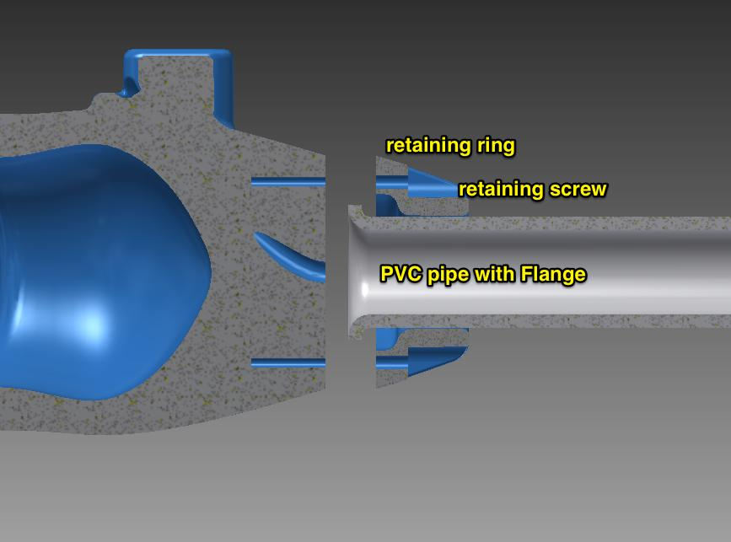

The flange fits into the 3D printed PVC Retainer component, which screws on to the Forearm Cup component.

* Insert hex tensioners in tensioner sockets. Secure with a couple turns of a tensioner screw. You will adjust the tensioners later.

### IV. String it up

A “threader” wire is extremely helpful, as illustrated in this video: <http://youtu.be/gaRp_Ma73_E>

* Thread elastic bands through the channels on the backs of the fingers and thumb, through the palm.
  + Use beads to terminate the elastic bands.
* Thread fishing line through the under-channels of the fingers, and through the internal palm channels.
  + Use beads to secure fishing line at each finger tips.
  + Leave more than enough loose string to reach the tensioners on the Upper Arm Gauntlet
* Thread fishing lines through PVC pipe.
* Press PVC pipe into Palm socket
* Thread fishing line through the Forearm Cup channel
* Thread fishing line through the Upper Arm Gauntlet channel
* Route fishing line from through the tensioner channels to the tensioners.
* Tie off fishing line at tensioners, adjust tension. Test and adjust, test and adjust.

### V. Fitting

* The fine art of fitting and padding prosthetics is beyond the scope of this documentation. [see: [Customizing Forearm Cups](https://docs.google.com/document/d/1nX6Jt51XNMu29M--agSNmPBqvqLpu98dOMyuvXja2xc/edit)]

Please consult a prosthetist, use skin-safe padding, watch out for redness, chafing, or muscle strain, and make sure recipients understand that this is an experimental device for evaluation purposes. See

***Make sure recipients understand and sign the Disclaimer above.***

## Revisions

* June 24, 2014: First release, v0.3 with documentation.
* July 28, 2014: Second release, v0.43, with the following improvements over v0.3
  + Hyperextension stop
  + pull-pull portals for active opening fo the hand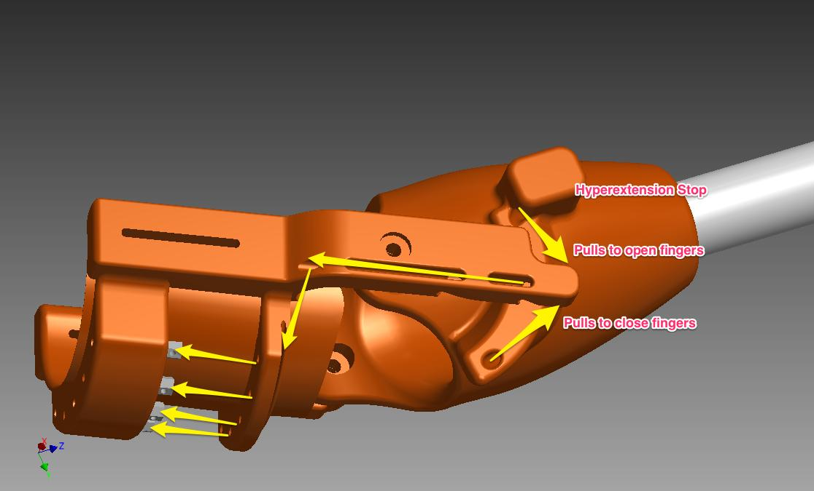
  + PVC Flange Lock

