**Experiment:10**

**Title :**

**Write a code in JAVA for a simple Word Count application that counts the number of**

**occurrences of each word in a given input set using the Hadoop Map-Reduce framework on local-standalone set-up.**

**Aim :**

Count the number of occurences using Hadoop Map Reduce

**Prerequisites:**

JDK and Hadoop installation

**Objectives :**

**counts the number of occurrences of each word in a given input set**

**Theory:**

In Hadoop, [MapReduce](https://dzone.com/articles/mapreduce-design-patterns-1" \t "_blank) is a computation that decomposes large manipulation jobs into individual tasks that can be executed in parallel across a cluster of servers. The results of tasks can be joined together to compute final results.

MapReduce consists of 2 steps:

* **Map Function –**It takes a set of data and converts it into another set of data, where individual elements are broken down into tuples (Key-Value pair).

**Example –**(Map function in Word Count)

|  |  |  |
| --- | --- | --- |
| **Input** | Set of data | Bus, Car, bus,  car, train, car, bus, car, train, bus, TRAIN,BUS, buS, caR, CAR, car, BUS, TRAIN |
| **Output** | Convert into another set of data  (Key,Value) | (Bus,1), (Car,1), (bus,1), (car,1), (train,1),  (car,1), (bus,1), (car,1), (train,1), (bus,1),  (TRAIN,1),(BUS,1), (buS,1), (caR,1), (CAR,1),  (car,1), (BUS,1), (TRAIN,1) |

* **Reduce Function –**Takes the output from Map as an input and combines those data tuples into a smaller set of tuples.

**Example –**(Reduce function in Word Count)

|  |  |  |
| --- | --- | --- |
| **Input**  **(output of Map function)** | Set of Tuples | (Bus,1), (Car,1), (bus,1), (car,1), (train,1),  (car,1), (bus,1), (car,1), (train,1), (bus,1),  (TRAIN,1),(BUS,1), (buS,1), (caR,1), (CAR,1),  (car,1), (BUS,1), (TRAIN,1) |
| **Output** | Converts into smaller set of tuples | (BUS,7),  (CAR,7),  (TRAIN,4) |

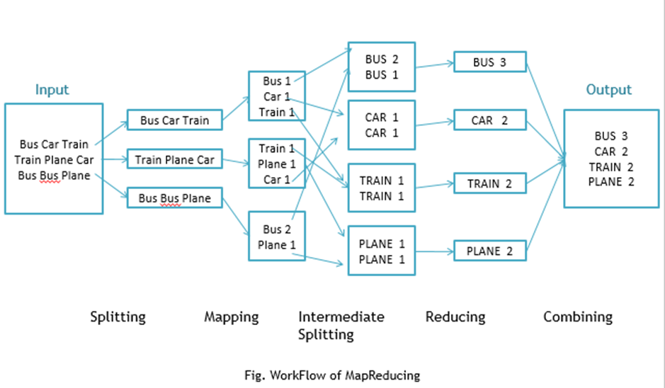

Workflow of MapReduce consists of 5 steps:

1. **Splitting** – The splitting parameter can be anything, e.g. splitting by space, comma, semicolon, or even by a new line (‘\n’).
2. **Mapping** – as explained above.
3. **Intermediate splitting** – the entire process in parallel on different clusters. In order to group them in “Reduce Phase” the similar KEY data should be on the same cluster.
4. **Reduce** – it is nothing but mostly group by phase.
5. **Combining** – The last phase where all the data (individual result set from each cluster) is combined together to form a result.

**Steps**

1. Open Eclipse> File > New > Java Project >( Name it – MRProgramsDemo) > Finish.
2. Right Click > New > Package ( Name it - PackageDemo) > Finish.
3. Right Click on Package > New > Class (Name it - WordCount).
4. Add Following Reference Libraries:
   1. Right Click on Project > Build Path> Add External
      1. */usr/lib/hadoop-0.20/****hadoop-core.jar***
      2. *Usr/lib/hadoop-0.20/lib/****Commons-cli-1.2.jar***

**package PackageDemo;**

**import java.io.IOException;**

**import org.apache.hadoop.conf.Configuration;**

**import org.apache.hadoop.fs.Path;**

**import org.apache.hadoop.io.IntWritable;**

**import org.apache.hadoop.io.LongWritable;**

**import org.apache.hadoop.io.Text;**

**import org.apache.hadoop.mapreduce.Job;**

**import org.apache.hadoop.mapreduce.Mapper;**

**import org.apache.hadoop.mapreduce.Reducer;**

**import org.apache.hadoop.mapreduce.lib.input.FileInputFormat;**

**import org.apache.hadoop.mapreduce.lib.output.FileOutputFormat;**

**import org.apache.hadoop.util.GenericOptionsParser;**

**public class WordCount {**

**public static void main(String [] args) throws Exception**

**{**

**Configuration c=new Configuration();**

**String[] files=new GenericOptionsParser(c,args).getRemainingArgs();**

**Path input=new Path(files[0]);**

**Path output=new Path(files[1]);**

**Job j=new Job(c,"wordcount");**

**j.setJarByClass(WordCount.class);**

**j.setMapperClass(MapForWordCount.class);**

**j.setReducerClass(ReduceForWordCount.class);**

**j.setOutputKeyClass(Text.class);**

**j.setOutputValueClass(IntWritable.class);**

**FileInputFormat.addInputPath(j, input);**

**FileOutputFormat.setOutputPath(j, output);**

**System.exit(j.waitForCompletion(true)?0:1);**

**}**

**public static class MapForWordCount extends Mapper<LongWritable, Text, Text, IntWritable>{**

**public void map(LongWritable key, Text value, Context con) throws IOException, InterruptedException**

**{**

**String line = value.toString();**

**String[] words=line.split(",");**

**for(String word: words )**

**{**

**Text outputKey = new Text(word.toUpperCase().trim());**

**IntWritable outputValue = new IntWritable(1);**

**con.write(outputKey, outputValue);**

**}**

**}**

**}**

**public static class ReduceForWordCount extends Reducer<Text, IntWritable, Text, IntWritable>**

**{**

**public void reduce(Text word, Iterable<IntWritable> values, Context con) throws IOException, InterruptedException**

**{**

**int sum = 0;**

**for(IntWritable value : values)**

**{**

**sum += value.get();**

**}**

**con.write(word, new IntWritable(sum));**

**}**

**}**

**}**

The above program consists of three classes:

* Driver class (Public, void, static, or main; this is the entry point).
* The Map class which **extends** the public class Mapper<KEYIN,VALUEIN,KEYOUT,VALUEOUT>  and implements the Map function.
* The Reduce class which extends the public class Reducer<KEYIN,VALUEIN,KEYOUT,VALUEOUT> and implements the Reduce function.

6. Make  a jar file

Right Click on Project> Export> Select export destination as **Jar File** > next> Finish.

7. Take a text file and move it into HDFS format:

To move this into Hadoop directly, open the terminal and enter the following commands:

**[training@localhost ~]$ hadoop fs -put wordcountFile wordCountFile**

8. Run the jar file:

*(Hadoop jar jarfilename.jar packageName.ClassName  PathToInputTextFile PathToOutputDirectry)*

**[training@localhost ~]$ hadoop jar MRProgramsDemo.jar PackageDemo.WordCount wordCountFile MRDir1**

9. Open the result:

**[training@localhost ~]$ hadoop fs -ls MRDir1**

**Found 3 items**

**-rw-r--r-- 1 training supergroup 0 2016-02-23 03:36 /user/training/MRDir1/\_SUCCESS**

**drwxr-xr-x - training supergroup 0 2016-02-23 03:36 /user/training/MRDir1/\_logs**

**-rw-r--r-- 1 training supergroup 20 2016-02-23 03:36 /user/training/MRDir1/part-r-00000**

**[training@localhost ~]$ hadoop fs -cat MRDir1/part-r-00000**

**BUS 7**

**CAR 4**

**TRAIN 6**

**Conclusion:**

Hence, we have studied Map reduce using Hadoop

**Questions:**

1. What is MapReduce? ..

2. Mention three benefits/advantages of MapReduce.

3. What are the main components of MapReduce? ..

4. What are the configuration parameters required to be specified in MapReduce?

5. Define shuffling in MapReduce.