

Handout: Fundamentals of Test Closure
Version: Fundamentals of Test Closure/Handout v1.0
Date: 25-02-11

Cognizant
500 Glen Pointe Center West
Teaneck, NJ 07666
Ph: 201-801-0233
www.cognizant.com

TABLE OF CONTENTS

Introduction 3
About this Module 3
Target Audience 3
Module Objectives 3
Pre-requisite 4
Session 1: Test Closure – An Overview 5
Learning Objectives 5
Introduction 5
Need for Test Closure 5
Test closure Activities and deliverables 6
Attachments 6
Summary 6
Test Your Understanding 7
Exercises 7
Session 2: Test Summary Report 8
Learning Objectives 8
Test Summary Report 8
Learning Objectives 10
AQI/PQI Preparation 10
Session 4: Issues encountered and Lessons learnt 13
Learning Objectives 13
Issues encountered and Lessons learnt 13
Session 5: Defect Causal Analysis 14
Learning Objectives 14
Defect Causal Analysis 14
Session 6: Project Closure 16
Learning Objectives 16
Project Closure – An Introduction 16
Best Practices 17
Case Study 17
Closure Meeting – An Overview 18
Project Archival and Resources Releasing 18
Glossary 19
References 19
Websites 19
Books 19
STUDENT NOTES: 20

Introduction

About this Module
This Module will give a clear understanding of the importance of the Test Closure phase. This also explains the various activities performed during this phase, the inputs required, and the key deliverables.

Target Audience
Campus Associate Trainees

Module Objectives

After completing this course, you will be able to:
- Describe Test Closure
- Identify the need for Test Closure
- Identify the various activities that are done as part of Test Closure
- Identify the outputs of Test Closure
- Identify the components of the Test Summary Report
- Identify how and when the inputs need to be provided for the Test Summary Report
- Describe Application Stability Report
- Identify the various factors affecting the stability of an application
- Identify the weightage of Factors
- Identify how to decide whether an application can be delivered or not to the Clients
- Identify critical issues
- Identify how to document the resolutions of the issues
- Identify how to use the documented inputs as lessons learnt for future implementations
- Identify the root cause for defects (review and application)
- Identify how to prevent these defects in future releases
- Describe Project Closure
- Identify the need for Closure Meetings
- Identify the components of Closure Report
- Identify and document the Best Practices
- Describe the Project Archival process
- Identify the need for the project case study

Pre-requisite
Understanding of the SDLC, STLC phases, and the activities carried out in each of these phases.

Session 1: Test Closure – An Overview

Learning Objectives

After completing this session, you will be able to:
- Describe Test Closure
- Identify the need for Test Closure
- Identify the various activities that are done as part of Test Closure
- Identify the outputs of Test Closure

Introduction
Test Closure is the final phase in STLC and ensures that all the testing activities are performed in adherence to the Test Plan. Test Closure is performed at the end of all testing activities that are in the scope for every release of a project.

Need for Test Closure
The Testing team plans a number of activities and the adherence to those activities in terms of coverage and completeness. The Test Plan is validated accordingly. It becomes essential for the testing team to understand how they have executed the project and performed the testing.
Test closure is needed for the following activities:
- To validate if all the agreed activities within the scope of testing are completed successfully as per the Test Plan
- To arrive at the Go/No-Go decision on the application to move the production based on the inferences from the testing
- To retrospect and understand the following in the testing strategy and process followed
  - What went well?
  - What could have been done better to make the application or testing process effective?
  - What were the factors that contributed to the variances?
  - What were the Best Practices created or adopted and the effectiveness of using those best practices in the project?
  - What were the lessons learnt and how this knowledge can be used to do better in future releases?
- To measure and analyze the variances - Planned versus Actual (Effort, Schedule, Cost and Quality) in accordance with the Test Plan and the Project plan
- The inferences from the retrospection can be utilized to improve the process and execution during future releases

Test closure Activities and deliverables
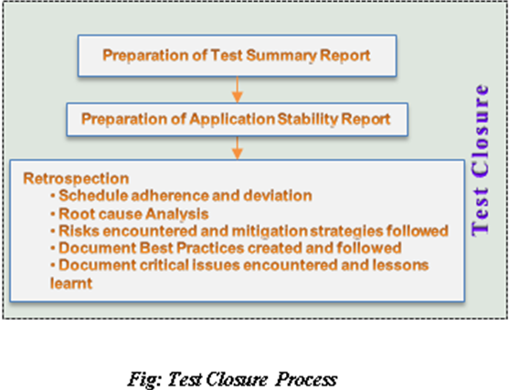

Attachments
S.No | Description | Attachment
1 | Test Summary Report | 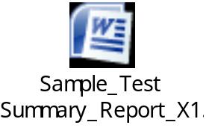
2 | Application Quality Index | 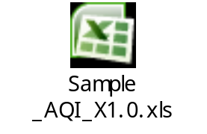
3 | Critical Issues Encountered | 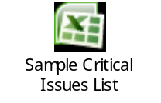
4 | Lessons Learnt | 

Session 2: Test Summary Report

Learning Objectives

After completing this course, you will be able to:
- Identify the components of the Test Summary Report
- Identify how and when the inputs need to be provided for the Test Summary Report

Test Summary Report
Test Summary Report is a document which is prepared during the Test Closure. It briefs the overall activities of the testing phase of a project. It summarizes all the test results of the project. The list of items that are tested as part of a particular release and the items that are not tested are detailed in the Test Summary Report. The Test Summary Report is prepared after the completion of the test execution.
- A Test Summary Report summarizes the following:
  - Various activities carried out during the testing of an application and the outcome
  - Scope of testing (items that are tested and not tested)
  - Inference of the stability of the application from testing
  - Summary of all the test results of the project
  - Brief summary of Metrics that are generated
  - Details of known issues in the application and recommendations
  - Risks of moving the application to the next phase of testing or production
  - Reference to the Placeholders of the Test Deliverables
- Test Summary Report is shared with all the stakeholders of the project
All the known issues and the recommendations are documented as part of the “Known Issues and Recommendations” section in the report. If there are any outstanding issues that cannot be fixed due to some technical reasons or some other constraints, then those issues are listed as Known Issues and communicated to the Client.
Likewise, if there are any recommendations from the test team, they can also be documented in the Recommendations section.

The following inputs are required to prepare the Test Summary Report:
- Approved Test Plan
- Required information of the testing activities* like
  - Scope of testing (Items to be tested and Not tested)
  - Number of test cases prepared
  - Number of test cases executed
  - Number of test cases passed
  - Number of test cases failed
  - List of defects and summary of defects by
    - Status
    - Severity
    - Priority
    - Module
    - Trend of defects
- Delivery Metrics details
* - If there are multiple rounds / types of testing then these information need to be captured for each of them
Session 3: Application Stability report

Learning Objectives

After completing this course, you will be able to:
- Describe Application Stability Report
- Identify the various factors affecting the stability of an application
- Identify the weightage of Factors
- Identify how to decide whether an application can be delivered or not to the Clients

AQI/PQI Preparation
AQI stands for Application Quality Index and PQI means Product Quality Index. Both are one and the same and are used according to the nature of the project.
Application Stability Report briefs the stakeholders about the stability of the application based on the various assessment criteria. The output of this report is a percentage value for Overall System Stability and Overall Risk. Based on the Overall System Stability percentage value and the other assessment criteria like Outstanding Critical / High defects, the Delivery Head or whoever responsible for delivery of the application to the Customer will recommend the customer to proceed with the release of this application to its end users. It is basically a ‘Go’ or ‘No Go’ decision making based upon the system stability value.
Following are the various assessment criteria for determining the stability of the application:
- Test Coverage Factor
- Test Case Success Factor
- Outstanding Defects Factor
- Failed Test Case Impact Factor
- Non Coverage Risk Factor
Test Coverage Factor determines the amount of coverage of test cases execution with respect to the application. It can be calculated using the formula for ‘Test Coverage Ratio’.
Test Case Success Factor determines the amount of passed test cases that are executed. It can be calculated using the formula for ‘Test Pass Percentage’.
Outstanding Defects Factor deals with the defects which still exist in the application and are yet to be fixed. The various severities of defects that AQI focuses on are as follows:
- Critical
- High
- Medium
This can be calculated using the following formula:
(Outstanding defects of Severity ‘A’/Total Number of defects of Severity ‘A’ logged) * 100
Failed Test Case Impact Factor deals with the impact of the failed test case with respect to the application. If there is going to be an impact in the Business due to a failed test case, then appropriate weightage should be selected against this failed test case. This will be explained further in the example.
Non Coverage Risk Factor also deals with the impact of the non-executed test case with respect to the application. If there is going to be an impact in the Business due to a non-executable test case, then appropriate weightage should be selected against the non-executed test case. This will also be explained further in the example.
In addition to these, there are two major weightages that determine the value for each criterion. They are the ‘Factor Weightage’ and the ‘Status Weightage’. The Factor Weightage determines the impact of the factor with respect to the AQI calculation. Following are the various weightages and their values:

Factor Weightage
Weightage | Value
No Risk Component - No Impact | 0.1
Less Risk Component - Very less impact | 0.2
Moderate Risk Component - Medium Impact | 0.3
High Risk Component - High Impact | 0.4
Potential component - Critical Impact | 0.5

The Status Weightage indicates the impact of the factor with respect to its status. Please refer to the “Status Weightage reference” sheet in the sample AQI sheet attached in the “Attachments” section.
The Test Coverage Factor and Test Case Success Factor are calculated and entered in the AQI sheet. The ‘Status Weightage’ is automatically populated based on the value provided. The ‘Factor Weightage’ is entered based on the impact.
The Outstanding Critical Defects and Outstanding Medium Defects Factors are calculated and entered as part of the AQI sheet. The corresponding ‘Factor Weightage’ is entered as well. The ‘Status Weightage’ is populated automatically.
Next, all the failed test cases are listed and for each failed test case the ‘Factor Weightage’ is provided based on the impact of the failed test case. The same procedure should be followed for the ‘Non Coverage Risk Factor’ as well. In this, all the non-executed test cases are listed out.
After providing all these inputs, the AQI sheet processes all the data entered and provides the ‘Overall System Stability’ value. The remaining percentage, which is subtracted from 100, is considered as the ‘Overall Risk’. The ‘Go / No-Go’ decision is made based on the stability value and the outstanding defects count. Upper Limit and Lower Limit are defined for the Stability and Outstanding defects while deciding the ‘Go / No-Go’.
For example, the criteria for “Go” decision is the Stability of the application should lie between 90% - 100% and there is no Outstanding ‘Critical/High/Medium’ defects. If the values that are logged in and calculated using the AQI sheet match with this particular criteria then the decision will be ‘Go’ for the release.
his implies that the specific version of the application is fit for release and this can be delivered to the Clients.
Whereas, if the values mentioned as part of the formula does not match the actual values calculated through AQI sheet, then the decision is ‘No-Go’ for the release. The formula and the limits (Upper and Lower) definition can be customized according to the Project.

Session 4: Issues encountered and Lessons learnt

Learning Objectives

After completing this course, you will be able to:
- Identify critical issues
- Identify how to document the resolutions of the issues
- Identify how to use these documented inputs as lessons learnt for future implementations

Issues encountered and Lessons learnt
- During Test Closure, the issues that were encountered by the testing team are identified and discussed
- The negative impact of those issues and the resolutions followed for those critical issues are documented
- Unresolved outstanding issues are listed out
- The resolutions that were effective can be taken as lessons learnt while planning for future releases

Session 5: Defect Causal Analysis

Learning Objectives

After completing this course, you will be able to:
- Identify the root cause for defects (review and application)
- Identify how to prevent these defects in future releases

Defect Causal Analysis
- Defects (application and review) that are not identified in one phase and are identified in later phases are listed
- These defects may have a negative impact on the project
- The root causes for the leakage of these defects from one phase to another are identified using the following techniques:
  - Fishbone diagram
  - Pareto chart
- Once the causes are identified, these are taken as inputs for the defect prevention plan during the next release

Session 6: Project Closure

Learning Objectives

After completing this course, you will be able to:
- Describe Project Closure
- Identify the need for Closure Meetings
- Identify the components of Closure Report
- Identify and document the Best Practices
- Describe the Project Archival process
- Identify the need for the project case study

Project Closure – An Introduction
Project Closure is an activity to check whether all the project related activities, starting from initiation till release or implementation, are performed for a particular project. For any project, Project Closure happens only once, whereas the number of Test Closures depend on the number of releases.
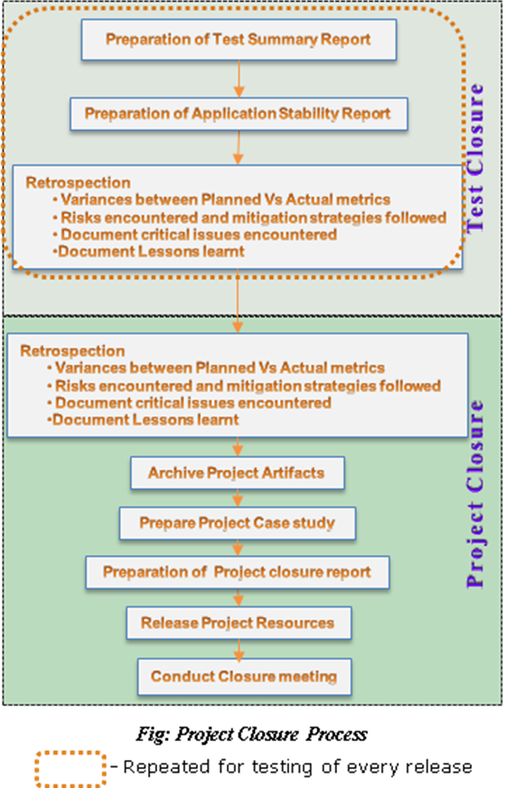

- A Project Closure is a formal activity performed at the end of the project to check whether all the project related activities are completed successfully for a particular project
- The inferences from the retrospection can be utilized to improve the organization process and execution of similar projects in future
- Project Closure activities are performed at the end of a Project whereas the Test closure is done for every release of testing

Following are the Project Closure activities:
- Documenting Best Practices
- The Best Practices adopted and created during the execution of the project is documented
- Archive Project Artifacts
- Before a project is closed, the Project artifacts will be archived and the resources will be released
- Release Project Resources
- The hardware, software, and the human resources are released from the project during the closure
- Prepare Project Closure report
- A Project Closure report is created by summarizing the activities during the project and their outcome. This also talks about the lessons learnt, best practices created and adopted, issues encountered during the project planning, and execution
- Conduct Closure Meetings
- Summary of the activities done as part of the Project Closure phase and their outcome are discussed during closure meetings

Best Practices
While executing a project, there can be a number of practices that are followed across all the phases. Among those practices some remain unique and effective. Such practices are identified and documented as Best Practices.
A Best Practice is one that consistently yields good and effective results. These Best Practices are shared across various projects or accounts to be followed by other projects if applicable. All the best practices followed, the effectiveness, and advantages of using these best practices are documented.

Case Study
- It is suggested to prepare a case study at the end of the project
- Generally, a case study is prepared by the Delivery Manager/Business development after taking relevant inputs from the delivery team
- The case study highlights the key differentiators in the project and the value additions to the customer
- It also highlights the best practices created and adopted and the benefits derived from them
- The advantages / positive implications in the project execution are highlighted in the case study
These case studies are used for Knowledge sharing and Business development processes.

Closure Meeting – An Overview
Closure meeting is conducted at the end of every project and this is considered as a primary activity of Project Closure. All the stakeholders of the project are invited for this meeting to discuss and analyze the planned and actual activities. Project Stakeholders are those who are the key players or the beneficiaries of a project. The following people are the major stakeholders of a project:
- Account Manager
- Project Manager
- Test Manager
- Process Facilitator
- Developers and Testers
Inputs for further improvements in terms of identifying risks, resolving issues, and process improvements can be gathered through such meetings.
Need for Closure meeting
- To make all the stakeholders understand and review the activities of a project
- Clear view of deviations from the plan
- Inputs for Improvements in the future in terms of the following:
  - Identifying risks
  - Resolving issues
  - Better process adherence
  - Availing and adopting best practices

Project Archival and Resources Releasing
A project is regarded complete after all the versions have been released to the customer and the project has been closed. Once a project is completed, the project related information and documents are archived. All the Project documents and information are maintained in a Version control tool such as VSS (Visual Source Safe), SVN (Sub Version), and so on.
A placeholder, like an archive folder, is created in a Server and all the project related documents are archived and stored here. The archiving process is initiated either by the Quality Facilitator or the Project Manager. The archival path is noted for future reference.
All the software, hardware and human resources are also released from the particular project. This ensures that there is no financial impact on the project and the resources are available for other purposes.

Glossary
SDLC – Software Development Life Cycle
STLC – Software Testing Life Cycle

References

Websites

<list of websites>

Books

<list of books>

STUDENT NOTES:

