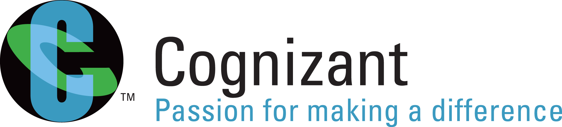

Handout: Software Testing Fundamentals
Version: Software Testing – An Introduction/Handout/xxxx/1.0
Date: 06-02-11

Cognizant
500 Glen Pointe Center West
Teaneck, NJ 07666
Ph: 201-801-0233
www.cognizant.com

TABLE OF CONTENTS

Introduction 4
About this Module 4
Target Audience 4
Module Objectives 4
Pre-requisite 4
Session 1: An Introduction 6
Learning Objectives 6
Software Quality 6
Software Quality Attributes 6
Verification 7
Validation 8
Difference between Verification & Validation: 8
What is Software Testing and its Significance 9
How Testing improves Software Quality? 9
What is a Software Defect? 9
Why does Software have bugs? 10
Significance and Cost of Software Defect 10
Why do Software Testing? 11
What do we Test? 12
When to stop Testing? 12
History and Evolution of Software Testing 13
General Testing Principles 14
Alignment of testing model to various development models 15
Testing Process aligned to Waterfall development model: 18
Testing process in Agile Development 19
Summary 20
Test Your Understanding 21
Session 2: Types of Testing 22
Learning Objectives 22
Functional Testing 22
Non-functional Testing: 23
Black Box Testing 24
White Box Testing 25
Difference between Black Box & White Box Testing 26
Manual Testing 26
Automation Testing: 26
Manual Vs Automation Testing 26
Functional and Non-functional Testing tools 27
Fresh Development Testing 27
Maintenance Testing 28
Summary 28
Test your Understanding 28
Session 3: Levels of Testing 30
Learning Objectives 30
Unit Testing 30
Component Integration Testing 31
System Testing (ST) 32
System Integration Testing (SIT) 32
User Acceptance Testing (UAT) 33
Summary 33
Test your Understanding 34
Glossary 35
References 36
Books 36
STUDENT NOTES: 37

Introduction

About this Module
This module will provide an introduction to Software Testing and explain the levels and Types of Testing

Target Audience
Campus Associated Trainees

Module Objectives

After completing this course, you will be able to:
- Define Software Quality
- List the Software Quality Attributes
- Understand Verification and Validation
- Understand what is Software Testing and its Significance
- Explain how Testing improves Software Quality
- Understand History and Evolution of Software Testing
- Describe Software Testing Principles
- Define what is a Software Defect and its significance
- Understand various software development methodologies
- Explain how testing process would differ based on the development methodology
- Understand Functional & Non-Functional Testing
- Understand Functional & Non-Functional Testing types
- Understand Functional & Non-Functional Testing Tools
- Understand Black box Vs White box Testing
- Understand Manual & Automation Testing
- Understand Fresh development & Maintenance Testing
- Understand the importance and necessity of different levels of testing
- Appreciate the benefits of testing at each level
  - Unit Testing
  - Component Integration Testing
  - System Testing
  - System Integration Testing
  - User Acceptance Testing

Pre-requisite
The audience should have the basic knowledge of SDLC activities.

Session 1: An Introduction

Learning Objectives

After completing this course, you will be able to:
- Define Software Quality
- List the Software Quality Attributes
- Understand Verification and Validation
- Understand what is Software Testing and its Significance
- Explain how Testing improves Software Quality
- Understand History and Evolution of Software Testing
- Describe Software Testing Principles
- Define what is a Software Defect and its significance
- Understand various software development methodologies
- Explain how testing process would differ based on the development methodology

Software Quality
Software quality may be defined as conformance to explicitly mentioned functional and performance requirements, explicitly documented development standards and implicit characteristics that are expected of all professionally developed software.

Software quality measures how well software is designed (quality of design), and how well the software conforms to that design and requirements (quality of conformance). While quality of conformance is concerned with implementation, the quality of design measures how valid the design and requirements are in creating a worthwhile product.

Software quality has different dimensions derived from perspectives of Producers and Consumers. From a Producers view, Quality is defined as Meeting the requirements of software. From a consumers view, Quality is defined as Meeting customers’ needs.

Software Quality can be achieved only through continuous improvement which is best illustrated in Deming’s cycle also called as PDCA cycle. The plan–do–check–act cycle is a four-step model for carrying out change. Just as a circle has no end, the PDCA cycle should be repeated again and again for continuous improvement.

Software Quality Attributes
Software Quality is commonly described in terms that are known as Quality Attributes. A Quality Attribute is a property of a software product that will be judged directly by stakeholders. Quality attributes are—and should be—quantifiable in specifications by appropriate and practical scales of measure. The ISO software-quality model ISO – 2001 defines six quality-attribute categories: functionality, reliability, usability, efficiency, maintainability, and portability. The categories, in turn, are further subdivided into sub-characteristics.

- Functionality - A set of attributes that bear on the existence of a set of functions and their specified properties. The functions are those that satisfy stated or implied needs.
- Reliability - A set of attributes that bear on the capability of software to maintain its level of performance under stated conditions for a stated period of time.
- Usability - A set of attributes that bear on the effort needed for use, and on the individual assessment of such use, by a stated or implied set of users.
- Efficiency - A set of attributes that bear on the relationship between the level of performance of the software and the amount of resources used, under stated conditions.
- Maintainability - A set of attributes that bear on the effort needed to make any changes to the existing software
- Portability - A set of attributes that bear on the ability of software to adapt to various operating environments

An attribute is an entity which can be verified or measured in the software product. Attributes are not defined in the standard, as they vary between different software products.
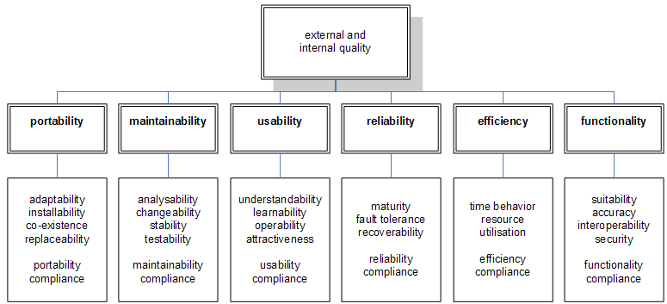

Verification
Verification is the process of ensuring that software being developed will satisfy the functional specifications and conform to the standards. This process always helps to verify “Are we building the product right?” (According to the functional and technical specifications).

The major Verification activities are reviews, including inspections and walkthroughs.

- Reviews are conducted during and at the end of each phase of the life cycle to determine whether established requirements, design concepts, and specifications have been met. Reviews consist of the presentation of material to a review board or panel. Reviews are most effective when conducted by personnel who have not been directly involved in the development of the software being reviewed.
- Formal reviews are conducted at the end of each life cycle phase. The acquirer of the software appoints the formal review panel or board, who may make or affect a go/no-go decision to proceed to the next step of the life cycle. Formal reviews include the Software Requirements Review, the Software Preliminary Design Review, the Software Critical Design Review, and the Software Test Readiness Review.
- Informal reviews are conducted on an as-needed basis. The developer chooses a review panel and provides and/or presents the material to be reviewed. The material may be as informal as a computer listing or hand-written documentation.
- An inspection or walkthrough is a detailed examination of a product on a step-by-step or line-of-code by line-of-code basis. The purpose of conducting inspections and walkthroughs is to find errors. The group that does an inspection or walkthrough is composed of peers from development, test, and quality assurance

Validation
Validation is the process of ensuring that software being developed will satisfy the user needs. This process always helps to verify “Are we building the right product?” (According to the needs of the end user).

Difference between Verification & Validation:

Verification testing ensures that the expressed user requirements, gathered in the Project Initiation Phase, have been met in the Project Execution phase. One way to do this is to produce a user requirements matrix or checklist and indicate how you would test for each requirement.
Example
If the requirement is that a product should not weigh more than 15 kg (About 33 lbs.).Verification is checking on that whether this requirement is being addressed during the design review using a check list.
Validation testing ensures that any requirement has been met by the end product developed.
Example
If the requirement is that a product should not weigh more than 15 kg (About 33 lbs.).Validating is checking whether the developed product is actually not weighing more than 15 kg by testing the product manually or using automation.

What is Software Testing and its Significance
Software testing is a process of validating a software application or program. Software testing also identifies important defects, flaws, or errors in the application code that must be fixed.

Significance of Software Testing:

- To produce a defect-free quality product.
- To make sure all the requirements are satisfied and the best design system architecture is used.
- To ensure Customers/user satisfaction.
- To reduce the possible risks associated with the software, thereby reducing the loss.

How Testing improves Software Quality?
Testing is essential to develop high-quality software and to ensuring smooth business operations. It can’t be given less importance; the consequences are too dire. Businesses—and, in some cases, lives—are at risk when a company fails to adequately and effectively test software for bugs and performance issues, or to determine whether the software meets business requirements or end users’ needs.

Testing helps to measure the quality of software in terms of the number of defects found, the tests run, and the system requirements covered by the tests. Testing helps to find defects and the quality of the software increases when those defects are fixed thereby reduces overall level of risk in a system.

Testing helps to improve the quality by:
- Meeting the conformance standards & Guidelines,
- Meeting the performance standards
- Providing stability to the system

What is a Software Defect?
A software bug is the common term used to describe an error, flaw, mistake, failure, or fault in a computer program or system that produces an incorrect or unexpected result, or causes it to behave in unintended ways.
There was widespread confusion in understanding the differences between the different terms that was used as a synonym for Software Defect. International Software Testing board along with IEEE has defined each of the terms and clearly outlined the difference in each of the terms.
- Bug/defect/fault: A flaw in a component or system that can cause the component or system to fail to perform its required function, e.g. an incorrect statement or data definition. A defect, if encountered during execution, may cause a failure of the component or system.
- Mistake/error: A human action that produces an incorrect result. [The same as IEEE 610 standard]
- Failure: Deviation of the component or system from its expected delivery, service or result.

It is getting difficult to standardize the process of recording and analyzing software defects due to organization dependent methods of communicating the defects, decision making & subsequent resolution. Every organization uses its own convenient process & infrastructure to resolve software defects.

Why does Software have bugs?
Most importantly we should know why software has defects.
There are many reasons for Bug in software, Most are human introduced and some are machine oriented. Here is the broad list:
- Miscommunication or no communication – As to specifics of what an application should or shouldn’t do (the application’s requirements). There is a high probability for these kinds of errors to occur when there are too many stake holders involved.
- Software complexity – The complexity of current software applications can be difficult to comprehend for anyone without experience in modern-day software development.
- Programming errors - Programmers, like anyone else, can make mistakes. These can be syntax or logical errors.
- Changing requirements - The customer may not understand the effects of changes, or may understand and request them anyway – redesign, rescheduling of engineers, effects on other projects, work already completed that may have to be redone or thrown out, hardware requirements that may be affected, etc.
- Poorly documented code - It’s tough to maintain and modify code that is badly written or poorly documented; the result is bugs.

Significance and Cost of Software Defect
While considering the impact of failures arising from defects we have not found, we need to consider the impact on the success of the project when these defects are found. The cost of finding and fixing defects rises considerably across the life cycle;
If an error is made and the consequent defect is detected in the requirements at the specification stage, then it is relatively cheap to find and fix. Similarly, if an error is made and the consequent defect detected in the design at the design stage, then the design can be corrected and reissued with relatively little expense. The same applies for construction. If however a defect is introduced in the requirement specification and it is not detected until acceptance testing or even once the system has been implemented, then it will be much more expensive to fix. This is because rework will be needed in the specification and design before changes can be made in construction; because one defect in the requirements may well propagate into several places in the design and code; and because all the testing work done-to that point will need to be repeated in order to reach the confidence level in the software that we require.
It is quite often the case that defects detected at a very late stage, depending on how serious they are, are not corrected because the cost of doing so is too expensive. Also, if the software is delivered and meets an agreed specification, it sometimes still won't be accepted if the specification was wrong. The project team may have delivered exactly what they were asked to deliver, but it is not what the users wanted. This can lead to users being unhappy with the system that is finally delivered.
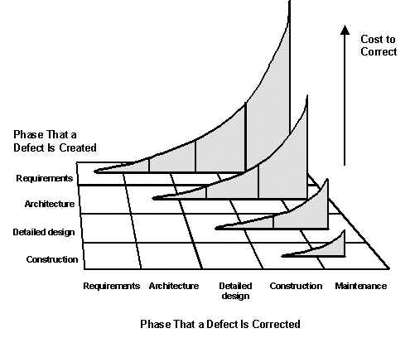

Why do Software Testing?

“A clever person solves a problem. A wise person avoids it.” Albert Einstein

Why test software? “To find the bugs!” is the instinctive response and many people, developers and programmers included, think that that’s what debugging during development and code reviews is for, so formal testing is redundant at best.

Software Testing help us answers questions like
- Does Software really work as expected?
- Does Software meet the users’ requirements?
- Is it what the users expect?
- Do the users like it?
- Is it compatible with the other systems, as desired?
- How does it perform?
- Is it ready for release?

What do we Test?
First, test what’s important. Focus on the core functionality—the parts that are critical or popular—before looking at the ‘nice to have’ features. Concentrate on the application’s capabilities in common usage situations before going on to unlikely situations.
The value of software testing is that it goes far beyond testing the underlying code. It also examines the functional behaviour of the application. Behaviour is a function of the code, but it doesn’t always follow that if the behaviour is “bad” then the code is bad. It’s entirely possible that the code is solid but the requirements were inaccurately or incompletely collected and communicated. It’s entirely possible that the application can be doing exactly what we’re telling it to do but we’re not telling it to do the right thing.
Testing can involve some or all of the following factors
- Business Requirements
- Functional/Technical design requirements
- Programmer code
- Standards & processes
- Performance

When to stop Testing?
Testing in software systems is a complex task due to interdependency of system, complexity of applications etc. Complete testing is not possible for almost all projects and a determination needs to be made early on by the project test team, SQA and PM on when to stop testing.

Some of the common factors and constraints that should be considered when decided on when to stop testing are:
- Critical or Key Test cases successfully completed. Certain test cases, even if they fail, may not be show stoppers.
- Testing budget of the project. Or when the cost of continued testing does not justify the project cost.
- Functional coverage, code coverage, meeting the client requirements as per the target benchmark.
- Defect detection rates fall below certain specified level & High priority bugs are resolved.

Testing is potentially endless process. Once the product is delivered to the customer starts testing everyday when they use the product. So the decision has to be made early, as what is the acceptable risk, based on level of testing possible.

History and Evolution of Software Testing
Software industry has evolved through the past 5 decades and each decade has its own distinctive characteristics. Software now being created has increased in size and complexity. Due to the complexity growing demand over the quality of Software being shipped to the customer there was a major shift in the attitude towards Software Testing which was till then considered only as a debugging activity.
Phase I – before 1956: This phase was considered as the Debugging oriented period where there was no clear difference between testing and debugging.
Phase II – 1957 to 1978: This phase was considered as the Demonstration oriented where debugging and testing was distinguished as a separate activity. During this phase Testing was considered as an activity to make sure it satisfies the specification.
Phase III – 1979 to 1982: For the first time Software Testing was described as the process of executing a program with the intent of finding errors. This phase was described as the Destruction phase as Testing was done to detect implementation faults. This shift led to the early association of testing and other verification/validation activities.
Phase IV – 1983 to 1987: During this phase of Evaluation period a methodology was created which integrated analysis, review and testing activities in the software lifecycle. This technique helps to ensure the detect faults in requirements and design as well as in implementation.
Phase V – Since 1988: This period was considered as the Prevention phase as Testing was mainly considered as an activity to prevent faults in requirements, design and implementation. The prevention model sees test planning, test analysis, and test design activities playing a major role, while the evaluation model mainly relies on analysis and reviewing techniques other than testing.
Since then the drive towards process maturity became mainstream thus requiring Software Testing also to be planned, executed and improved. Software Test tools have been invented to different testing purposes and slowly becoming a norm of the industry.

General Testing Principles
A number of testing principles have been suggested over the past 40 years and offer general guidelines common for all testing.

Principle 1 – Testing shows presence of Defects:
Testing can show that defects are present, but cannot prove that there are no defects. Testing reduces the probability of undiscovered defects remaining in the software but, even if no defects are found, it is not a proof of correctness. Lesser the number of defects in software, the better is the quality of the software.

Principle 2 – Exhaustive Testing is impossible:
Testing everything (all combinations of inputs and preconditions) is not feasible except for trivial cases. Instead of exhaustive testing, risk analysis and priorities should be used to focus testing efforts if the detailed testing is not feasible for various other reasons.

Principle 3 – Early Testing:
To find defects early, testing activities shall be started as early as possible in the software or system development life cycle, and shall be focused on defined objectives.

Principle 4 – Defect Clustering:
Testing effort shall be focused proportionally to the expected and later observed defect density of modules. A small number of modules usually contains most of the defects discovered during pre-release testing, or is responsible for most of the operational failures.

Principle 5 – Pesticide Paradox:
If the same tests are repeated over and over again, eventually the same set of test cases will no longer find any new defects. To overcome this "pesticide paradox", test cases need to be regularly reviewed and revised, and new and different tests need to be written to exercise different parts of the software or system to find potentially more defects.

Principle 6 – Testing is Context Dependant:
Testing is done differently in different contexts. For example, safety-critical software is tested differently from an e-commerce site.

Principle 7 – Absence-of-errors fallacy:
Finding and fixing defects does not help if the system built is unusable and does not fulfil the users’ needs and expectations.

Alignment of testing model to various development models
There are various software development life cycle methodologies available for executing software development. Below is the description on few of the important development methodologies.

Waterfall Model: The waterfall methodology proceeds from one phase to the next in a sequential manner. For example, one first completes requirements specification, which after sign-off is considered "set in stone." When requirements are completed, one proceeds to design. The software in question is designed and a blueprint is drawn for implementers (coders) to follow—this design should be a plan for implementing the requirements given. When the design is complete, an implementation of that design is made by coders. Towards the later stages of this implementation phase, separate software components produced are combined to introduce new functionality and reduced risk through the removal of errors.
Thus the waterfall model flows such that moving from one phase to another phase is feasible only if the preceding phase is completed and is perfect.
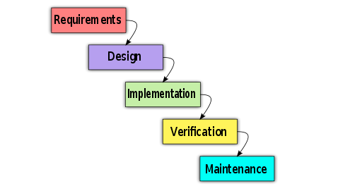
Testing

Fig: Waterfall Model

Iterative Model: The incremental, or iterative, development/testing model break the project into small parts. Each part is subjected to multiple iterations of the waterfall model. At the end of iteration, a new module is completed or an existing one is improved on, the module is integrated into the structure, and the structure is then tested as a whole. For example, using the iterative development model, a project can be divided into 12 one- to four-week iterations. The system is tested at the end of implementation in each iteration, and the test feedback is immediately incorporated at the end of each test cycle. The time required for successive iterations can be reduced based on the experience gained from past iterations. The system grows by adding new functions during the development portion of iteration. Each cycle tackles a relatively small set of requirements; therefore, testing evolves as the system evolves.
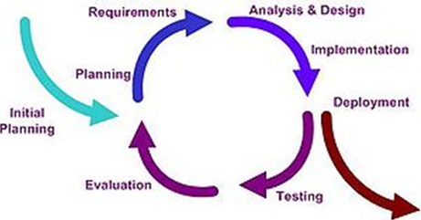 Fig: Iterative Model
Spiral Model: In the Spiral Model, a cyclical and prototyping view of software development is shown. Test are explicitly mentioned (risk analysis, validation of requirements and of the development) and the test phase is divided into stages. The test activities include module, integration and acceptance tests. However, in this model the testing also follows the coding. The exception to this is that the test plan should be constructed after the design of the system. Also known as the spiral lifecycle model, this model of development combines the features of the prototyping model and the waterfall model. The spiral model is intended for large, expensive and complicated projects.
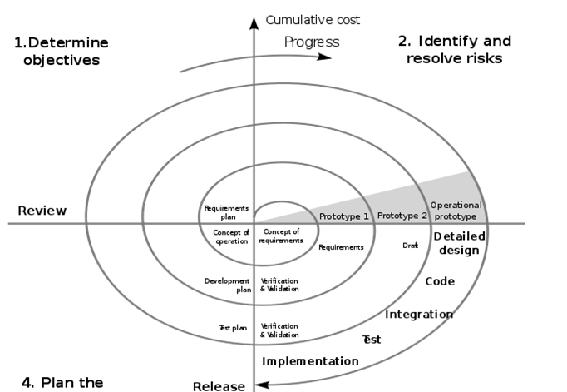
Fig: Spiral Model
Agile Methodology: Agile testing involves testing from the customer perspective as early as possible, testing early and often as code becomes available and stable enough, since working increments of the software are released often in agile software development. Most software development/testing life cycle methodologies are either iterative or follow a sequential model (as the waterfall model does). As software development becomes more complex, these models cannot efficiently adapt to the continuous and numerous changes that occur. Agile methodology was developed to respond to changes quickly and smoothly. Although the iterative methodologies tend to remove the disadvantage of sequential models, they still are based on the traditional waterfall approach. Agile methodology is a collection of values, principles, and practices that incorporates iterative development, test, and feedback into a new style of development. 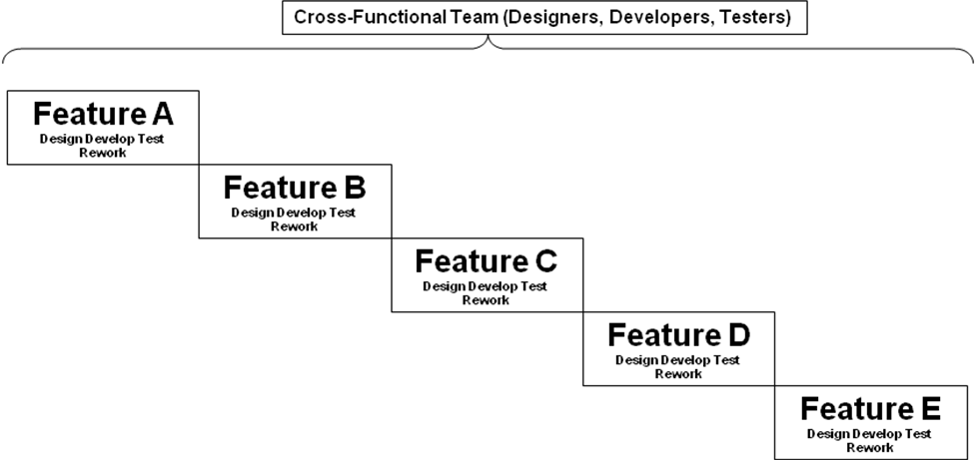
Fig: Agile Model

Testing Process aligned to Waterfall development model:
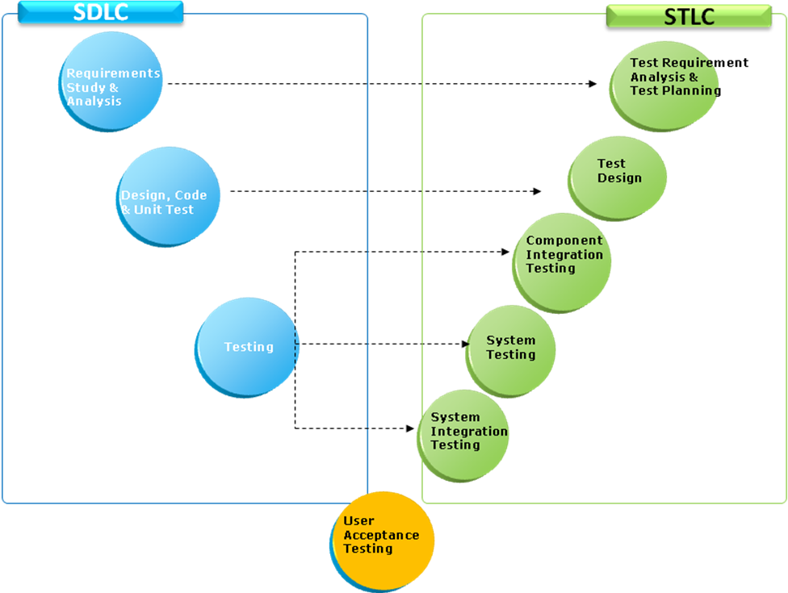

SDLC Phases:
- Requirements analysis: In the Requirements analysis phase, the requirements of the proposed system are collected by analyzing the needs of the user(s). The user requirements document will typically describe the system’s functional, physical, interface, performance, data, security requirements etc as expected by the user.
- Design, Code & Test: Systems design is the phase where system engineers analyze and understand the business of the proposed system by studying the user requirements document... Technical documentation like entity diagrams, data dictionary, High level design, Low level design, and code for the software will also be produced in this phase. The architecture/design of the software is arrived in during design. The design is converted into software using coding. Each unit is coded and tested individually. The tested units are then integrated and built into a complete product/software.

STLC Phases:
- Test Requirement Analysis: The functional and Non-functional requirements are broken down into testable requirements in this phase. The Testing team is also involved in the requirement analysis phase along with the development team.
- Test Planning: The strategy/approach on how to test these testable requirements are arrived at during this phase. When to test each of these requirements and who will test is also be decided during this phase.
- Test Design: Development of Test scenarios and Test cases to test these requirements is done during this phase. Test Design is done by the Testing team while the development team is doing the designing and coding of the software.
- Component Integration testing: Testing the interfaces between components, interactions to different parts of a system such as an operating system, file system and hard ware against the testable requirements. Integration Testing is generally done after the individual units are developed and unit tested by the development team.
- System testing: Execution of these test cases to test the behavior of the whole system/product as defined by the scope of a development project or product. The main focus of system testing is verification against specified requirements.
- System Integration Testing: Testing of software to ensure the data flow across the developed software and the other external interfaces is System Integration Testing. This is generally performed after System Testing or in parallel
- Acceptance testing: Testing with respect to user needs, requirements, and business processes conducted to determine whether or not to accept the system.

Testing process in Agile Development
Agile Testing is a mix of Iterative and Incremental approach, along with focus on customer involvement and interaction, etc. supports early delivery of value to the customer. Most software development life cycle methodologies are either iterative or follow a sequential model (as the waterfall model does). As software development becomes more complex, these models cannot efficiently adapt to the continuous and numerous changes that occur. Agile methodology was developed to respond to changes quickly and smoothly. Although the iterative methodologies tend to remove the disadvantage of sequential models, they still are based on the traditional waterfall approach. Agile methodology is a collection of values, principles, and practices that incorporates iterative development, test, and feedback into a new style of development.
The key differences between agile and traditional methodologies are as follows:
- Development is incremental rather than sequential. Software is developed in incremental, rapid cycles. This results in small, incremental releases, with each release building on previous functionality. Each release is thoroughly tested, which ensures that all issues are addressed in the next iteration.
- People and interactions are emphasized, rather than processes and tools. Customers, developers, and testers constantly interact with each other. This interaction ensures that the tester is aware of the requirements for the features being developed during a particular iteration and can easily identify any discrepancy between the system and the requirements.
- Working software is the priority rather than detailed documentation. Agile methodologies rely on face-to-face communication and collaboration, with people working in pairs. Because of the extensive communication with customers and among team members, the project does not need a comprehensive requirements document.
- Customer collaboration is used, rather than contract negotiation. All agile projects include customers as a part of the team. When developers have questions about a requirement, they immediately get clarification from customers.
- Responding to change is emphasized, rather than extensive planning. Extreme Programming does not preclude planning your project. However, it suggests changing the plan to accommodate any changes in assumptions for the plan, rather than stubbornly trying to follow the original plan.
Agile methodology has various derivate approaches, such as Extreme Programming, Dynamic Systems Development Method (DSDM), and SCRUM. Extreme Programming is one of the most widely used approaches.

Summary
- Software quality may be defined as conformance to explicitly mentioned functional and performance requirements, explicitly documented development standards and implicit characteristics that are expected of all professionally developed software.
- The Key software quality attributes of a software are
  - Functionality
  - Reliability
  - Usability
  - Efficiency
  - Maintainability
  - Portability
- Testing model varies with the development methodology
- A software defect is the common term used to describe an error, flaw, mistake, failure, or fault in a computer program or system that produces an incorrect or unexpected result, or causes it to behave in unintended ways.

Test Your Understanding
- Define Software Quality
- Explain the various Software quality attributes?
- How does testing improve the software quality?
- What is a software defect?
- What is the significance of a defect on the software cost?
- What are the various development methodologies?
- How is Agile development different from waterfall?

Session 2: Types of Testing

Learning Objectives

After completing this chapter, you will be able to understand:

- Functional & Non-Functional Testing
- Functional & Non-Functional Testing types
- Functional & Non-Functional Testing Tools
- Black box Vs White box Testing
- Manual & Automation Testing
- Fresh development & Maintenance Testing

Functional Testing
It tests the functioning of the system or software i.e. what the software does. The functions of the software are described in the functional specification document or requirements specification document.
Examples of Functional requirement:
- The registered users should be able to login to the application
- After logging in, the user should be able to purchase the products available online using the shopping cart
- The user should also be able to redeem the reward points accumulated till date

Functional testing considers the specified behavior of the software.
Example for Functional Testing:
1. Smoke testing
2. Sanity testing
3. Exploratory testing
4. Ad hoc testing
Smoke Testing:
This is a build verification test done to ensure that the new build does not cause any showstopper issues to the application under test. This test is done to ensure there are no critical defects in the application which cause the application to fail.

Sanity Testing:
It’s the most basic test done to check if the system does not have any showstoppers. This testing is done by the independent testing team once the build is deployed into the QA environment.

Exploratory Testing:
Exploratory testing seeks to find out how the software actually works, and to ask questions about how it will handle difficult and easy cases. The quality of the testing is dependent on the tester's skill of inventing test cases and finding defects. The more the tester knows about the product, domain and different test methods, the better the testing is expected to be.

Adhoc Testing:
This is not a structured testing and the least formal method. It is performed with improvisation; the tester seeks to find defects with any means that seem appropriate. This type of testing will be required when the testing team / tester feels that there is a need to validate the system not limited to the test cases at the same time perform some free form testing

Non-functional Testing:
Non-functional testing tests the characteristics of the software like how fast the response is, or what time does the software takes to perform any operation.
Non-functional testing is the validation of the software against the Non-functional requirements specified in the requirements specification document.
Examples of Non-functional requirement:
- Each page of the application should load in 5 seconds
- The application should be able to handle 500 users concurrently
- The application should be accessible to visually challenged people

Example for Non-functional Testing
1. Performance Testing
2. Scalability Testing
3. Reliability Testing
4. Stress Testing
5. Interoperability Testing
6. Localization Testing
7. Installation Testing
8. Usability testing
9. Security Testing
10. Recovery testing
11. Load Testing
12. Portability Testing
13. Compatibility Testing

Performance Testing:
Testing to evaluate the compliance of a system or component with specified requirements like throughput, availability, response time and capacity planning

Scalability Testing:
Testing the ability of the system, process to continue working when it is changed in size or volume in order to meet the growing need

Reliability Testing:
Reliability testing brings out the errors which arise because of certain repeated operations

Interoperability Testing:
Testing information exchange between two or more interfaces / platforms

Localization Testing:
Testing the application in its native language i.e. say Japanese, Chinese

Installation Testing:
Testing done to establish that a program can be installed and uninstalled on various supported platforms

Usability Testing:
Usability testing is a type of testing done to ensure that the intended users of a system can carry out the intended tasks efficiently, effectively and satisfactorily.

Security Testing:
Determines whether the system/software meets the specified security requirements like Preservation of confidentiality, integrity and availability of information

Recovery Testing:
Recovery testing is basically done in order to check how fast and better the application can recover against any type of crash or hardware failure etc

Load Testing:
Testing done to determine the maximum sustainable load the system can handle. i.e., testing at the highest transaction arrival rate in performance testing

Portability Testing
Testing the ease with which a software component can adapt to various operating environments

Compatibility Testing:
Testing is done to ensure that the product features work consistently with different infrastructure components. E.g. browsers, Operating Systems, or hardware

Black Box Testing
Testing the behavior of the application for the desired functionalities against the requirements without focusing the internal details of the system is called Black box Testing
It is usually performed by an independent testing team or the end users of the application
The application is tested with relevant inputs and is tested to validate if the system behaves as desired
This can be used to test both Functional and Non-functional requirements
External descriptions of the software like SRS (Software Requirements Specification), Software Design Documents are used to derive the test cases.

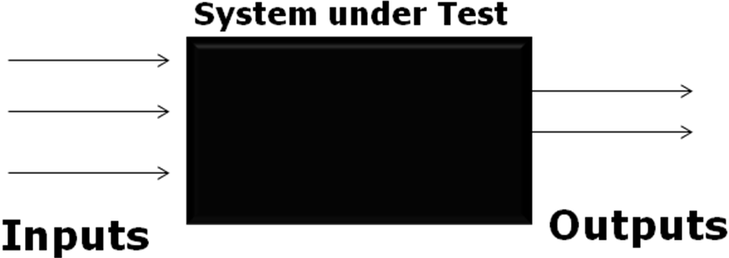

White Box Testing

White Box testing tests the structure of the software or software component. It checks what happens inside the software code step by step. Also Known as Clear box testing, glass box testing, or structural testing.

It requires knowledge of internal code structure and good programming skills. It tests paths within a unit and also flow between units during integration of units

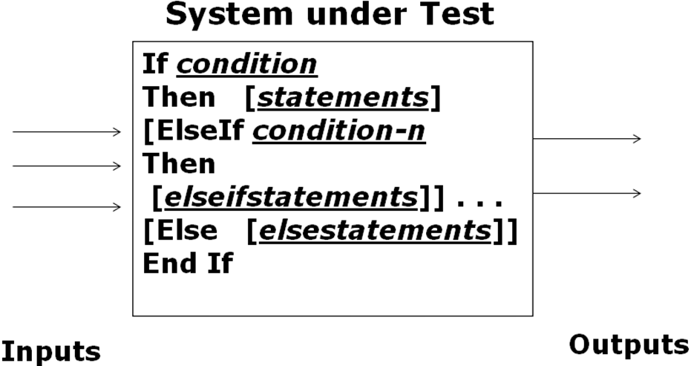

Difference between Black Box & White Box Testing
White box testing is concerned only with testing the software product; it cannot guarantee that the complete specification has been implemented. Black box testing is concerned only with testing the specification; it cannot guarantee that all parts of the implementation have been tested. Thus Black box testing is testing against the specification and will discover faults of omission, indicating that part of the specification has not been fulfilled. White box testing is testing against the implementation and will discover faults of commission, indicating that part of the implementation is faulty. In order to fully test a software product both black and white box testing are required.
White box testing is much more expensive than black box testing. It requires the source code to be produced before the tests can be planned and is much more laborious in the determination of suitable input data and the determination if the software is or is not correct. The advice given is to start test planning with a black box test approach as soon as the specification is available. White box planning should commence as soon as all black box tests have been successfully passed, with the production of flow graphs and determination of paths. The paths should then be checked against the black box test plan and any additional required test runs determined and applied

Manual Testing
Manual testing is the process of manually testing software for defects. It requires a tester to play the role of an end user, and use most of all features of the application to ensure correct behavior. To ensure completeness of testing, the tester often follows a written test plan that leads them through creation and execution of test cases.

Automation Testing:
Using Automation tools to write and execute test cases is known as automation testing. No manual intervention is required while executing an automated test suite.
Testers write test scripts and test cases using the automation tool and then group into test suites. These test suites are then scheduled to run or run manually to test and generate a defect report by the tool.

Manual Vs Automation Testing
Executing the test cases manually without any tool support is known as manual testing.
Taking tool support and executing the test cases by using automation tool is known as automation testing.
- Manual Tests take more Effort and Cost more than Automated Test to write and run
- Manual Tests provide limited Visibility and have to be Repeated by all Stakeholders
- Automated Tests can have varying scopes and can test single units of code by Mocking the dependencies
- Automated tests may require less complex setup and teardown
Following table shows the difference between manual testing and automation testing.
Manual Testing | Automation Testing
1. Time consuming and tedious: Since test cases are executed by human resources so it is very slow and tedious. | 1. Fast Automation runs test cases significantly faster than human resources.
2. Huge investment in human resources: As test cases need to be executed manually so more testers are required in manual testing. | 2. Less investment in human resources: Test cases are executed by using automation tool so less tester are required in automation testing.
3. Less reliable: Manual testing is less reliable as tests may not be performed with precision each time because of human errors. | 3. More reliable: Automation tests perform precisely same operation each time they are run.
4. Non-programmable: No programming can be done to write sophisticated tests which fetch hidden information. | 4. Programmable: Testers can program sophisticated tests to bring out hidden information.

Functional and Non-functional Testing tools
A few of the Functional and Non-functional testing tools are listed below. The tools are also classified under respective type of testing for easy and better understanding.

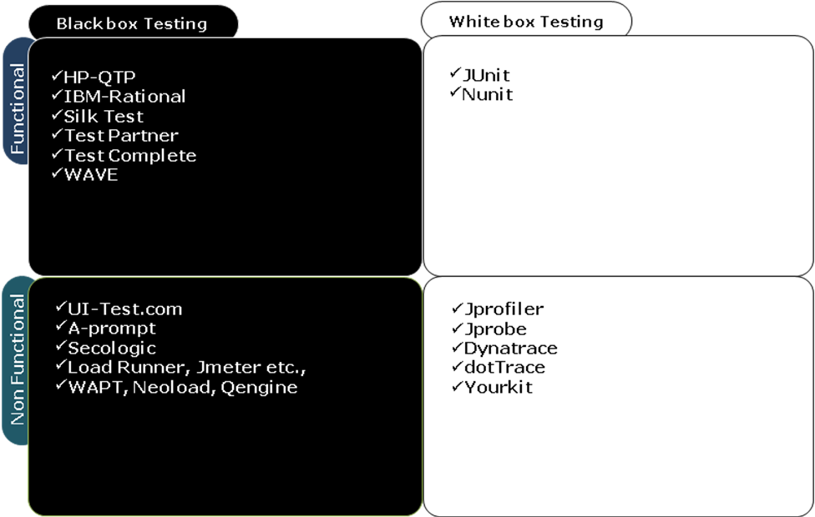

Fresh Development Testing
Fresh Development Testing is primarily testing of an application, which is developed from the scratch or which undergoes a major enhancement. Entire testing process has to be defined for this type of Testing.
Test scenario design is given higher emphasis and takes more time as compared to Test Execution. Generally, this type of testing will have a higher defect density since the application is being tested for the first time.
Most of the levels of testing would be applicable in this case, as the application is being freshly developed and follows the entire SDLC phases.
Regression testing would be a small portion of the overall testing, which will be mainly concerned with regressing for critical functions and defect fixes. These are not usually automated unless agile methodology is followed for development.

Maintenance Testing
Maintenance Testing is testing of an application, which is already in production and may undergo changes.
Testing process would usually be defined and set in place, in this case. Minor changes may be made to it based on the need to suit the requirement of a specific release.
Artifacts created for earlier releases will generally be available for reference.
If the change is very minor, requests are raised to test. Hence, referred as ticket based or request based testing. If the change is major, then release based testing is done
Regression testing will generally be part of the testing, as we need to ensure the new change made to the software does not introduce any defect in the existing modules of the software which were working as desired before the change.
If the application is being tested by the same team, over a period of time, error prone areas of the application are usually much familiar.
Regression testing will always be a considerable part of the testing, primarily focused around critical functions of the existing applications. Most of these tests are automated.

Summary
- Functional testing is the validation of the software against the functional requirements specified in the requirements specification document.
- Non-functional testing is the validation of the software against the Non-functional requirements specified in the requirements specification document.
- Testing the behavior of the application for the desired functionalities against the requirements without focusing the internal details of the system is called Black box Testing
- White Box testing tests the structure of the software or software component. It checks what happens inside the software code step by step.
- Executing the test cases manually without any tool support is known as manual testing.
- Taking tool support and executing the test cases by using automation tool is known as automation testing.
- Fresh Development Testing is primarily testing of an application, which is developed from the scratch or which undergoes a major enhancement
- Maintenance Testing is testing of an application, which is already in production and may undergo changes

Test your Understanding
- What are the various types of Testing? How are they related to each other?
- List the key differences between Black box and White box Testing
- What is Functional testing?
- What is Non-functional testing? List a few types of Non-functional testing
- List the basic differences between fresh development and Maintenance testing

Session 3: Levels of Testing

Learning Objectives

After completing this chapter, you will be able to:
- Understand the importance and necessity of different levels of testing
- Appreciate the benefits of testing at each level
  - Unit Testing
  - Component Integration Testing
  - System Testing
  - System Integration Testing
  - User Acceptance Testing

Unit Testing
Testing of on an individual program / function / stored procedure is called Unit Testing. In object-oriented programming, the smallest unit is a method, which belongs to base / super class/abstract class/derived child class.
The field validations, presence of menu controls & layout of the page are tested with different inputs after coding /UI Design.

In Unit Testing, the code is executed & tested to ensure that each line of code is run for the required unit test cases.

Unit Testing is done by the developers themselves.

The cost of fixing a defect detected during unit testing is very less in comparison to that of defects detected at higher levels. The defects found at this level will cause less rework and are save cost than those found in the later levels of Testing.

Example
In the Leave management application, development of UI, connecting to the database, retrieving and updating the database could be individual units. Testing of these units after they are developed is an example for unit testing

Component Integration Testing
The individual software modules/pages that are already unit tested, are integrated and tested for their functionalities to ensure the data flow across modules/units. This is called Component Integration Testing.

This helps ensure that the individual units work together as a whole and the data flows (back and forth) across the units as per the requirement specification.

This is usually performed after two or more programs or application components have been successfully unit tested.

This is done by the developers themselves or by an independent testing team.

This is also referred as Assembly Testing and API Testing

Example
In the Leave management application, there can be multiple components. One component may get the leave type (Vacation, Sick, Maternity, Personal, Comp Off) details from the admin user and store in the Leave Type master table. Another component may enable to apply leave and in the “Leave Application” screen the data for type of leave will be retrieved from Leave Type master table. Validation the data flow between these two modules is an example for Component Integration Testing

Approaches to Component Integration Testing
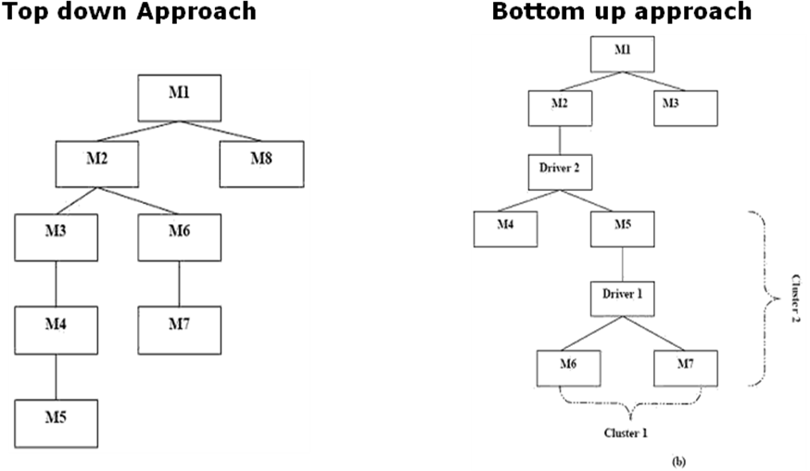
Top Down
Top level units are tested first and lower level units are tested step by step after that in the Top Down approach. This approach is used for testing when top down approach is followed in development.
Test Stubs are needed to simulate lower level units which may not be available during the initial phases
In the above diagram, the control hierarchy is first identified. This is the module that drives/controls the module. Here the control paths to the module are integrated first. Sequence of integration would be M1, M2, M3, (M3, M4, M5), (M2, M6, M7).
Bottom Up
Bottom most units are tested first and then move upwards step by step in the Bottom Up approach. This approach is used for Testing when bottom up approach is followed in development.
Test Drivers are needed to simulate higher level units which may not be available during the initial phases.
In the above diagram, the control hierarchy is first identified. This is the module that drives/controls the module. Here the control paths to the module are integrated first. Sequence of integration would be M1, M2, M3, (M3, M4, M5), (M2, M6,M7).
Big Bang
All or most of the units are combined together and tested at one go in this approach. This is used when the testing team receives the entire software in a bundle.

System Testing (ST)
Testing of complete, integrated system/software is called System Testing. Testing is performed on the entire system where the system is validated against the Functional Requirement Specification(s) (FRS) and/or a System Requirement Specification (SRS).

Testing is done against both Functional and Non-Functional requirements. Black box Testing is preferred to do this type of testing.

Example
In the Leave management application, testing of the functionalities of the system specified in the requirements document for implementation is an example for System Testing. The below could be a few functionalities – Apply, Approve, reject, cancel leaves.

System Integration Testing (SIT)
System integration testing is carried out to check if the system works in conjunction with the other systems/interfaces as below and the data flow is as desired across these systems/interfaces

- LAN / WAN, communications middleware
- other internal systems (billing, stock, personnel, overnight batch, branch offices, other countries)
- external systems (stock exchange, news, suppliers)
- intranet, internet / www
- 3rd party packages
- electronic data interchange (EDI)
- Printers

This is generally performed after System Testing or in parallel to it.

Example
In the Leave management application, retrieval of the employee details from the Employee Management system and sending the leave details to the Payroll Management system could be the external interfaces. Testing if the data flows across these systems as desired is an example for System Integration Testing.

Approaches to System Integration Testing
- Risk Based
  - System Integration points that are critical to the business are first identified in this approach. They are then prioritized and tested sequentially to uncover the defects
- “Divide and conquer”
  - Test the outside first (at the interface to your system, e.g. test a package on its own)
  - Test the connections one at a time first
(your system and one other)
  - Combine incrementally - safer than “big bang”
(non-incremental)

User Acceptance Testing (UAT)
UAT is the testing done by end users allowing them to verify day-to-day business scenarios in the system. This validates if the software meets a set of agreed acceptance criteria

UAT validates if the application is fit for deployment. This type of testing is performed generally in the customer’s (more close to the actual) environment. This is performed after the ST, SIT or in parallel to them.

Example
In the Leave management application, testing of the Leave Management system by a select group of employees of the organization to validate if the system meets their actual business needs is an example for User Acceptance Testing.

Summary
- Testing of on an individual program / function / stored procedure is called Unit Testing. In object-oriented programming, the smallest unit is a method, which belongs to base / super class/abstract class/derived child class.
- The individual software modules/pages that are already unit tested, are integrated and tested for their functionalities to ensure the data flow across modules/units. This is called Component Integration Testing.
- There are three approaches to CIT – Top down, Bottom up and Big Bang
- Testing of complete, integrated system/software is called System Testing. Testing is performed on the entire system where the system is validated against the Functional Requirement Specification(s) (FRS) and/or a System Requirement Specification (SRS).
- System integration testing is carried out to check if the system works in conjunction with the other systems/interfaces and the data flow is as desired across these systems/interfaces
- There are two approaches to SIT – Big Bang, Divide and Conquer
- UAT is the testing done by end users allowing them to verify day-to-day business scenarios in the system. This validates if the software meets a set of agreed acceptance criteria

Test your Understanding
Explain the various levels of testing and the key differences between those

Glossary
SDLC – Software Development Life Cycle

References

Books

- Software Testing Fundamentals—Concepts, Roles, and Terminology, John E. Bentley, Wachovia Bank, Charlotte NC
- Software Quality Awareness Series-1 by Philip B Crosby.
- ISO9126 Software Quality Attributes
- CSTE Book of Knowledge

STUDENT NOTES:

