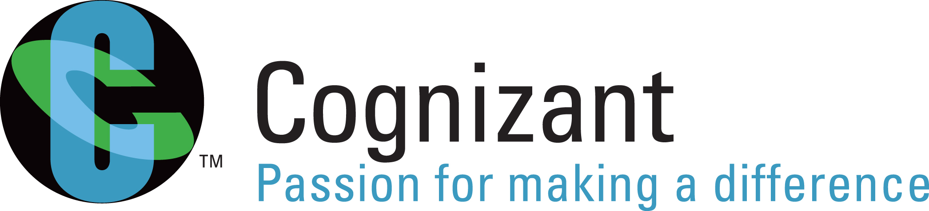

Handout: Fundamentals of Knowledge Transition and Requirements Analysis
Version: Fundamentals of Knowledge Transition and Requirement Analysis /Handout/V1.0
Date15-03-2011

Cognizant
500 Glen Pointe Center West
Teaneck, NJ 07666
Ph: 201-801-0233
www.cognizant.com

TABLE OF CONTENTS

Introduction 4
About this Module 4
Target Audience 4
Module Objectives 4
Pre-requisite 4
Session 1: Introduction 5
Learning Objectives 5
Introduction to Knowledge Transition and Requirement Analysis 5
Importance of tester involvement in these phases 5
Session 2: Knowledge Transition Concepts 7
Learning Objectives 7
Sources of knowledge transition 7
Methodology of Knowledge Transition 8
Transition Planning 8
Knowledge Acquisition 9
Reverse Knowledge Transition 10
Knowledge Retention 10
Requirements Gathering 11
Session 3: Requirement Analysis 14
Learning Objectives 14
Requirement Analysis and Verification 14
Requirement Types and Documents 14
Analysis of Requirement Specifications 17
Prioritization of Requirements 18
Clarification Management 18
Requirement Defects 19
Requirements Change Management 20
Requirements Coverage 20
KT & Requirements Analysis Phase – Application Development Vs Maintenance 20
Session 4: Tools & Deliverables 22
Learning Objectives 22
Tools used in Requirements Analysis Phase 22
Deliverables 23
Summary 25
Test your Understanding 25
Glossary 27
References 28
Websites 28
Books 28
STUDENT NOTES: 29

Introduction

About this Module
This module provides a detailed description about the various activities involved in Knowledge Transition and Requirements Analysis Phase.

Target Audience
Campus Associated Trainees

Module Objectives

After completing this module, the student will be able to:

- Explain the concept of Knowledge Transition and Requirements Analysis
- Understand the importance of tester involvement in these phases
- Understand the Sources, Modes & Phases Involved in Knowledge Transition
- Understand the Requirement Types, Analysis and Verification
- Explain Requirements Change Management
- Explain the Tools & Deliverables involved in this phase

Pre-requisite
Completion of Fundamentals of Software Testing course.

Session 1: Introduction

Learning Objectives
After completing this chapter, you will be able to:
- Explain what is knowledge transition
- Understand the significance of knowledge transition
- Understand the requirement analysis process
- Importance of tester involvement in these phases

Introduction to Knowledge Transition and Requirement Analysis
Knowledge Transition and Requirements Analysis are major activities in the initial stage of the testing life cycle and are critical to the success of a project. Knowledge Transition (KT) is the process of the project team gaining information on the application, business process and testing processes from the client/SME at the beginning of a project. It results in knowledge-building, enhanced expertise and know how amongst the target audience. It is the individual or work-group focused transfer of competencies essential to preserve the intellectual capital of the organization, create more flexibility in the workforce and provide employees with a wider diversity of skills. As testers, it is important that the knowledge on the product/service/application is gathered and assimilated by the tester just after the project kicks off. Requirement Analysis is an activity that commences after the successful completion of the knowledge transition phase. It typically includes two activities:
- Eliciting requirements: The task of communicating with customers and users to determine what their requirements are. This is sometimes also called requirements gathering
- Analyzing requirements: Determining whether the stated requirements are unclear, incomplete, ambiguous, or contradictory, and then resolving these issues
It is important to identify all the stakeholders, take into account all their needs and ensure they understand the implications of the new systems. Analysts can employ several techniques such as interviews with stakeholders, prototyping, and building use cases to elicit the requirements from the customer. Where necessary, the analyst will employ a combination of these methods to establish the exact requirements of the stakeholders, so that a system that meets the business needs is produced.

Importance of Tester Involvement in these Phases
Testers need a solid understanding of the product or application so that they can devise better and more complete test plans, designs, procedures and cases. Test team involvement at these phases can eliminate ambiguities about the desired behavior of the application later in the project life cycle. Also, early involvement allows the test team to learn over time, which aspects of the application are the most critical to the end user and which are the highest risk elements. This knowledge enables testers to focus on the most important parts of the application first, avoiding over-testing of rarely used areas and under-testing of the more important ones.
Testers involved from the beginning of the development life cycle, can help recognize omissions, discrepancies, ambiguities, and other problems that may affect the project requirements, testability, correctness and other qualities.

Session 2: Knowledge Transition Concepts

Learning Objectives
After completing this chapter, you will be able to:
- Explain the sources of knowledge transition
- Understand the importance of knowledge transition planning
- Understand the methodology of knowledge transition
- Understand the concept of reverse knowledge transition
- Explain knowledge retention
- Understand the concept of requirement gathering

Sources of Knowledge Transition
This section details the sources of knowledge transition. The major sources include client/business team and the onsite team deployed by the organization.
KT from Customer / Onsite: As the name suggests KT from Customer/Onsite is transfer of knowledge on the application/product from client or the organization’s onsite team to the offshore project team. Since it is an initial session, the existing documents related to the system and business may be provided. The channel of transition varies from project to project.
Generally there are two approaches to this transition. A brief note on each of them is mentioned below.

Big Bang Approach - Knowledge Transition for the first time during the start of an engagement – Application, Project / Program.

Big Bang approach of KT is applicable to a start of a new project. The customer after entering into a business with an IT sector for the first time provides a high level KT on what the application is, to the project team. This helps the developers and testers to understand the objective of the project. It also provides a brief outline about the application and business.

Incremental Approach – KT for other applications or incrementally during the future releases / enhancements

In general any application/product that is in use may undergo enhancements at later stage due to the changing customer needs. The transition during each enhancement phase includes additional features or modifications to the existing features to be made to an existing application/project. This transition, pertaining to other related applications that are provided incrementally during the future releases / enhancements is classified as incremental knowledge transition.

Internal KT: The knowledge transition that happens within the project team, without the involvement of the client is usually referred to as Internal KT. This can happen within a project when there are new resources, replacing someone or during ramp ups. This includes application/product/domain related sessions.

Methodology of Knowledge Transition
Various methods can be adopted to achieve knowledge transfer effectively. Some of these are outlined below. System information will also be gathered through informal discussions.

- Conference Calls - A formal presentation/lecture by an SME may be arranged to give a detail view of the application to understand efficiently about the system. The various channels of transfer includes, conference calls (Audio and Video), Web Ex sessions, Live Meeting etc.

- Query-Responses - While engaged in normal day-to-day work, queries raised by testers will have to be clarified by business/project team. Valuable system related information is shared through this process.

- Self Study – This involves the study of available documents that can be retrieved, viewed and interpreted by oneself without the aid of others.

- Shadowing Day to Day activities - A less-experienced performer pairs with a veteran performer on-job to facilitate knowledge transfer. Knowledge Transfer takes place on the actual job site with task accomplishment as a part of the process. It also involves learning skills and applying knowledge hands-on and on-job following or as a part of a defined structured learning process.

Knowledge Transition from Other Internal Systems – Some internal sources like the Community of Practice, Knowledge Repositories, and Content Management System etc also serve as a channel for knowledge transition.

Transition Planning
This is the first phase within Transition. The objective is to ensure readiness of the project team as well as the client to begin the KT – both from a resource and infrastructure perspective. Plans for on-boarding team members with requisite skills, reviews of existing/pre-developed knowledge transition plans, and fine tuning Knowledge Assessment/Knowledge Transition plans follow. Initial support and risk plans are also developed, leading to the next phase. It also includes offshore transition planning (when the initial KT is received by the onsite team from the client) where a gap analysis is conducted to identify areas, requiring future work (e.g.: incomplete or missing documentation, the need for additional tools or training), and transferring of knowledge to the offshore staff.
The Knowledge Transfer Plan is a complete, stand-alone document that provides a brief overview of the transition goals, any assumptions that the plan is based on, and any risks that have been identified that could severely limit your ability to complete the transition on schedule.
The following is a synopsis of the information contained in the plan.
  - Scope (in-scope and out of scope)
  - Transitioning Strategy
  - Applications services taking into account each functional area with business line
  - Transition Schedule
  - KT Calendar
  - Receivables and Deliverables during each phase
  - Hardware Software requirements
  - Escalation Process
  - Status Reporting
  - Progress Review/Team Meetings
  - Team Meetings
  - Milestones
  - Resource Management Plan
  - Training Process
  - Risk and Mitigation Strategy

Knowledge Acquisition
During this phase, the testing team (primarily onsite resources) interacts with the client SMEs (subject matter expert) to gain understanding of the following:
- Business process flows
- Application functionality
- QA processes
- QA tools usage
Knowledge Acquisition happens through class room sessions, documentation sharing and self study and hands-on training on the application. Generally there is a daily plan for the class room and other knowledge sharing sessions scheduled between the SMEs and the incumbent testing team. Knowledge is typically acquired by the onsite team from the client SMEs and is passed on to the offshore team on daily basis. KT effort variation, schedule variation and effectiveness are continually monitored during this phase

Reverse Knowledge Transition
Reverse knowledge transition is simply the flow of knowledge in a direction opposite of the standard hierarchical top down approach. It is an important part of the transition phase as it helps in evaluating the effectiveness of knowledge transition. The knowledge acquired by the incumbent team during KT is captured in various application and process understanding documents.
The knowledge level of the transition team is validated in the following ways:
  - Understanding documents – Reviewed by SMEs for completeness and clarity
  - Application Walkthrough – Transition team walks through the application navigation to the client SMEs
  - Feedback from SMEs– The knowledge level of the transition team is rated on several parameters by the client SMEs and the overall score needs to be above the predetermined threshold for the KT to be signed off

Knowledge Retention
Knowledge retention deals with ways to capture knowledge “before it walks out the door” and avoid “reinventing the wheel.” The need for knowledge retention is driven by trends in outsourcing. In order to retain and disseminate the acquired knowledge, a framework must be set up. This involves putting in place a routine Knowledge Management system, or organizational learning system, to gradually build up a body of knowledge both in recorded form, and shared by the team. A system such as this will require the following:
- 1. A place to store practice knowledge – tips, hints, manuals, guides, and other team documents. Example – a team SharePoint site, and document library
- 2. A set of processes for reviewing ongoing activity. These might include After Action reviews of new contracts or new projects. Lessons learnt from these will be stored in the knowledge store (above).
This combination of people, process and technology creates a local knowledge management system which over time will build up the repository of knowledge, and spread learning and best practice.

Requirements Gathering
On the successful completion of reverse knowledge transition, the project team starts gathering requirements. Requirements are a description of how a system should behave or a description of system properties or attributes. Requirement gathering involves the task of communicating with customers and users to determine what their requirements are. Testers should interact closely with multiple work-groups, often with conflicting goals, to arrive at a bona fide requirements list. Some of the common issues faced during requirements gathering are mentioned below.
- Ambiguous understanding of business processes
- Inconsistency within a single business process by multiple users
- Insufficient input from stakeholders
- Conflicting stakeholder interests
- Changes in requirements after project has begun
Currently, organizations have started to use tools that are better equipped to handle the complex and multilayered process of requirements gathering. Some of the tools used are:
- Prototypes
- Use cases
- Data flow diagrams

Prototypes:
Prototypes are “Mockups” of an application. They help users get an idea of what the system will look like, and make it easier to make design decisions without waiting for the system to be built. Often the end users may not be able to provide a complete set of application objectives, detailed input, processing, or output requirements in the initial stage. After the user evaluation, another prototype will be built based on feedback from users, and again the cycle returns to customer evaluation. The cycle starts by listening to the user, followed by building or revising a mock-up, and letting the user test the mock-up, then back. Major improvements in communication between users and developers were often seen with the introduction of prototypes. Early views of applications lead to fewer changes later and hence reduced overall costs considerably.

Use Cases:
A use case is a set of scenarios that describs an interaction between a user and a system. Use cases capture who (actor) does what (interaction) with the system, for what purpose (goal), without dealing with system internals. A complete set of use cases specifies all the different ways to use the system, and therefore defines all behavior required of the system, bounding the scope of the system.

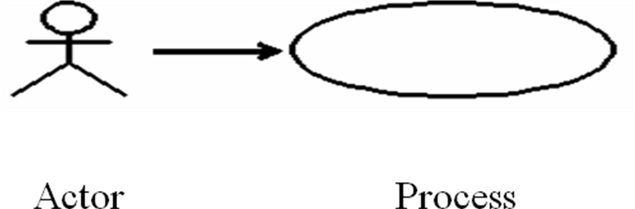

Example:

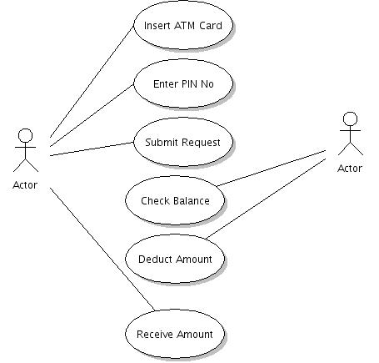

Data flow Diagrams:
A data flow diagram (DFD) is a graphical representation of the "flow" of data through an information system. DFDs can also be used for the visualization of data processing. It shows how the system is divided into sub-systems (processes), each of which deals with one or more of the data flows to or from an external agent, and which together provide all of the functionality of the system as a whole. It also identifies internal data stores that must be present in order for the system to do its job, and shows the flow of data between the various parts of the system.

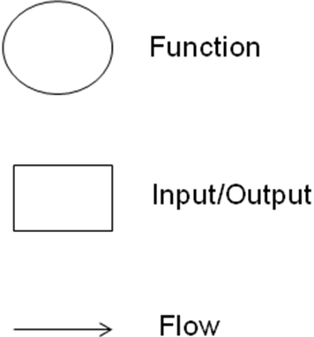

Example:

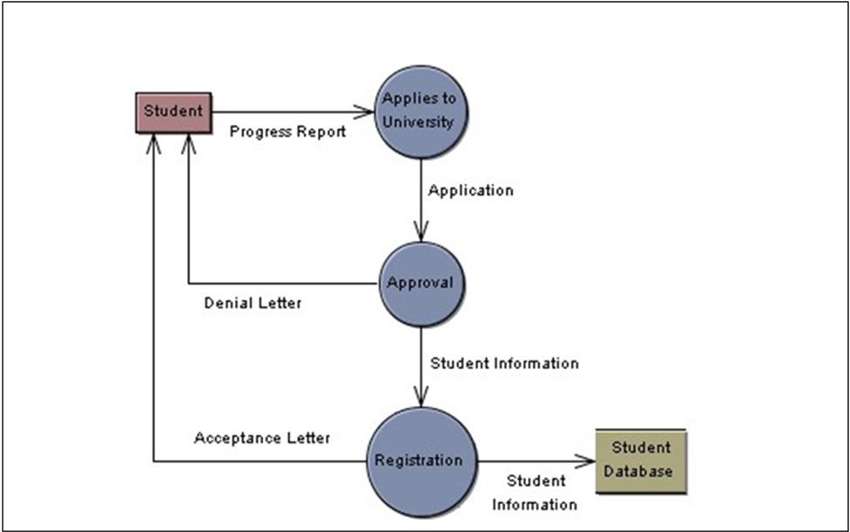

Session 3: Requirement Analysis

Learning Objectives
After completing this chapter, you will be able to:
- Explain the types of requirements
- Analyze the requirement specifications
- Prioritize the requirements
- Understand clarification management
- Analyze requirement defects
- Understand requirements change management
- Understand the concept of requirements coverage
- Understand the difference between Application Development and Maintenance in this phase

Requirement Analysis and Verification
Requirements Analysis is the process of understanding the customer needs and expectations from a proposed system or application and is a well defined stage in the Software Development Life Cycle model. Requirements are a description of how a system should behave or a description of system properties or attributes. It can alternatively be a statement of ‘what’ an application is expected to do. Given the multiple levels of interaction between users, business processes and devices in global corporations today, there are simultaneous and complex requirements from a single application, from various levels within an organization and outside as well. The Requirements Analysis Process covers the complex task of eliciting and documenting the requirements of all these users, modeling and analyzing these requirements and documenting them as a basis for system design. A streamlined process is a prerequisite to successful projects that align with the client’s business goals and meet the project’s requirement specifications.

Requirement Types and Documents
A requirement can be defined as a high level statement of the system. It is a statement that identifies a necessary attribute, capability, characteristic, or quality of a system in order to have value and utility to a user. It can also be expressed as below:
- Statement of the business need from the client to the developer/tester
- A specification of what has to be built
- Requirements can state either the business need or how the system should behave
Mainly based on the functionality of the system it is classified as Functional and Non- functional requirements.

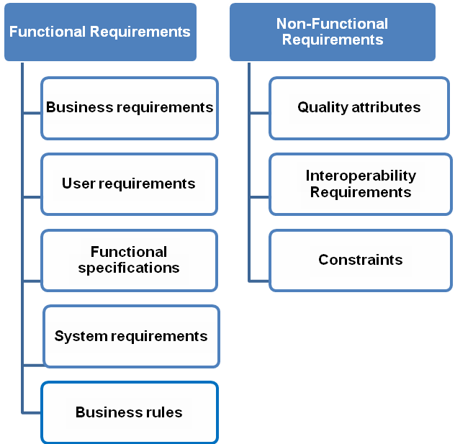

Functional Requirements:
In general, this describes the functions that the system needs to execute, statements of services the system should provide, how the system should react to particular inputs and how the system should behave in particular situations. It depends on the type of software, expected users and the type of system where the software is used. It can be further categorized as Business Requirements, User Requirements, Functional Specifications, System Requirements and Business Rules.
- Business Requirements – Business requirements represent high-level objectives of the organization or customer who requests the system. They describe why the organization is implementing the system—the objectives the organization hopes to achieve, the business objectives, scope of the project, business constraints and current business process. They are usually expressed in terms of broad outcomes the business requires, rather than specific functions the system may perform.
Example – ATM should allow the withdrawal of given amount from the account with a cap on maximum amount and number of withdrawals.
- User Requirements – User requirements describe the user goals, tasks or activities that the users must be able to perform with the product and the flow of the system. It conveys how the system should interact with the end user or to another system to achieve a specific business goal. Common users are client managers, client QA team and system end users. They are usually represented in the form of tables and diagrams.
Example – The system shall complete a standard withdrawal from a personal account, from login to cash, in less than two minutes for a first-time user.
- Functional Specifications – These specify what has to be done by identifying the necessary task, action or activity that must be accomplished. They describe the existing process, new process, use cases, process flow and reporting requirements. They are also referred to as behavioral requirements.
Example – The system shall provide users with the ability to select whether or not to produce a hardcopy transaction receipt before completing a transaction.
- System Requirements – System requirements describe the top-level requirements for a product that contains multiple subsystems. It is a structured document having detailed description about the system. It is used by the system end users, software developers and system architects.
Example:
- The ATM shall communicate to the Bank via the Internet.
- The ATM shall issue a printed receipt to the customer at the end of a successful session.
- Business Rules – These are constraints to be considered on the aspect of a business while developing a product. It includes corporate policies, industry standards and computational algorithms. It typically has existence on the outside of the boundaries of any specific software system. It requires that specific functionality be implemented to ensure that the system enforces or complies with those rules. It is also used to control internal system processing based on specific combinations of data values, system states, conditions, or other user-defined criteria.
Example:
- Limit is $1000 a day (24 hour window)
- No more than three withdrawals per day (24 hour window)

Non-Functional Requirements:
In general, this refers to the constraints on the services offered by the system such as time constraints, constraints on the development process, standards, etc. It defines the system properties and constraints e.g. reliability, response time, storage requirements, scalability, usability, security. It can be further categorized as Quality Attributes, organizational, external requirements.

- Quality Attributes – These describe the system’s characteristics in various dimensions that are important either to users or to developers and maintainers. Quality attributes of a system include availability, performance, usability, portability, integrity, efficiency, robustness, and many others. These characteristics are referred to as quality factors or quality of service requirements
Example – All displays shall be in white 14 point Arial text on black background.
It must be able to perform in adverse conditions like high/low temperature etc
  - Interoperability Requirements - These specify the interfaces between the system application and other applications, interface between the system application and other hardware or devices like printers, bar code readers, interface to human users, communication interfaces to exchange information
Example:
- User Interfaces: The customer user interface should be intuitive, such that 99.9% of all new ATM users are able to complete their banking transactions without any assistance
- Hardware Interfaces: The hardware should have following specifications:
Ability to read the ATM card
Ability to count the currency notes
Touch screen for convenience
Keypad (in case touchpad fails)
Continuous power supply
Ability to connect to bank’s network
Ability to take input from user and validate user
- Constraints – These are requirements prescribing stipulations or limitations on how the system can be built. It usually refers to design and implementation constraints, which are restrictions imposed on the choices available to the developer for some legitimate reason. Some of the common constraints on the application are reliability, performance, security, usability and safety. Constraints may be user constraint or system constraint.
Example - The cabin door will always be locked, which will open only when user swipes his/her ATM card in the slot and is validated as genuine.

Analysis of Requirement Specifications
Testers use requirement documents and interactions with users/clients to develop the initial versions of the system and acceptance tests based on functional requirements, quality requirements, and the specification of the system behavior. A requirement can be considered testable if it is possible to design a procedure in which the functionality being tested can be executed, the expected output is known, and the output can be programmatically or visually verified.
A variety of requirement tests can be applied to ensure that each requirement is relevant and that everyone has the same understanding of its meaning.
Following is the checklist that can be used by testers during the requirements phase to verify the quality of requirements. Using this checklist is a first step towards trapping requirements -related defects as early as possible, so they don’t propagate to subsequent phases, where they would be more difficult and expensive to find and correct. All stakeholders responsible for requirements should verify that requirements possess the following attributes:
- Correctness (Do the requirements reflect the user’s needs? Are they stated without error?);
- Completeness (Have all functional and quality requirements described in the problem statement been included?);
- Consistency (Do any requirements contradict with each other?);
- Clarity (It is very important to identify and clarify any ambiguous requirements);
- Relevance (Is the requirement pertinent to the problem area? Requirements should not be superfluous);
- Redundancy (A requirement may be repeated; if it is a duplicate it should be combined with an equivalent one);
- Feasibility (Can the requirements be implemented given the conditions under which the project will progress?)
- Testability (Can each requirement be covered successfully with one or more test cases? Can tests determine if the requirement has been satisfied?);
Link to the Template for requirement review checklist: https://c20search/Process%20Space/inc/Docs/ApplicationDevelopment/QCAD-REQRW.doc

Prioritization of Requirements
Prioritization allows everyone to understand the relative value to stakeholders of the requirement. When customer expectations are high, timelines are short, and resources are limited, you want to make sure the product contains the most essential functions. Prioritization helps the project team to focus on critical business areas, which need to be tested earlier in the testing cycle. It helps testers to detect defects early in the testing life cycle. It helps conflicts, plan for staged deliveries, and make the necessary trade-off decisions.

Clarification Management
A requirement can be tested and clarified by asking the stakeholders detailed questions. More than just understanding the “inputs and outputs” of the software, testers need deeper knowledge that can come only from understanding the thought process used during the specification of product or application functionality. Such understanding not only increases the quality and depth of the test procedures developed, but also allows testers to provide feedback regarding the requirements. Clarifications that were posted should be tracked and can be used as a knowledge repository for the project.
Testers should list all the clarifications with an “Open” status and should assign to the corresponding stakeholder. The stakeholder should revert back with answers to the clarifications with status as “Closed” or if waiting for more information should change the status as “In Progress”. Tester, if not clarified with the answer should provide additional information and change the status to “Re Open”.
Link to the Issue Tracker template: https://c20search/Process%20Space/inc/Docs/SupportServices/Admin/QTAG-ISSTRK.xls

Requirement Defects
The beginning of the software life cycle is critical for ensuring high quality in the software being developed. Defects injected in the early phases can persist and be very difficult to remove in later phases. Since many requirements documents are written using a natural language representation, there are very often occurrences of ambiguous, contradictory, unclear, redundant and imprecise requirements. Some of the common requirements/specification defects are:
- Functional Description Defects – The overall description of what the product does and how it should behave is incomplete and or ambiguous.
- Feature Defects – Features refer to functional aspects of the software that map to functional requirements as described by the users and clients. Features also map to quality requirements such as performance and reliability. Feature defects are due to feature descriptions that are missing, incorrect, incomplete or superfluous.
- Feature Interaction Defects – These are due to an incorrect description of how the features should interact. For example, suppose one feature of a software system supports adding a new customer to a customer database. This feature interacts with another feature that categorizes the new customer. The classification feature impacts on where the storage algorithm places the new customer in the database, and also affects another feature that periodically supports sending advertising information to customers in a specific category. When testing, we certainly want to focus on the interactions between these features.
- Interface Description Defects – These are defects that occur in the description of how the target software is to interface with external software, hardware and users.

Requirements Change Management
Requirements generally change with time. Once defined and approved, requirements should fall under change control. For many projects, requirements are altered before the system is complete. This is partly due to the complexity of computer software and the fact that users don't know what they want before they see it. This characteristic of requirements has led to requirements management studies and practices. Process and workflow, authorization and assignment controls who, what, when and where change happens, and communicates the impact of that change across the lifecycle to all involved.
Requirements management is the process of managing changing requirements during the requirements engineering process and through system development and release. Often requirements are incomplete and inconsistent and ofcourse new requirements emerge during the process as the business needs change and a better understanding of the system is developed. Different viewpoints, which also have to be considered as the project evolves, have different requirements and these are sometimes in conflict with those that were stated at the beginning of the project.
Regardless of the type of requirement you are working with, managing change to the set or any of the individual parts can and should be handled in a uniform fashion – one that automatically communicates the intent to change; controls the acceptance or approval of change; enables the analysis of the impact of the change; tracks the actual changes made and communicates the implemented change to all impacted or interested stakeholders.

Requirements Coverage
The coverage of requirements is a fundamental need throughout the software life cycle. Requirements coverage views focus on the localization of the requirements in the rest of the system. These views show if and where a certain requirement is covered in the system. This can be coverage in, for example, the system architecture, in the detailed design, or in the test cases. Be it during design, coding or testing, the ability to ensure that the software meets the expected requirements is something that every customer aspires for. As the software matures and goes into several iterations of enhancements and bug fixes, it becomes more and more daunting to ensure requirement coverage in the software. Some tools offer the capability of mapping requirements to the other project artifacts, such as, use cases, test cases and design documents. Some projects prefer to follow simple spreadsheet based traceability matrix of requirements to various other artifacts.

KT & Requirements Analysis Phase – Application Development Vs Maintenance
In this phase, for application development, the knowledge transition approach adopted is Big Bang. Other activities include Requirements Gathering, Analysis of all the requirement specifications and preparation of system understanding document to evaluate the application/business understanding. Similarly, for application maintenance projects, the incremental approach of knowledge transition is adopted. The activities include performing an impact analysis on the change requests received, analyzing the related requirements, and updating the existing knowledge base.

Session 4: Tools & Deliverables

Learning Objectives
After completing this chapter, you will be able to:
- Get an idea on the requirements management tools
- Understand the preparation of understanding document
- Identify Testable and Non-testable requirements
- Establish the Requirements Traceability Matrix

Tools used in Requirements Analysis Phase
This section briefs the tools that are used for requirements management. Requirements management is the process of documenting, analyzing, tracing, prioritizing and agreeing on requirements and then controlling change and communicating to relevant stakeholders. It is a continuous process throughout a project. Requirements management tools help us to manage and track requirements effectively. Some of the common requirement management tools are listed below.
- Doors - Requirements Management Tool by IBM
IBM Rational DOORS is a requirements management tool that helps increase quality, improve requirements communication, collaboration, and verification across the enterprise.
- Requisite Pro - Requirements Management Tool by IBM
Rational RequisitePro is a requirements management and use case writing tool to help improve communication and traceability, enhance collaborative development, and integrate requirements throughout the lifecycle.
Quality Center-Requirements Module
The Requirements Management module in Quality Center helps capture, manage and track requirements throughout the development and testing cycle.
Key Features:
- Manage different types of requirements throughout the application lifecycle
- Store requirements centrally with native control and baselining capabilities
- Graphically represent and map requirements to business processes
- Share and reuse application requirements
- Manage user stories for Agile projects
- Align testing priorities based on business risk and establish requirements traceability
The detailed presentation of the Quality Center - Requirements Module is provided below
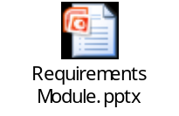

Deliverables
The deliverables in the KT and Requirement Analysis phase includes the preparation of system understanding document, identified set of testable and non-testable requirements and the requirements traceability matrix.

(1) System Understanding Document
Testers can reverse present to the Stakeholders (Business analysts, System analysts etc...) their understanding of requirements. This acts as evaluation criteria for the testers and also helps in establishing common understanding between all the stakeholders. System understanding document is a way to evaluate the understanding of testers on the overall system/requirements. This helps in establishing common understanding between all the stakeholders and a knowledge repository document for future use.
Link to the System Understanding template: https://c20search/Process%20Space/inc/Docs/AVM/Testing/QTTS-TSTKT.doc

(2) Identified Testable and Non-Testable Requirements
At the end of the requirements analysis phase, the testers should have a clear picture of the requirements and the categorized testable and non-testable requirements. Testability can be referred to as the degree to which the characteristics that provide for testing exist, and economically feasible tests can be devised for determining whether the developed software will satisfy the requirements. Requirements that satisfy the factor of testability are considered testable requirements.
Example - The ATM shall issue a printed receipt to the customer at the end of a successful session. The receipt shall contain:
• Date and time
• Machine location
• Account information
• Amount of the transaction
• Available balance

On the other hand, non-testable requirements would be too subjective and test cases for those cannot be devised.
Example:
- The application/product should be user friendly.
- The search engine should return valid information for any query raised by the user.
- The system should be robust.

(3) Requirements Traceability Matrix
Requirements traceability defines a relationship between two or more requirements. Tracing requirements to other requirements helps ensure that no requirements are inadvertently overlooked during the testing process. When analyzing the impact of a change proposed in a specific requirement, the traceability links indicate other requirements that might be affected by the change. It ensures that each requirement is identified in such a way that it can be associated with all parts of the system where it is used. To this point, each requirement has been considered as a separately identifiable entity. It is also important to consider the connections among requirements to understand the effect of one requirement on others. There must be a way of dealing with a large number of requirements and the complex connections among them. Rather than trying to tackle everything simultaneously, it is better to divide requirements into manageable groups. This could be a matter of allocating requirements to subsystems, or to sequential releases based on priority. Once that is done, the connections can be considered in two phases: first the internal connections among the requirements in each group, then the connections among the groups. If the requirements are grouped in a way that minimizes the connections between groups, the complexity of tracing connections among requirements will be minimized.
The following are the components of the RTM. It can be established in the Quality Center (a test management tool) and also in an excel spreadsheet.
    - Test Requirement
    - Test Scenarios
    - Test Cases
    - Test Logs / Defect Ids

Link to the RTM template:
https://c20search/Process%20Space/inc/Docs/AVM/Testing/QTTS-TTRACE.xls

Summary
Knowledge Transition and Requirement Analysis are important activities in the testing methodology which helps in the identification and prevention of defects early. During this phase tester acquires the knowledge on the application/product, understands and verifies the requirements which allows for better organization, planning, tracking and testing.

Glossary

Requirement: A high level statement of the system
Stakeholder: Any group or individual who can affect or who is affected directly/indirectly by achievement of a firm's objectives
KT – Knowledge Transition
DFD – Data Flow diagram
RTM: Requirement Traceability Matrix
QC – Quality Center
Testability: Testability can be referred to as the degree to which the characteristics that provide for testing exist, and economically feasible tests can be devised for determining whether the developed software will satisfy the requirements.
Traceability: Defines a relationship between two or more requirements.

References

Websites

- www.sqaforums.com
- www.qualityworld.com

Books

- Software Engineering: A Practitioner's Approach, seventh edition by Roger Pressman
- HP Education Services QC Students Guide
- Cognizant Academy. Software Testing. Cognizant Technology Solutions, 2004

STUDENT NOTES:

