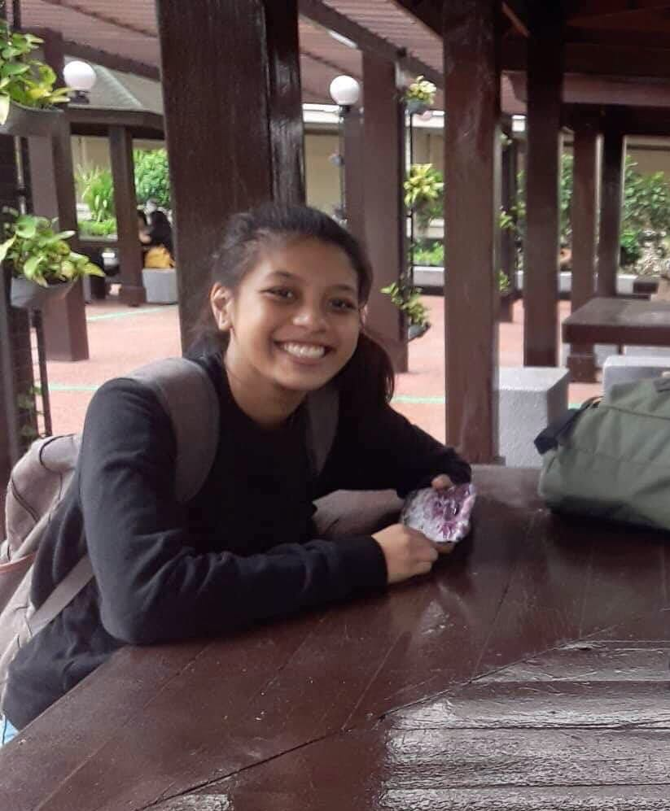

**CHELSIA MARIE C. BAÑEZ**

5G High Noon Compound, JM Panganiban St.,

Marikina City

[cmcbanez@gmail.com](mailto:ebanezph@yahoo.com)

Mob: 09362025320

**E-Commerce Specialist**

A result oriented achiever with expertise in internet startup and SEO boosting capabilities that can add value to the team by increasing the efficiencies and market innovation for the company

PROFESSIONAL PROFILE

* A proactive individual with a track record in start-up Webhosting and Web development management
* Street smart, creative, and enthusiastic internet specialist with a remarkable achievement of creating her own start up webhosting domain and web design business

AREAS OF EXPERTISE

* Business Development
* Turnkey Reseller programs

WORK EXPERIENCE

February 2021- present

**Owner – Banez Hosting (** [**https://store228020.duoservers.com/**](https://store228020.duoservers.com/) **)**

* Lead the management and continuous improvement of webhosting systems

* Work closely with key people who utilized the service of Banez Hosting to ensure effective service and customer support.

* Oversee the promotion of the company by linking with various social media and SEO platforms

* Design and deliver zoom/training events to communicate webhosting business

**Liason Officer (ASEAN) - 2019**

* Assisted the team leader to get players to their respected hotel rooms

**EDUCATION**

**COLLEGE**

2019- 2023 – **Emilio Aguinaldo College (Manila)**

Bachelor of Science in Information Technology

1113-1117 San Marcelino St., Paco, Manila 1007

2018 – **College of Saint Benilde**

AB- CDA Consular of Diplomatic Affairs

2544 Taft Ave, Malate, Manila, 1004 Metro Manila

**SENIOR HIGH SCHOOL**

2016 – 2018 – **De La Salle Araneta University**

ABM Accountancy, Business and Management

Salvador Araneta Campus, 303 Victoneta Ave, Potrero, Malabon, 1475 Metro Manila

**GRADE SCHOOL - HIGH SCHOOL**

2011- 2016 – **Espiritu Santo Parochial School**

1912 Rizal Avenue cor. Tayuman St., Brgy 344 Zone 35, Santa Cruz, Manila, 1014 Metro Manila

**COMMUNITY ASSOCIATIONS:**

Captain - De La Salle Araneta University Taekwondo Varsity Team (2016)

**SEMINARS/WEBINARS**

October 10, 2019 – Arduino Programming

* Emilio Aguinaldo College Manila, Bldg. 7 – Rm.414

June 5, 2021 – Ethical Hacking

* Upskill I.T. Workshop (webinar)