1. Case Study 8: Online Food Ordering Website
An online food ordering website allows users to browse restaurants, view food menus, add items to a cart, and place food orders online. It makes ordering food easy and convenient.
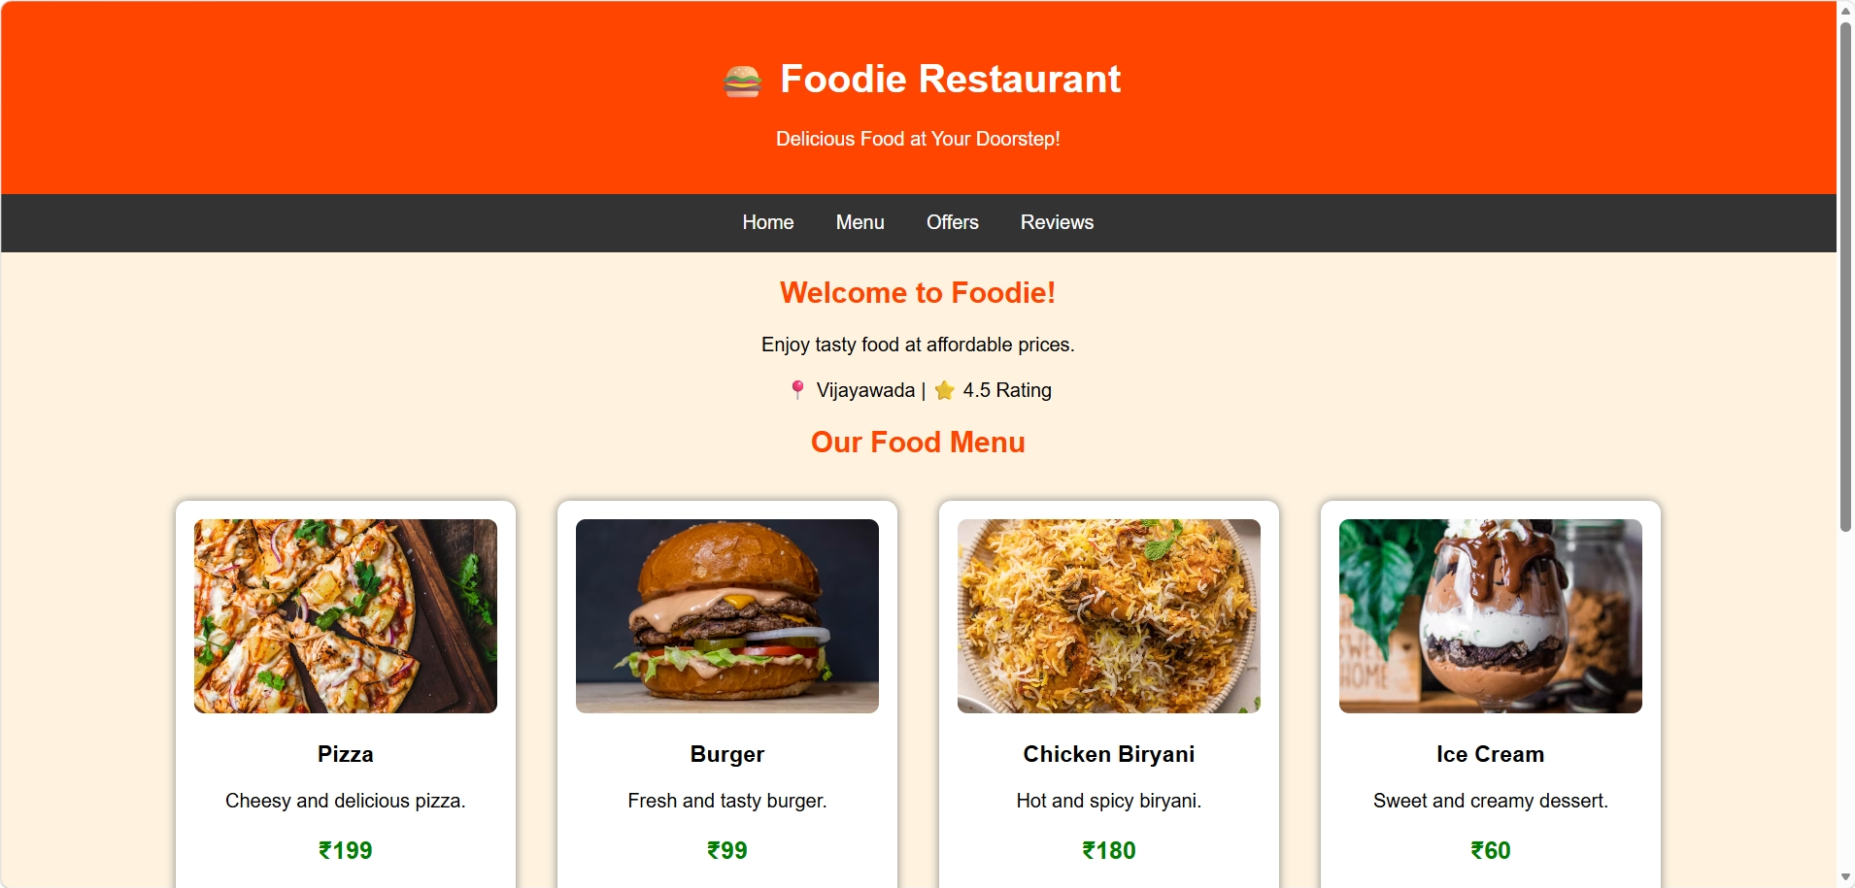
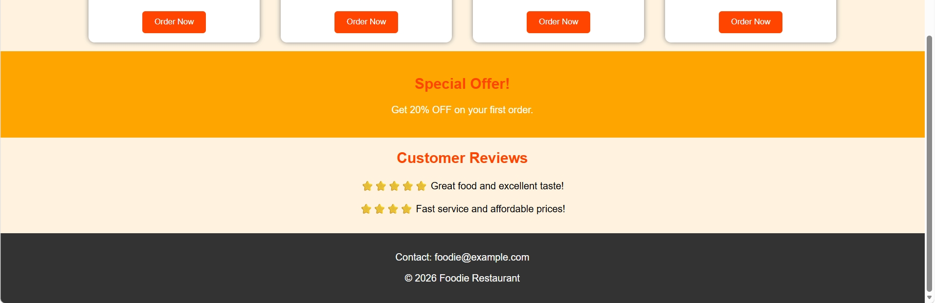

2. Case Study 16: Travel Agency Website
A travel agency website helps users explore tourist destinations, view tour packages, compare travel options, and plan trips. It provides information about destinations, hotels, transportation, and bookings.
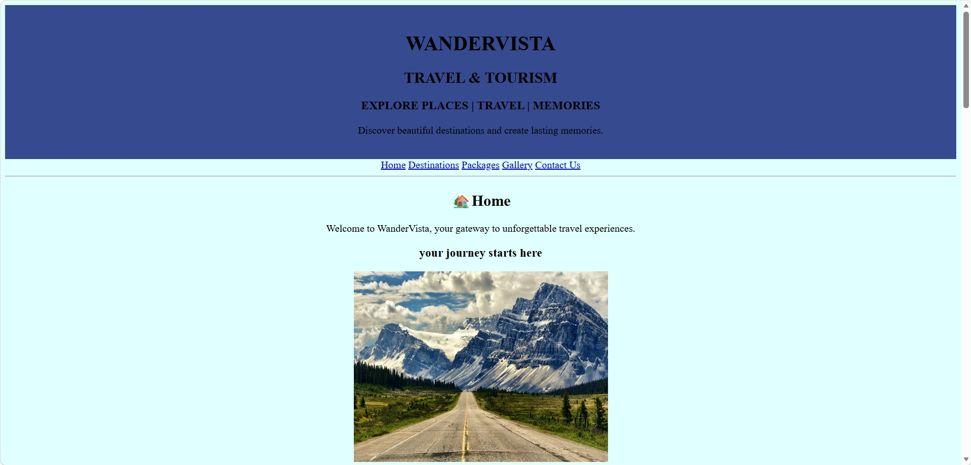
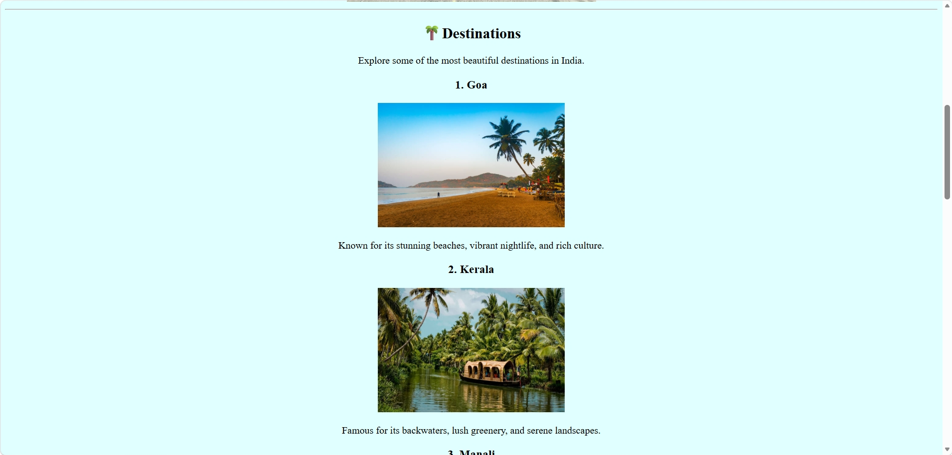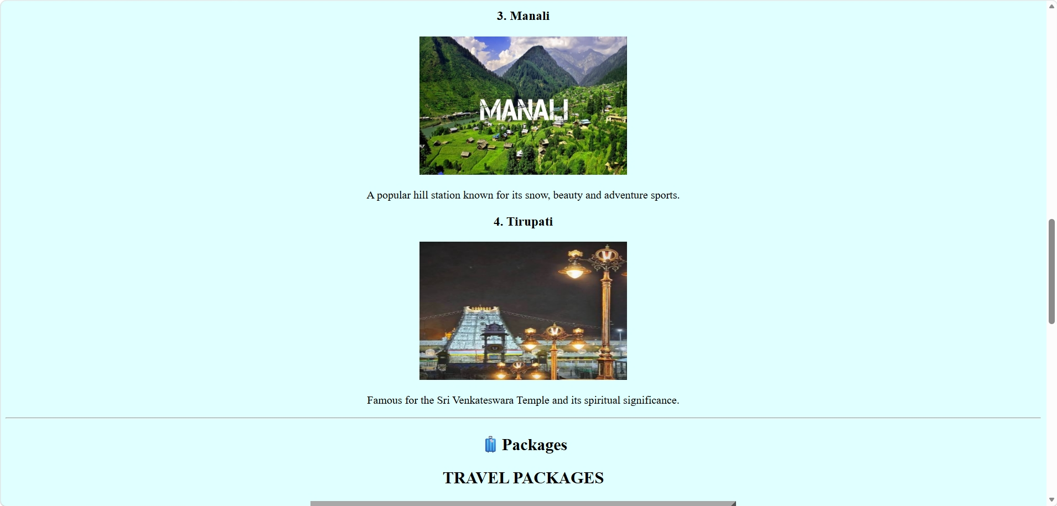
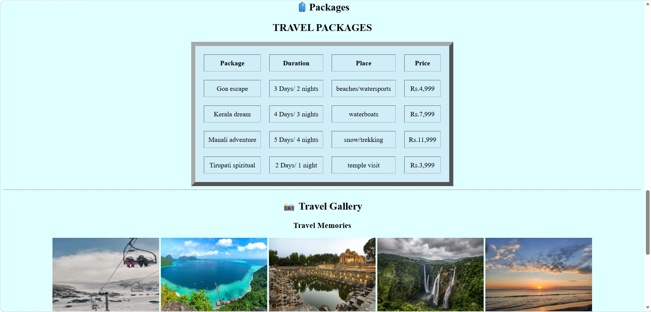


3. Case Study 22: Movie Review and Rating Website
A movie review and rating website allows users to explore movies, read reviews, give ratings, and share their opinions. It helps people choose movies based on ratings and feedback from other viewers.
