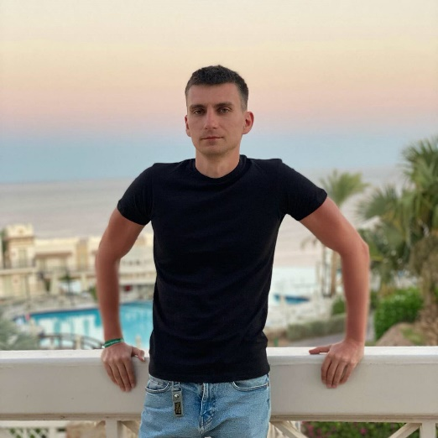

**Contact**

**Phone:**

[063 275 3857](tel://0632753857/)

**Email:**

[sasha.checheliuk@gmail.com](mailto:sasha.checheliuk@gmail.com)

**LinkedIn:**

[linkedin.com/in/checheliuk](http://www.linkedin.com/in/checheliuk)

**Git:**[github.com/checheliuk](https://github.com/checheliuk)

**Tech Skills**

* C#
* ASP.NET WebForms
* ASP.NET MVC
* ASP.NET Core
* ADO.NET
* LINQ to SQL
* Entity Framework
* SQL
* JavaScript
* TypeScript
* Angular
* RxJS
* HTML
* CSS

**Language**

* English - Intermediate

**Full Stack Web Developer**

**Oleksandr Checheliuk**

Looking for

Full Stack .Net position

**Back-end:** .NET Core

**Front-end:** Angular

Work Experience

#### **Web Developer |**[**Onseo**](https://www.linkedin.com/company/onseo)

##### **Oct 2017 - up to now | Ukraine**

##### **Developing and supporting UK gambling sites**

**Tech: JavaScript, HTML, CSS**

#### **Web Developer |**[**Win Interactive LLC**](https://www.linkedin.com/company/win-interactive-llc/)

##### **Nov 2016 - Oct 2017 | Ukraine**

##### **Developing mobile web portal application for Casino and Sports web sites**

**Tech: C#, ASP.NET MVC, JavaScript, AngularJS, HTML, CSS**

#### **Web Developer |**[**Xvand Technology**](https://www.linkedin.com/company/xvand-technology/)

##### **Sep 2014 - Nov 2016 | Ukraine**

##### **Developing and supporting online jewelry store**

**Tech: C#, ASP.NET MVC, ASP.NET WebForms, SQL, LINQ to SQL, JavaScript, jQuery, HTML, CSS**

#### **Web Developer |**[**CDM A/S**](https://www.linkedin.com/company/cdm-a-s/)

##### **May 2013 - Sep 2014 | Ukraine**

##### **Developing CRM applications for the Danish Government**

**Tech: C#, ASP.NET MVC, LINQ to SQL, JavaScript, HTML, CSS**

#### **Web Developer | Freelance**

##### **May 2012 - up to now | Ukraine**

**Tech: C#, ASP.NET WebForms, ASP.NET MVC, ASP.NET Core, ADO.NET, LINQ to SQL, Entity Framework, SQL, JavaScript, TypeScript, Angular, AngularJS, RxJS, HTML, CSS**

**Education**

#### [**Vinnitsa National Technical University**](https://www.linkedin.com/school/vinnytsia-national-technical-university/)

#### **Consolidated Information | Master's Degree**

##### **September 2014 – June 2016 | Ukraine**

#### [**Vinnitsa National Technical University**](https://www.linkedin.com/school/vinnytsia-national-technical-university/)

#### **Information Security Management | Master's Degree**

##### **September 2009 – June 2014 | Ukraine**