**Actividad 5.2**

**Documentación de Ejercicios**

# A01794935 - Sergio Enrique Pulido Morales

El presente trabajo ha sido realizado cumpliendo las políticas del curso y con los criterios de evaluación de la actividad. Asimismo, establezco que el contenido de este trabajo ha sido documentado en fuentes bibliográficas autorizadas, por tanto, la información redactada no ha sido plagiada de otro documento o trabajo ajeno ni de cualquier otra fuente de carácter confidencial.

**Pruebas de Software y Aseguramiento de la Calidad** | Fecha: 05/01/2025

Exercise #1: Compute sales

Req1. The program shall be invoked from a command line. The program shall receive two files as parameters. The first file will contain information in a JSON format about a catalogue

of prices of products. The second file will contain a record for all sales in a company.

Req 2. The program shall compute the total cost for all sales included in the second JSON archive. The results shall be print on a screen and on a file named SalesResults.txt. The total cost should include all items in the sale considering the cost for every item in the first file. The output must be human readable, so make it easy to read for the user.

Req 3. The program shall include the mechanism to handle invalid data in the file. Errors should be displayed in the console and the execution must continue.

Req 4. The name of the program shall be computeSales.py

Req 5. The minimum format to invoke the program shall be as follows: python computeSales.py priceCatalogue.json salesRecord.json

Req 6. The program shall manage files having from hundreds of items to thousands of items.

Req 7. The program should include at the end of the execution the time elapsed for the execution and calculus of the data. This number shall be included in the results file and on the screen.

Req 8. Be compliant with PEP8

* Results

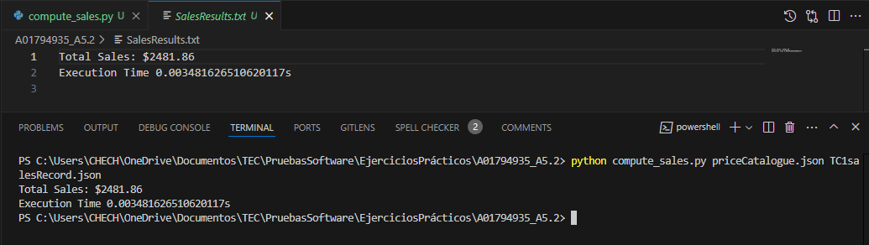

* Pylint

It was necessary to change the file name because don’t compliance with the snake_case naming style.

Due that I remember the previous suggestions in the last activity, I prevent lint issues.

* Flake8

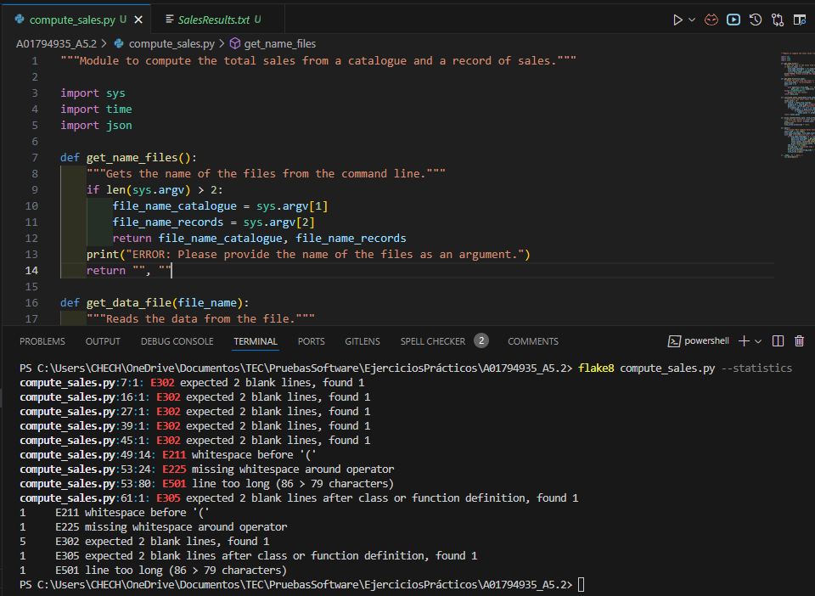

Check and fix the Flake8 issues, and corroborate that function is executing correctly.

