**Actividad 4.**

**Documentación de Ejercicios**

# A01794935 - Sergio Enrique Pulido Morales

El presente trabajo ha sido realizado cumpliendo las políticas del curso y con los criterios de evaluación de la actividad. Asimismo, establezco que el contenido de este trabajo ha sido documentado en fuentes bibliográficas autorizadas, por tanto, la información redactada no ha sido plagiada de otro documento o trabajo ajeno ni de cualquier otra fuente de carácter confidencial.

**Pruebas de Software y Aseguramiento de la Calidad** | Fecha: 30/01/2025

Ejercicio #1: Compute statistics

Req1. The program shall be invoked from a command line. The program shall receive a file as parameter. The file will contain a list of items (presumable numbers).

Req 2. The program shall compute all descriptive statistics from a file containing numbers. The results shall be print on a screen and on a file named StatisticsResults.txt. All computation MUST be calculated using the basic algorithms, not functions or libraries. The descriptive statistics are mean, median, mode, standard deviation, and variance.

Req 3. The program shall include the mechanism to handle invalid data in the file. Errors should be displayed in the console and the execution must continue.

Req 4. The name of the program shall be computeStatistics.py

Req 5. The minimum format to invoke the program shall be as follows: python computeStatistics.py fileWithData.txt

Req 6. The program shall manage files having from hundreds of items to thousands of items.

Req 7. The program should include at the end of the execution the time elapsed for the execution and calculus of the data. This number shall be included in the results file and on the screen.

Req 8. Be compliant with PEP8

* Resultados

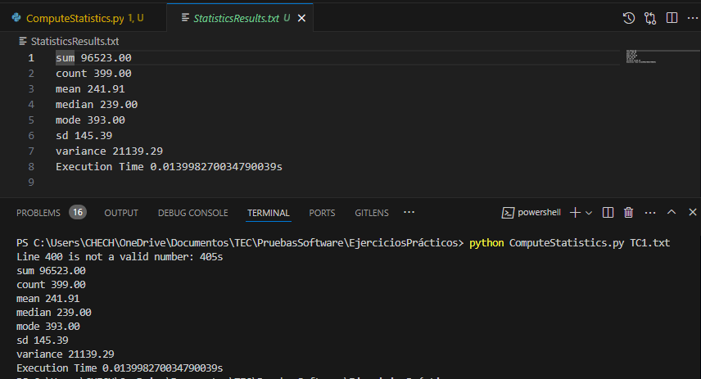

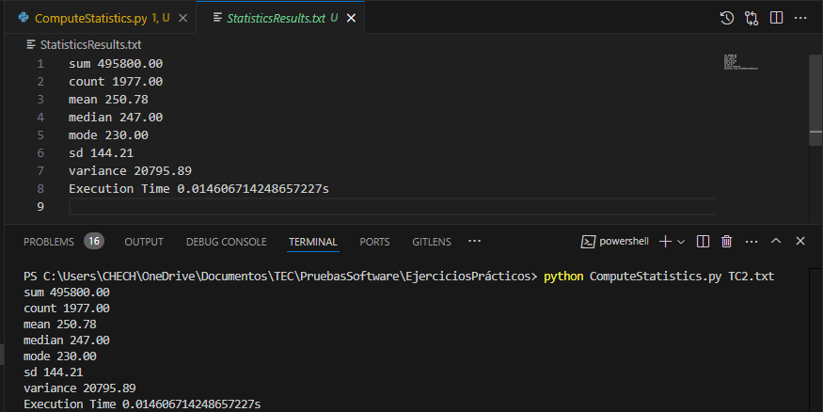

Ejercicio #2: Converter

Req1. The program shall be invoked from a command line. The program shall receive a file as parameter. The file will contain a list of items (presumable numbers).

Req 2. The program shall convert the numbers to binary and hexadecimal base. The results shall be print on a screen and on a file named ConvertionResults.txt. All computation MUST be calculated using the basic algorithms, not functions or libraries.

Req 3. The program shall include the mechanism to handle invalid data in the file. Errors should be displayed in the console and the execution must continue.

Req 4. The name of the program shall be convertNumbers.py

Req 5. The minimum format to invoke the program shall be as follows: python convertNumbers.py fileWithData.txt

Req 6. The program shall manage files having from hundreds of items to thousands of items.

Req 7. The program should include at the end of the execution the time elapsed for the execution and calculus of the data. This number shall be included in the results file and on the

screen.

Req 8. Be compliant with PEP8.

* Resultados

Ejercicio #3: Count Words

Req1. The program shall be invoked from a command line. The program shall receive a file as parameter. The file will contain a words (presumable between spaces).

Req 2. The program shall identify all distinct words and the frequency of them (how many times the word “X” appears in the file). The results shall be print on a screen and on a file named WordCountResults.txt. All computation MUST be calculated using the basic algorithms, not functions or libraries.

Req 3. The program shall include the mechanism to handle invalid data in the file. Errors should be displayed in the console and the execution must continue.

Req 4. The name of the program shall be wordCount.py

Req 5. The minimum format to invoke the program shall be as follows: python wordCount.py fileWithData.txt

Req 6. The program shall manage files having from hundreds of items to thousands of items.

Req 7. The program should include at the end of the execution the time elapsed for the execution and calculus of the data. This number shall be included in the results file and on the screen.

Req 8. Be compliant with PEP8

* Resultados