**COEN 241: Home-Work 2**

**Name: Juhi Checker**

**SCU ID: 1605378**

**Q1. Provide a screenshot of invoking the figlet function**

1. Below is a screenshot of invoking the figlet function using the faas-cli invoke command. Before invoking the command the figlet function needs to be deployed using faas-cli store deploy function.

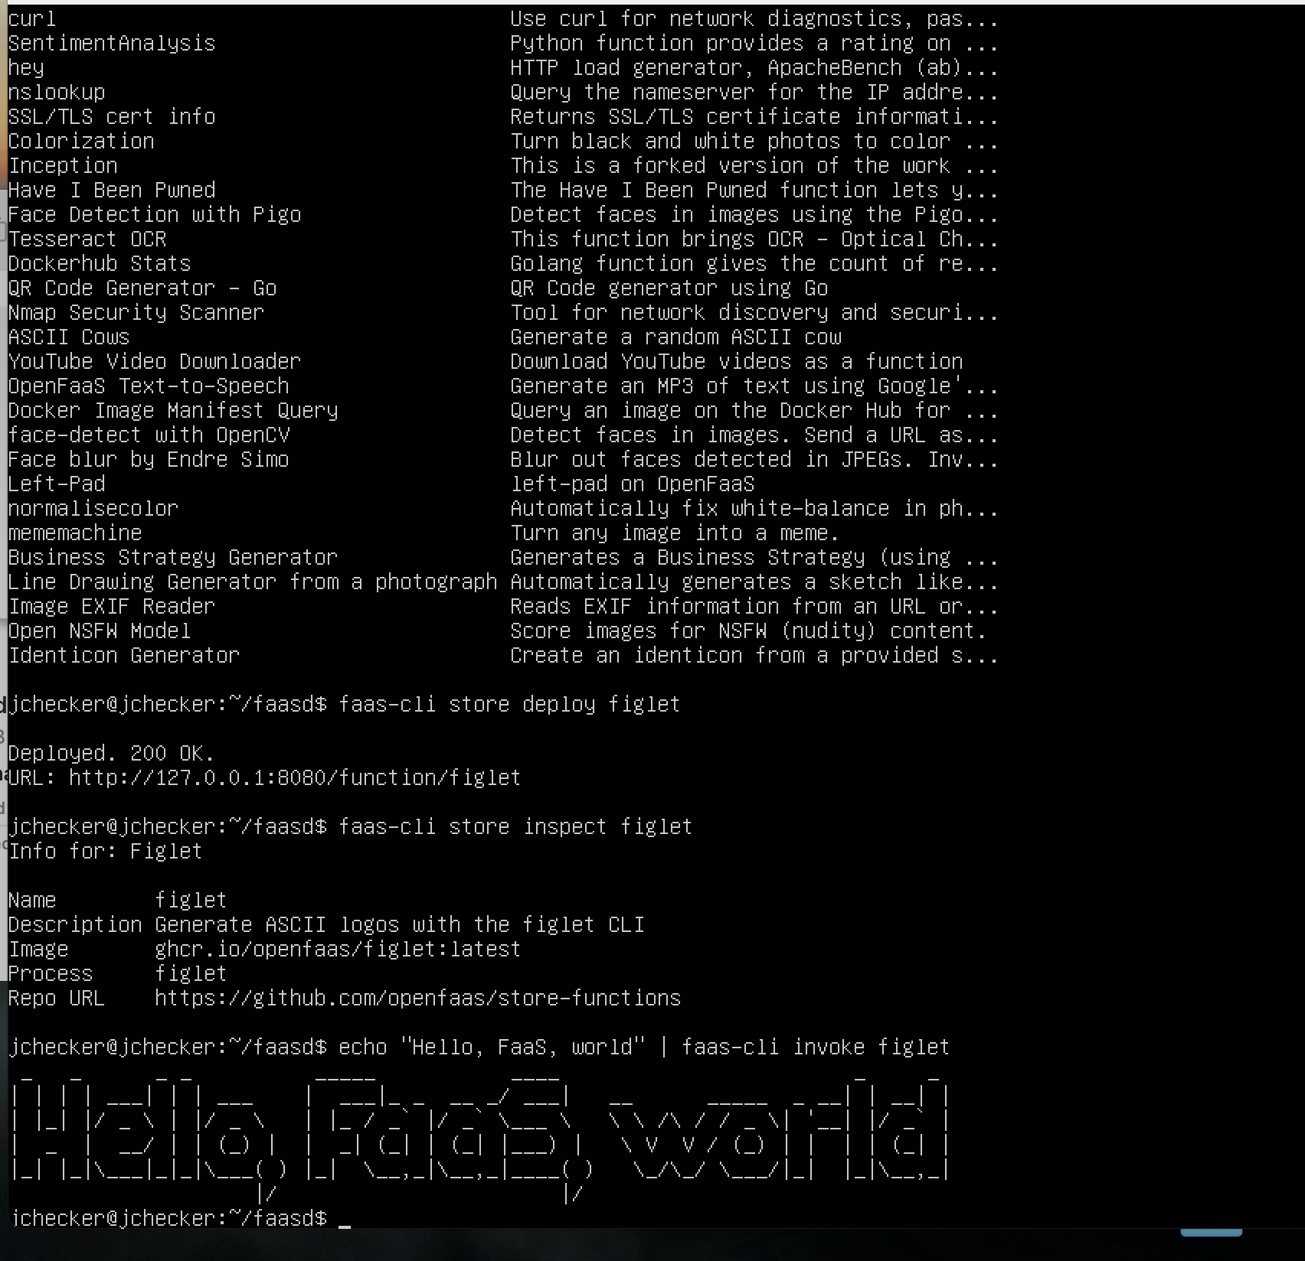

**Q2 & Q3. Complete slack-request/handler.py and slack-interactive/handler.py.**

1. Please find the changed code in the Github repository.

Github repository: <https://github.com/checkerjuhi21/CloudComputing/tree/main/HW2>

**Q4. Provide a screenshot of running the following command**

**sudo journalctl -u faasd –lines 40**



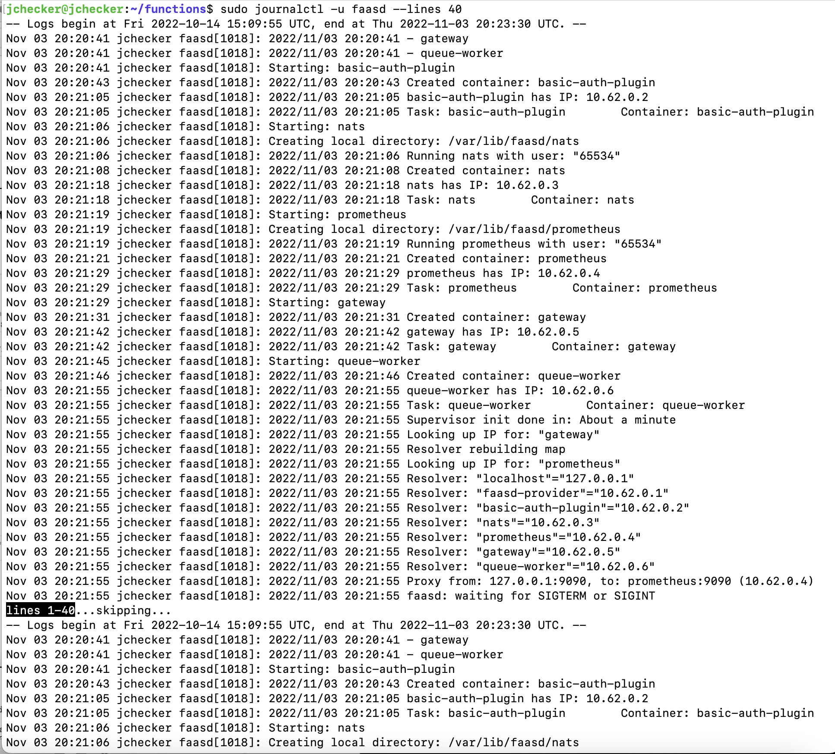

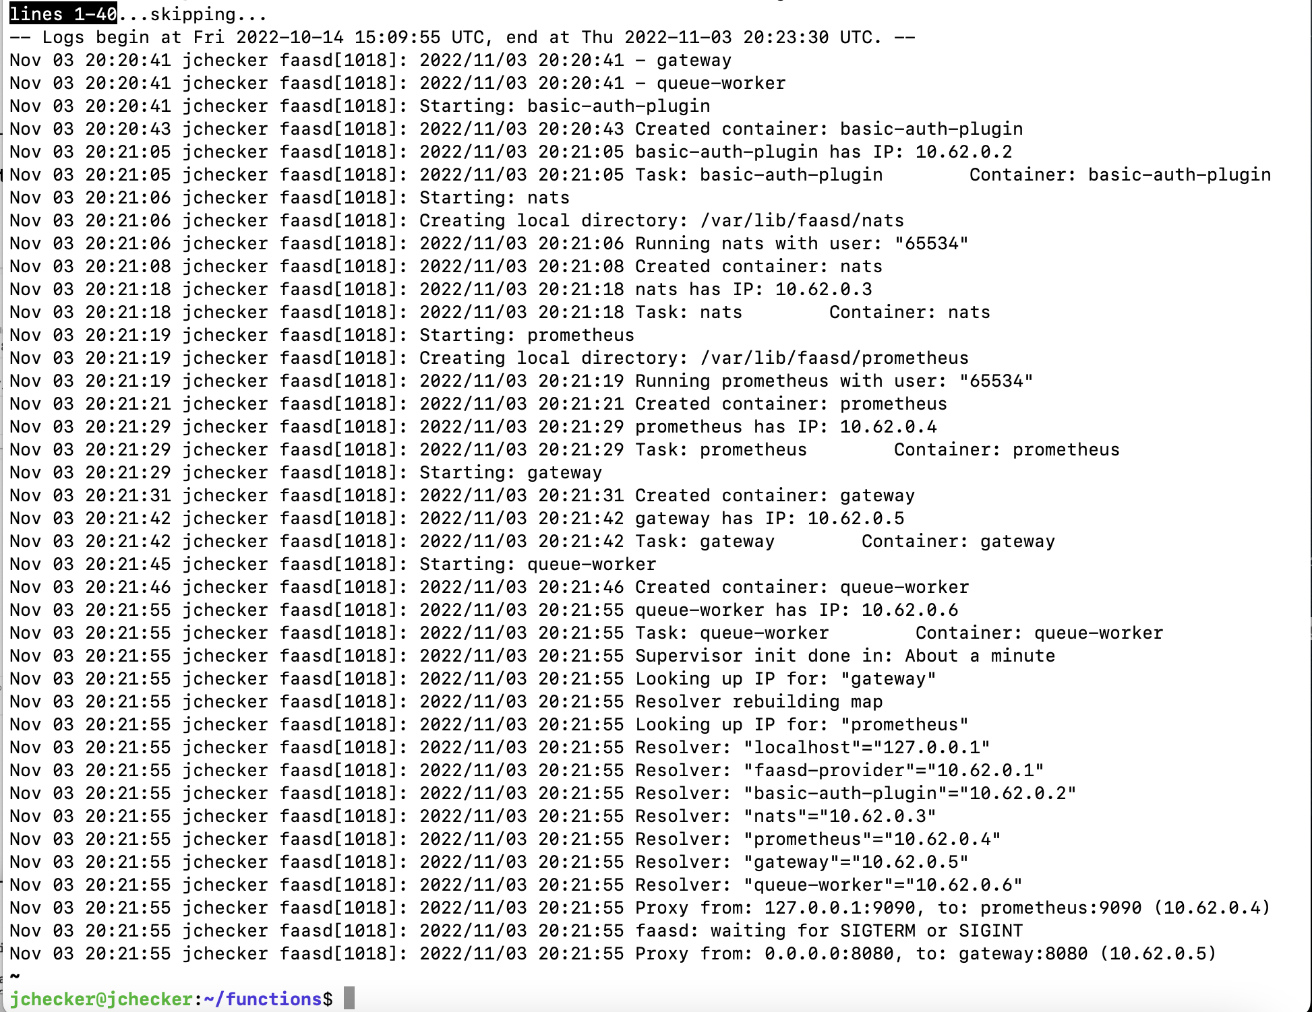

**Q5. Provide a screenshot of your OpenFaaS gateway AFTER deploying figlet, slack-handler  
and slack-interactive functions**

1. Deploying the figlet, slack-react and slack-interactive function

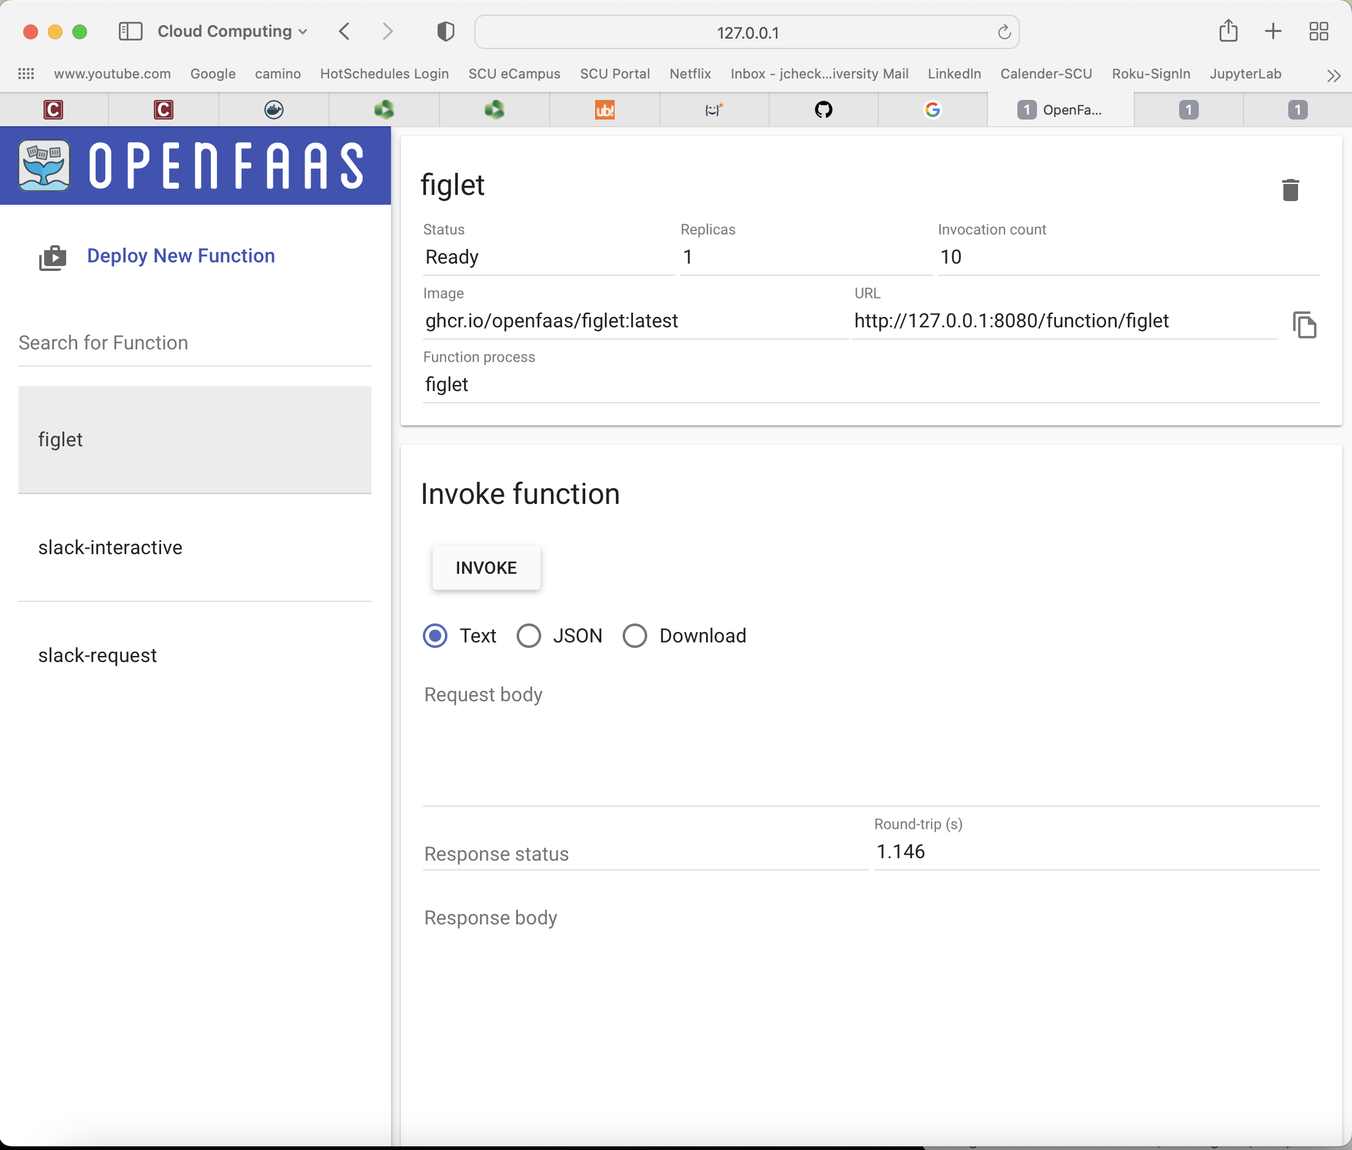

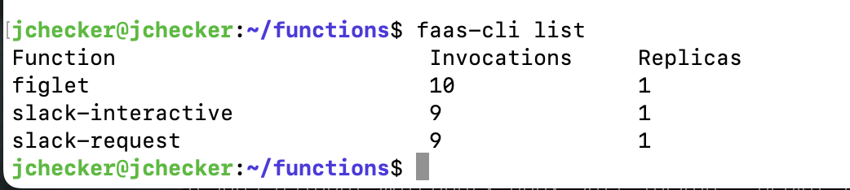

**Q6. Provide a screenshot of invoking slack-request and slack-interactive functions**

1. OpenFaaS gateway after invoking slack-react handler

On local host:

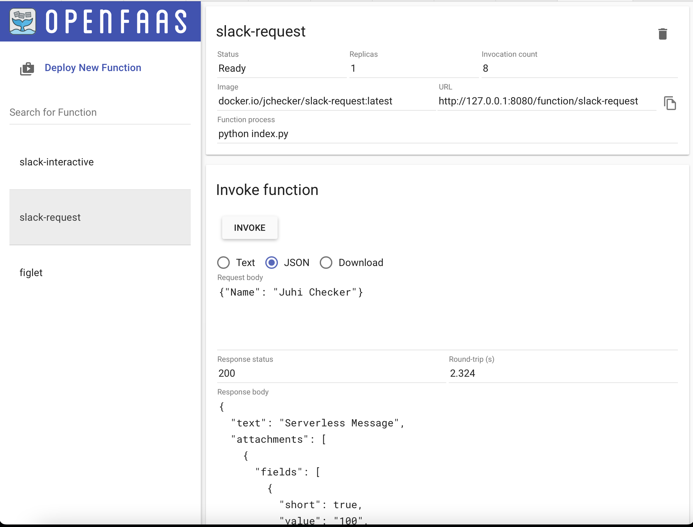

On terminal using curl:

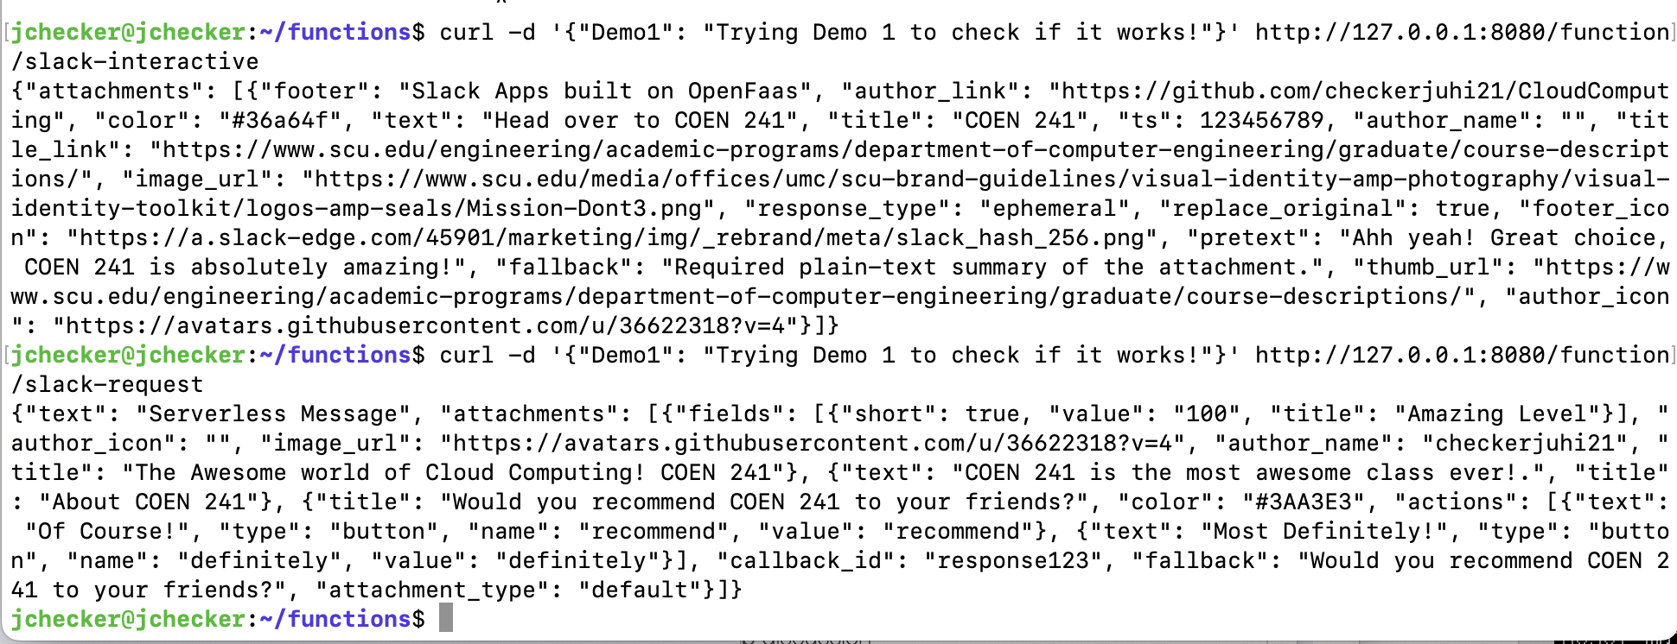

On terminal using invoke:

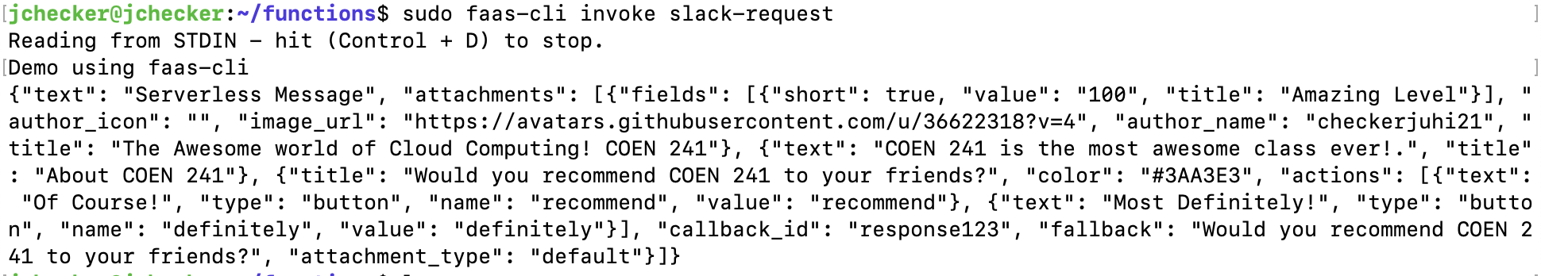

OpenFaaS gateway after invoking slack-interactive

On local host:

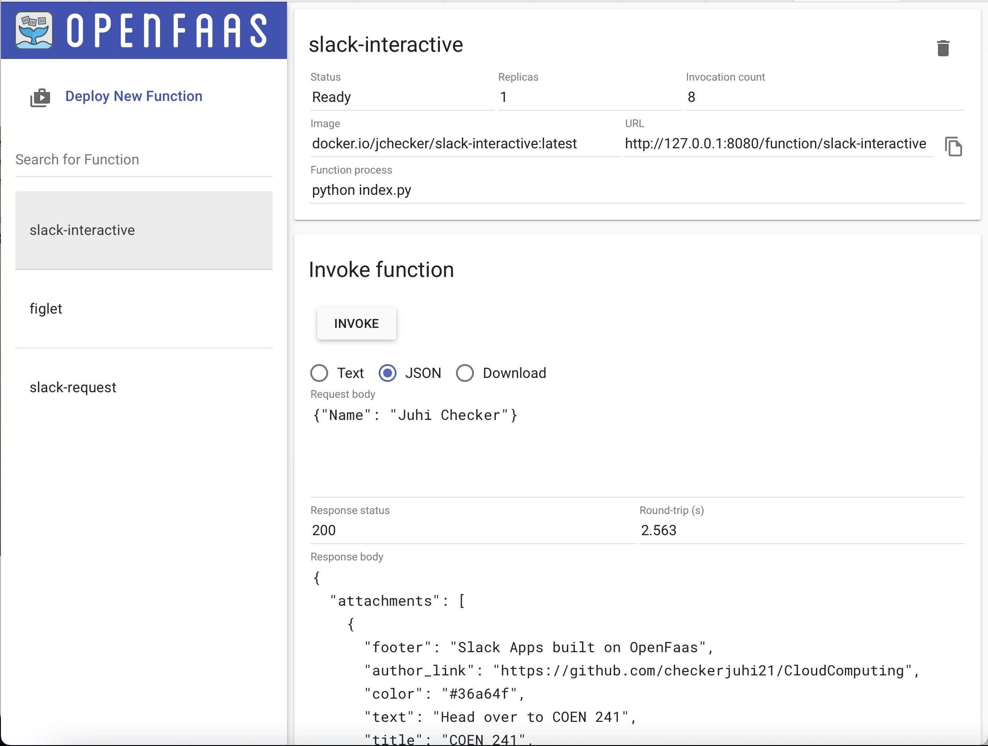

On terminal using curl:



On terminal using invoke:

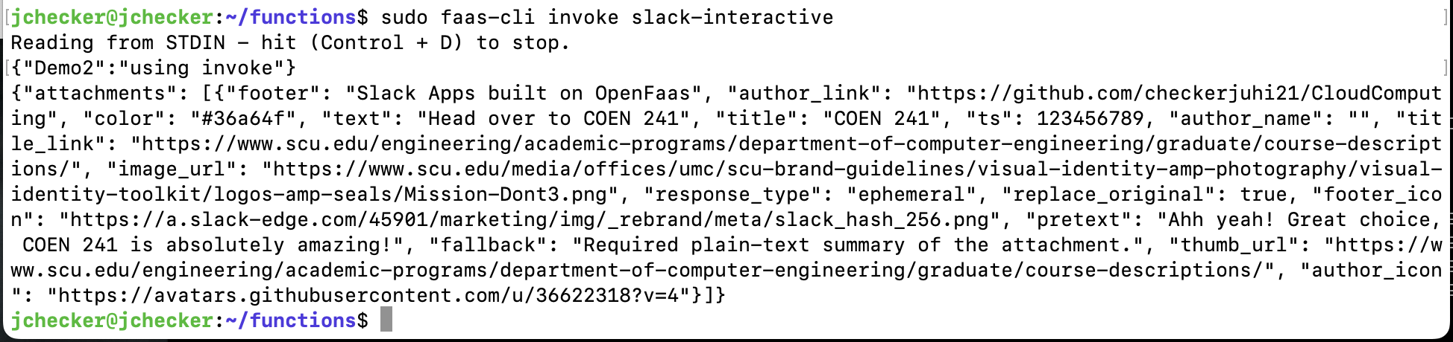

**Q7. What is the command to invoke the slack-request function**

Via Curl

curl -d '{"Demo1": "Trying Demo 1 to check if it works!"}' <http://127.0.0.1:8080/function/slack-request>

Via faas-cli

sudo faas-cli invoke slack-request

**Q8. What is the output you see when you invoke the slack-request function?**

Via curl



Via faas-cli



**Q9. What is the command to invoke the slack-interactive function?**

A.

Via curl

curl -d '{"Demo1": "Trying Demo 1 to check if it works!"}' <http://127.0.0.1:8080/function/slack-interactive>

Via faas-cli

sudo faas-cli invoke slack-interactive

**Q10. What is the output you see when you invoke the slack-interactive function?**

Via curl:



Via faas-cli:



**Q11. How would you pass different arguments to the functions?**

1. There are 4 methods to pass arguments:
2. Via OpenFaaS UI: You can go to the UI, click on the function you want to call. Pass the arguments below the invoke button and click invoke. The function then runs and generates the output.
3. Via curl: You can pass your input using the curl command as shown above.
4. Via faas-cli invoke: when you use this command, the function asks for input from the user and then you write your input and press CNT+D on keyboard to execute.
5. Via echo: You can use echo command like done in figlet to pass arguments to the function.

**Q12. How would you change the slack-interactive function to react to different inputs?**

1. urllib is a package in which the unquote function is defined in handler.py (slack-interactive function). It is used to decode any string into a URL. The default encoding is UTF-8. After that, we utilize the json.load() method to transform a valid JSON string, such as urlstring, into a Python dictionary. This information is saved in the response. After storing it in response, we can see that we aren't using it anywhere. We may change the slack-interactive function to react to different inputs using the answer in our application. Because Response is also a Python dictionary, it can be used within the data. As a result, when we use json.dumps(data), the function will start responding to various inputs.