**COEN 241: Homework 3**

**Name: Juhi Checker**

**SCU ID: 1605378**

**Task 1**

1. What is the output of “nodes” and “net”

Ans. Output of nodes and net

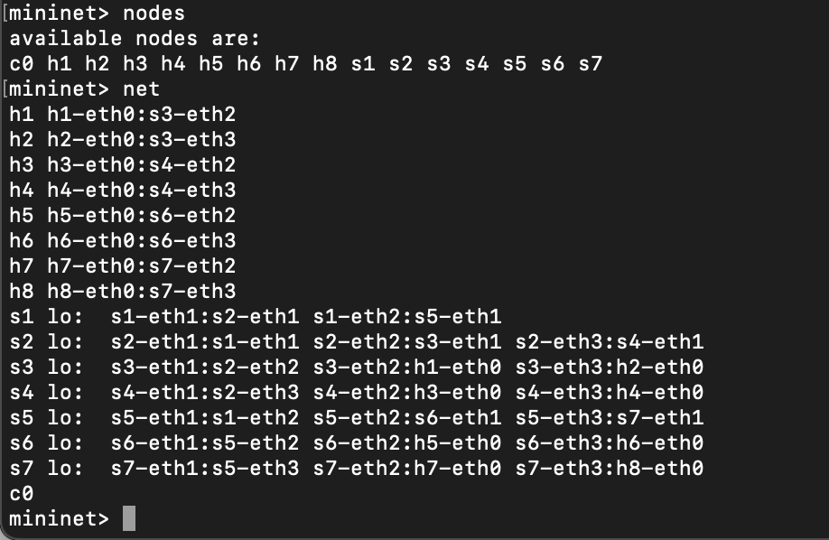

1. What is the output of “h7 ifconfig”

Ans. 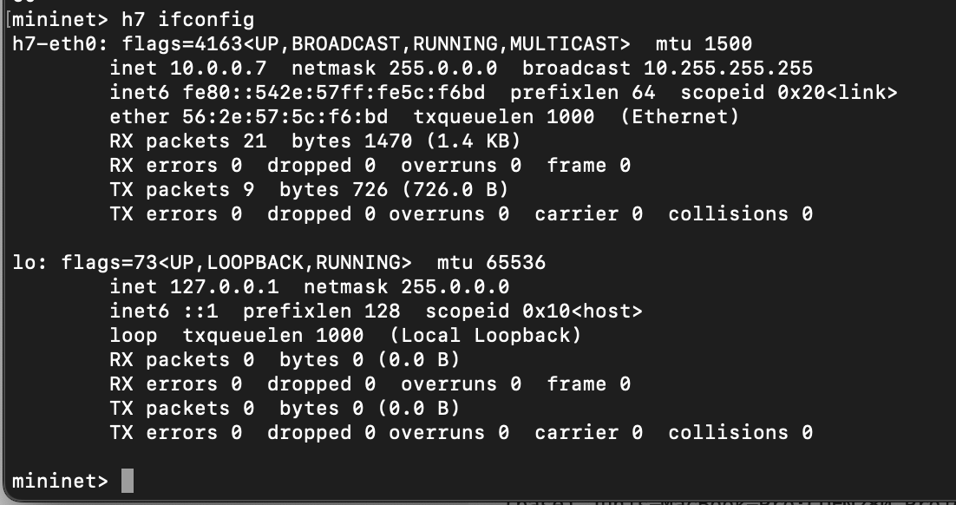

**Task 2**

1. Draw the function call graph of this controller. For example, once a packet comes to the controller, which function is the first to be called, which one is the second, and so forth?

Ans. When the of_tutorial.py file runs the following steps happen:

1. Launch() function is called and start_switch() component executes.
2. Start_switch() component calls Tutorial class and connection sets ups.
3. By doing addListernerByName() calls Tutorials’ _handle_PacketIn() function
4. The _handle_PacketIn() function calls the act_like_hub or act_like_switch function is executed
5. The above function after performing the steps inside the function calls resend_packet function
6. The resend_packet function forwards/sends the message to the mentioned port

1. Have h1 ping h2, and h1 ping h8 for 100 times (e.g., h1 ping -c100 p2).

a. How long does it take (on average) to ping for each case?

b. What is the minimum and maximum ping you have observed?

c. What is the difference, and why?

Ans.

h1 ping -c 100 h2

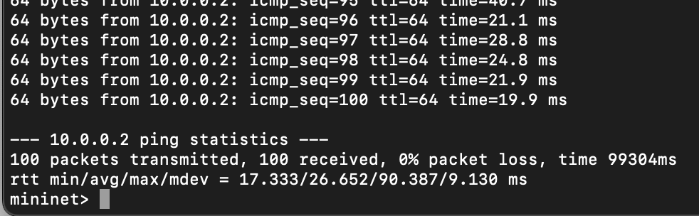

h1 ping -c 100 h8

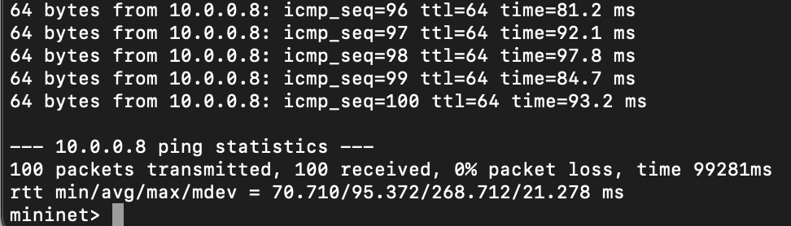

1. Average for h1 ping h2 = 26.652 ms

Average for h1 ping h8 = 95.372 ms

1. Minimum value for h1 ping h2 = 17.333 ms

Minimum value for h1 ping h8 = 70.710 ms

Maximum value for h1 ping h2 = 90.387 ms

Maximum value for h1 ping h8 = 268.712 ms

1. It can be observed that average, minimum and maximum value for h1 ping h2 is lesser than h1 ping h8. This can be because for h1 has to only traverse through one switch which is s3 to reach the destination. Whereas, in second case where h1 pings h8, h1 has to traverse through s3, s2, s1, s5 and s7 to reach to h8.
2. Run “iperf h1 h2” and “iperf h1 h8”  
   a. What is “iperf” used for?  
   b. What is the throughput for each case?  
   c. What is the difference, and explain the reasons for the difference.

Ans.

Running iperf h1 h2

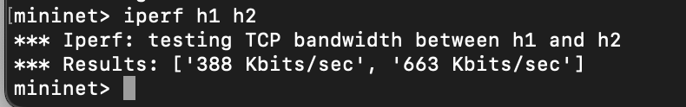

Running iperf h1 h8

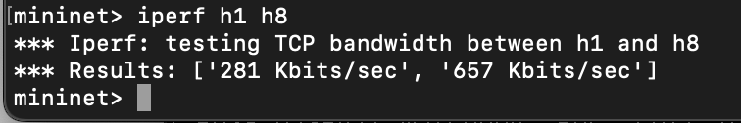

* 1. Iperf command is used for testing the TCP bandwidth between two hosts for network performance and quality of network.
  2. Throughput for iperf h1 h2 = 388 Kbits/sec and 663 Kbits/sec

Throughput for iperf h1 h8 = 281 Kbits/sec and 657 Kbits/sec

* 1. It is observed that throughput is higher in both case in iperf h1 h2 than iperf h1 h8. This can be because since h1 has to traverse through only one switch to get to h2 and so the data can be passed at a higher rate. Whereas, it was seen in the previous task that from h1 to h8 we have to traverse through 5 switches which makes the data transmission a bit slower.

1. Which of the switches observe traffic? Please describe your way for observing such

traffic on switches (e.g., adding some functions in the “of_tutorial” controller).

Ans. In order to observe the traffic on switches I add print statement in _handle_PacketIn() function of of_tutorial.py. On running the code again, it was observed that each switch sees the traffic following because every time someone wants to send a packet _handle_PacketIn function is called.

**Task 3**

1. Describe how the above code works, such as how the "MAC to Port" map is established. You could use a ‘ping’ example to describe the establishment process (e.g., h1 ping h2).

Ans. The new function act_like_switch when packets arrive the function maps the MAC addresses. Due to the mapping during the next ping the controller sends the packets to the know (mapped) addresses. Whereas, if the address is not mapped then it will send packets to all the destinations and learn it. Essentially, controller maps the MAC address to a port if MAC address is the one the sender wants to send the packet to. This process makes sending packets faster therefore increasing the throughput.

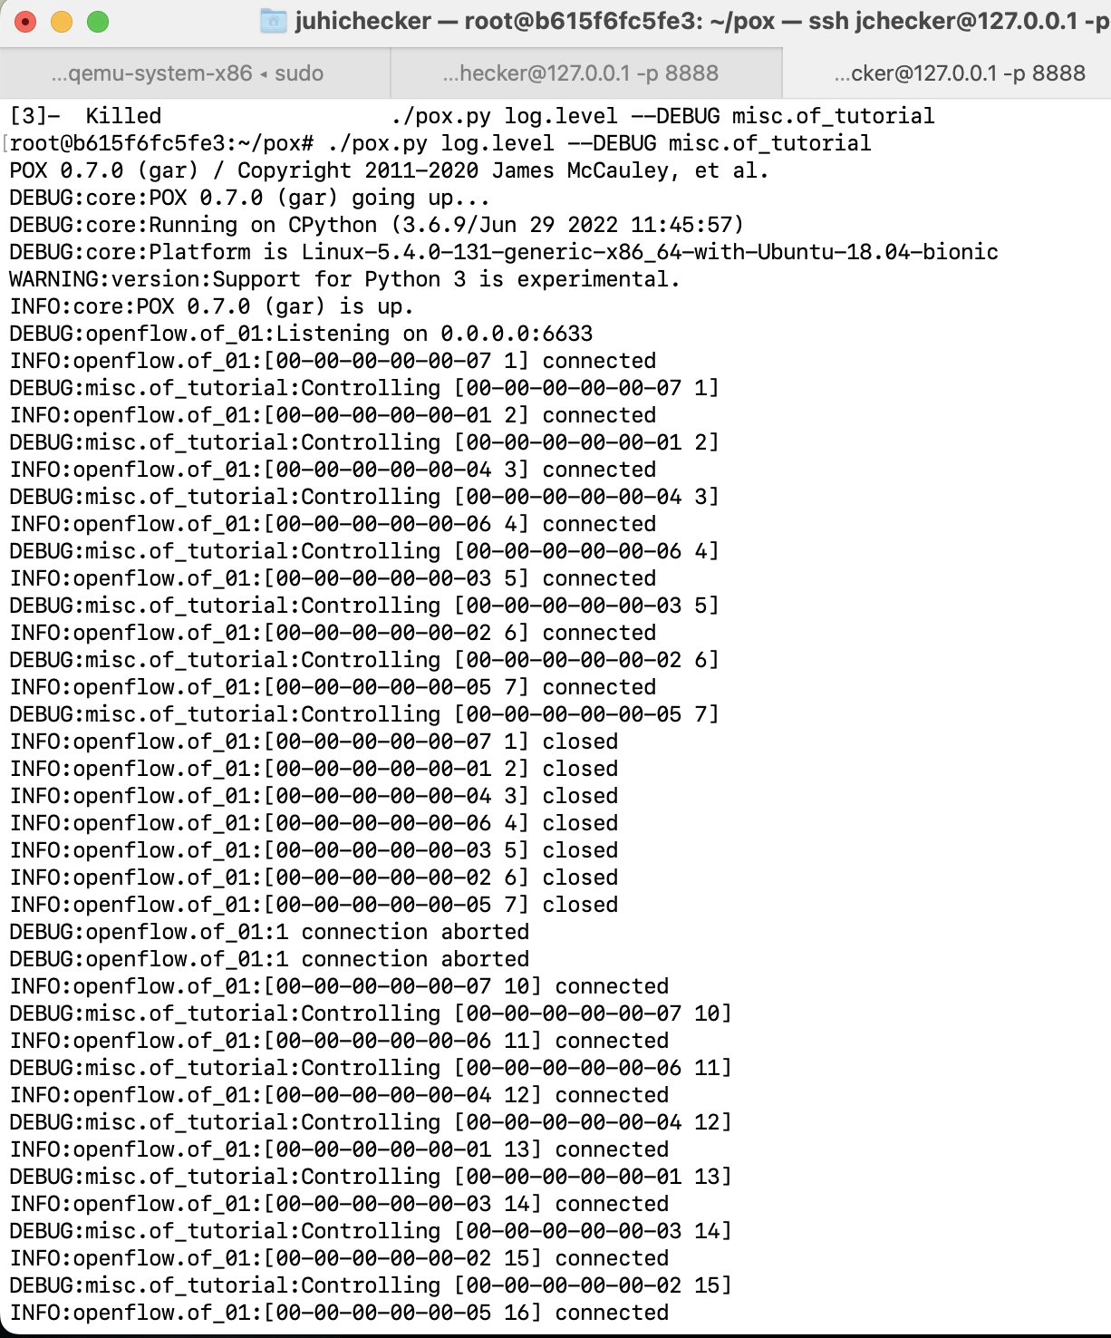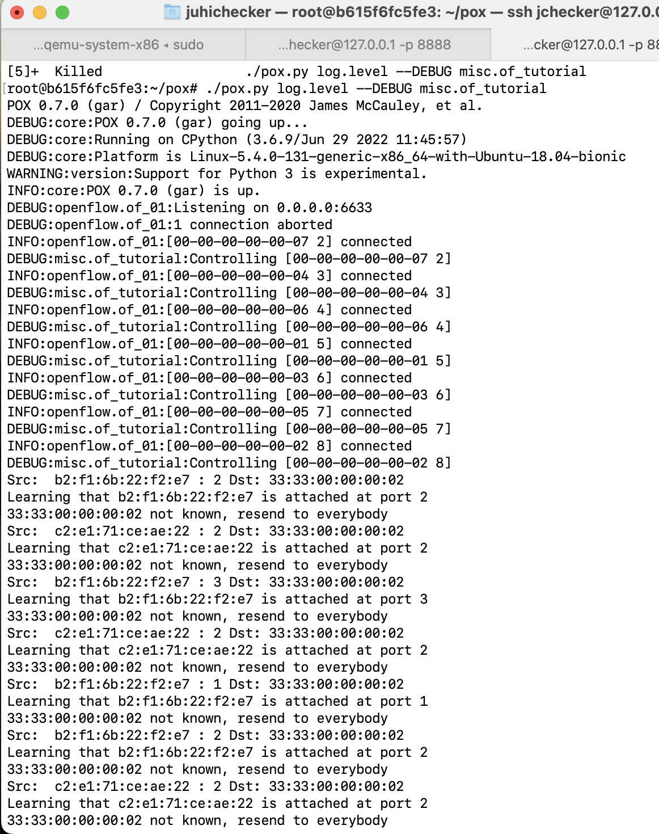

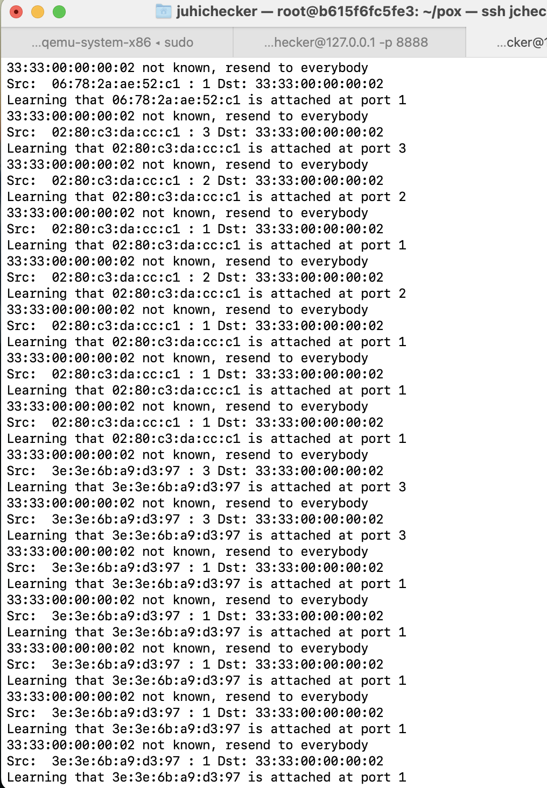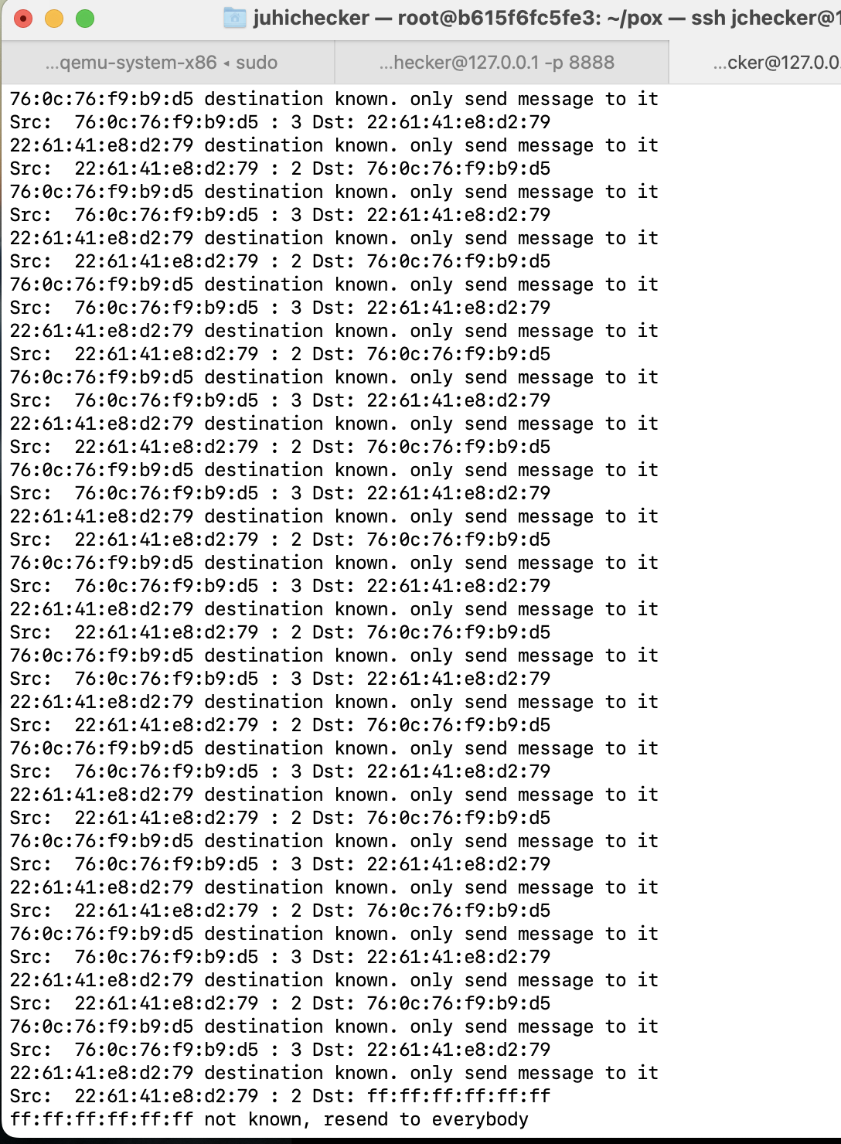

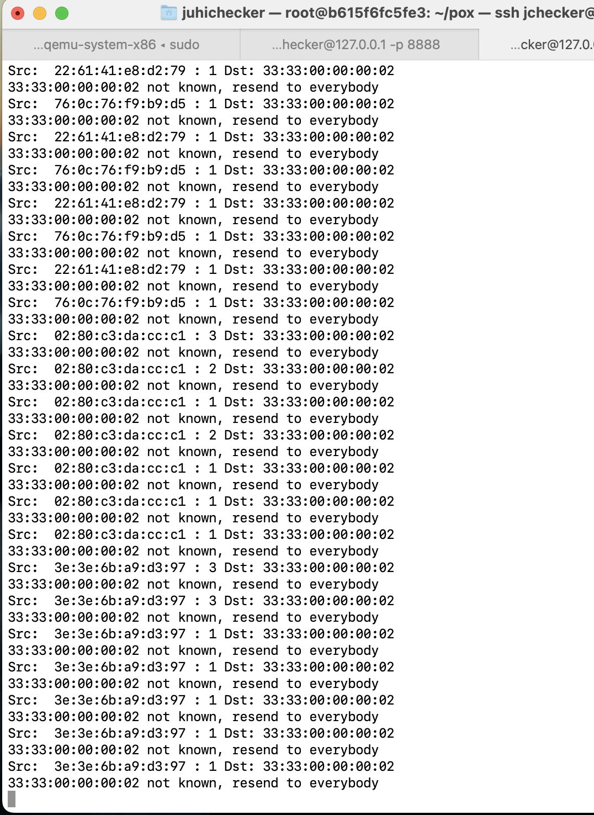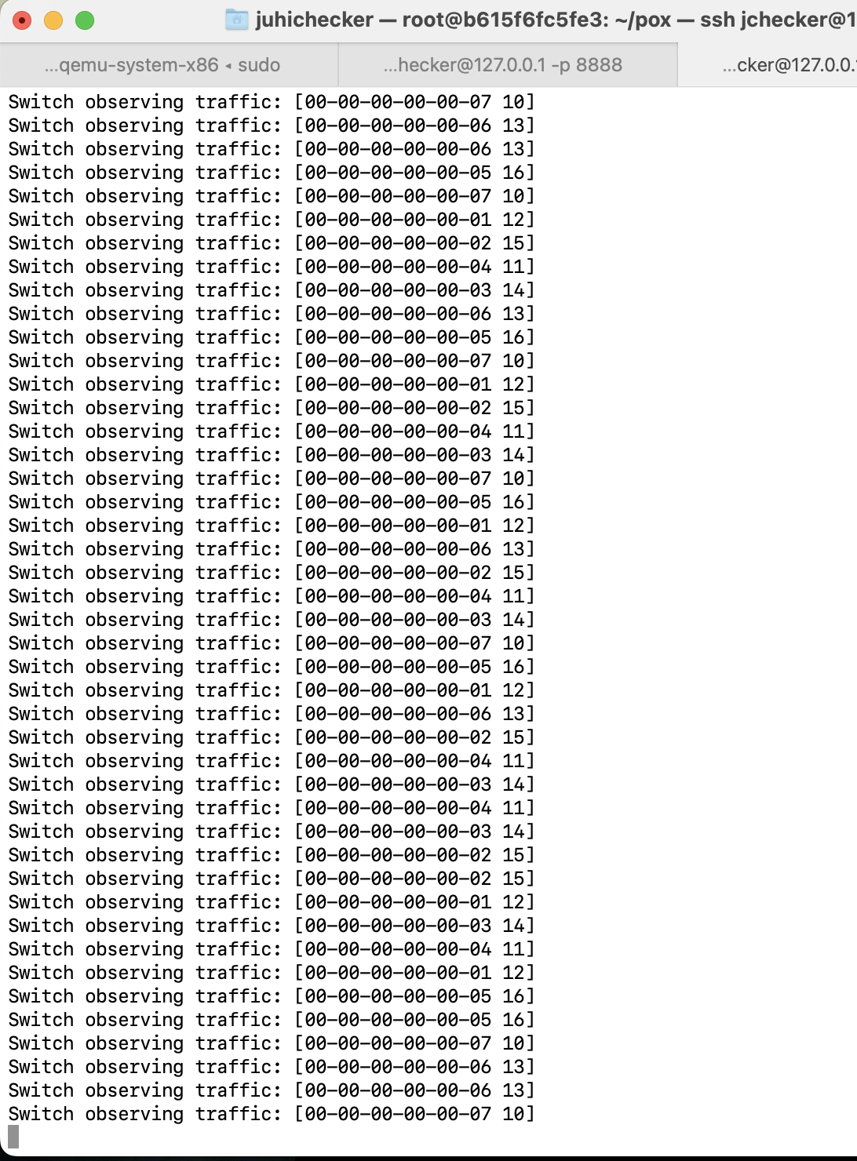

1. Have h1 ping h2, and h1 ping h8 for 100 times (e.g., h1 ping -c100 p2).

a. How long did it take (on average) to ping for each case?

b. What is the minimum and maximum ping you have observed?

c. Any difference from Task 2 and why do you think there is a change if there is?

Ans.

h1 ping -c100 h2

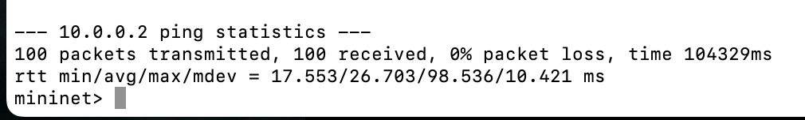

h1 ping -c100 h8

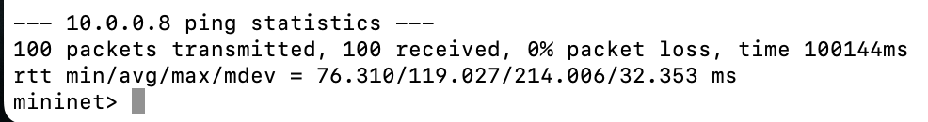

1. Average for h1 ping h2 = 26.703 ms

Average for h1 ping h8 = 119.027 ms

1. Minimum value for h1 ping h2 = 17.533 ms

Minimum value for h1 ping h8 = 76.310 ms

Maximum value for h1 ping h2 = 98.536 ms

Maximum value for h1 ping h8 = 214.006 ms

1. It can be observed that average, minimum and maximum value for h1 ping h2 is lesser than h1 ping h8. In terms of h1 ping h2 in Task 2 is almost same and slightly higher than Task 3. In h1 ping h3, the maximum value is significantly lower than in Task 3 than Task 2 and this is because in Task 3, it sends the packets first time and it saves the mac address. In all the later packets it directly maps mac address to port using mac_to_port and so it is faster.
2. Run “iperf h1 h2” and “iperf h1 h8”.  
   a. What is the throughput for each case?  
   b. What is the difference from Task 2 and why do you think there is a change if  
   there is?

Ans.

* 1. Throughput in each of the following cases: Iperf h1 h2 and iperf h1 h8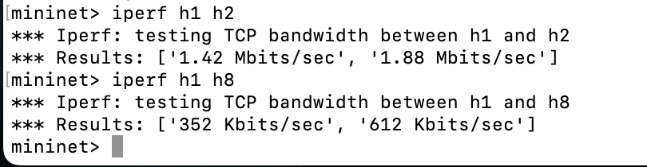
  2. The throughput in Task 3 for second case is more than Task 2 and this can be because once mac_to_port learns all the ports then it becomes faster to transmit the packets to the destination. This also causes less traffic on the network. It was also expected that in the first case Task 3 would perform better than Task 2 for the above mentioned reasons.