Site Purpose

**The Mountain Spoke**is a retail store and shop located in Bozeman, Montana specializing in bicycles, bicycle parts, bicycle repair, and tours. The owner-operated company caters to bicycle enthusiasts in that region. In addition, the company also sponsors and organizes tours in the area to serious bicyclists from around the world. The goal is to provide a fresh new website experience for their clients and potential clients that reflects their culture of bicycle enthusiasm with products, repair service, parts, and tour trips.

Target Audience

This site is mainly for the bicycle enthusiasts that are local to the Bozeman, Montana area. We are targeting all the needs for a local bicycle rider. This will cover the biking enthusiast and also the casual rider. Our main focus is the bicycling enthusiast and trying to convert the casual rider into an enthusiast. We are going to sell bikes, parts and also offer service repair. We will focus some of our efforts in visiting tourists but our main focus will be on local customers.

Site Map

* The header will contain the logo, title and a navigation that can guide the user through the following pages:
  + The home page is a contemporary, exciting landing page providing images of mountain biking and related activities, including a call to action and readily available navigation and contact information.
  + The adventure tours page describes the details for bicycle adventures that the company supports daily with guides throughout the season. This will include information about the length, skill level required, cost, and location of the tours.
  + The event page highlights the "Cycle the Continental Divide" annual event with information about the dates, route, costs, and basic requirements. This will include a registration form on the page that collects information including the registrant's full name, email, phone, date of birth, home state or country, and special accommodations/comments.
  + A sales page displaying bicycle models of different makes and some basic specifications.
  + A service page listing the repair services offered by the company.
  + A contact page will contain contact information including a showing a Google map of the company address at 3950 Valley Commons Drive Bozeman, MT and a contact us form.

Color Scheme

The colors I want to choose will be the natural colors and the soft and neutral browns and greens with a variation of the tones and to better blend with the pictures of the bicycle and nature shots that will be shown in the pages and tours. The main body will be colored a light brown and I will use a darker green as a highlight to different aspects of the page.

Typography

The font for The Mountain Spoke header is going to be in Rock Salt

<link href="https://fonts.googleapis.com/css?family=**Rock+Salt|Spinnaker**" rel="stylesheet">

1. font-family: 'Rock Salt', cursive;

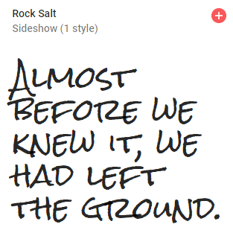

The font for the main body will be Spinnaker

1. Spinnaker font-family: 'Spinnaker', sans-serif;

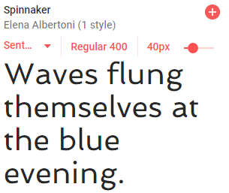

Wire-Frame Sketches

SMALL VIEW SKETCH

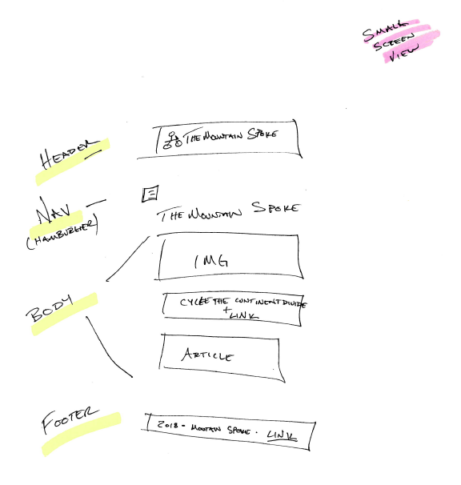

MEDIUEM VIEW SKETCH

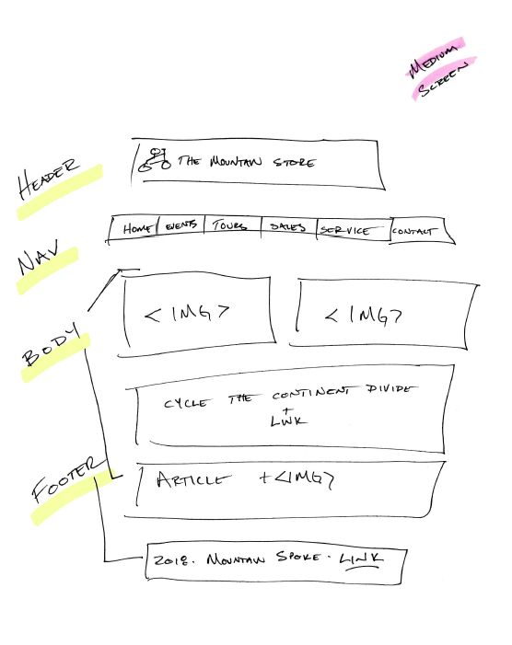

LARGE VIEW SKETCH

