Site Purpose

To provide

Target Audience

For

Site Map

The

Color Scheme

The

Typography

The

Wire-Frame Sketches

SMALL VIEW SKETCH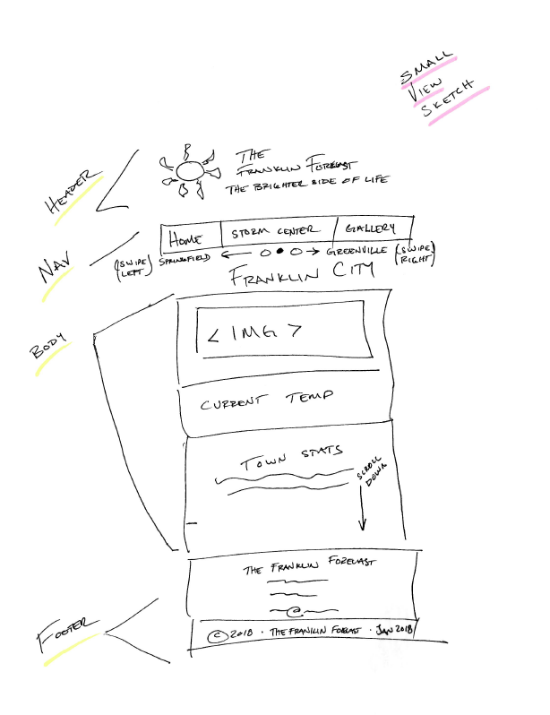

MEDIUEM VIEW SKETCH

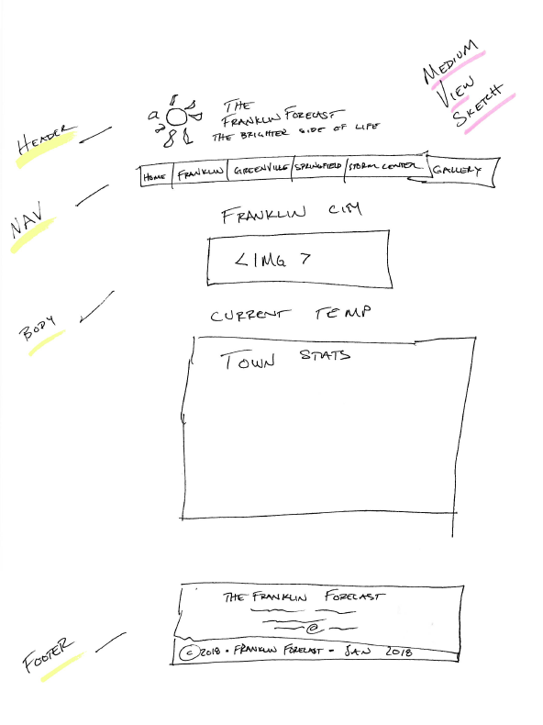

LARGE VIEW SKETCH

