Climate change impacts on forests and the livelihoods of tribal people of northeast India

Dr. Kiranmay Sarma¹ and Dr. Kamaleswar Kalita²

1: University School of Environment Management, GGS Indraprastha University,
New Delhi-110078
2: Department of Geography, Tinsukia College
Tinsukia-786125, Assam
Corresponding author:kamaleshkalita@rediffmail.com

Abstract
The degradation of forest lands has severe impacts on the environment and livelihoods of the people including health and socio-economic condition. One of the main drivers of forest degradation is slash-and-burn agriculture, practiced traditionally in the hills of tropics, accounts 60 percent global forest loss every year. In northeast India this method of agriculture is practiced extensively and about 0.45 million families are involved in this activity. The forest area covered annually by this cultivation is about 10,000 km². At present in northeast the estimated land under shifting cultivation or jhum, which is locally known, is estimated to be 44,000 km². Loss of forests due to shifting cultivation has caused many problems ranging from flooding to aridity and for catastrophic losses to water quality. Besides, burnt practices of biomass release GHG (greenhouse gases) and this could play significant role for climate vulnerability in the region like northeast. Climate vulnerability significantly affects the traditional matriarchal society in many parts of tribal areas, socio-economic and ecological conditions, health and the livelihoods. In all these aspects women are the most sufferers and vulnerable. The increasing numbers of flash floods in this region destroy the standing crops, and damaging the down slope areas with the debris carried by the flood water. This becomes a regular event during the rainy seasons. The rich customs and traditions of the tribal people help to develop some innovative strategies using locally available resources to overcome this type of unwanted situations.

Key words: climate change, vulnerability, shifting cultivation, socio-ecological stress, tropical deforestation

Introduction
Forest deforestation in the tropical areas plays important role in global climatic change (Barbier and Burgess, 2001). The rapid deforestations have contributed immensely in the global economy and these lead to rise in global temperature (Yadav and Sarma, 2013).Though global forest loss occurred for centuries but the rapid rate of tropical deforestation has become international concern only during the last few decades. Tropical forests, the home of over half of the global biodiversity stock, are vital in influencing the regional climate and are being destroyed at an alarming rate due to various anthropogenic activities (Laurence et al., 2001).Climate change refers to any change in climate over a longer period of time, whether due to natural variability or as a result of human activities. Deforestation caused by the burning of biomass increases atmospheric carbon-dioxide and other trace gases and it accounts for 10 to 25 percent of overall greenhouse gas emissions (Fearniside, 1993). The demographic pressure and agriculture expansion in the tropical countries cause for large - scale deforestation and is a major source of carbon emission from terrestrial ecosystems (Yadav et al., 2013; Allen and Barnes, 1985). The estimatedglobal annual carbon emissions from this tropical land use change range from 0.4 to 2.6 Pg (Houghton, 1995). Tropical degradation contributes about 17 percent of global greenhouse gas emissions which is considered to be the second largest source (FAO, UNDP, UNEP, 2008). It is estimated that about half of the deforestation in the tropics is the result of expansion of traditional agricultures, and slush-and-burn or shifting cultivation contributes the largest portion of it (Shimrah et al., 2019; Kumar et al., 2008; Geist et al., 2001). The other contributing factors for tropical deforestation that have rendered the forests vulnerable to fire are forest fragmentations due to logging, grazing and collection of non-timber forest products (Narendran et al., 2008). These forest fires have reflective impacts on the human health and socio-economic system of the region as well as the physical environment including land use and land cover, climate change and forest ecosystem. The main occupation of the people of the hills of northeast India is predominantly agriculture. The very customary and traditional method used is shifting cultivation, locally known as jhum. In this slush-and-burn method of agriculture, huge stocks of bioresources are lost every year. As a consequence, there are physical, environmental, socio-economic and health impacts in these areas. This practice has been immensely contributing towards the climate change and global warming which have been mostly unnoticed or neglected for years. In this paper an attempt has been made how climate change has impact on the forests and livelihoods of the hill people of northeast India. In northeast India jhum is done in all the hill areas except Sikkim.

Methods and Materials
To carry out this research, relevant information and data were collected both from the secondary and primary sources. These include the literatures on urbanization, agriculture and forest resources by visiting different government departments, academic institutions and libraries. Published and unpublished data on land and forest resources were also collected from the journals, theses and technical reports. However, primary information on the climate change and its impact on the livelihoods were collected by using semi-structured questionnaire survey. The target groups for this survey were village heads, women self-help group members, jhum farmers, hunters and forest department officials. The representative states for this study were three Garo hills districts of West, South and East from Meghalaya. One districts each from Manipur i.e., Ukhrul and Kohima from Nagaland. The ground knowledge of the authors who have extensively worked in these areas for more than two decades help in finding the actual facts in the remaining parts of northeast. The data collected were compiled and analysed so to represent the real scenario. The maps are prepared in the GIS (Geographical Information System) environment.

Tropical deforestation through slash-and-burn agriculture
Shifting cultivation which is prominent in the hilly tropical regions of the world has immense impacts on the environment. The practice of shifting cultivation is reported to account for 60 percent global forest loss every year (Lele et al., 2008). One of the consequences is that the carbon initially held in forest is released to the atmosphere, either immediately when the trees are burned or more slowly through unburned organic matter decayed. This age-old slash-and-burn agriculture commonly known as jhum in northeast India is regarded as one of the traditional methods of cultivation. Shifting cultivation has a rich customary ecological knowledge base and remains an important livelihood for the tribal population living in the hills of the region. The clearing of vegetation by burning is a key aspect of shifting cultivation, there is no doubt that carbon dioxide and other greenhouse gases are emitted in the course of a cultivation cycle (Yadav, 2013).About 0.45 million families in northeast India annually cultivate about 10,000 km² of forest, whereas total area of northeast affected by jhum is estimated to be 44,000 km² (Singh, 1990). In the process of jhum cultivation forest vegetation is cut and burnt on site and the plot is cultivated for crops (Fig.-1). When final crop is harvested, the site becomes fallow and allowed the sites for natural regeneration. After few years these plots are again used for cultivation (DSWC, 2001;Toky and Ramakrishnan, 1981). Due to population pressure and demand on land for other developmental activities, the gap of years (jhum cycle) has reduced even to 2-3 years in many parts of northeast India which was 12-15 years in past decades (Sarma, 2010).

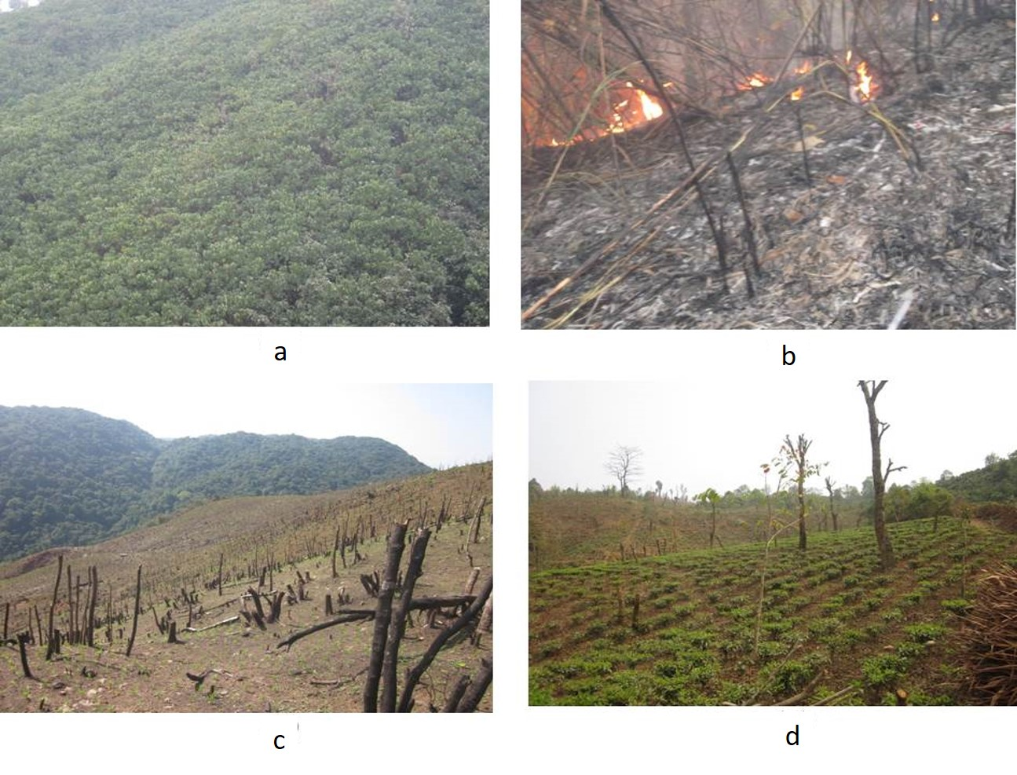
Fig. 1: (a) Dense forests (b) Garo hills of Meghalaya, northeast India are being burnt (c) to make the base for agriculture and in the process; it is converted into jhum land (d). With the increasing population and demand on land traditional cropping pattern has been converted into cash rich plantation crop.

Forests help immensely in maintaining a sustainable water supply of good quality for the people of the area as well as for the people living downstream. Forest ecosystems act as a sponge, soaking up and storing water when it is in abundant and releasing it during the dry period. Filtering of water is performed by vegetation and soil biota and its retention and storage depend on site characteristics (De Groot et al., 2002).Loss of forests has been caused for many problems ranging from flooding to aridity and for catastrophic losses to water quality. It has been reported that reduction in native forest cover causes substantial decrease in supply of drinking water (Sarma, 2014).The conservation of forest biodiversity, including restoration and rehabilitation, can be a key adaptation strategy to help vulnerable people cope with climate vulnerability (Dharmaji et al., 2005).

Impacts of tropical deforestation on the hills of northeast India
Forests and land characteristics of northeast India are heavily influenced by traditional shifting cultivation activities. The vegetation frees abandoned and current shifting cultivation areas are considered to be vulnerable to sheet erosion to the areas which are located downslope in a hilly region where intensity of rainfall is high. Different physical factors viz., slope, drainage density, soil characteristics, geology and land use/ land cover enhance the activity (Fig. 2). This is one of the main impacts of slush-and-burn agriculture which is solely practiced in the hills of northeast to be addressed seriously (Sarma et al., 2012). Again in the burnt practices of biomass during shifting cultivation there is release of GHG (greenhouse gas) and this could play significant role for climate vulnerability in the region like northeast which are considered as the biodiversity hotspot area (Crutzen and Andreae, 1990). Like other forms of agriculture, if slash-and-burn agriculture is not managed properly this could lead to severe environment degradation.

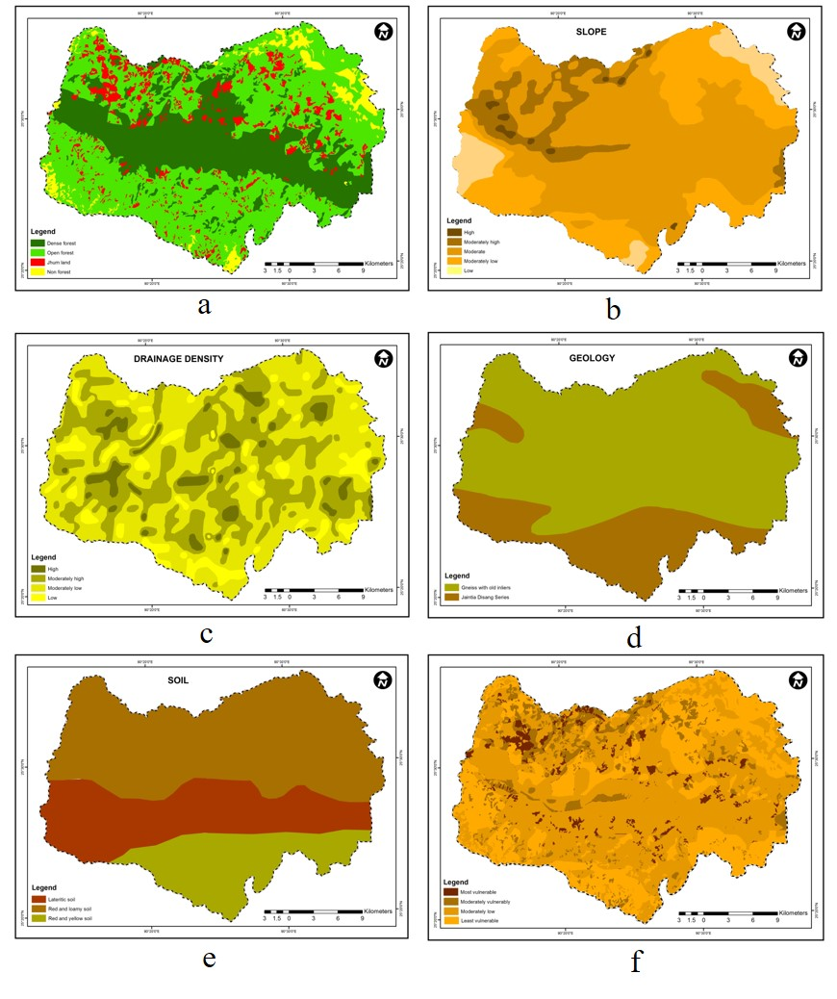
Fig.-2 (a) Land use and land cover, (b) slope instability, (c) density of drainage, (d) fragile geology (e) soil characteristics (f) Nokrek Biosphere Reserve of Garo hills of Meghalaya, India play important role for enhancing sheet erosion vulnerability.

Changes of agro-based economy
In many parts of northeast India, the traditional shifting cultivation is in the transitional phase as parts of the regions are replaced by economically viable cash crops concentrated in small plots with multi-species complex agro-ecosystem (Ramakrishnan, 1992). Due to the introduction of plantation crops, the ecological diversity of the region has permitted large number of horticulture crops. This has led to the evolution of a wide spectrum of genetic variability in these crops for various traits. The crop diversity has also been enriched with the introduction, acceptance, and adoption of new cash crops from outside, such as the potato, areca nut (Areca catechu), pineapple and different tea varieties which is playing a major role in the economy of the region. Many more new crops are being adopted in recent times (Klienman et al., 1996). Climate vulnerability significantly affects the traditional local economic structures of the tribal people which are not considered as formal sectors. In these sectors workers are the one who become economically most vulnerable at the time of crisis. The tribal people of northeast are still marginalized from political influence and economic opportunities. Majority of the population live below the poverty line and the ecosystems they dwell in are among the most sensitive ecosystems of the world. Forest ecosystems and indigenous tribal people are exposed to multiple drivers of changes including globalization, economic policies and increasing pressure on land and forest resources. Climate change is expected to add additional stress on these already challenged ecosystems and livelihoods.The poor jhum cultivators are deprived from the basic facilities for education, healthcare and most importantly alternative avenues for income generation. Poverty, poor infrastructure facilities, reliance on subsistence farming and forest products for livelihoods, substandard health indicators (high infant mortality rate and low life expectancy), and other indicators of development make this region more vulnerable to climate change. It is revealed that the capacities to adapt the changes among the communities are found to be inadequate. In most cases even children are engaged for livelihood generations, and not getting rights of childhood. The other economic pursuits of the tribal people of this region are collection of forest products, fishing and hunting.

Women and community-based climate vulnerability
The local community-based climate vulnerability and climate change affect each and everyone in a big way. The impacts are different between men and women as well as among regions, generations, age classes, income groups, and occupations. Gender inequality and climate change are inseparably linked. Climate vulnerability can have disproportionate impacts on the women’s well-being. Through both direct and indirect risks, it can affect their livelihood opportunities and overall life expectancy (Burton et al., 2002; Yohe and Tol, 2002; IPCC 2007). An increase in climate related disease outbreaks will have quite different impacts on women than on men. In general, women tend to have more limited access to the assets like physical, financial, human and social that would enhance their capacity to adapt to climate change, such as land, agricultural inputs, credit system, decision-making processes, technology, and training and extension services. Thus, any climate adaptation strategy should include actions to build up women’s assets. Interventions should pay special attention to the need to enhance women’s capacity to manage risks with a view to reducing their vulnerability and increasing their opportunities for development (FAO, 2000).The conservation of biodiversity is a key adaptation strategy to help vulnerable people to cop up with climate changes. The conservation of traditional crop variety is an important tool to climate change adaptation.
Among the tribal communities of northeast India, women play a crucial role in enhancing, maintaining and using the biodiversity sustainably, particularly agriculture and forest resources. They are appeared to be better natural resources managers in all the spheres. They actively participate in most of the household and subsistence agricultural activities and invest most of their productive life in the land-based production processes (Shiva, 1988). Women are responsible for supplying water and fuel and play a crucial role in food security besides looking after their children. Since climate vulnerability affects the mountain natural resources and biodiversity that provide water, food, and energy, the depletion of natural resources has particularly negative consequences for women. Women will have to work harder to access these resources with the extinction of some plant species due to the changes in climate and the water sources. This will increase their already heavy workload, but also increase their awareness of changes. Though among the Garo tribes of Meghalaya women leads as village heads called ‘Nokma’ and they have leadership roles in informal local networks and organizations, they are not visible by the outsiders and taken seriously by the male members of the family (Yadav and Sarma, 2013).

Climatic and socio-ecological stress
The original lush green vegetation of many parts of the northeast hills are converted into degraded forms by the activities of agriculture, logging, transportation, collection of food, fodder and fuelwood, grazing etc., and have rendered the forests vulnerable to fire (Upadhaya et al., 2013). The traditional slash-and-burn agriculture which has been practising since unrecorded history in this region could also lead to severe environment degradation if it is not properly managed. Reductions of jhum cycles in these tribal areas have exerted pressure to the land and this leads to large scale removal of top soil layers due to lack of soil binding components and reduces the water holding capacity of the soil and increases the run off. The perennial rainfall in this part of the globe ultimately acts as sorrow but not blessings to the people. This ultimately destroys the habitats which finally reduces ecological diversity and causes extinction of even many undiscovered indigenous species too (Jeeva et al., 2006). Climatic and ecological stress can influence the socioeconomic set up of these areas in a number of ways. Drivers of deforestation like shifting cultivation, urbanization, forest fire, mining, extraction of timber and lactation are predominated as climatic and ecological stress (Yadav, 2012). It can influence the economy (e.g., cash crop, livestock, farming, forestry, tourism, fishery, etc.) as well as human health. The mining of coal and aided by shifting cultivation carried out mainly in Garo hills district of Meghalaya cause extensive degradation of the rich forests that support a variety of succession communities. Increasing human intervention and excessive exploitation of these resources have resulted in great changes and provide alarming signals of accelerated biodiversity loss (Yadav et al., 2013). The consequences of these biodiversity losses from climate vulnerability are likely to be the worst for the poor and marginalized people who solely depend on natural resources. Climate change may be projected to reduce the livelihood assets of the poor people in terms of access to water, homes, and essential infrastructures. Climate change is also expected to have a negative impact on traditional coping mechanisms thereby increasing the vulnerability of the world’s poor to perturbations such as drought, flood and diseases. Due to the lack of proper drinking water and high dependency on natural resources people are vulnerable to the impact and ill effects of climate change. The forest cover in the northeast village areas is minimal and agriculture is the mainstay with a total focus on paddy cultivation on seasonal cycle. Flash floods often deluge sloppy plots, destroying standing crops and damaging the downslope areas with the debris carried by the flood water. To overcome these types of problems tribal people have forced to develop some innovative strategies using locally available resources. Most of the areas it is seen that bamboo, which are found in abundant, is used as mat across inlet channels to trap the silt and debris brought by the flood water (Yadav and Sarma, 2013).

Conclusions
Many parts of northeast hills of India have undergone remarkable changes in recent decades due to varied livelihood activities. These have been slowly eradicating the traditional practices of the tribal people of the region. The phenomena like shifts in the agricultural calendar due to changed climate in response to varying annual precipitation patterns result re-sowing after an early season failure, and use of failed crops as food, borrowing money and selling assets, and even migrating due to lack of drinking water become common to the hill dwellers. Many of the coping strategies adopted by the locals even enhance the depletion of the household’s livelihood asset base and may actually render it more vulnerable while the changes are more prominent. To overcome these changes communities are compelled to go for introducing high yielding crops for sustainability, maintaining multiple cropping systems, growing more than one crop per year, construction of water harvesting systems and livelihood diversification.

Reference
Allen, J.C. and Barnes, D.F. (1985): The causes of deforestation in developing countries. Ann. Ass. Am Geogr, 75:163–184.
Barbier, E.B. and Burgess, J.C. (2001): The economics of tropical deforestation. Journal of Economic Survey, 15(3): 413-433.
Burton, I.; Huq, S.; Lim, B. and Pilifosova, O. (2002): From impacts assessment to adaptation priorities: the shaping of adaptation policy. Clim Policy. 2:145–159.
Crutzen, P.J. and Andreae, M.O. (1990): Biomass burring in the tropics: impact on atmosphere chemistry and biogeographical cycle. Science. 250:1669-1678.
De Groot, R.S.; Wilson, M.A. and Boumans, R.M.J. (2002): A typology for the classification, description and valuation of ecosystem functions, goods and services. Ecological Economics.41: 393–408.
Dharmaji, B.; Raban, A.; Pisupati, B. and Baulch, H. (2005): A guiding frame for mainstreaming biodiversity and development into National Adaptation Programmes of Action (NAPAs). IUCN.
DSWC (2001): A report on the survey of shifting cultivation in Meghalaya. Directorate of Soil and Water Conservation (DSWC), Government of Meghalaya, Shillong.
FAO, UNDP, UNEP (2008): UN Collaborative Programme on Reducing Emissions from Deforestation and Forest Degradation in Developing Countries (UN-REDD). Framework Document 20 June 2008.
FAO. (2000): Gender and nutrition. Retrieved from the World Wide Web: http://www.fao.org/sd/2001/PE0703a_en.htm.
Fearniside, P. M. (1993): Deforestation in Brazilian Amoazonia: The effect of population and land tenure. Ambio 22:537-545.
Geist, H.; Eric, J.; and Lambin, F. (2001): What Drives Tropical Deforestation? A meta-analysis of proximate and underlying causes of deforestation based on subnational case study evidence. LUCC Report Series No. 4. Louvain-la-Neuve: CIACO
Houghton, R.A. (1995): Land-use change and the carbon cycle. Global Change Biology 1: 275–287.
IPCC. (2007): Climate change 2007: the physical science basis: contribution of working group I to the fourth assessment report of the intergovernmental panel on climate change. In: Solomon, S.; Qin, D.; Manning, M.; Chen, Z., Marquis, M.; and Averyt, K.B. (eds.). Cambridge University Press, Cambridge. pp. 996.
Jeeva, S.R.D.N.; Laloo, R.C. and Mishra, B.P. (2006): Traditional agricultural practices in Meghalaya, North-East India. IJTK 5: 7-18.
Klienman, P.J.A.; Bryant, R.B. and Dimentel, D. (1996): Assessing ecological sustainability of slash-and-burn agriculture through soil fertility indicators. Agron. J. 88:122–127.
Kumar, A.; Marcot, B.G. and Roy, P.S. (2008): Spatial Patterns and Ecology of Shifting Forest Landscapes in Garo Hills, India: R. Lafortezza et al. (edtn) Patterns and Processes in Forest Landscapes. Consequences of human management, 125 Springer Science Business Media B.V.
Laurance, W.F.; Cochrane, M.A.; Bergen, S.; Fearniside, P.M.; Delamonica, P.; Barber, C.D.; Angelo, S. and Fernandes, T. (2001): The future of the Brazilian Aamazon. Sceince, 29:438-439.
Lele, N.; Joshi, P.K. and Agrawal, S.P. (2008): Assessing forest fragmentation in northeastern region (NER) of India using landscape matrices. Ecological Indicators, 8: 657-663.
Narendran, K.M.; Cochrane, A. and Sukumar, R. (2008): A comparative analysis of spatial, temporal and ecological characteristics of forest fires in seasonally dry tropical ecosystems in the Western Ghat. Forest Ecology and Management, 256: 607–617.
Ramakrishnan, P.S. (1992): Shifting Agriculture and Sustainable Development: An Interdisciplinary Studyfrom North-Eastern India. UNESCO-MAB Series, Paris. Parthenon Publishers, Carnforth, Lancashire, UK. p. 424.
Sarma, K. (2010): Shifting Cultivation: The Sole Livelihood of the People of Garo Hills, Meghalaya. Ecotone. Vol 2(2). pp. 16-19.
Sarma, K. and Barik, S.K. (2010): Geomorphological risk and conservation imperatives in Nokrek Biosphere Reserve, Meghalaya Using Geoinformatics. NeBIO, 1(2):14-24.
Sarma, K., Sarma, R.K. and Barik, S.K. (2012): Soil Erosion Vulnerability Mapping of Nokrek Biosphere Reserve, Meghalaya Using Geographic Information System. Disaster and Development. Vol. 6(1&2). pp. 19-32.
Sarma, K. (2014): Tropical deforestation and climate change: possible impacts in the north-east hills of India. In: Gogoi, M. (ed.), Climate Change: Dimension and Direction. Touch the Earth Publications. India. pp. 117-125.
Shimrah, T.; Sarma, K.; Varga, O.G.; Szilard, S. (2019): Quantitative assessment of landscape transformation using earth observation datasets in Shirui Hill of Manipur, India. Remote Sensing Applications: Society and Environment. Vol. 15. pp. 1-6.
Shiva, V. (1988): Staying Alive: Women, Ecology, and Development. London: Zed Books.
Singh, G. (1990): Soil and water conservation in India. In: Proceedings of Symposium on Water Erosion, Settlement and Resource Conservation, RI. CSWCTR. Dehradun.
Toky, O.P. and Ramakrishnan, P.S. (1981): Cropping pattern and yields in agricultural systems of the northeastern hill region of India. Agroecosystem 7: 11–25.
Upadhaya, K.; Thapa, N.; Lakadong, J.N.; Barik, S.K. and Sarma, K. (2013): Priority areas for conservation in Northeast India: a case study in Meghalaya based on plant species diversity and endemism. International Journal of Ecology and Environmental Sciences. Vol. 39(2). pp. 125-136.
Yadav, P. K., Kapoor, M. and Sarma, K. (2012): Land Use Land Cover Mapping, Change Detection and Conflict Analysis of Nagzira-Navegaon Corridor, Central India Using Geospatial Technology. International Journal of Remote Sensing and GIS, Vol. 1(2): 90-98.
Yadav, P.K. (2013): Slash-and-burn agriculture in north-east India. Expert opinion on Environmental Biology 2 (1).
Yadav, P.K. and Sarma, K. (2013): A Framework for Indigenous Community-Based Climate Vulnerability and Capacity Assessment in the Garo Hills, North-East India. Journal of Biodiversity Management & Forestry. Vol. 2(3). pp. 1-9.
Yadav, P.K.; Sarma, K. and Kumar, R. (2013): A framework for assessing the impact of urbanization and population pressure on Garo hills landscape of North-East India. International Journal of Conservation Science has been selected for vol. 4(2):2013.
Yohe, G. and Tol, R.S.J. (2002): Indicators for social and economic coping capacity—moving toward a working definition of adaptive capacity. Glob Environ Change 12:25–40.
***

