Using Python and Hyperspectral Data for Early / Low-Severity Plant Disease Detection: A Downy Mildew Case Study
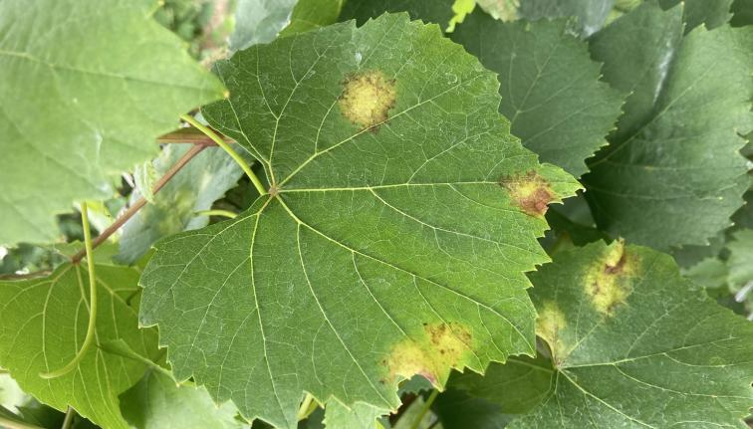Image source: Cornell IPM
This workshop uses a case study from Cornell Agritech’s NASA Acres project to map grapevine downy mildew in New Yorks’s finger lakes region, and to test how handheld hyperspectral measurements can support early disease detection. Leaf-level reflectance spectra were collected from symptomatic and asymptomatic plants to test whether disease status is associated with consistent spectral differences, especially within the top canopy. The hyperspectral data analysis pipeline discussed in this workshop helps identify biologically meaningful wavelength patterns and vegetation indices while also showing participants how to move from raw spectra to visualization, dimensionality reduction, and classification.
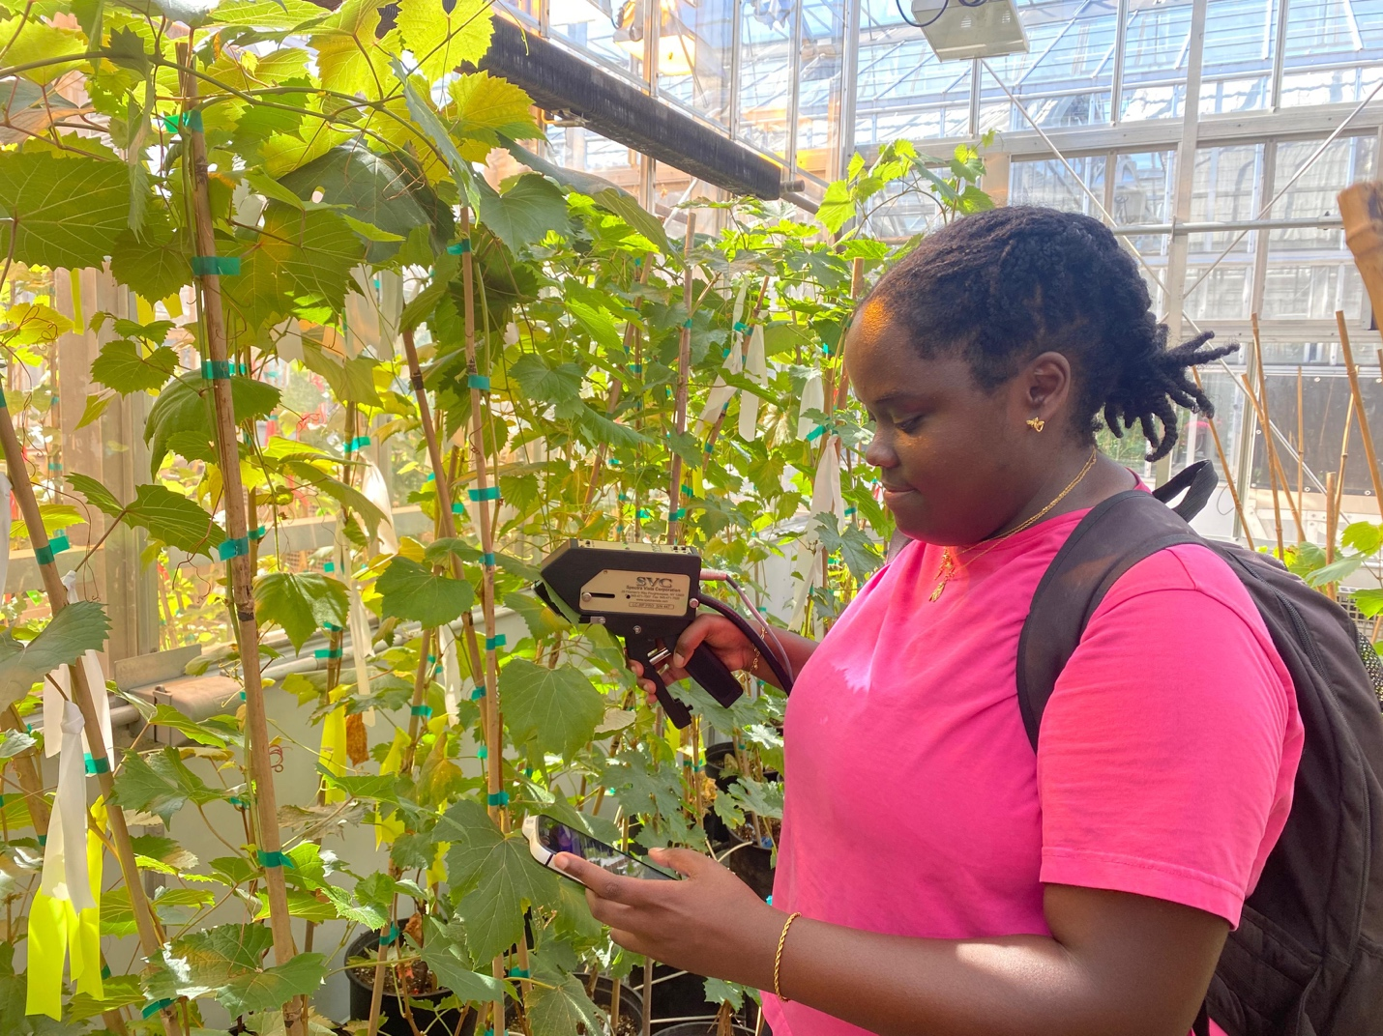
A handheld contact spectroradiometer was used to capture the spectra of grapevine leaves.
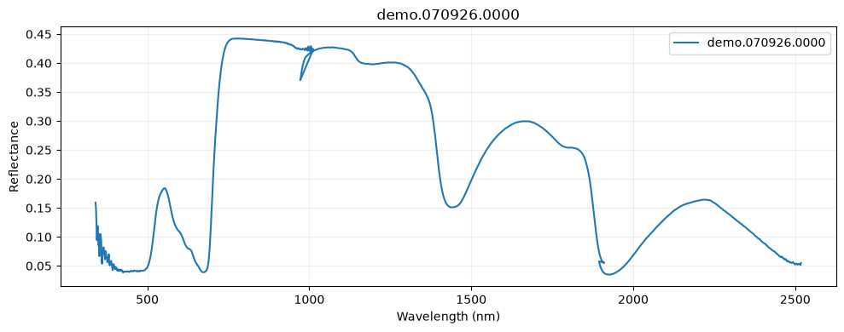
Raw spectra were preprocessed into final spectra, which will be analyzed by the participants. The preprocessing pipeline has been discussed in detail in APS_2026_hyperspectral_notebook2.ipynb.
Participants
Plant pathologists with limited to moderate coding experience who want to analyze hyperspectral data for disease detection.
Core Learning Goal
Participants will learn how hyperspectral reflectance data can be cleaned, visualized, reduced, and modeled in Python to distinguish healthy plants from early or low-severity downy mildew infection.
Analysis Goals
By the end of the workshop, participants should be able to:
- Load hyperspectral reflectance data into Python.
- Inspect metadata and confirm they are using only top canopy samples.
- Plot average reflectance curves for healthy versus symptomatic plants.
- Identify spectral regions that differ between treatment groups.
- Calculate a few vegetation indices.
- Perform dimensionality reduction using PCA.
- Train a simple classification model for early/low-severity disease detection.
- Evaluate model performance using interpretable metrics.
- Identify the most informative wavelengths or indices.
Participants should produce:
- A reflectance curve plot comparing healthy vs downy mildew samples
- A plot showing spectral differences between classes
- A small table of calculated vegetation indices
- PCA scatterplot and PC ranking bar plot
- A classification accuracy / confusion matrix
- A feature importance plot or ranked wavelength/index table
Participants should learn how to use AI to:
- Understand unfamiliar Python code.
- Debug common errors.
- Summarize model outputs in plain language.
- Check for risks like data leakage, overfitting, and confounding.

AI Mini-Module: This has been integrated into the pipeline discussed in the workshop
Prompt 1: Explain Code
Explain this Python code line by line for a plant pathologist who is new to hyperspectral data analysis.
Prompt 2: Debug an Error
I got this Python error while analyzing hyperspectral reflectance data. Explain what it means and suggest the smallest fix. Here is the code and error:
[paste code/error]
Prompt 3: Improve the Analysis
I am using top-canopy hyperspectral reflectance to classify asymptomatic vs symptomatic downy mildew samples. What are the main risks of overfitting or data leakage in this workflow?
Prompt 4: Interpret Results
Here is my confusion matrix and model performance table. Summarize what the model is doing well, what it is doing poorly, and what I should be cautious about biologically.

