Gort Service Debugger by Phillip H. Blanton

How to use the Service Debugger.
The service debugger should be used in DEBUG mode only. When properly configured, hitting F5 in Visual Studio will launch a simple windows application with a list of available services...
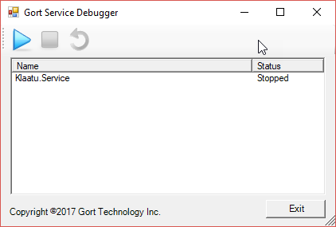
From here you can start, stop and restart the services as necessary.
To configure the ServiceDebugger, reference the ServiceDebugger.dll, then modify the service Main() as follows...

/// <summary>
/// The main entry point for the application.
/// </summary>
static void Main()
{
ServiceBase[] ServicesToRun;
ServicesToRun = new ServiceBase[]
{
new DTBService()

/*
// Optional
, new OtherService(),
new YetAnotherService()
// etc...
*/
};
#if (DEBUG)
ServiceDebugger.ServiceLoader.StartServices(ServicesToRun);
#else
ServiceBase.Run(ServicesToRun);
#endif
}
The ServiceDebugger shall NOT be deployed with the service compiled in release mode. It is compiled out and not required in release mode.

