

SFRA payment cartridge
integration

iint_checkoutcom_sfra | Version 26.3.0



Table of Contents
- Summary 1-3
- Component Overview 2-4
- Functional Overview 2-4
- Use Cases 2-4
- Limitations, Constraints 2-4
- Compatibility 2-4
- Privacy, Payment 2-4
- Implementation Guide 3-5
- Setup 3-5
- Configuration 3-5
- Custom Code 3-5
- External Interfaces 3-5
- Testing 3-5
- Operations, Maintenance 4-6
- Data Storage 4-6
- Availability 4-6
- Translation 4-6
- Support 4-6
- User Guide 5-7
- Roles, Responsibilities 5-7
- Business Manager 5-7
- Storefront Functionality 5-7
- Known Issues 6-8
- Release History 7-9
1. Summary

Checkout.com is a software platform that has integrated 100% of the value chain to create payment infrastructures that truly make a diﬀerence. Checkout.com is authorised and regulated by the Financial Conduct Authority under the Electronic Money Regulations 2011 (reference number 900816) to issue electronic money and provide payment services.

The Checkout.com cartridges allows Salesforce Commerce Cloud (SCC) store owners to process payments through the Checkout.com Payment Gateway.

This implementation guide describes how to integrate the Checkout.com SFRA payment cartridge into an SFCC reference application. The integration is cross-browser, cross-device compatible, and can accept online payments from all major credit cards.

The Checkout.com LINK cartridge package contains 3 folders:

- int_checkoutcom - Site Genesis integration for the checkout.com payment gateway

- int_checkoutcom_sfra - SFRA integration for the checkout.com payment gateway

- bm_checkoutcom - BM integration for the checkout.com payment gateway

These integrations have been designed using Javascript Controllers and don’t contain any deprecated Pipelines code. For a maximisation of the conversion rate, the buyer is not redirected to third party sites during the payment process. Consequently, the shop operator does not need a PCI DSS certification to use the solution.

In order to test or eﬀectively process payments through the Checkout.com Payment Gateway, you will need to open an account. Please contact your Checkout.com account manager or send an email to support@checkout.com HYPERLINK "mailto:support@checkout.com" HYPERLINK "mailto:support@checkout.com" HYPERLINK "mailto:support@checkout.com" for more information.

Supported Payment Methods

The Checkout.com SFRA cartridge for SFCC provides support for the following payment methods

⦁ Credit cards – Accept all major credit and debit cards including Visa, Mastercard, AMEX, Diners, Discover and more
⦁ ApplePay
⦁ Bancontact
⦁ EPS
⦁ Fawry
⦁ GooglePay
⦁ iDEAL
⦁ Klarna
⦁ KNET
⦁ MADA
⦁ MultiBanco
⦁ P24
⦁ PayPal
⦁ QPay
⦁ MBWay
⦁ Bizum
⦁ Sequra
⦁ Tabby
⦁ ACH
⦁ Tamara
⦁ AlipayHK
⦁ AlipayCN

Supported Payment Types

⦁ Cards
⦁ Wallets
⦁ Cash and ATM payment
⦁ Bank Transfer
⦁ Direct Debit
⦁ Invoice and pay later

- Components Overview

- Functional Overview

The Checkout.com SFRA cartridge for SFCC connects your online store with the Checkout.com gateway and automates all payment processes, delivering a comprehensive payment integration with simple usability and maximum performance.
- Consolidated expertise for all payment methods and services
- End-to-end automation of all payment processes
- Seamless integration into the SCC checkout process
- Central administration directly in the SCC backend
- No PCI DSS certification necessary for you as a merchant
- Fast time-to-market due to the use of scalable cloud technologies

The following features are available directly through the SCC Business Manager and the Hub, Checkout.com’s payment management backend:
- Fully featured transaction management: handle authorisation, capture, void, full or partial refund, blacklisting and chargebacks
- Customer/Card holder details, cards and address management
- Integrated risk engine with handling of fraud prevention

Checkout.com’s Site Genesis cartridge for SFCC allows shoppers to perform secure payments without leaving the store and gives store owners a full control over payments and customer management.
The payment workﬂow can be summarised into 3 steps:
- Display a payment form
- Submit the form, charge the customer for the total amount of the order, handle the response
- Display the order confirmation page or the cart with an error message in case of failure
∙
Upon completion of a payment, detailed information about the order and the corresponding transactions are available in the order details in the SFCC Business Manager.

- Use Cases

There is currently a single use case for this cartridge: the shopper is using one of the Checkout.com payment methods to complete a purchase on an SFCC website:
- On the billing checkout step, a payment form is displayed

- The shopper provides payment details and places an order

- In case of payment success, the shopper is redirected to the order confirmation page

- In case of payment failure, the shopper is redirected to the cart and can try again Please see section 5.3 Storefront functionality for images of the payment process.

- Limitations, Constraints

- The Checkout.com SFRA cartridge integration doesn't support multi-shipping and subscriptions.

- Compatibility
SFRA 7.0.1 Compatibility Mode 22.7 and Recommended node version 18.19.1
Backward Compatibility with SFRA 6.3.0 and below:
      - Replace the package.json and .stylelintrc.json with corresponding files in link_checkoutcom\Documentation\SFRA\SFRA-6.3.0
      - Recommended node version 14.17.4

- Privacy, Payment

This integration requires access to the following customer data elements:
- Card Details
- Billing Address
- Shipping Address
- Order Details
- Customer Profile
- Some custom properties of Customer Payment Instruments.

- Implementation Guide

- Setup

The Checkout.com SFRA integration is contained in the storefront cartridge int_checkoutcom_sfra. This single cartridge contains all the payment processor integration functionalities. The integration is compatible with storefronts based on Javascript Controllers.
The int_checkoutcom_sfra cartridge folder contains the following files:

CONTROLLERS & PROCESSORS
- controllers/Checkout.js
- controllers/CKOMain.js
- controllers/CKOKlarna.js
- controllers/CheckoutServices.js
- controllers/COPlaceOrder.js
- controllers/Order.js
- controllers/PaymentInstruments.js
- scripts/payment/processor/CHECKOUTCOM_APM.js
- scripts/payment/processor/CHECKOUTCOM_APPLE_PAY.js
- scripts/payment/processor/CHECKOUTCOM_CARD.js
- scripts/payment/processor/CHECKOUTCOM_GOOGLE_PAY.js
- scripts/payment/processor/CHECKOUTCOM_KLARNA.js

FORMS
- forms/default/alternativePaymentForm.xml
- forms/default/applePayForm.xml
- forms/default/cardPaymentForm.xml
- forms/default/googlePayForm.xml
- forms/default/klarnaForm.xml
- forms/default/creditCard.xml

HELPERS
- scripts/helpers/apmHelper.js
- scripts/helpers/applePayHelper.js
- scripts/helpers/cardHelper.js
- scripts/helpers/ckoHelper.js
- scripts/helpers/googlePayHelper.js
- scripts/helpers/klarnaHelper.js

STATIC FILES
- static/default/css/apm.css
- static/default/css/applepay.css
- static/default/css/googlepay.css
- static/default/css/checkoutcom.css
- static/default/account/payment.css
- static/default/js/apm.js
- static/default/js/applepay.js
- static/default/js/cardPayment.js
- static/default/js/checkoutcom.js
- static/default/js/cleave.js
- static/default/js/googlepay.js
- static/default/paymentInstruments/paymentInstruments.js

TEMPLATE FILES
- templates/custom/ajax/output.isml
- templates/custom/common/response/3DSecure.isml
- templates/custom/common/response/failed.isml
- templates/mandate/OrderMandate.isml
- templates/redirects/3DSecure.isml
- templates/redirects/apm.isml
- templates/redirects/failed.isml
- templates/walletPayments/applePayForm.isml
- templates/walletPayments/googlePayForm.isml
- templates/ckoPayments.isml
- templates/default/account/payment/paymentForm.isml
- templates/default/checkout/billing/paymentOptions.isml

MISCELLANEOUS
- int_checkoutcom_sfra.properties
- scripts/hooks.json
- scripts/config/ckoApmConfig.js
- scripts/config/ckoApmFilterConfig.js
- scripts/config/ckoCurrencyConfig.js
- scripts/config/ckoMadaConfig.js
- scripts/config/constants.js

The int_checkoutcom_sfra Checkout.com SFRA cartridge is used for both testing (sandbox mode) and production (live mode). Once the cartridge installed, a parameter in the custom preferences of the SFCC Business Manager will allow you to set the running mode according to your needs.
- Configuration

The steps required to enable the Checkout.com SFRA cartridge on your website are as described below. The following assumes you have a sandbox with a clean and functional Site Genesis site:
- Download the int_checkoutcom_sfra cartridge from the LINK Marketplace.

- Upload int_checkoutcom_sfra cartridge to your server, using a tool like UX Studio, Webdav, or the sgml-scripts based on Node.js. Apply the standard ﬂow used to upload cartridges to your environment.
- In the Business Manager, go to Administration > Sites > Manage Sites

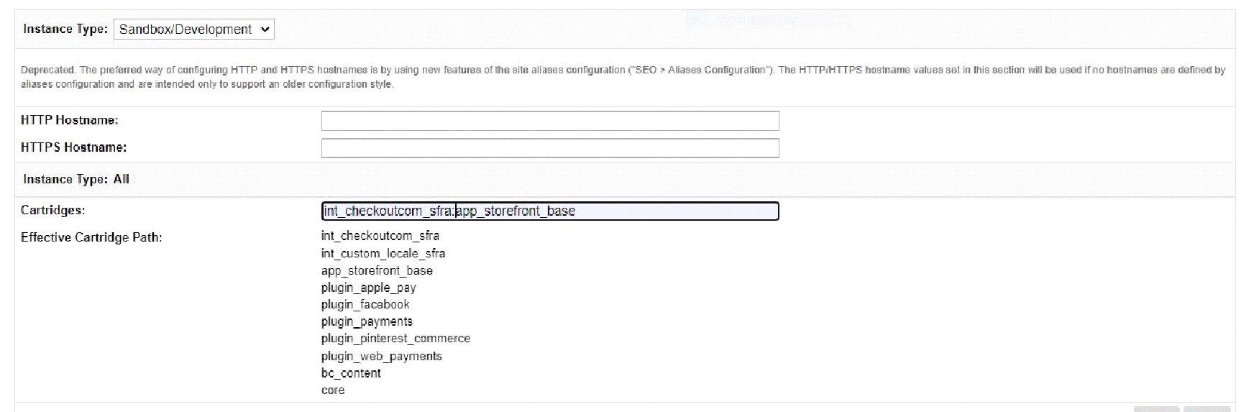

In your target sites’s settings, add int_checkoutcom_sfra to the cartridge path.

- Go to Administration > Site Development > Site Import & Export to import the XML files available in the metadata folder.

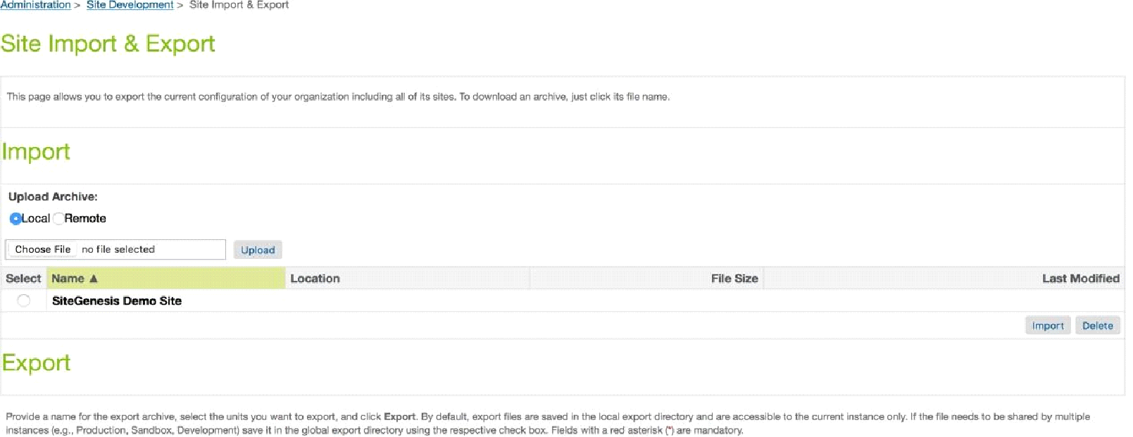

Once in the Site Import section, follow the steps below to import the metadata folder:
- Open a file browser (e.g. Windows Explorer in Windows) and locate the metadata folder of the cartridge. Step down the folder hierarchy until you are in the subfolder “sites”. Re-name the contained folder “SiteGenesisGlobal” to the name of the site for which you want to import int_checkoutcom_sfra settings, payment methods and services.
- Navigate back to the project’s root folder and create a zip metadata.zip out of the folder metadata.
- Login to Business Manager and go to Administration > Site Development > Site Import & Export
- Go to the section “Upload archive”. Choose “local” and click on the Browse button
- Navigate in the file system, select the metadata.zip then click on “Open” and upload the zip file.
- Check the import status in the Status section.
After the import has been completed successfully, all required Checkout.com data will be available globally and for the selected sites.

NOTE: - There is an additional configuration required for the checkout.com card payments.
We have to manually add “Checkout.com Card” as a processor in the “CREDIT_CARD” payment method to make it work for the CHECKOUTCOM card payments.

- External Interfaces

The Checkout.com service endpoints are the external interface that this integration connects to. The documentation for the web service requests and responses can be found in the charge with full card section of the Checkout.com documentation.

- Firewall Requirements

There are no specific firewall requirements.

- Testing

In order to test the payment workﬂow in sandbox mode, Checkout.com provides a set of card numbers allowing to simulate multiple payment cases.

Use any future expiry date (mm/yy) with these test cards.

CARD | NUMBER | CVV
Visa | 4242424242424242 | 100
Visa | 4543474002249996 | 956
MasterCard | 5436031030606378 | 257
MasterCard | 2223000010479399 | 299
MasterCard | 5199992312641465 | 010
AMEX | 345678901234564 | 1051
AMEX | 378282246310005 | 1000
Diners Club | 30123456789019 | 257
JCB | 3530111333300000 | 100
Discover | 6011111111111117 | 100

Klarna Test Credentials: https://docs.klarna.com/resources/developer-tools/sample-data/sample-customer-data/

- Operations,Maintenance

- Data Storage

No custom objects are created by this cartridge.

- Availability

The Checkout.com payment gateway is expected to have continuous availability. The Checkout.com Payment Gateway API provides a 99.99% uptime SLA.
In case of unavailability of the service, shoppers might see their payment attempts declined. The unavailability of the checkout.com Gateway services will however have no impact on your SFCC site. All storefront and business manager features will remain accessible and usable.
In case of unavailability of the service, please send an email to support@checkout.com HYPERLINK "mailto:support@checkout.com" HYPERLINK "mailto:support@checkout.com" HYPERLINK "mailto:support@checkout.com".

- Translation

This Checkout.com cartridge is provided with the English language by default. It’s however possible to add custom translations for any language, using the translation files available in the resources folder.

- Support

For questions regarding an account, contact your Checkout.com account manager or send an email to support@checkout.com HYPERLINK "mailto:support@checkout.com" HYPERLINK "mailto:support@checkout.com" HYPERLINK "mailto:support@checkout.com".
- User Guide

- Roles, Responsibilities

There are no recurring tasks to be perform in order to run the Checkout.com SFRA cartridge integration.

- Business Manager

The configuration parameters of the Checkout.com SFRA cartridge are available in:
Merchant Tools > Site Preferences > Custom Preferences.

The following configuration screens are available:

- CKO [1] Sandbox Keys

The Checkout.com sandbox API credentials. A private key, a public key and a private shared key
for the NAS platform and also included a custom preference for the NAS enabled.

If you want to use the NAS keys then choose NAS from the dropdown. The default value for the custom preference is NAS.

These credentials allow your online store to connect and communicate with the sandbox/test payment gateway.

They will be available in your Checkout.com account once it’s been opened by your Account Manager. Please see the Contact section for more information on how to contact Checkout.com.

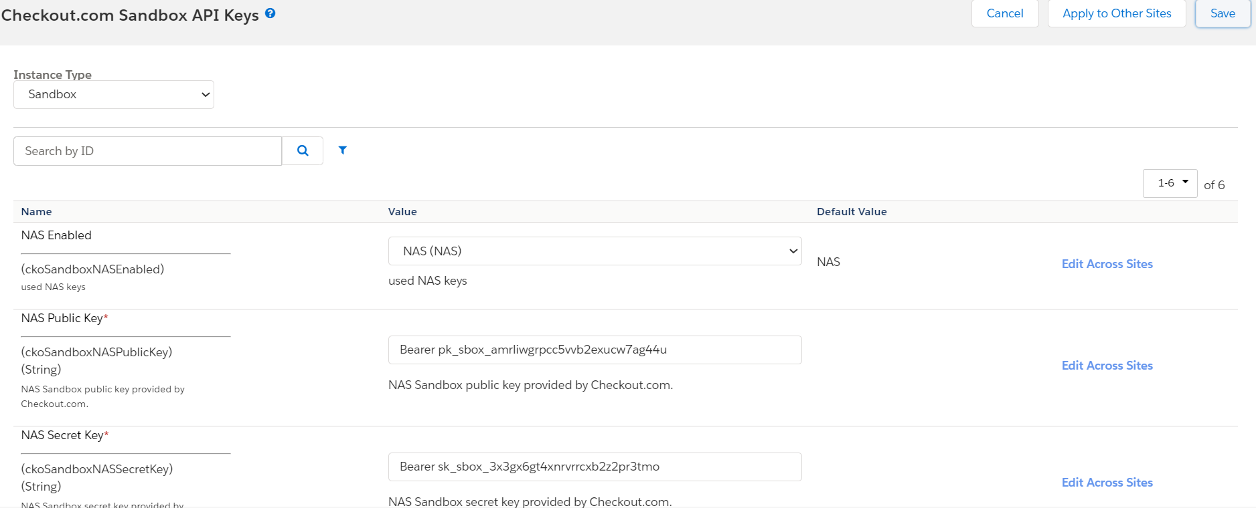

- CKO [2] Live Keys

The Checkout.com live API credentials. A private key, a public key and a private shared key for the NAS platform and also included a custom preference for the NAS enabled.

If you want to use the NAS keys then choose NAS from the dropdown. The default value for the custom preference is NAS.

These credentials allow your online store to connect and communicate with the live/production payment gateway.

They will be available in your Checkout.com account once it’s been opened by your Account Manager. Please see the Contact section for more information on how to contact Checkout.com.

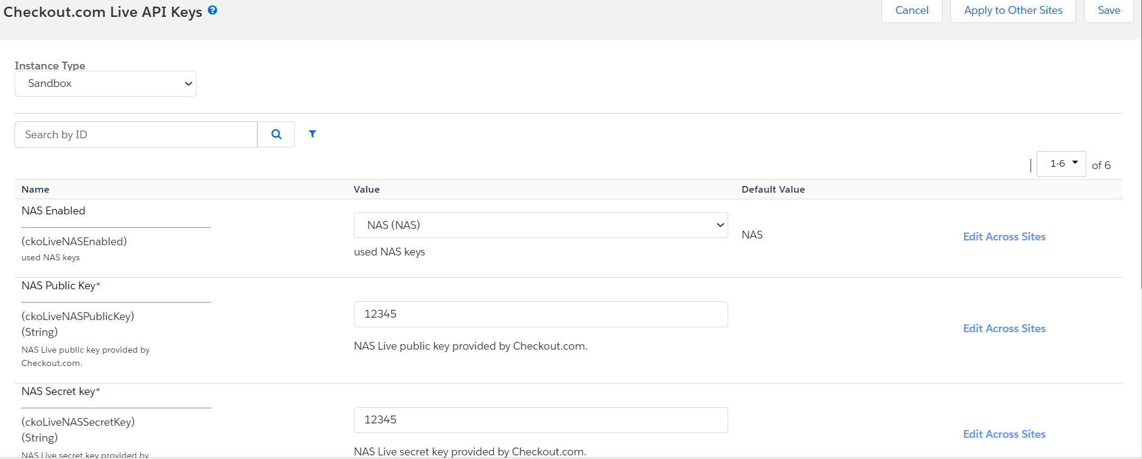

- CKO [3] Business Details

The legal address and billing descriptors for your online store.

- CKO [4] Payment Settings

The Checkout.com gateway global payment settings and card payment settings. The following parameters are available.
- Enable
Enables the Checkout.com cartridge. This preference is used to enable the checkout.com integration on site.
- Enable debug mode
When the debug mode is enabled, the cartridge will log all gateway response in the log files of your website.
- 3D Secure
Should 3D Secure be active
- Processing Channel Id
Holds processing channel ID
- Attempt Non 3D Secure
In case of failure of a 3D secure check, should the gateway try to fallback to a regular transaction without 3D Secure check.
- Auto capture
After authorisation, should the transaction be captured immediately or with a delay.
- Auto capture time
An integer or decimal number specifying how long after the authorisation the capture should happen.
Time provided in minutes. Ex: A provided time of 0.2 minutes corresponds to 12 seconds between the initial card authorisation and the capture.
It’s recommended to avoid setting the auto capture time to 0, in order to avoid collision between the authorisation confirmation and the capture confirmation.
- Enable MADA Payment Cards
Enable payments with mada cards in the middle east.
- Checkout MADA Bins
This preference is used to store the mada cards bin in json format for Appla Pay and Cards.
- Service Endpoint
This preference defines the base URL for Checkout.com API calls. If provided, all requests will be routed to this endpoint. Eg: https://ksa.api.sandbox.checkout.com. By default, the service uses the URL specified in the service credentials.
- Enable Risk.js
This preference is used to enable Checkout.com Risk.js SDK integration for device fingerprinting. By default, this will be enabled.

- CKO [5] APM Settings

The Checkout.com Alternative Payment Methods settings.
This section is used to enable the APM payment methods that you want to add on your store.

- CKO [6] Google Pay Settings

The Checkout.com Google Pay payment method settings.
For google pay setup follow the guide of google pay on checkout.com, the link is :- https://www.checkout.com/docs/payments/payment-methods/wallets/google-pay

The Checkout.com Google Pay payment method settings.

⦁ Enable Google Pay

Enable the google pay on your site.

⦁ Environment

Should the Google Pay option run in test or production mode.

⦁ Google Pay merchant ID

Enable payments with Google Pay.

⦁ Button Style

This preference is to decide the google pay button color.

⦁ Enable 3D Secure For Google Pay

Enable payments with Google Pay using 3D Secure authentication.

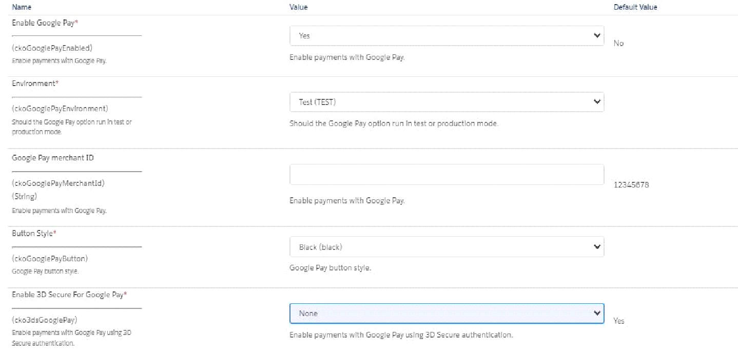

- CKO [7] Apple Pay Settings

For apple pay setup follow the guide of apple pay on checkout.com, the link is :-https://www.checkout.com/docs/payments/payment-methods/wallets/apple-pay

The Checkout.com Apple Pay payment method settings.

⦁ Enable Apple Pay

Enable the Apple pay on your site.

⦁ Environment

Should the Apple Pay option run in test or production mode.

⦁ Apple Pay merchant ID

Enable payments with Apple Pay.

⦁ Button Style

This preference is to decide the apple pay button color.
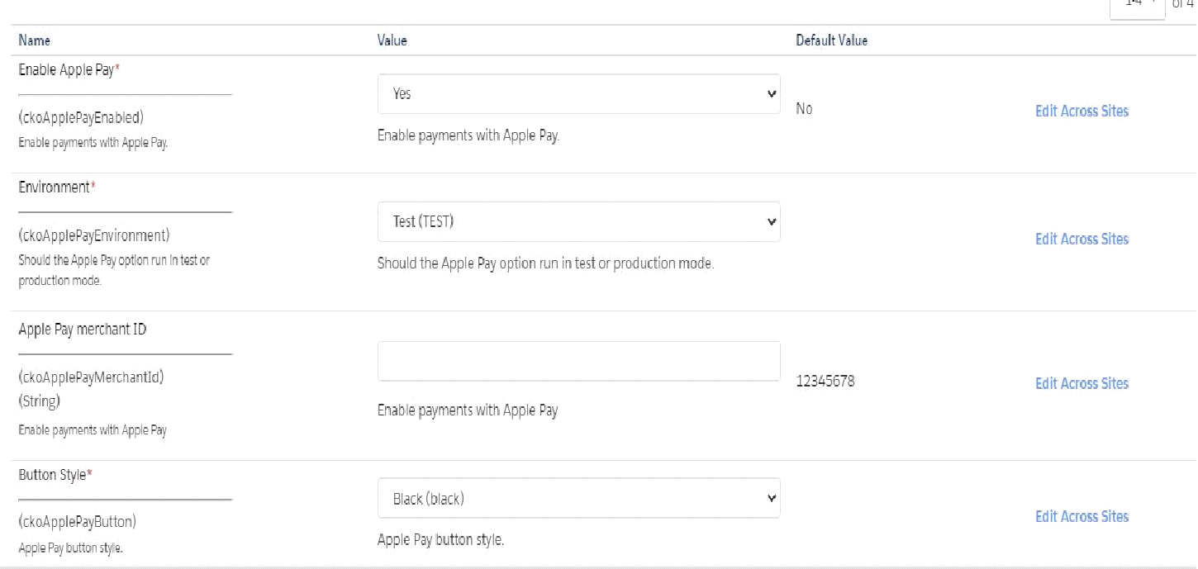

- CKO [9] Klarna Settings

For klarna setup follow the guide of klarna on checkout.com, the link is :- https://www.checkout.com/docs/payments/add-payment-methods/klarna#Get_payment_details

The Checkout.com Klarna payment method settings.

⦁ Enable Klarna

Enable the Klarna on your site.

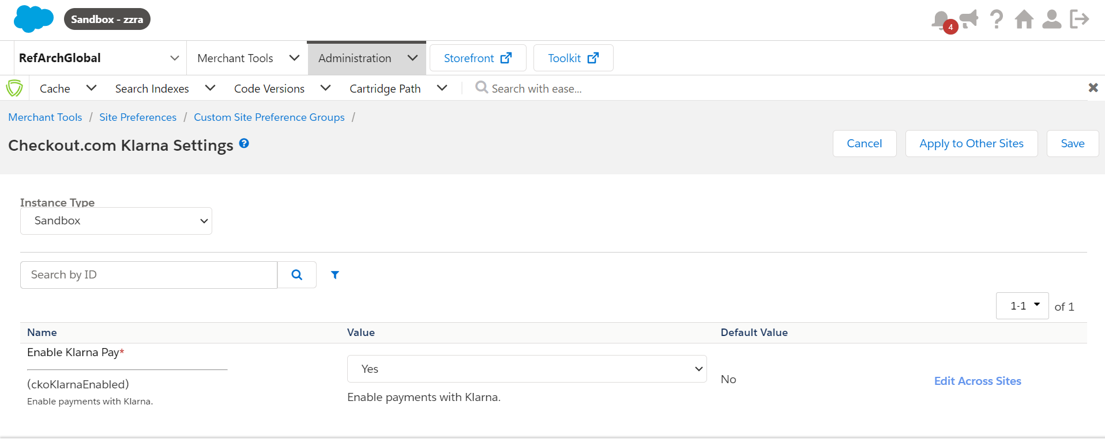
- CKO [10] Alma Settings

The Checkout.com Alma payment method settings.

⦁ Enable Alma

Enable payments with Alma. Alma is only available for France (FR).

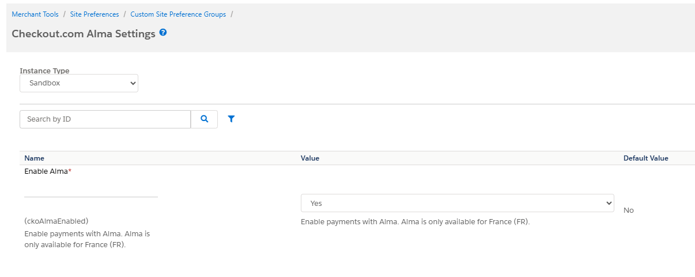

- CKO [11] Sequra Settings

The Checkout.com Sequra payment method settings.

⦁ Enable Sequra

Enable payments with Sequra. Sequra is available for EUR currency.

⦁ Enable Capture

Enable automatic capture for Sequra payments.

⦁ Enable Pay Later Invoice (Paga después: Recíbelo primero)

Enable Sequra Pay Later Invoice payment method.

⦁ Enable Pay Later PP5 (Paga después)

Enable Sequra Pay Later PP5 payment method.

⦁ Enable Pay in 3 SP1 (Divide en 3)

Enable Sequra Pay in 3 SP1 payment method.

⦁ Enable Pay in Installments PP3 (Fracciona tu pago)

Enable Sequra Pay in Installments PP3 payment method.

⦁ Enable Flexi (Flexi)

Enable Sequra Flexi payment method.

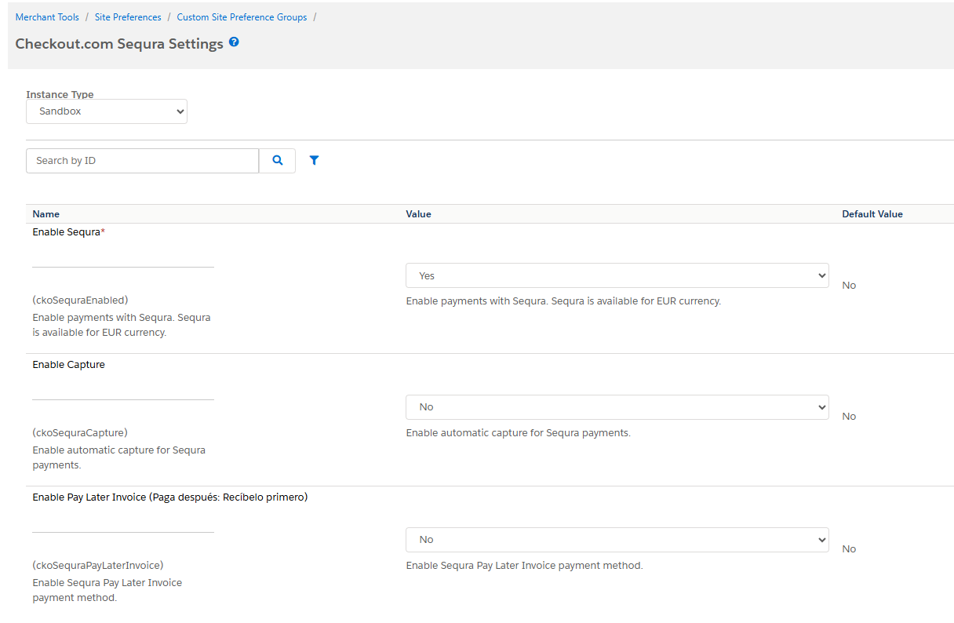

- CKO [12] MBWay Settings

The Checkout.com MBWay payment method settings.

⦁ Enable MBWay

Enable the MBWay payment on your site.

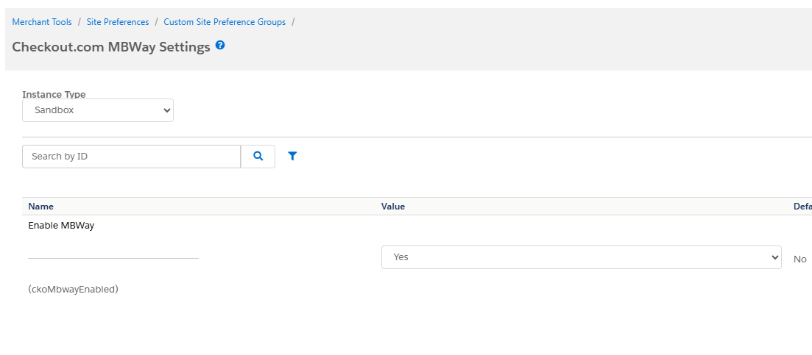

- CKO [13] Bizum Settings

The Checkout.com Bizum payment method settings.

⦁ Enable Bizum

Enable the bizum payment on your site.

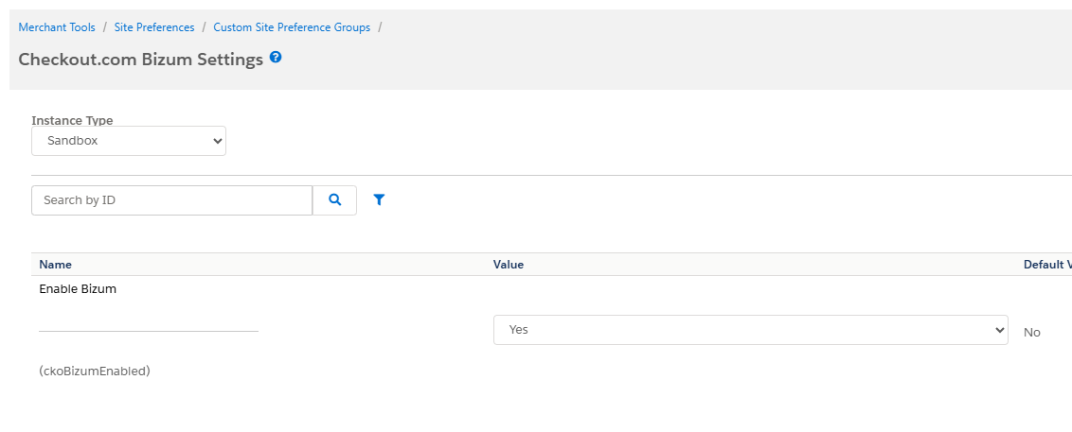

- CKO [14] Tabby Payment Settings

The Checkout.com Tabby payment method settings.

⦁ Enable Tabby

Enable Tabby as a payment method on the checkout page.

⦁ Enable Capture

When set to Yes, Tabby payments will be processed as Sale (auto-capture) transactions. When set to No (default), Tabby payments will be processed as Authorization transactions.

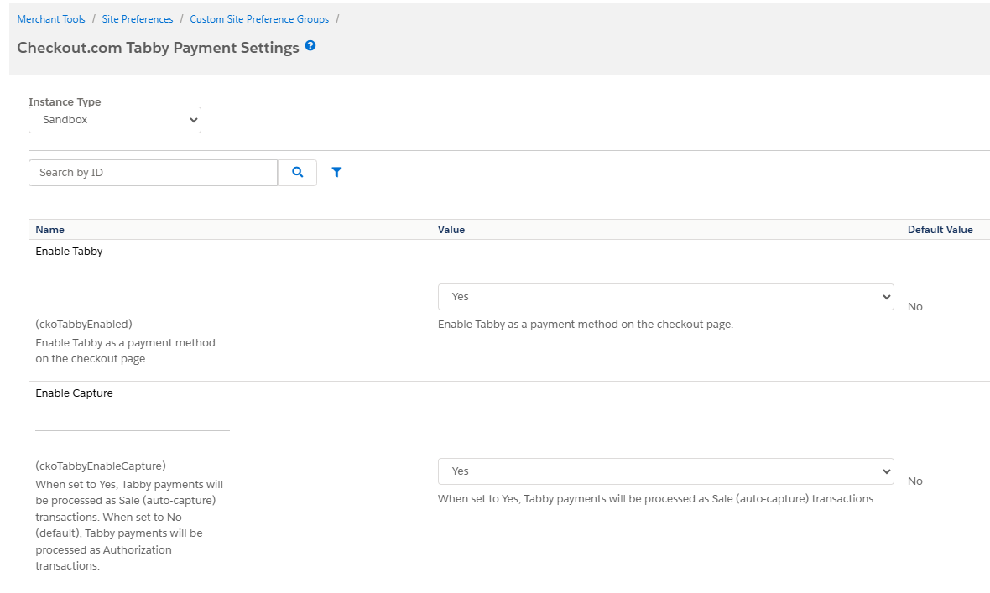

- CKO [15] ACH Payment Settings

The Checkout.com ACH payment method settings.

⦁ Enable ACH Direct Debit

Enable ACH Direct Debit payments via Plaid. Only available for USD / US billing addresses.

⦁ Plaid Client ID

Plaid Client ID for ACH Direct Debit integration. Required when ACH is enabled. Alphanumeric only.

⦁ Plaid Secret

Plaid Secret key for ACH Direct Debit integration. Required when ACH is enabled. Alphanumeric only.

⦁ Plaid Client Name

Display name shown to shoppers in the Plaid Link bank authentication popup. Alphanumeric only.

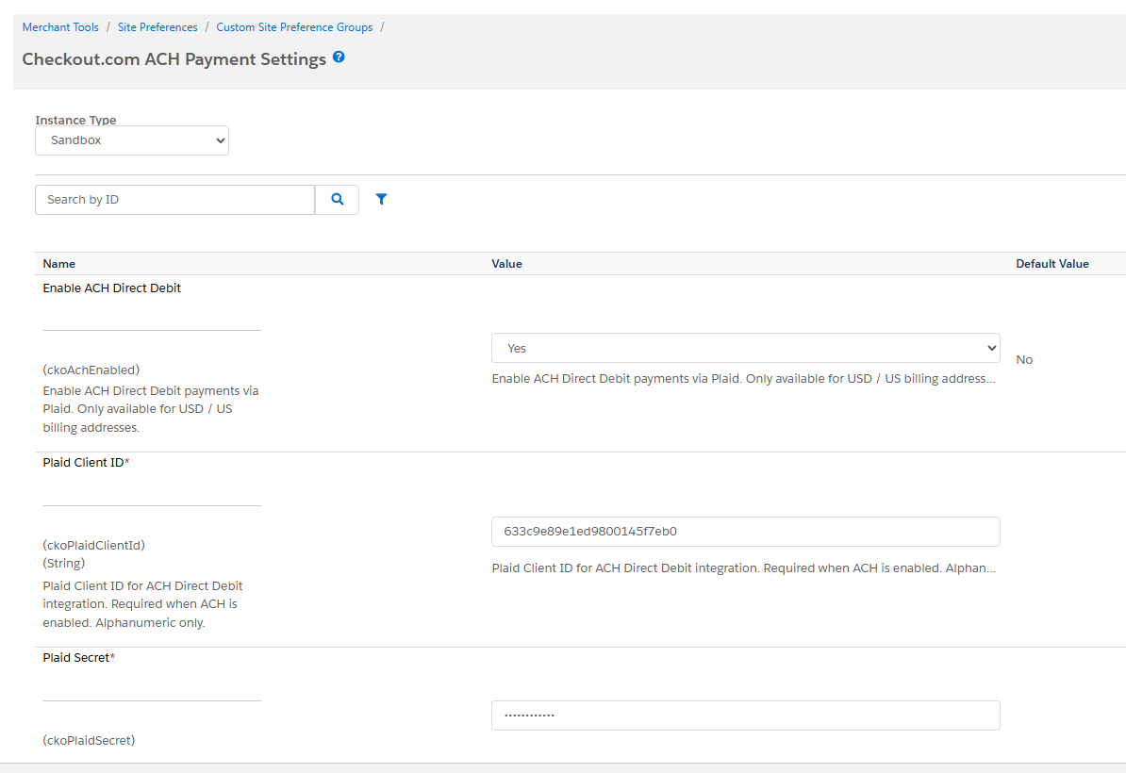

- CKO [16]Tamara Settings

The Checkout.com Tamara payment method settings.

⦁ Enable Tamara

Enable Tamara as a payment method on the checkout page.
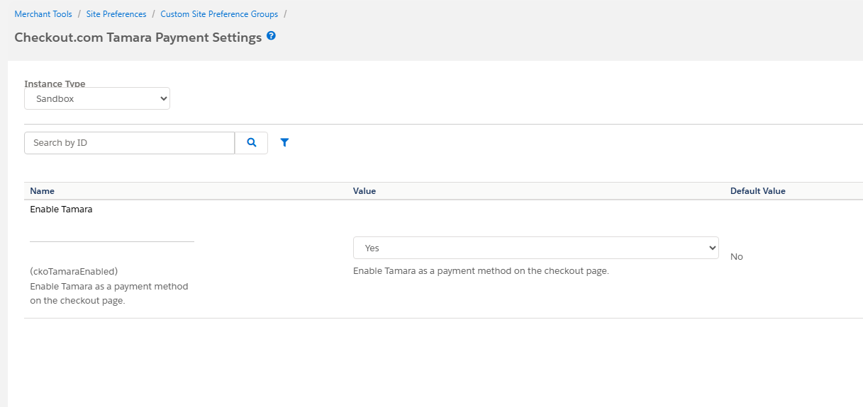

- CKO [17] AlipayHK Settings

The Checkout.com AlipayHK payment method settings.

⦁ Enable AlipayHK

Enable AlipayHK as a payment method on the checkout page. AlipayHK is available for Hong Kong (HK) and Singapore (SG) with HKD and SGD currencies.

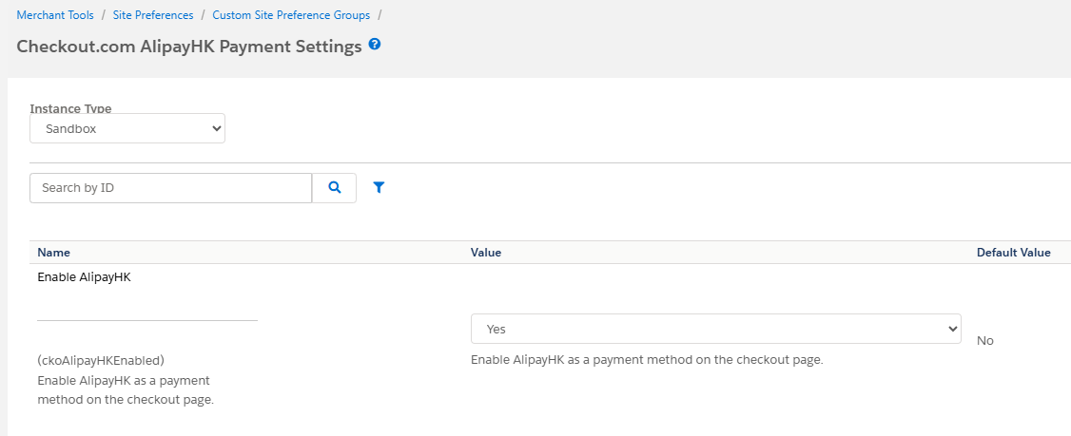

- CKO [18] AlipayCN Settings

The Checkout.com AlipayCN payment method settings.

⦁ Enable AlipayCN

Enable AlipayCN as a payment method on the checkout page. AlipayCN is available for China (CN), Hong Kong (HK) and Singapore (SG) with CNY, HKD and SGD currencies.

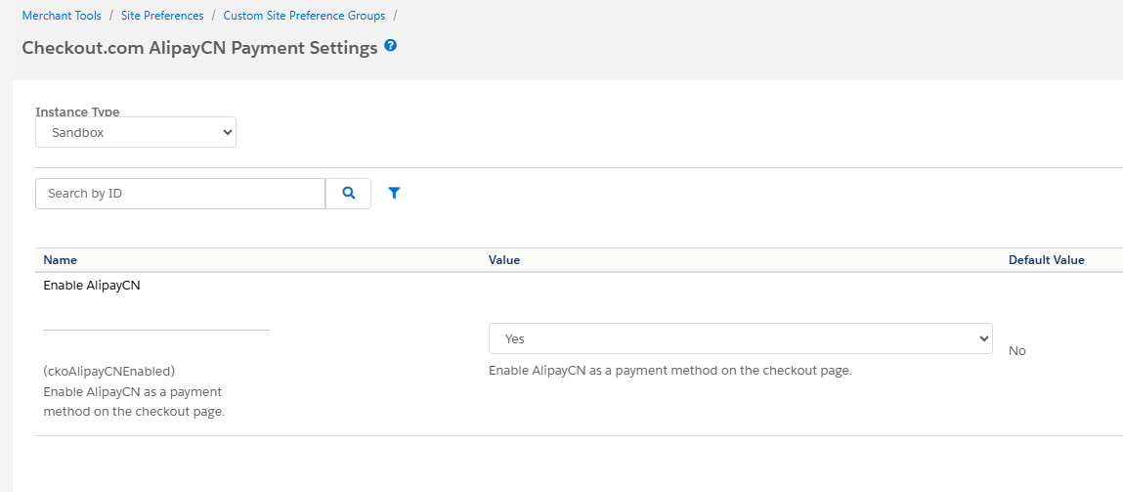

- Storefront Functionality

Once enabled, the Checkout.com SFRA integration will add a new functionality to your Salesforce Commerce Cloud store.
The Checkout.com Card payments, Apple Pay payments, Google Pay payments, Klarna and Alternative Payment methods will show as payment options on the billing page.

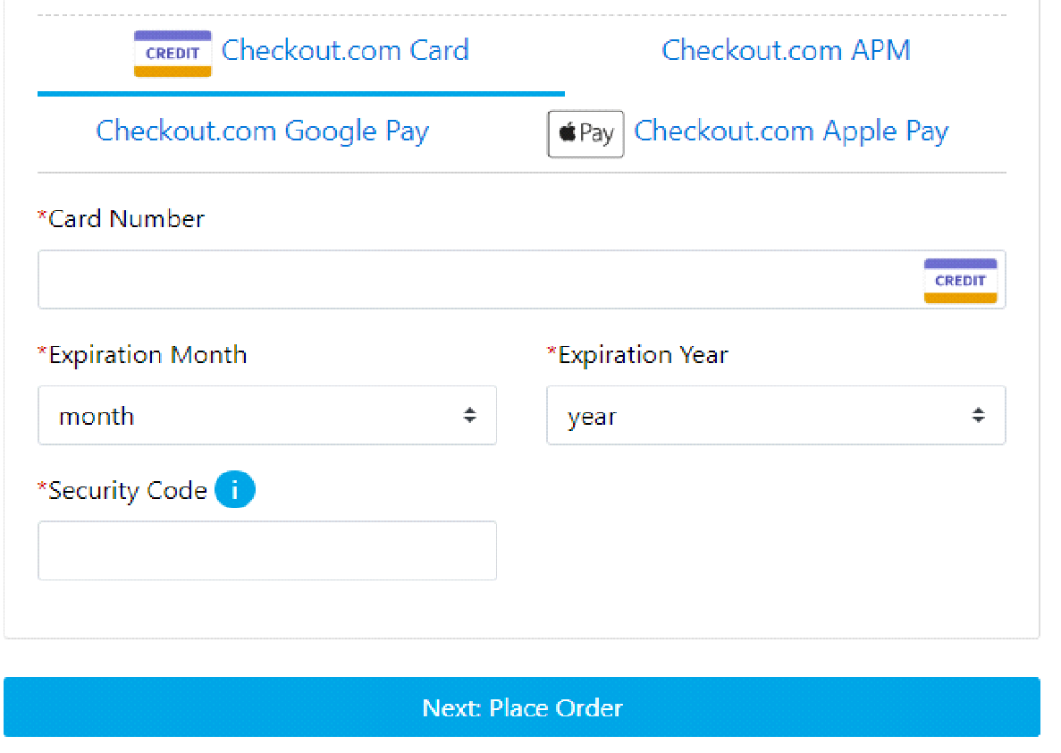

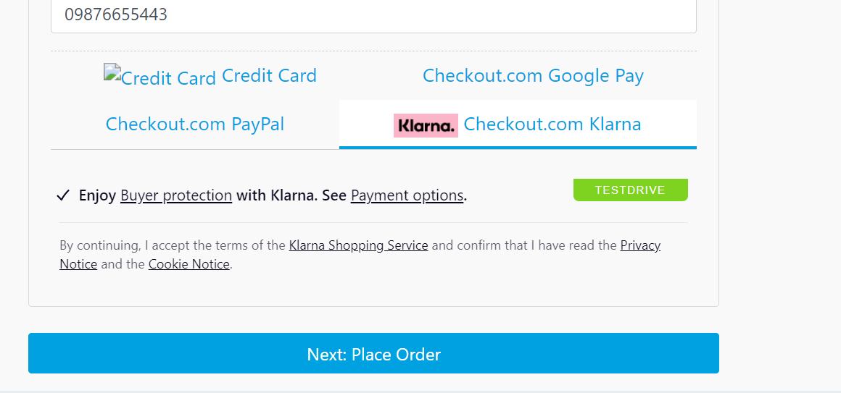

After having chosen a payment option and provided payment details, the shopper can proceed to the order review page.
Clicking on the “Place Order” button will send a charge request to the Checkout.com payment server, without having to redirect the shopper.
In case of successful payment, the shopper will be redirected to the order confirmation page.

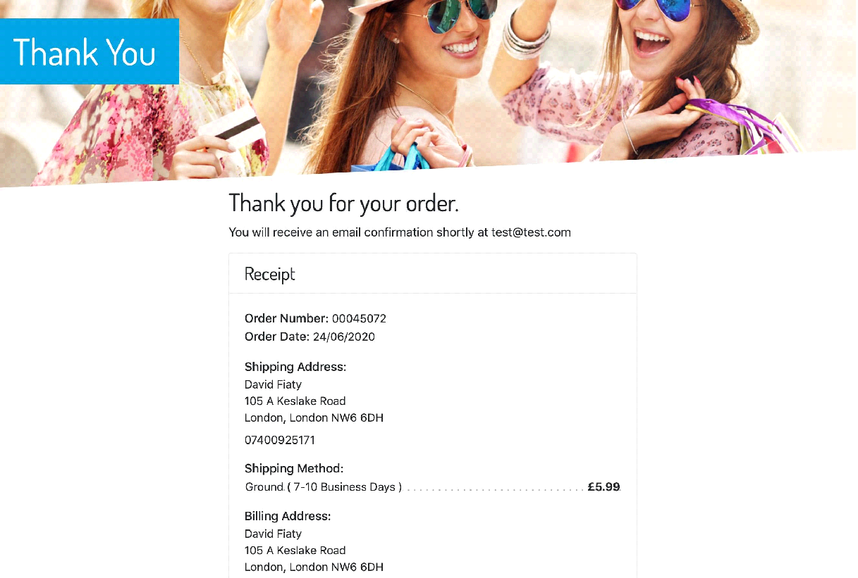

6. Known Issues
No known issues at this time.

