Australia Post (auspost.com.au) - Comprehensive Site Analysis Report V2

Migration Scope & Complexity Assessment - Based on Sitemap URL Analysis

Date: June 2026
Total URLs analyzed: 683
In-scope: 674 pages
Excluded: 5 eCommerce (/shop) + 4 external domain URLs
Source URL: https://auspost.com.au/

Table of Contents
- 1. Templates Inventory
- 2. Blocks / Components Catalog
- 3. Page Counts by Template
- 4. Integrations Analysis
- 5. Complex Use Cases & Observations
- 6. Migration Estimates

1. Templates Inventory
The following 12 unique page templates have been identified across auspost.com.au (excluding eCommerce/shop pages). Templates are categorized based on their structural layout, content patterns, and functional purpose. This V2 analysis is based on actual sitemap CSV data covering 674 in-scope URLs.
Template Name | Complexity | Reasoning | Reference URL Examples
Homepage | High | Hero carousel, tracking widget, quick-links grid, promotional cards, delivery info, shop promo, I-want-to links | https://auspost.com.au/
Category Landing / Hub Page | Medium | Section hero with breadcrumbs, H1 + description, content card grid, FAQ accordion. Primary service categories. | https://auspost.com.au/about-us  https://auspost.com.au/about-us/supporting-communities  https://auspost.com.au/about-us/sustainability
Service/Product Detail Page | Medium | Hero banner, feature bullets with icons, step-by-step cards, location finder, feature cards, FAQ, disclaimers | https://auspost.com.au/receiving/parcel-deliveries/parcel-lockers  https://auspost.com.au/sending/parcels-australia/express-post  https://auspost.com.au/business/shipping/parcels-domestic
Content / Story Page | Medium | Hero image, rich body, YouTube videos, image+text columns, card grids, partnership content, transcript toggles | https://auspost.com.au/about-us/supporting-communities/mental-health  https://auspost.com.au/community-hub/mental-health-wellbeing/beyond-blue-community-van
Article / Blog Page | Low | Standardized article template with title, featured image, body text, author/date, related articles. Used for business guides, selling tips, travel guides. | https://auspost.com.au/business/business-ideas/selling-online/ecommerce-trends  https://auspost.com.au/money-travel/travel-services/tips-and-guides/travel-insurance-for-bali
Tool / Calculator Page | High | Interactive form-based tool, real-time API integration, dynamic results, related product cards | https://auspost.com.au/currency-converter  https://auspost.com.au/parcels-mail/calculate-postage-delivery-times/
Help & Support Hub | High | Category cards, search bar, multi-channel contact, chat widget. Includes Parcel Send help subsection. | https://auspost.com.au/help-and-support  https://auspost.com.au/business/parcel-send-help-and-support
Location Finder / Directory | High (finder) / Low (directory) | Google Maps + autocomplete + filters for finder; alphabetical suburb listing for directory pages | https://auspost.com.au/locate  https://auspost.com.au/locate/post-office/vic
Travel Insurance Product Pages | Medium | Product comparison layout, plan cards, coverage details, quote CTA, claim info, reviews | https://auspost.com.au/travel-insurance  https://auspost.com.au/travel-insurance/compare-travel-insurance-plans
Information / Policy Page | Low | Long-form text with headings, tables, links, footnotes. Legal/policy/pricing content. | https://auspost.com.au/privacy  https://auspost.com.au/terms-conditions  https://auspost.com.au/disruptions-and-updates/pricing-updates
Business Landing Page | Medium | Business-focused hero, service category cards, integration CTAs, marketing solutions | https://auspost.com.au/business  https://auspost.com.au/business/marketing-and-communications
Profile / Bio Page | Low | Person profile with photo, title, bio text. Used for board members, leadership, stakeholder council. | https://auspost.com.au/about-us/corporate-information/board-of-directors/debra-hazelton  https://auspost.com.au/about-us/corporate-information/leadership-team/gary-starr

Note: The site is built on Adobe Experience Manager (AEM) with extensive use of client-side JavaScript for navigation and interactive features. The mega-navigation is shared across all templates.

2. Blocks / Components Catalog
The following 26 reusable blocks and components have been identified across the site. Components are listed with their design variations noted where applicable.
Block Name | Complexity | Description & Behaviour | Reference URL(s)
Global Header / Mega Navigation | High | Multi-level mega menu with 3 audience tabs (Personal, Business, Enterprise & Gov). Collapsible mobile hamburger. Quick links panel (Track, Postcode, etc). Auth0 login button. Coveo-powered search overlay. Responsive breakpoints. | All pages  https://auspost.com.au/
Global Footer | Medium | Two sections: (1) Collapsible "Quick links" and "Read our blogs" accordions, (2) Global footer with legal links, social media icons (Facebook, X, LinkedIn), Help & support link, Aboriginal acknowledgement statement. | All pages  https://auspost.com.au/
Hero Banner | Medium | Full-width hero with background image, H1 heading, description paragraph, and CTA button with arrow icon. Variant with colour overlay (red gradient). Used on homepage and landing pages. | https://auspost.com.au/  https://auspost.com.au/about-us/supporting-communities/mental-health
Tracking Widget | High | Inline search form with text input for tracking number, "Track" button. Integrates with MyPost tracking API. Positioned prominently below hero on homepage. | https://auspost.com.au/
Quick Links Bar (Icon + Text) | Low | Horizontal scrollable list of icon+text link items. Each item has an icon, label, and chevron arrow. Used for primary service shortcuts. | https://auspost.com.au/ (below tracking widget)
Promotional Card (Image + Text + CTA) | Medium | Card with optional image, H4 heading, description paragraph, and one or more CTA links. Used in carousels and grids. Variants: with image, without image, multi-CTA, horizontal layout. | https://auspost.com.au/  https://auspost.com.au/currency-converter  https://auspost.com.au/disruptions-and-updates
Content Card Carousel | Medium | Horizontally scrollable card container showing 2-3 promotional cards at a time with navigation dots/status indicators. Auto-advances. | https://auspost.com.au/ (middle section)
Section Heading + Link List | Low | H2 heading with description paragraph, followed by a vertical list of text links with arrow icons. Used for "Delivery information" section pattern. | https://auspost.com.au/ (Delivery information section)
Shop Promo Block (Image Grid + Text) | Medium | Three image links in a row (Postage, Collectables, Gifts) with a right-side text panel containing eyebrow, heading, description and "Shop now" CTA. | https://auspost.com.au/ (Buy online section)
I Want To (Quick Links Grid) | Low | Vertical list of icon + text links for quick actions. H2 heading "I want to" followed by 10 action links with icons. | https://auspost.com.au/ (bottom section)
Breadcrumbs | Low | Horizontal breadcrumb navigation showing page hierarchy (Personal > Category > Page). Separator arrows between items. | All content pages  https://auspost.com.au/sending/delivery-speeds-and-coverage
Data Table | Medium | Responsive table with header row, service names as row headers with links, data cells. Used for delivery speeds, postcode ranges, pricing. | https://auspost.com.au/sending/delivery-speeds-and-coverage
Feature List (Icon + Text) | Low | Vertical bulleted list where each item has a checkmark/tick icon followed by descriptive text. Used to highlight service benefits. | https://auspost.com.au/receiving/parcel-deliveries/parcel-lockers
Step-by-Step Cards | Medium | Numbered cards (1, 2, 3) with H4 heading and description. Used to explain processes (e.g., "How to use a Parcel Locker"). Cards arranged in a grid. | https://auspost.com.au/receiving/parcel-deliveries/parcel-lockers
Location Finder (Google Maps) | High | Embedded Google Maps with Places Autocomplete search, location type dropdown filter, service filter, geolocation button, search results overlay. Complex third-party integration. | https://auspost.com.au/locate  https://auspost.com.au/receiving/parcel-deliveries/parcel-lockers
FAQ Accordion | Medium | Collapsible FAQ section with H2 heading "Frequently asked questions". Individual questions expand to reveal answers. Dynamically loaded content. "View more FAQs" link. | https://auspost.com.au/sending/delivery-speeds-and-coverage  https://auspost.com.au/receiving/parcel-deliveries/parcel-lockers
Video Embed (YouTube) | Medium | Embedded YouTube iframe player with transcript toggle button. Used for partnership/story content. Multiple videos can appear in a grid layout. | https://auspost.com.au/about-us/supporting-communities/mental-health
CTA Banner (Full Width) | Low | Full-width coloured banner with heading, description text, and primary CTA button. Used as call-to-action section divider. | https://auspost.com.au/receiving/parcel-deliveries/parcel-lockers  https://auspost.com.au/sending/delivery-speeds-and-coverage
Currency Converter Tool | High | Interactive form with amount input (AUD), destination currency searchable dropdown, and "Go" button. Real-time exchange rate API integration. Results display. | https://auspost.com.au/currency-converter
Help Category Cards | Medium | Large clickable cards with icon, H3 title, and description. Used on Help & Support page to route users to correct support channel. 4-card grid layout. | https://auspost.com.au/help-and-support
Contact Channel Block | Medium | Three-column layout with icon, heading (Enquire online / Chat / Call us), description, and action link/button. Chat has "Ask a question" button. Call has expandable phone numbers. | https://auspost.com.au/help-and-support
Search Bar (Coveo) | High | Full-width search input with placeholder text and search button. Powered by Coveo search platform. Returns AI-assisted search results. Used on Help and global search. | https://auspost.com.au/help-and-support  All pages (header search)
App Download Banner | Low | Promotional block with bulleted features list, App Store and Google Play badge links. Used to promote AusPost mobile app. | https://auspost.com.au/disruptions-and-updates
Disclaimer / Footnotes | Low | Text block with superscript number references and corresponding footnote paragraphs with legal/disclaimer text. Common at page bottom. | https://auspost.com.au/currency-converter  https://auspost.com.au/receiving/parcel-deliveries/parcel-lockers
Alert / Notice Banner | Low | Inline notification bar with icon, text message, and optional dismiss button. Used for cookie consent and service disruption alerts at page top. | https://auspost.com.au/ (cookie banner)  https://auspost.com.au/locate
Suburb Index / Directory Listing | Low | Alphabetical listing component with state dropdown, letter filter tabs, and linked list of suburb names. Used for location directory pages. | https://auspost.com.au/locate/post-office/vic

Screenshots Reference
The following screenshots have been captured for visual reference:
- Homepage (full page)
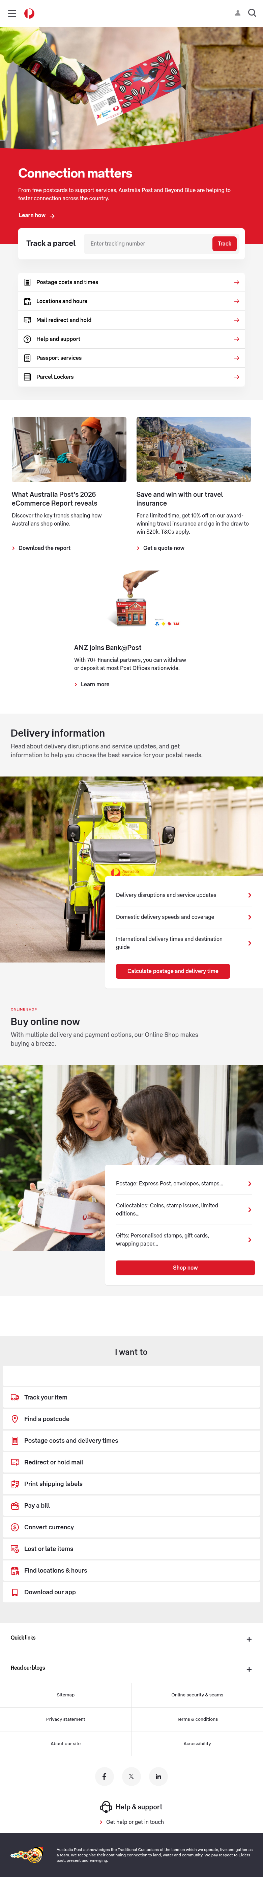

- Content Page - Delivery Speeds & Coverage
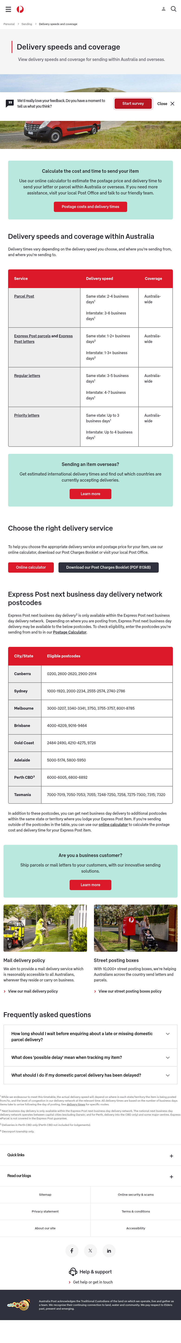

- Content Page - Mental Health (Story template)
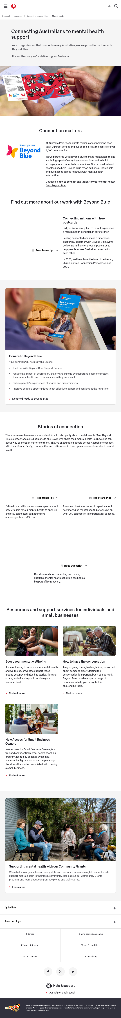

- Service Page - Parcel Lockers
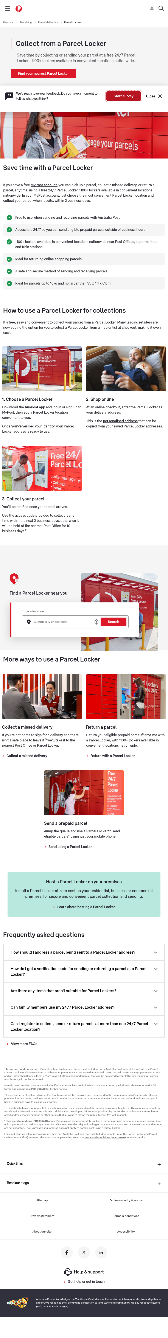

- Tool Page - Currency Converter
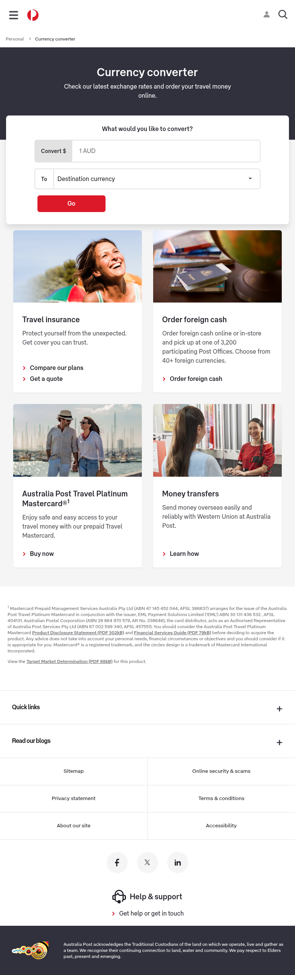

- Location Finder
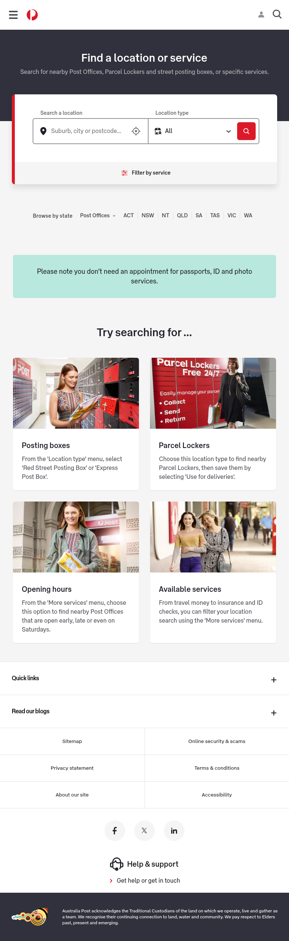

- Help & Support Hub
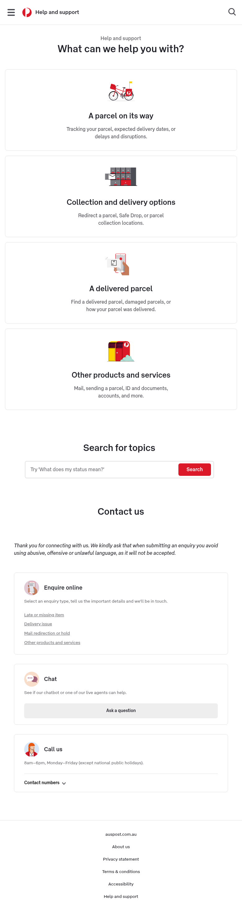

3. Page Counts by Template
Based on actual sitemap CSV analysis (683 total URLs, 674 in-scope after excluding 5 eCommerce/shop URLs and 4 external domain URLs), the following distribution has been determined by template type:
Template Type | Pages | Auto-Migration | Manual Migration | Notes
Homepage | 1 | No | Yes | Unique layout, multiple interactive widgets
Category Landing / Hub Page | 20 | Partial | Partial | Standard card layouts auto; custom widgets manual
Service/Product Detail Page | 120 | Yes (mostly) | Some | Standardized content; Maps embeds need manual
Content / Story Page | 93 | Yes (mostly) | Some | Rich text auto; YouTube/interactive manual
Article / Blog Page | 181 | Yes | No | Highly standardized article template, bulk auto-migratable
Tool / Calculator Page | 2 | No | Yes | Heavy API integrations, custom development
Help & Support Hub | 43 | Partial | Partial | Hub page manual; help articles auto-migratable
Location Finder / Directory | 17 | Partial | Partial | Directory pages auto (16); Map finder manual (1)
Travel Insurance Product Pages | 12 | Partial | Partial | Product pages content auto; quote integration manual
Information / Policy Page | 50 | Yes | No | Simple long-form text, highly standardized
Business Landing Page | 14 | Partial | Partial | Standard content auto, integrations manual
Profile / Bio Page | 30 | Yes | No | Simple bio+photo template, bulk migratable
Misc Landing Pages | 8 | No | Yes | Custom campaign/referral pages
TOTAL (in-scope) | 674* | ~450 auto (67%) | ~224 manual (33%) | *Excludes 5 eCommerce + 4 external

Migration Classification Summary
- Automatically Migratable (~67%): Pages with standardized content models, simple text + image layouts, consistent templates (articles, policy pages, guides, directory listings, bio pages, standard content pages)
- Requires Manual Migration (~33%): Pages with dynamic functionality, third-party integrations, custom interactive tools, unique layouts, and complex JavaScript-driven features

4. Integrations Analysis
The following 21 third-party integrations and services have been identified through script analysis, network requests, and page inspection:
Integration Name | Type | Complexity | Purpose & Pages Used
Adobe Experience Manager (AEM) | CMS Platform | High | Core CMS powering all pages. AEM clientlibs, components, and DAM assets throughout.
Adobe Launch (DTM) | Tag Manager | Medium | Adobe Data Collection tag manager (assets.adobedtm.com). Manages all marketing tags.
New Relic (Browser APM) | Monitoring | Low | Real User Monitoring (RUM) via nr-spa-1216.min.js. Performance tracking. All pages.
FullStory | Session Analytics | Medium | Session replay (edge.fullstory.com). NPS surveys, site intercepts, datalayer. All pages.
Google Tag Manager / GA4 / Ads | Analytics/Ads | Medium | GTM, GA4 (G-00W0WNR1CM), Google Ads (AW-964765464), DoubleClick (DC-4621208). All pages.
Facebook Pixel | Advertising | Low | Facebook Events tracking (pixel: 662331570529793) with scroll depth and microdata. All pages.
LinkedIn Insights | Advertising | Low | LinkedIn analytics tag (snap.licdn.com) for audience building. All pages.
Coveo Search | Enterprise Search | High | AI search platform (platform-au.cloud.coveo.com). Powers site search and Help search.
Auth0 (Authentication) | Identity/Auth | High | Auth0 SPA auth (welcome.auspost.com.au). MyPost login, session management. All pages.
Google Maps Platform | Maps/Geo | High | Maps JS API + Places Autocomplete. Location finder on /locate and Parcel Locker pages.
YouTube (Embedded) | Video | Low | YouTube iframe embeds for video content. Community/story pages.
Vudoo | Interactive Media | Medium | Interactive content platform (vudoo.io). Enhanced media on community pages.
Custom Analytics (dd.auspost) | Analytics | Medium | Custom analytics endpoint (dd.auspost.com.au/tags.js). Internal analytics aggregation.
Covermore (Travel Insurance) | Partner API | High | Travel insurance quotes (auspost.poweredbycovermore.com). Partner integration.
Western Union | Partner Service | Medium | International money transfer service integration. Money-travel section.
Post BillPay | External Platform | Medium | Bill payment platform (www.postbillpay.com.au). External redirect.
Salesforce (Help Portal) | CRM/Support | High | Salesforce help portal (helpandsupport.auspost.com.au). Forms, chatbot, case mgmt.
DataGuard (Bot Protection) | Security | Medium | CAPTCHA/bot protection (geo.captcha-delivery.com). Conditional trigger.
MyPost Tracking API | Internal API | High | Parcel tracking service (auspost.com.au/mypost/track). Real-time tracking. Homepage.
Postage Calculator API | Internal API | High | Rate calculation engine. Dynamic pricing based on weight/size/destination.
Coveo AI Search | AI Platform | High | AI-powered search (platform-au.cloud.coveo.com). Headless engine with organization endpoints.

5. Complex Use Cases & Observations
The following 14 complex behaviours, edge cases, and functionality require special attention during migration:
Use Case | Instances | Location | Why It Is Complex
Authenticated User State (Auth0 SSO) | All pages (~674) | Global header login/user menu | Auth0 silent auth runs on every page via iframe. User state changes nav options and personalized content. Requires SSO architecture decision.
Coveo AI-Powered Search | 2 implementations | Header search + /help-and-support | Enterprise search with Headless engine, organization endpoints, platform URL config. Requires Coveo SDK and API keys.
Multi-Level Mega Navigation | 1 (global) | All pages - header | 4-level nested nav with 3 audience segments, mobile responsive, keyboard accessible, context-sensitive help links per page.
Google Maps Location Finder | 2-3 pages | /locate, /parcel-lockers | Full Maps SDK + Places Autocomplete + geolocation + custom markers + location API. March 2025 pricing changes add cost.
Real-Time Tracking Widget | 2+ pages | Homepage, /mypost/track/ | Live parcel tracking with API calls. Authenticated and unauthenticated flows. Status polling.
Postage Calculator (Dynamic Pricing) | 1 SPA | /parcels-mail/calculate-postage-delivery-times/ | Multi-step form, real-time pricing API, weight/size validators, service comparison, delivery date estimation. Heavy JS app.
Currency Converter (Live Rates) | 1 page | /currency-converter | Live exchange rate API with 40+ currencies. Searchable dropdown, real-time calculation.
Live Chat / Chatbot | 1+ pages | /help-and-support | AI chatbot with live agent escalation. Salesforce integration. Real-time messaging.
Bot Protection / CAPTCHA | Conditional | All pages (triggered) | DataGuard CAPTCHA blocks automated access. Will interfere with migration scraping. Needs IP whitelisting.
FullStory NPS Surveys | All pages (conditional) | Dynamic overlay/modal | Conditional NPS display based on cookies and probability. Config + usecase logic + view rendering.
Context-Sensitive Help Links | All pages | Footer help link | Each page sets different help category code (DelNet100, DelLoc600, etc.) for contextual FAQ routing.
Dynamic FAQ Loading | ~10+ pages | Service pages (FAQ sections) | FAQ content loaded dynamically (shows "Loading..." initially). Fetched from external CMS/Salesforce KB.
Location-Specific Pages | 4000+ locations | /locate/post-office/{state}/{suburb}/{postcode} | Individual location pages from database. Requires data feed and dynamic page generation system.
Partner Service Redirects | 5+ integrations | BillPay, Covermore, Western Union | External partner platforms with session continuity and return-URL handling.

6. Migration Estimates
The following estimates are based on the 674 in-scope pages, 12 templates, 26 components, 21 integrations, and complexity levels identified. Estimates assume a team of 3-4 frontend developers, 1 AEM/EDS specialist, and 1-2 QA engineers.

6.1 Effort Breakdown
Phase | Tasks | Effort (Days) | Notes
Discovery & Planning | Template mapping, content model, integration architecture | 12-18 | Stakeholder workshops, technical design
Infrastructure Setup | EDS project, block library, build pipeline, preview env | 5-8 | Foundation work
Global Components | Header/mega-nav, footer, breadcrumbs, Coveo search, Auth0 | 20-30 | Highest complexity
Block Dev (Low) | Hero, CTA, quick links, feature lists, disclaimers, alerts, app download, profile card | 12-15 | ~9 blocks x 1-1.5 days
Block Dev (Medium) | Cards, carousels, tables, step-by-step, FAQ, video, help cards, contact, shop promo, insurance cards | 20-28 | ~10 blocks x 2-3 days
Block Dev (High) | Tracking widget, location finder, currency converter, Coveo search, suburb directory | 25-35 | ~5 blocks x 5-7 days
Template Assembly | Build all 12 templates, test responsive | 18-24 | Assembly + testing
Automated Content Migration | Script-based migration of ~450 pages (articles, policies, guides, bios, directories) | 12-18 | Import scripts + validation
Manual Content Migration | Custom migration of ~224 pages with tools, integrations, custom layouts | 35-50 | Page assembly + integration testing
Integration Development | Auth0, Coveo, Google Maps, Tracking API, Calculator API, chat, analytics | 22-32 | Complex API work
QA & Testing | Cross-browser, accessibility, performance, UAT, regression | 22-30 | All pages, all breakpoints
Content Freeze & Cutover | Final sync, DNS, go-live support, monitoring | 5-7 | Coordinated cutover
TOTAL |  | 208-295 days | Range for unknowns

6.2 Timeline Estimate
Phase | Duration | Team Size | Dependencies
Discovery & Planning | Weeks 1-3 | 3-4 people | Stakeholder availability
Infrastructure & Global Components | Weeks 3-9 | 3 developers | Design tokens, API credentials
Block Development | Weeks 6-15 | 2-3 developers | Approved designs
Template Assembly & Content Migration | Weeks 13-22 | 3-4 people | Blocks complete
Integration Development | Weeks 8-20 | 2 developers | API access, partner coordination
QA & Testing | Weeks 18-25 | 2 QA engineers | Feature complete
UAT & Go-Live | Weeks 25-28 | Full team | Business sign-off
TOTAL | ~28 weeks (7 months) | 4-5 FTE average | Parallel workstreams

6.3 Cost Estimate Summary
Category | Effort Range | Cost (AUD)*
Automated Migration | 30-40 days | $60,000 - $80,000
Manual/Custom Migration | 110-150 days | $220,000 - $300,000
Block & Template Development | 75-112 days | $150,000 - $224,000
QA & Testing | 22-30 days | $44,000 - $60,000
Project Management | 28 weeks x 0.5 FTE | $56,000 - $70,000
TOTAL |  | $530,000 - $734,000

* Blended rate AUD $2,000/day

6.4 Key Risks & Assumptions
- Bot protection may block scraping
- Auth0 integration complexity
- Coveo requires licensed access
- Google Maps API cost increase
- 4000+ location pages need data feed
- External partner coordination needed
- Content freeze business impact
- Dynamic FAQ source migration
- Analytics re-instrumentation
- Mobile app deep links routing

Document End
This V2 analysis was conducted in June 2026 based on actual sitemap CSV data from auspost.com.au (683 URLs total, 674 in-scope). Dynamic content, authenticated areas, and internal systems were not assessed. Estimates should be validated with Australia Post technical teams who have access to the full AEM authoring environment.

