Krungthai Bank Website Analysis
Comprehensive Site Analysis & Migration Assessment

Target Site: https://krungthai.com/
Date: April 2026
Prepared for: AEM Edge Delivery Services Migration

Table of Contents
1. Executive Summary
2. Templates Inventory
3. Blocks / Components Catalog
4. Page Counts by Template
5. Integrations Analysis
6. Complex Use Cases & Observations
7. Migration Estimates
8. Appendix: Screenshots

1. Executive Summary
This document provides a comprehensive analysis of the Krungthai Bank website (krungthai.com) for migration to Adobe Experience Manager (AEM) Edge Delivery Services. Krungthai Bank is one of Thailand's largest state-owned commercial banks, and its website serves multiple customer segments (Personal, SME, Corporate) with bilingual content (Thai/English), banking products, investor relations, sustainability reporting, and various financial tools.

Key Findings
- 14 distinct page templates identified across personal, corporate, IR, and sustainability sections
- 22 reusable blocks/components cataloged with complexity ratings
- Bilingual site (Thai/English) with mirrored /th/ and /en/ URL structure
- Multiple customer segments with shared global navigation but segment-specific content
- Live exchange rate feed from external subdomain (exchangerate.krungthai.com)
- Loan calculator and financial planning tools requiring JS reimplementation
- Stock price widget via embedded iframe on Investor Relations pages
- Branch/ATM locator with province/district dropdown filtering and geolocation
- Heavy use of jQuery-based carousels (slick.js) across all page types
- Multiple external platform integrations (Internet Banking, Corporate Online, Krungthai BUSINESS, Careers portal, Complaint system)
- PDPA (Thailand Personal Data Protection Act) cookie consent banner on all pages
- Estimated ~350-500 content pages across Thai and English versions

2. Templates Inventory
The following table lists all unique page templates identified across the Krungthai Bank website. The site uses a consistent layout framework with segment-specific variations.
Template ID & Name | Complexity | Description | Reference URL(s)
T01 - Personal Banking Homepage | High | Hero carousel (5+ slides with auto-play), "Quick Help" service shortcuts carousel, promotions carousel, live exchange rate table, calculator tools section, financial partner articles carousel, news/updates carousel, social media links. Heavy JS. | https://krungthai.com/th/personal
T02 - Product Category Listing | Medium | Hero carousel showcasing products, product card grid/carousel with interest rate and term details, loan calculator form, benefits USP icons, CTA to branch/app, related articles carousel, FAQ accordion (10+ items), breadcrumbs, social share. | https://krungthai.com/th/personal/loan/personal-loan  https://krungthai.com/th/personal/cards/debit-card
T03 - Product Detail Page | High | Product hero banner, tabbed content (features, eligibility, documents, fees), interest rate tables, step-by-step application guide, document download links, related products carousel, FAQ section, CTA buttons (Apply via app / at branch). | https://krungthai.com/th/personal/loan/personal-loan/22  https://krungthai.com/th/personal/deposits/211/640
T04 - Corporate Banking Hub | Medium | Same global layout as personal but with corporate-specific hero carousel, service categories (Cash Management, International, Business Loans), exchange rate widget, corporate news feed. Links to Krungthai BUSINESS platform. | https://krungthai.com/th/corporate
T05 - SME Landing Page | Medium | SME-specific hero, product cards for SME loans and services, success stories carousel, financial education content. | https://krungthai.com/th/content/sme
T06 - Investor Relations Hub | High | Hero banner, embedded stock price iframe widget, investor events calendar with date formatting, SET filing documents with PDF/ZIP downloads, Investor Kits tabbed by quarter (Q1-Q4), investor information cards carousel, chairman message section, contact details grid, FAQ accordion. | https://krungthai.com/th/investor-relations
T07 - News/Update Listing | Medium | News cards with thumbnail, date badge, category tag (News/Announcement), pagination or carousel navigation, category filter tabs. | https://krungthai.com/th/krungthai-update/news
T08 - News/Article Detail | Medium | Back navigation, category badge, article title (H1), publish date, hero image, rich text body with bullet lists and bold formatting, CTA buttons, related news carousel (5+ items), breadcrumbs, social share bar (Facebook, Line, Twitter, Embed). | https://krungthai.com/th/krungthai-update/news-detail/3457
T09 - Sustainability Hub | Medium | CSR project hero carousel, sustainability pillars navigation cards carousel, CSR project gallery carousel, CSR news feed carousel, sustainability report download section with PDF link. | https://krungthai.com/th/sustainability
T10 - About Bank Hub | Medium | Hero with vision/mission, quick-access cards (History, Board, Achievements, Structure), subsidiaries logo grid, corporate governance links, risk management section, career section. | https://krungthai.com/th/about-ktb
T11 - Content/Static Page | Low | Simple rich text content page with header, body text, optional images, breadcrumbs, social share. Used for privacy policy, disclaimer, PDPA forms, legal pages. | https://krungthai.com/th/content/privacy-policy  https://krungthai.com/th/content/contact-us/disclaimer
T12 - Branch/ATM Locator | High | Province/district dropdown filters, business hours filter, geolocation "Find Nearby" button, results list by service type (Branch, ATM, FX Counter), tab for domestic vs. international branches. Map integration. | https://krungthai.com/th/contact-us/ktb-location
T13 - Rates & Fees Page | Medium | Tabbed interest rate tables, fee schedules, exchange rate links, downloadable PDF documents. Data-heavy with structured tables. | https://krungthai.com/th/rates
T14 - Financial Calculator/Tool | High | Interactive form with dropdowns (occupation, income, amount, term), real-time calculation engine, results display, financial planning tool with multiple scenarios. | https://krungthai.com/th/financial-partner/calculator-tool/2  https://krungthai.com/th/financial-partner/calculator/financial-planning

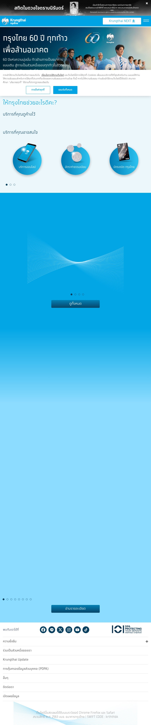
Figure 1: Personal Banking Homepage (T01)

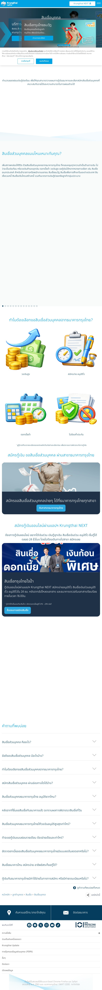
Figure 2: Product Category Listing - Personal Loans (T02)

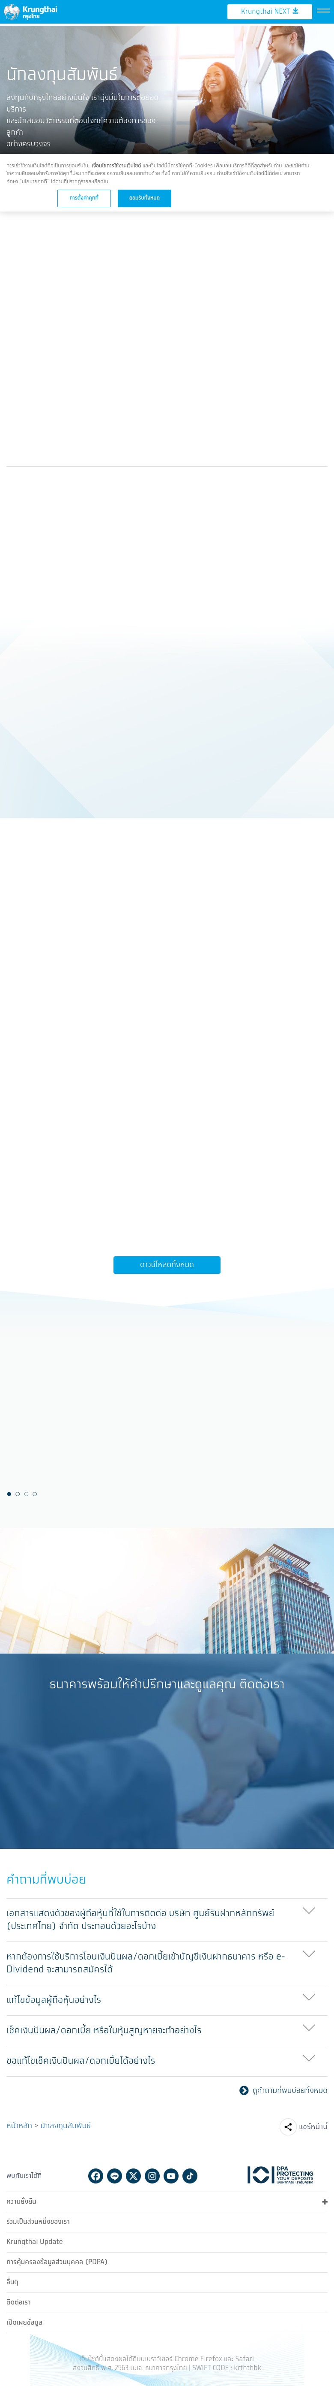
Figure 3: Investor Relations Hub (T06)

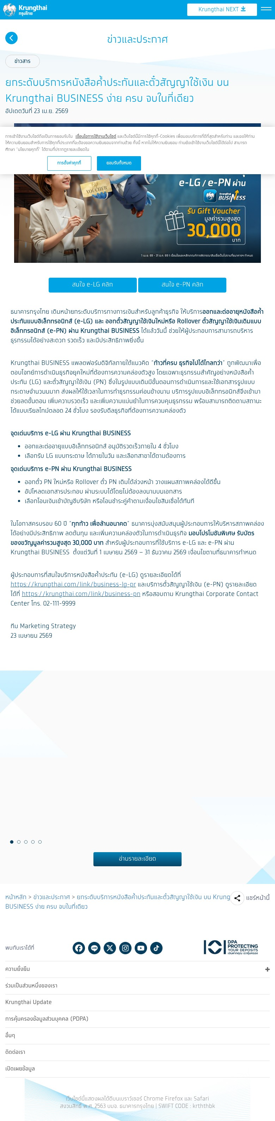
Figure 4: News Article Detail (T08)

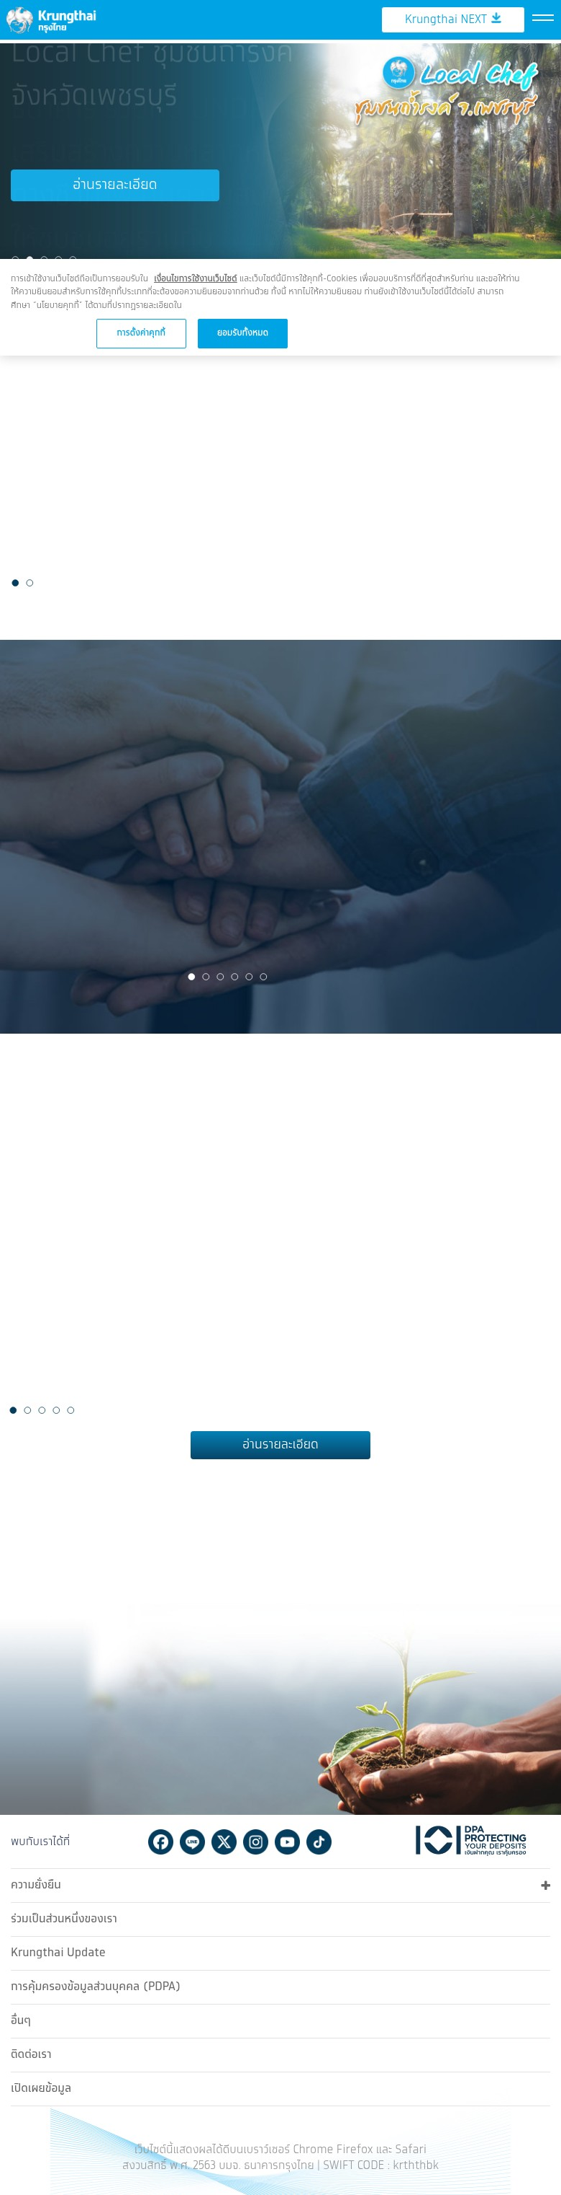
Figure 5: Sustainability Hub (T09)

3. Blocks / Components Catalog
The following catalog identifies all reusable blocks and components across the Krungthai Bank site. Design variations of the same content model are noted as variants rather than separate blocks.
Block ID & Name | Complexity | Description & Functionality | Reference URL(s)
B01 - Global Header | High | Bank logo, Krungthai NEXT app download CTA, hamburger menu, mega-menu with 9 customer segments (Personal, SME, Corporate, Financial Partner, IR, Sustainability, About, Contact, Rates), language toggle (TH/EN), text size controls, search icon. Mobile: full-screen overlay menu with multi-level navigation. | All pages
B02 - Global Footer | Medium | DPA (Data Protection) badge, social media icons (Facebook, Line, X/Twitter, Instagram, YouTube, TikTok), collapsible accordion sections (Sustainability, Careers, Krungthai Update, PDPA, Others, Contact, Disclosure), copyright with SWIFT code. | All pages
B03 - Hero Carousel | High | Full-width image carousel with auto-play, prev/next arrows, dot pagination. Responsive images (desktop/mobile variants). Overlay text with title, description, and CTA link. Used on homepage, product pages, sustainability, IR. Multiple design variants. | Homepage, Product, Sustainability, IR pages
B04 - Product Card Carousel | High | Horizontal scrolling product cards. Each card: product image, title, description, interest rate display, loan term, "Read Details" CTA. Dot pagination. Used for loans, deposits, cards, insurance products. | Product listing pages
B05 - Promotion Card Carousel | Medium | Image thumbnail cards with title overlay. Links to promotion detail pages. Horizontal scroll with dot navigation. "View All" link. | Homepage, product pages
B06 - Exchange Rate Table | High | Live currency rate display with flag icons (USD, GBP, EUR, JPY, HKD), buy/sell columns, last update timestamp, "View All" link to external exchangerate.krungthai.com. Real-time data feed. | Homepage (Personal, Corporate)
B07 - Loan Calculator Form | High | Interactive form: occupation dropdown, monthly income input, desired amount input, repayment period dropdown (12-60 months), "View Calculation" submit button. Client-side JS calculation. Results display area. | Personal loan listing page
B08 - FAQ Accordion | Low | Expandable Q&A pairs (10+ items typical). Each item has question header with toggle button, collapsible answer panel. Schema.org FAQ markup for SEO. "View All FAQ" link. | Product pages, IR page
B09 - Quick Help / Service Shortcuts | Medium | Circular icon cards carousel with service labels (Online Services, Fees, Debit Card, Transaction Code, Loans, etc.). "Services you may be interested in" heading. Dot pagination. | Homepage
B10 - News Card Carousel | Medium | News item cards with thumbnail image, date badge with category (News/Announcement), headline text. Horizontal carousel with dot pagination. "Read Details" link. | Homepage, news listing, article detail (related)
B11 - Financial Partner Articles | Medium | Article cards with thumbnail, category badge (SME Tips, Loans, etc.), article title. Horizontal carousel. "View All" link. | Homepage, product pages
B12 - Breadcrumb Navigation | Low | Hierarchical path with ">" separators. Links to parent pages. Current page at end. | All interior pages
B13 - Social Share Bar | Low | Facebook, Line, Twitter/X, Embed link sharing icons. "Share this page" toggle. Horizontal layout. | All content/detail pages
B14 - Cookie Consent Banner | Low | PDPA-compliant bottom overlay. Accept all / Cookie settings buttons. Link to disclaimer. Privacy dialog with consent management. | All pages (first visit)
B15 - Contact/CTA Bar | Low | Fixed bottom bar with "Find Branch/Phone" and "Contact Bank" icon links. Links to branch locator and contact page. | Product pages
B16 - Investor Kits Tabs | Medium | Quarterly tab navigation (Q1-Q4). Each tab shows document thumbnails (Factsheet, Analyst Presentation, MD&A, Financial Statements) with download links. "Download All" button. | Investor Relations hub
B17 - Stock Price Widget | High | Embedded iframe displaying live KTB stock price from external source. Real-time data feed. | Investor Relations hub
B18 - Investor Calendar | Medium | Event list with formatted dates (day, month, year in Thai), event description. "View All" link to full calendar. | Investor Relations hub
B19 - SET Filing Documents | Medium | Document cards with thumbnail, title, download icon. PDF and ZIP file types. Links to /Download/ directory. | Investor Relations hub
B20 - Benefits/USP Icons Row | Low | Horizontal row of icon + text pairs highlighting product benefits (e.g., High Credit, Easy Apply, Low Interest, No Guarantor). Typically 4 items. | Product listing pages
B21 - App Download CTA Block | Medium | Featured image of loan product, title, description, disclaimer text, "Application Steps" CTA button. Promotes Krungthai NEXT app for online applications. | Product listing pages
B22 - Sustainability Report Download | Medium | Report cover image, title, year, download CTA button (PDF link), "View All" link to reports listing. Background image styling. | Sustainability hub

4. Page Counts by Template
Estimated page counts based on navigation structure, URL patterns, and content analysis. Counts include both Thai (/th/) and English (/en/) versions.
Template | Est. Page Count | Migration Type | Notes / Rationale
T01 - Personal Banking Homepage | 2 (TH+EN) | Manual | Complex multi-carousel layout, live data feeds, personalized recommendations.
T02 - Product Category Listing | ~20-25 | Semi-Automatic | Deposits, Cards, Loans, Insurance, Investment, Cash Mgmt categories. Standardized template with calculator variants.
T03 - Product Detail Page | ~80-120 | Semi-Automatic | Individual banking products (each loan type, card, deposit product, insurance plan). Structured data can be imported but tabbed content needs manual review.
T04 - Corporate Banking Hub | 2 (TH+EN) | Manual | Corporate-specific layout with different product categories and CTA flows.
T05 - SME Landing Page | 2 (TH+EN) | Manual | Custom layout for SME segment.
T06 - Investor Relations Hub | 2 (TH+EN) | Manual | Complex: stock widget iframe, calendar, document downloads, tabbed kits.
T07 - News/Update Listing | ~5-8 | Semi-Automatic | News listing, promotion listing, announcement listing, CSR news listing.
T08 - News/Article Detail | ~200-300+ | Automatic | Standardized article content with image + rich text. Ideal for bulk import. IDs go to 3400+.
T09 - Sustainability Hub + Sub-pages | ~15-20 | Semi-Automatic | Hub + ESG policy pages, CSR projects (~20 items), growing together sub-pages.
T10 - About Bank Hub + Sub-pages | ~15-20 | Semi-Automatic | Hub + history, org chart, board members, governance, risk management, career pages.
T11 - Content/Static Pages | ~20-30 | Semi-Automatic | Privacy, disclaimer, PDPA forms, sitemap, whistle-blowing, legal. Simple rich text.
T12 - Branch/ATM Locator | 2 (TH+EN) | Manual | Complex: Province/district filters, geolocation, map integration, results display.
T13 - Rates & Fees Page | ~5-8 | Manual | Data tables, interest rate schedules, downloadable PDFs. Data frequently updated.
T14 - Financial Calculator/Tool | ~3-5 | Manual | Custom JS calculation engines. Loan calculator, financial planning tool, FX tools.

Summary Totals
Migration Category | Est. Pages | Includes
Automatic Migration (bulk import) | ~200-300 | News articles, promotion detail pages, CSR news articles
Semi-Automatic (template + review) | ~150-200 | Product pages, product listings, about sub-pages, sustainability sub-pages, static content
Manual Migration (custom development) | ~30-40 | Homepages, IR hub, branch locator, calculators, rates pages, corporate hub
TOTAL ESTIMATED PAGES | ~380-540 | All content across Thai and English versions

5. Integrations Analysis
Integration Name | Type | Complexity | Description | Reference URL(s)
jQuery / jQuery Migrate 1.4.1 | Custom Code / Framework | Medium | Core JS framework powering all interactive elements. jQuery Migrate for backward compatibility. Must be replaced with vanilla JS or modern framework for EDS. | All pages
Slick.js Carousel | Plugin / UI | Medium | Used for all carousels site-wide (hero, products, promotions, news, articles). Multiple instances per page with different configurations. | All pages with carousels
Exchange Rate Feed | API / External | High | Live currency rates from exchangerate.krungthai.com. Displays USD, GBP, EUR, JPY, HKD with buy/sell prices and timestamp. | Homepage (Personal + Corporate)
Stock Price Widget (iframe) | Embed / External | High | Embedded iframe showing real-time KTB stock price data. Source appears to be SET (Stock Exchange of Thailand) or third-party provider. | https://krungthai.com/th/investor-relations
Krungthai NEXT App Integration | Embed / Mobile | Medium | QR code for app download, deep links to app features. Prominent CTA across site for online loan applications and banking. | All pages (header CTA)
Facebook Share API | API / Social | Low | Share functionality via Facebook sharer URL. Social media link in footer. | All content pages, footer
LINE Share API | API / Social | Low | Share functionality via lineit.line.me share URL. Footer link to LINE official account. | All content pages, footer
Twitter/X Share API | API / Social | Low | Share functionality via twitter.com share URL. | All content pages
PDPA Cookie Consent Manager | Custom Code / Compliance | Medium | Thailand Personal Data Protection Act compliant consent banner. Accept/Settings dialog. Required for legal compliance. | All pages
Internet Banking (ktbnetbank.com) | External Platform | Low | External link to consumer Internet Banking portal. No embedded integration. | Footer, E-Banking menu items
Corporate Online (newcb.ktb.co.th) | External Platform | Low | External link to corporate banking portal. | Corporate section, footer
Krungthai BUSINESS (business.krungthai.com) | External Platform | Low | External link to business banking platform. Featured in corporate news articles. | Corporate section, news articles
Careers Portal (careers.hr-krungthaigroup.com) | External Platform | Low | External HR/recruitment system. Link in footer and About section. | Footer, About Bank section
Complaint System (complaint.krungthai.com) | External Platform | Low | External complaint/feedback submission system. | Contact section, footer
E-Procurement (eprocurement.krungthai.com) | External Platform | Low | External procurement platform link. | Footer
NACC ITA Assessment (itas.nacc.go.th) | External / Government | Low | Link to National Anti-Corruption Commission assessment. | Footer disclosure section
PDF/ZIP Document Downloads | Custom Code / CDN | Medium | Document serving from /Download/ directory. Financial statements (ZIP), press releases (PDF), sustainability reports, investor kits. | IR, Sustainability, About pages

6. Complex Use Cases & Observations
Use Case | Instances / Scope | Where Found | Description | Why Complex / Migration Impact
Bilingual Content (Thai/English) | Entire site (~380-540 pages x2) | All pages (/th/ and /en/ paths) | Full site mirrored in Thai and English with /th/ and /en/ URL prefixes. Navigation, content, and product details must be maintained in both languages. | Requires i18n content model. Consider EDS language copies or translation workflow integration.
Live Exchange Rate Feed | 2 pages (Personal + Corporate homepages) | Homepage exchange rate table | Real-time currency data from exchangerate.krungthai.com with buy/sell rates and timestamps. Updates throughout the day. | Needs API integration or server-side data fetching. Cannot be static content. Consider client-side fetch or edge function.
Stock Price Widget (iframe) | 1 page (IR hub) | https://krungthai.com/th/investor-relations | Embedded iframe displaying real-time KTB stock data. External dependency on stock data provider. | iframe embed approach works for EDS. Need to confirm cross-origin security and responsive sizing.
Loan Calculator Engine | ~3 pages | Product listing pages (Personal Loans) | Client-side calculation with occupation dropdown, income, amount, and term inputs. Real-time computation of monthly payments. Complex financial formulas. | Must reimplemented as EDS block with vanilla JS. Calculation logic must be precisely replicated.
Branch/ATM Locator | 2 pages (TH+EN) | https://krungthai.com/th/contact-us/ktb-location | Multi-criteria search: 77 provinces, districts, business hours. Geolocation "Find Nearby" button. Results categorized by service type. Map display. | Most complex page. Needs backend API for location data, possible Google Maps integration, geolocation API.
Multi-segment Navigation | All pages | Global header | 9 customer segments (Personal, SME, Corporate, Financial Partner, IR, Sustainability, About, Contact, Rates) with deep multi-level mega-menu. Mobile: full-screen overlay with back-navigation. JavaScript-driven menu state. | Complex mega-menu block needed. Segment switching changes available sub-navigation. Consider conditional content loading.
Investor Kits Quarterly Tabs | 1 page | IR hub | Tabbed document section with Q1-Q4 navigation. Each tab shows 4 document types (Factsheet, Analyst Presentation, MD&A, Financial Statements) with download links. | EDS tabbed block with dynamic content per quarter. Document management for quarterly updates.
PDPA Compliance Requirements | All pages | Cookie consent banner, privacy policy | Thailand Personal Data Protection Act (PDPA) mandates consent management, privacy policy, data subject rights forms. Cookie banner with settings dialog. | Legal requirement. Must implement PDPA-compliant consent management. DPA badge in footer.
Carousel-Heavy Design Pattern | ~30+ pages | All major page types | Every major page uses multiple slick.js carousels: hero, products, promotions, articles, news. Some pages have 5+ carousels. Performance concern. | Replace with EDS-native lightweight carousel block. Consider reducing carousel count for performance. Critical for Core Web Vitals.
Document Download System | ~10 pages | IR, Sustainability, About | Financial statements (ZIP), press releases (PDF), sustainability reports, corporate governance documents served from /Download/ path. Version management by quarter/year. | Need DAM integration for document management. Consider EDS document listing block with proper metadata.

7. Migration Estimates
Estimates assume a team of 2-3 EDS developers, 1 content migration specialist, and 1 QA engineer.

7.1 Effort Breakdown by Phase
Task / Activity | Estimated Duration | Migration Type | Notes
Phase 1: Discovery & Design System
Design token extraction (KTB blue palette, typography) | 2-3 days | Semi-Automatic | Extract Krungthai brand colors, fonts, spacing from existing CSS
Template architecture design (14 templates) | 3-5 days | Manual | Map templates to EDS page structures with bilingual support
Block specification & design (22 blocks) | 4-5 days | Manual | Define block specs with content models for Thai/English
Phase 2: Block Development
Global Header (mega-menu, 9 segments) | 5-6 days | Manual | Most complex block with multi-level navigation and segment switching
Global Footer (accordion sections) | 2 days | Manual | Collapsible sections with DPA badge
Hero Carousel (3+ variants) | 3-4 days | Manual | Auto-play, responsive images, overlay text, multiple layouts
Product Card Carousel | 3-4 days | Manual | Product data display with interest rates and terms
Exchange Rate Table | 3-4 days | Manual | API integration for live data, currency flags, formatting
Loan Calculator Form | 4-5 days | Manual | Complex financial calculation engine in vanilla JS
FAQ Accordion | 1 day | Manual | Schema.org FAQ markup support
Stock Price Widget | 1-2 days | Manual | iframe embed with responsive sizing
Investor Kits Tabs + Calendar + Documents | 3-4 days | Manual | Tabbed quarterly content, date formatting, file downloads
Branch Locator | 5-7 days | Manual | Province/district filters, geolocation, results display, map
Remaining blocks (10+) | 6-8 days | Manual | Social share, breadcrumbs, CTA bar, USP icons, app download, etc.
Phase 3: Content Migration
News articles (~200-300) | 3-5 days | Automatic | Bulk import of standardized articles
Product pages (~80-120) | 5-7 days | Semi-Automatic | Product data mapping + tabbed content review
Product category pages (~20-25) | 3-4 days | Semi-Automatic | Template application + calculator/FAQ configuration
IR, Sustainability, About sub-pages (~50-60) | 4-5 days | Semi-Automatic | Document downloads, sub-page content migration
Static/content pages (~20-30) | 2-3 days | Semi-Automatic | Simple rich text content
English language versions | 5-7 days | Semi-Automatic | Mirror Thai content structure to English with translated content
Homepages + hub pages (~10) | 3-4 days | Manual | Complex multi-block assembly
Phase 4: Integration Setup
Exchange rate API integration | 2-3 days | Manual | API endpoint mapping, data formatting
Stock price widget configuration | 1 day | Manual | iframe embed setup and testing
Social media sharing | 1 day | Manual | Facebook, LINE, Twitter share configuration
PDPA cookie consent | 2 days | Manual | Compliance consent management implementation
Document download system | 2-3 days | Manual | DAM setup for PDF/ZIP serving
Analytics setup | 1-2 days | Manual | Tag configuration
Phase 5: QA & Testing
Template/block visual QA | 5-7 days | Manual | Cross-browser, responsive, bilingual testing
Content validation (Thai + English) | 3-5 days | Semi-Automatic | Bilingual content accuracy verification
Integration testing | 2-3 days | Manual | API endpoints, live data feeds, downloads
Performance testing | 2-3 days | Manual | Lighthouse, Core Web Vitals optimization
UAT support | 3-5 days | Manual | Stakeholder review and feedback cycles

7.2 Total Estimated Schedule
Phase | Duration | Estimated Hours
Phase 1: Discovery & Design System | 2 weeks | 72-104 hrs
Phase 2: Block Development | 5-7 weeks | 280-400 hrs
Phase 3: Content Migration | 4-5 weeks | 200-280 hrs
Phase 4: Integration Setup | 1.5-2 weeks | 72-96 hrs
Phase 5: QA & Testing | 3-4 weeks | 120-184 hrs
Buffer / Contingency (15%) | 2-3 weeks | 112-160 hrs
TOTAL | 17-23 weeks (~4-5.5 months) | 856-1,224 hrs

7.3 Recommended Migration Approach
Wave / Timeline | Focus Area | Scope & Deliverables
Wave 1 (Weeks 1-6) | Foundation + Quick Wins | Design system, global header/footer, news article bulk import (~200-300 pages Thai), static content pages. Delivers ~250 pages.
Wave 2 (Weeks 5-12) | Banking Products | Product card carousel, calculator, FAQ blocks. Product category + detail pages (~100-150). Personal and Corporate hubs. Delivers ~160 pages.
Wave 3 (Weeks 10-16) | Investor Relations & Sustainability | IR hub with stock widget, kits tabs, documents. Sustainability hub with CSR content. About Bank pages. Delivers ~50 pages.
Wave 4 (Weeks 14-18) | Complex Features + English | Branch locator, exchange rate feed, English language version mirror. Delivers ~200+ pages (EN mirror).
Wave 5 (Weeks 16-21) | QA, UAT & Launch | Comprehensive bilingual testing, performance optimization, stakeholder review, go-live preparation.

8. Appendix: Additional Screenshots
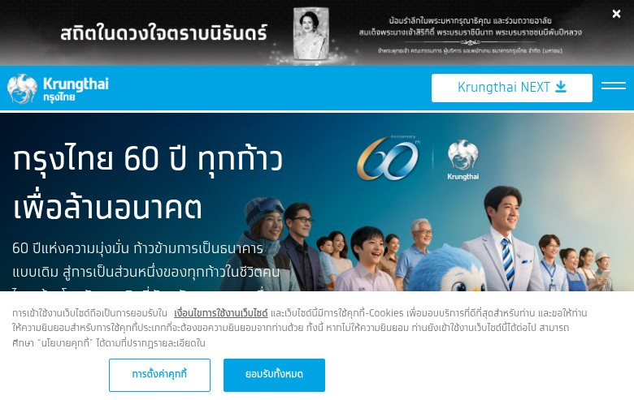
Figure A1: Homepage - Above the Fold (Viewport)

