URL Analysis Report
Asahi Kasei Home Products — "Saran" Site
https://www.asahi-kasei.co.jp/saran/
Prepared: 2026-09-01 | Method: full-site crawl + structural analysis of all 391 live pages | 434 pages, 32 PDFs

Executive Summary
The Saran site is a Japanese-language consumer brand site for Asahi Kasei Home Products (Saran Wrap®, Ziploc®, Cookper®, Frosch®, etc.). A full crawl discovered 434 HTML pages and 32 PDF documents across ~13 template types. Every one of the 391 live (HTTP 200) pages was fetched and its DOM structurally analyzed — block markup, embeds and integration signatures — so the block, integration and complexity findings below are measured across the whole site, not inferred from a sample.
The site is largely template-driven and content-heavy: two clusters — Preservation food-detail pages (159) and Recipe/kitchen-idea pages (86) — account for over half of all pages and are highly standardized, making them strong candidates for automated migration. A structurally separate B2B (業務用) sub-site (83 pages) carries its own header, footer and navigation and must be treated as a distinct template. Full-site analysis revealed three findings not visible in a sample: (1) the external recipe platform (ahp-recipe.jp) is linked from 236 pages / 60% — including 142 preservation pages, far beyond the recipe section; (2) Google Tag Manager loads on 373 pages / 95% and is the runtime delivery mechanism for analytics, the cookie-consent manager and Google Custom Search (which is why those appear in static markup on only ~9 pages); and (3) YouTube is embedded 77 times across 24 pages, concentrated in the B2B and product sections.

1. Templates Inventory
Unique page templates across the site, with complexity and absolute reference URLs. Templates and page counts were derived from all 434 crawled URLs; block, integration and complexity findings (sections 2, 4, 5) were measured by fetching and structurally analyzing every one of the 391 live pages.
Template | Complexity | Reasoning | Reference URL(s)
Homepage | Complex | Autoplay hero carousel (9 slides), 7+ distinct content sections, news/information feeds — bespoke one-off layout. | https://www.asahi-kasei.co.jp/saran/
Section landing / index | Medium | Card-grid landing with left/right nav rails and breadcrumb; a few near-identical instances per section. | https://www.asahi-kasei.co.jp/saran/products/  https://www.asahi-kasei.co.jp/saran/preservation/  https://www.asahi-kasei.co.jp/saran/recipe/
Preservation food detail | Simple | Highly standardized article: intro, cold/freeze how-to, related recipes, product cross-sell, related-food grid. 159 near-identical pages. | https://www.asahi-kasei.co.jp/saran/preservation/vegetables/food01.html
Recipe / kitchen-idea content | Medium | Editorial content pages; many link out to external recipe platform; filter form on the index. | https://www.asahi-kasei.co.jp/saran/recipe/idea_cooking/cooking03.html  https://www.asahi-kasei.co.jp/saran/recipe/world/
Product brand page | Medium | Feature callouts, spec/stat blocks, product lineup with store links, video block. Varies per brand. | https://www.asahi-kasei.co.jp/saran/products/saranwrap/  https://www.asahi-kasei.co.jp/saran/products/ziploc/
B2B business sub-site | Complex | Separate template with its own header/footer/nav, product slider, news table and multiple YouTube embeds. 83 pages. | https://www.asahi-kasei.co.jp/saran/products/business/
Editorial / sustainability | Complex | Full-width editorial with scroll-reveal animations and SDGs icon system; custom layout. | https://www.asahi-kasei.co.jp/saran/sustainability/
Corporate info | Medium | Mission banner, news-release list (dl/dt/dd) and a company-profile data table. | https://www.asahi-kasei.co.jp/saran/corporate_info/
Contact / FAQ | Complex | FAQ card grid, multiple contact blocks and an embedded AI chatbot iframe (dynamic/session). | https://www.asahi-kasei.co.jp/saran/customer/
Contact form | Complex | Multi-step inquiry forms (q142/q143/q144) — form logic and validation. | https://www.asahi-kasei.co.jp/saran/bb-form/q144/
CM / video | Simple | Grid of YouTube video embeds with minimal surrounding content. | https://www.asahi-kasei.co.jp/saran/cm/
Global landing | Simple | Small set of English/global brand landing pages. | https://www.asahi-kasei.co.jp/saran/global/
Utility (sitemap/about/cookie) | Simple | Static single-purpose pages. | https://www.asahi-kasei.co.jp/saran/sitemap.html  https://www.asahi-kasei.co.jp/saran/about_us.html

2. Blocks / Components Catalog
Reusable blocks derived from shared DOM structure. Where the content model is the same but the visual layout differs, these are noted as design variations of one block rather than new blocks. The 'Pages' column is the measured count across all 391 live pages (structural DOM match); percentages are of live pages.
Block / Component | Complexity | Pages | Behaviour & functionality | Reference URL(s)
Global header + mega-menu nav (consumer) | Complex | ~330 | Sticky header with multi-level dropdown menus (products, preservation, recipe, contact) each exposing sub-lists on hover. | All consumer /saran/* pages
Global footer | Medium | ~330 | Brand-logo row, multi-column sitemap, legal links, group link, copyright. | All consumer /saran/* pages
Breadcrumb | Simple | 370 (94%) | Home > Section > Page trail. | Nearly all /saran/* pages
Card grid (link cards) | Medium | 257 (65%) | Responsive grid of image+label link cards. Design variations: product grid, recipe grid, food-thumbnail grid, kitchen-idea grid. | https://www.asahi-kasei.co.jp/saran/products/  https://www.asahi-kasei.co.jp/saran/preservation/
Food-category / content tab navigation | Medium | 143 (36%) | Tabbed anchors (野菜/果物/魚介…) switching category panels; also used on product/B2B pages. | https://www.asahi-kasei.co.jp/saran/preservation/
News / information list | Simple | 56 (14%) | Date-titled definition list (dt/dd), often linking to PDFs. Variations: INFORMATION & NEWS on home; news-release list on corporate. | https://www.asahi-kasei.co.jp/saran/  https://www.asahi-kasei.co.jp/saran/corporate_info/
Hero carousel / slider | Complex | 44 (11%) | Autoplay tabbed slider with prev/next and pause. Variations: 9 slides (home), 3 (product), 4 (B2B), global landings. | https://www.asahi-kasei.co.jp/saran/  https://www.asahi-kasei.co.jp/saran/products/business/
Data table | Simple | 41 (10%) | Static key/value or spec tables. Variations: company profile, B2B product specs. | https://www.asahi-kasei.co.jp/saran/corporate_info/
Video embed (YouTube) | Medium | 24 (6%); 77 embeds | Embedded YouTube players in card layouts. Variations: consumer CM grid, B2B how-to grid, product page. | https://www.asahi-kasei.co.jp/saran/cm/  https://www.asahi-kasei.co.jp/saran/products/business/
Accordion / toggle | Medium | 23 (6%) | Expand/collapse sections (FAQ-style and content toggles). | https://www.asahi-kasei.co.jp/saran/customer/  https://www.asahi-kasei.co.jp/saran/products/business/
Product lineup + online-store CTA | Medium | ~45 | Product pack images with Amazon / LOHACO / Rakuten purchase links per SKU (retail links on 18–13 pages). | https://www.asahi-kasei.co.jp/saran/products/saranwrap/  https://www.asahi-kasei.co.jp/saran/preservation/vegetables/food01.html
Product feature-callout block | Medium | ~30 | Image + heading + copy feature rows (密着性, ハリ・コシ, M字型の刃 …). | https://www.asahi-kasei.co.jp/saran/products/saranwrap/
Stat / metric block | Medium | ~15 | Numeric performance figures with footnotes (透湿度 ~2.0x, 酸素 ~200x …). | https://www.asahi-kasei.co.jp/saran/products/saranwrap/
Retailer / SNS strip | Simple | ~30 | Row of store-locator + Amazon + LOHACO + Rakuten24 banners near the footer. | Product & preservation pages
Social-share buttons | Simple | 10 (3%) | Facebook / X / LINE share on content detail pages. | https://www.asahi-kasei.co.jp/saran/preservation/vegetables/food01.html
Scroll-reveal animation wrapper | Complex | 10 (3%) | Content revealed on scroll (sustainability editorial + some product pages). | https://www.asahi-kasei.co.jp/saran/sustainability/
FAQ card grid | Medium | ~6 | Per-brand FAQ entry cards linking to the external FAQ system. | https://www.asahi-kasei.co.jp/saran/customer/
Contact-info block | Simple | ~10 | Phone/mail contact panels with hours and mail-form links. | https://www.asahi-kasei.co.jp/saran/customer/  https://www.asahi-kasei.co.jp/saran/products/business/
Recipe search / filter form | Complex | 1 (+ index) | Keyword box + 7 filtered dropdowns with reset/search; posts to external recipe platform. Only 2 real <form> tags exist sitewide. | https://www.asahi-kasei.co.jp/saran/recipe/
AI chatbot embed | Complex | 4 | Iframe chat widget with product buttons and free-text search (dynamic/session). | https://www.asahi-kasei.co.jp/saran/customer/
Cookie-consent banner (GTM-injected) | Complex | Sitewide (runtime) | Iframe overlay with Accept/Reject/Settings. Injected at runtime via GTM (static markup on ~9 pages). | All pages (first visit)
Google Custom Search box (GTM-injected) | Medium | Sitewide (runtime) | Site search powered by Google CSE (adds #gsc.tab fragment); loaded via GTM. | All consumer pages (header)
B2B header/footer/nav | Complex | 58 live | Distinct navigation, contact footer with tel links and catalog download — separate design system. | https://www.asahi-kasei.co.jp/saran/products/business/

Representative template screenshots (above-the-fold). Full-length captures are in the screenshots/ folder.
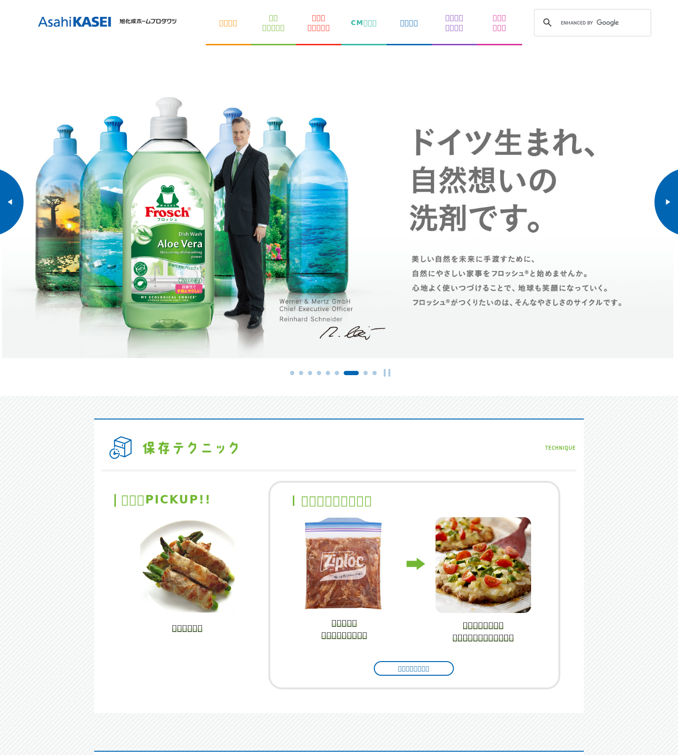
Homepage — hero carousel + section blocks
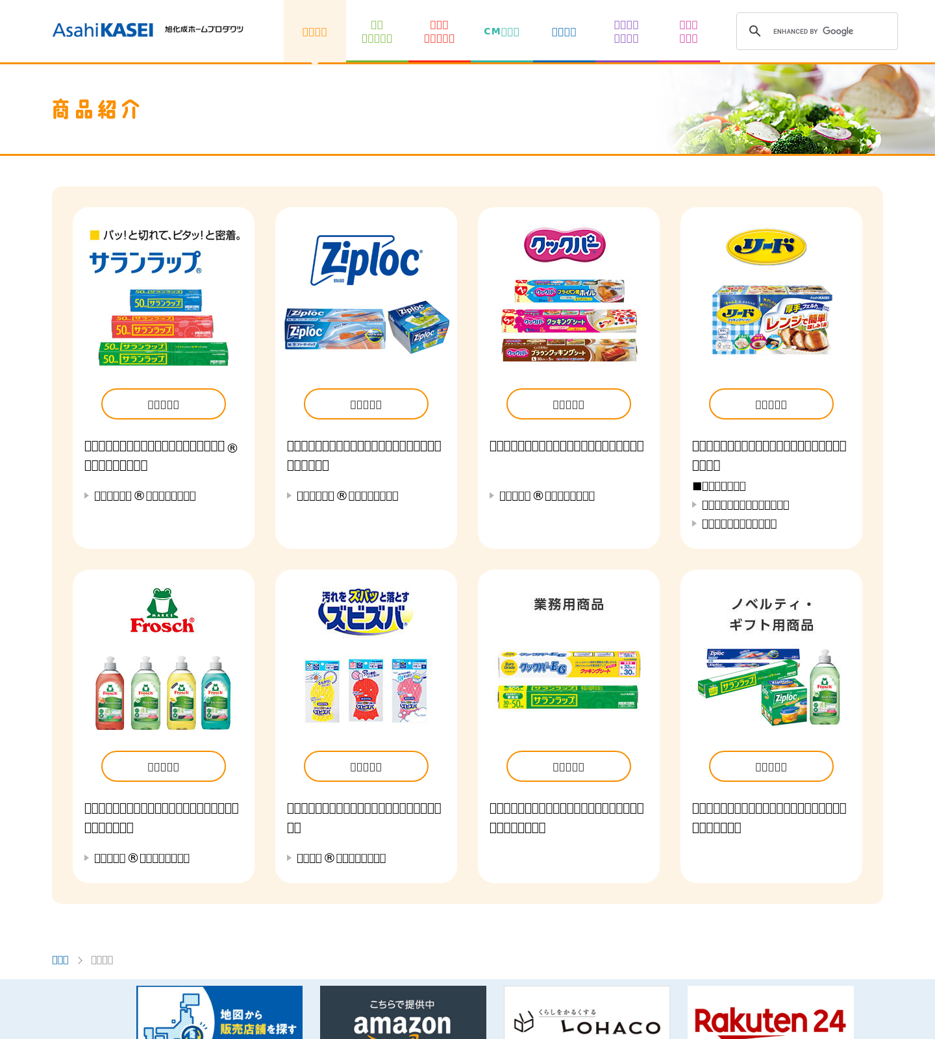
Product section index — card grid
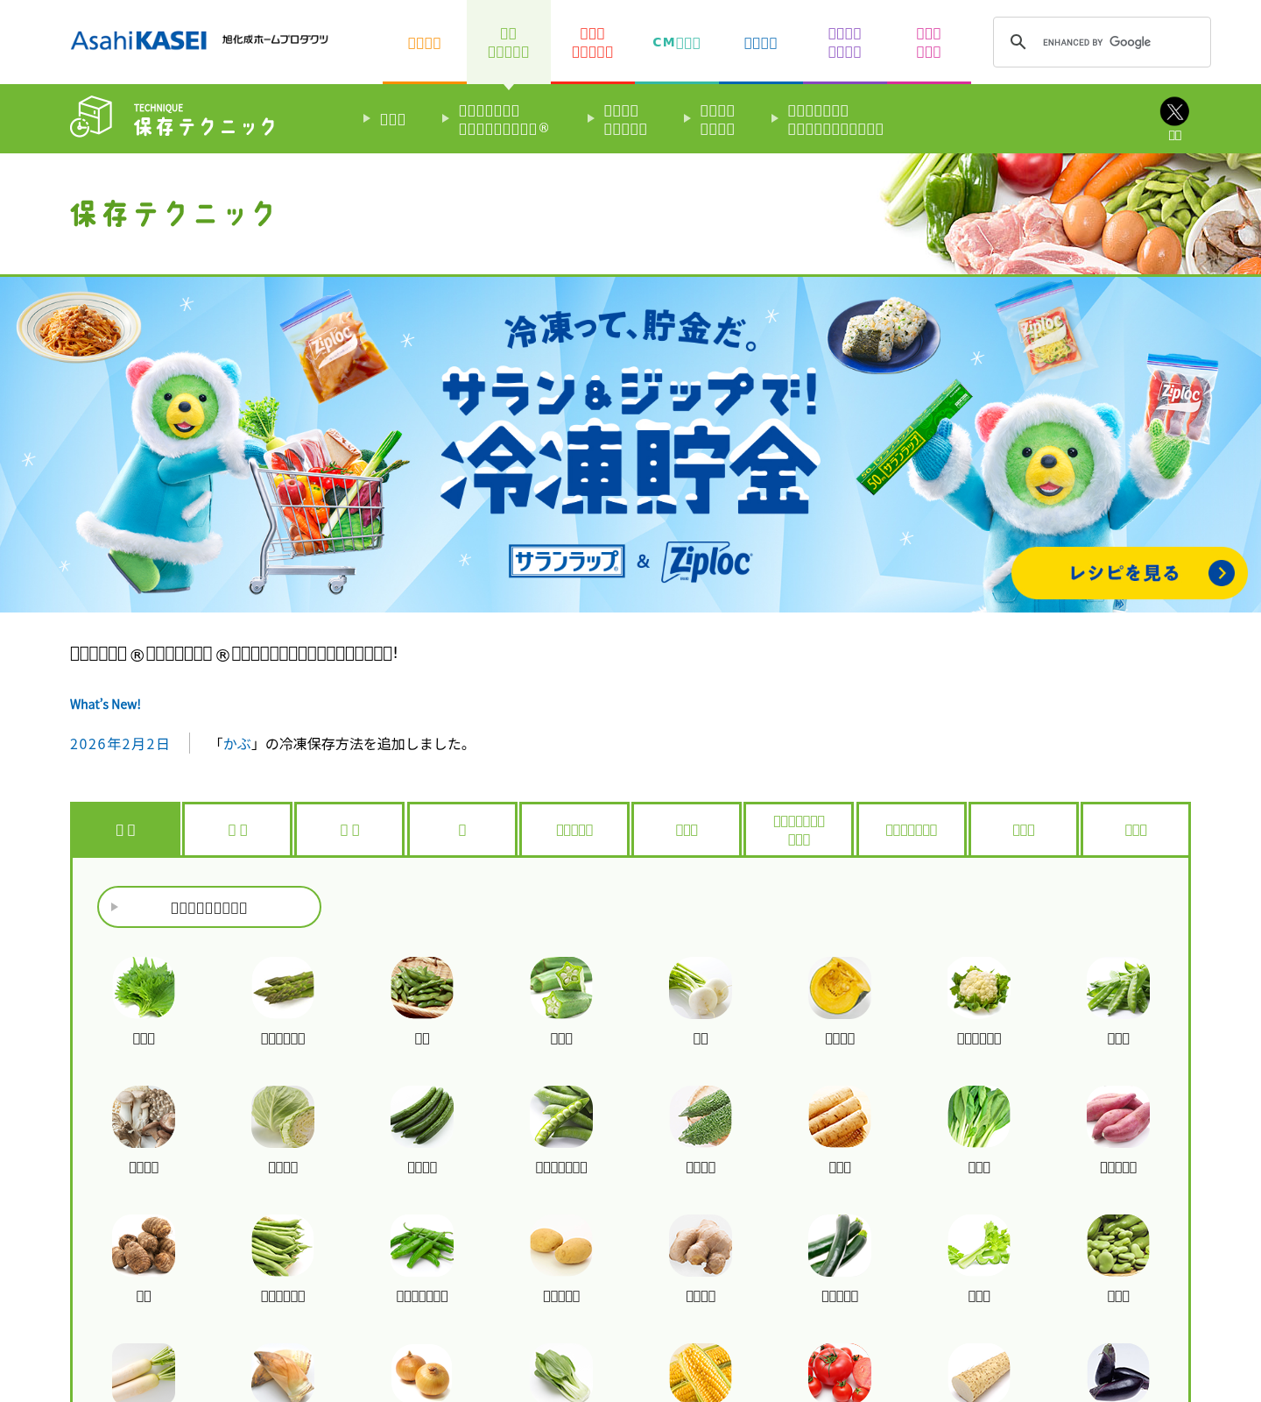
Preservation index — food-category tabs + grid
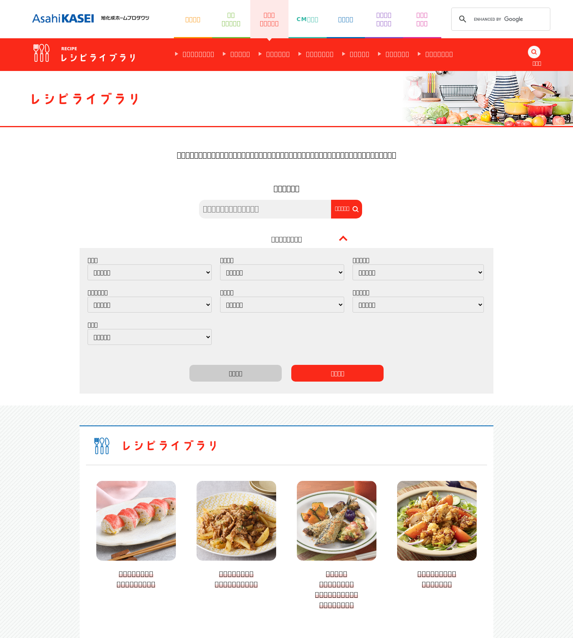
Recipe library — filter form + card grids
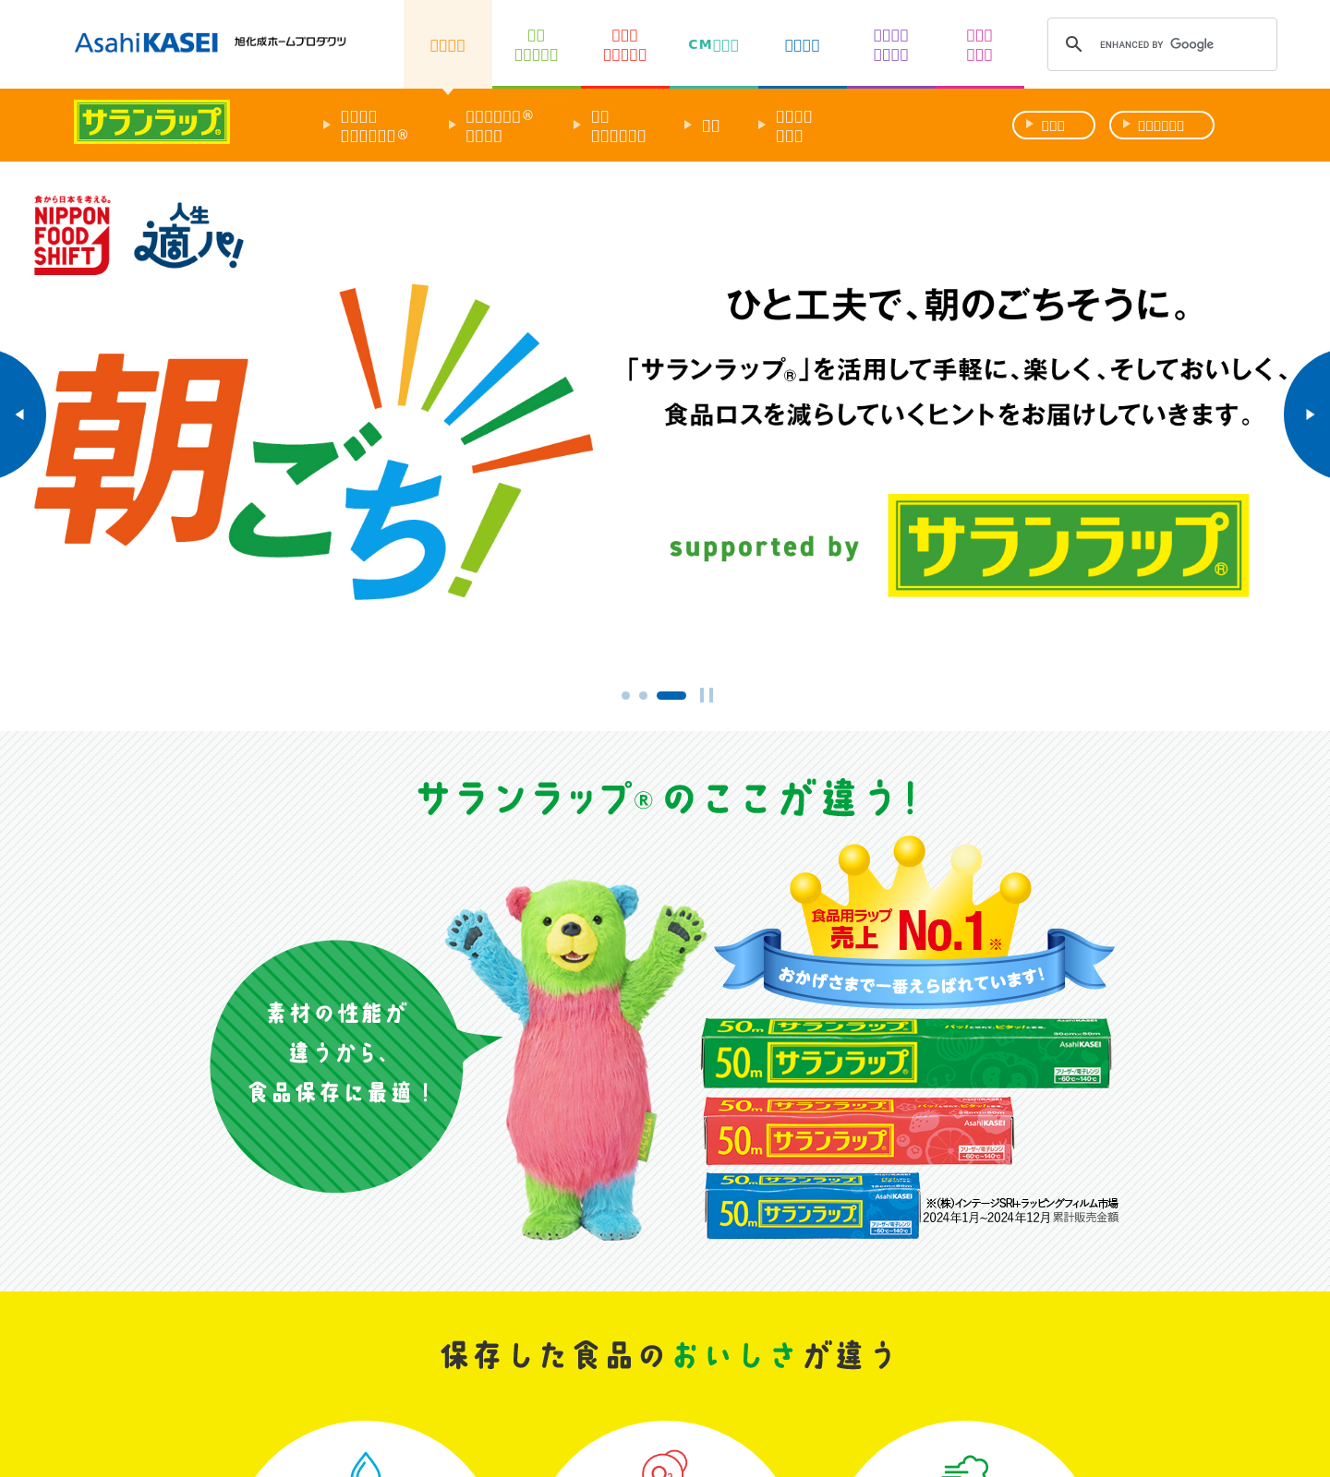
Product detail — feature callouts + lineup
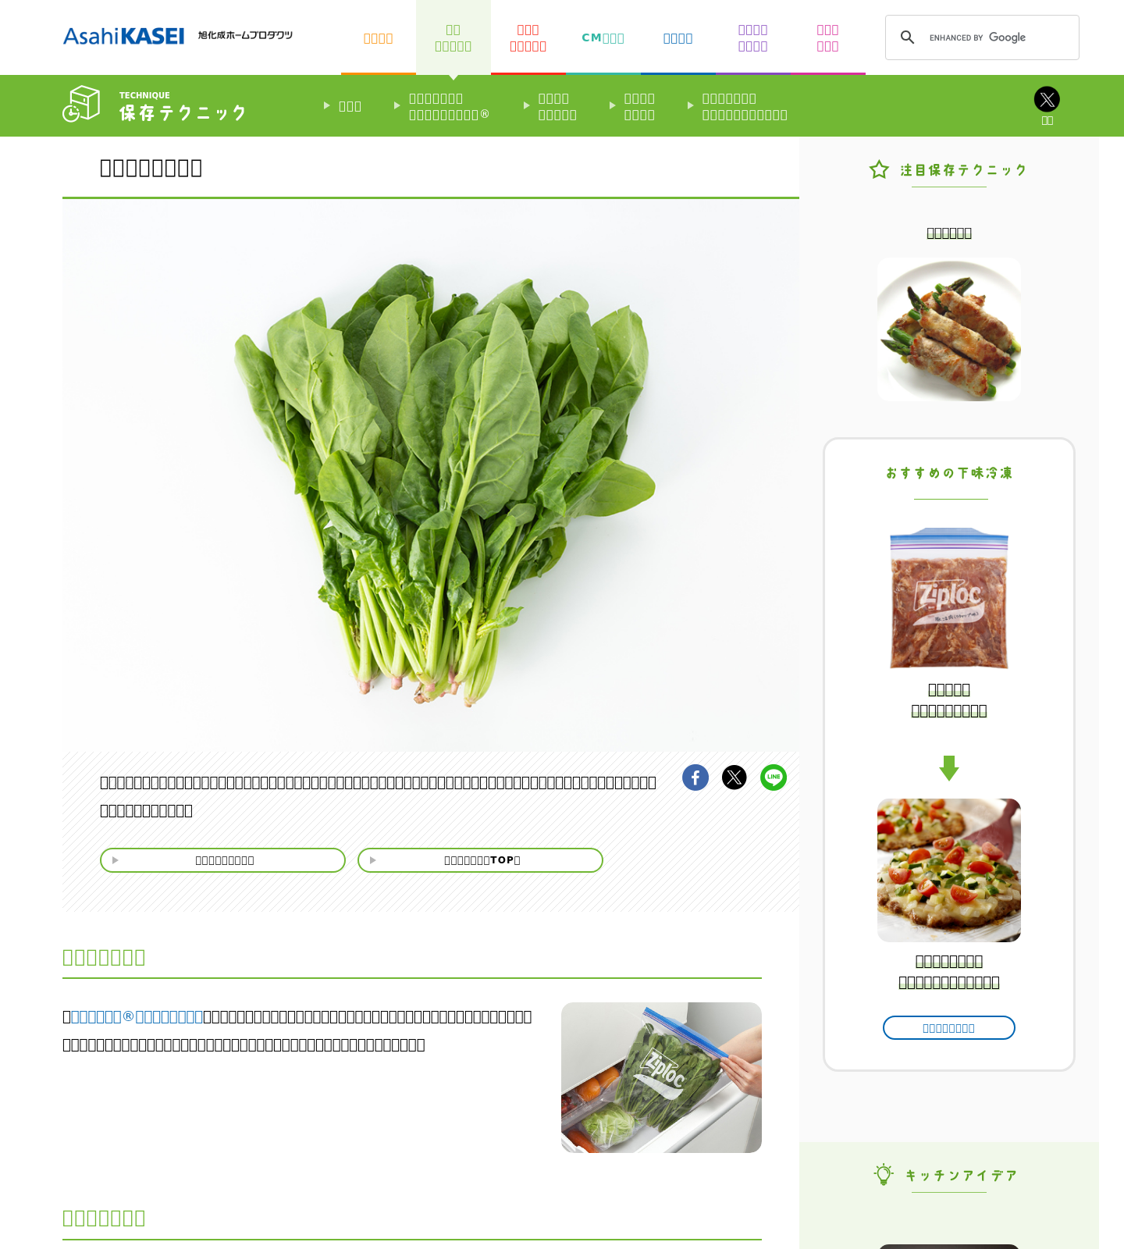
Preservation food detail — article + cross-sell
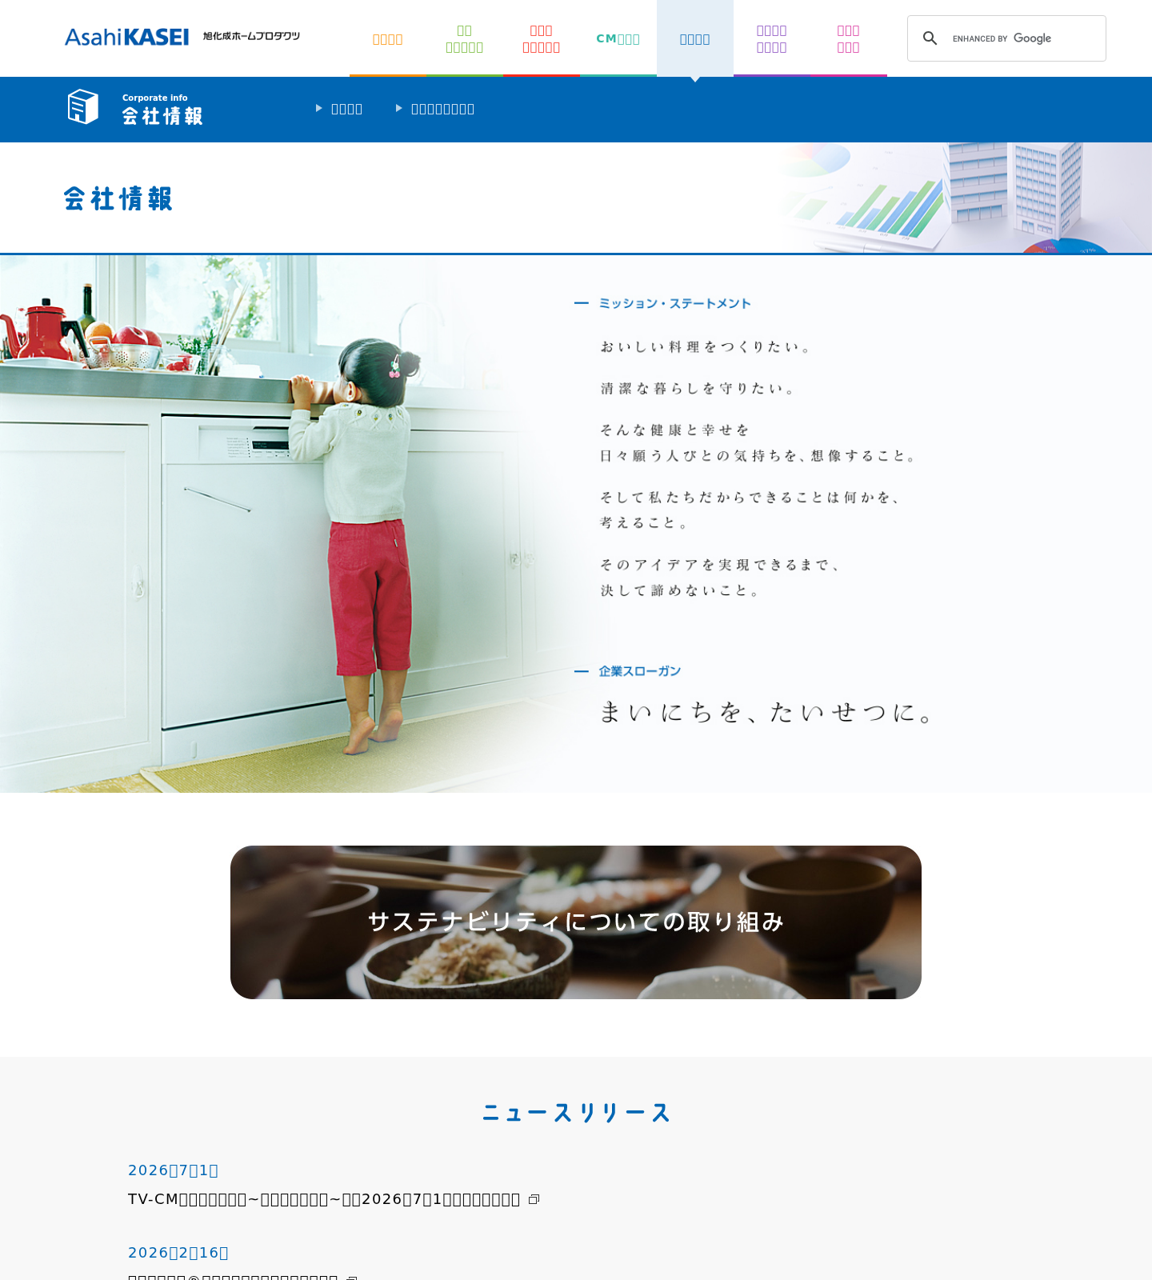
Corporate info — news list + profile table
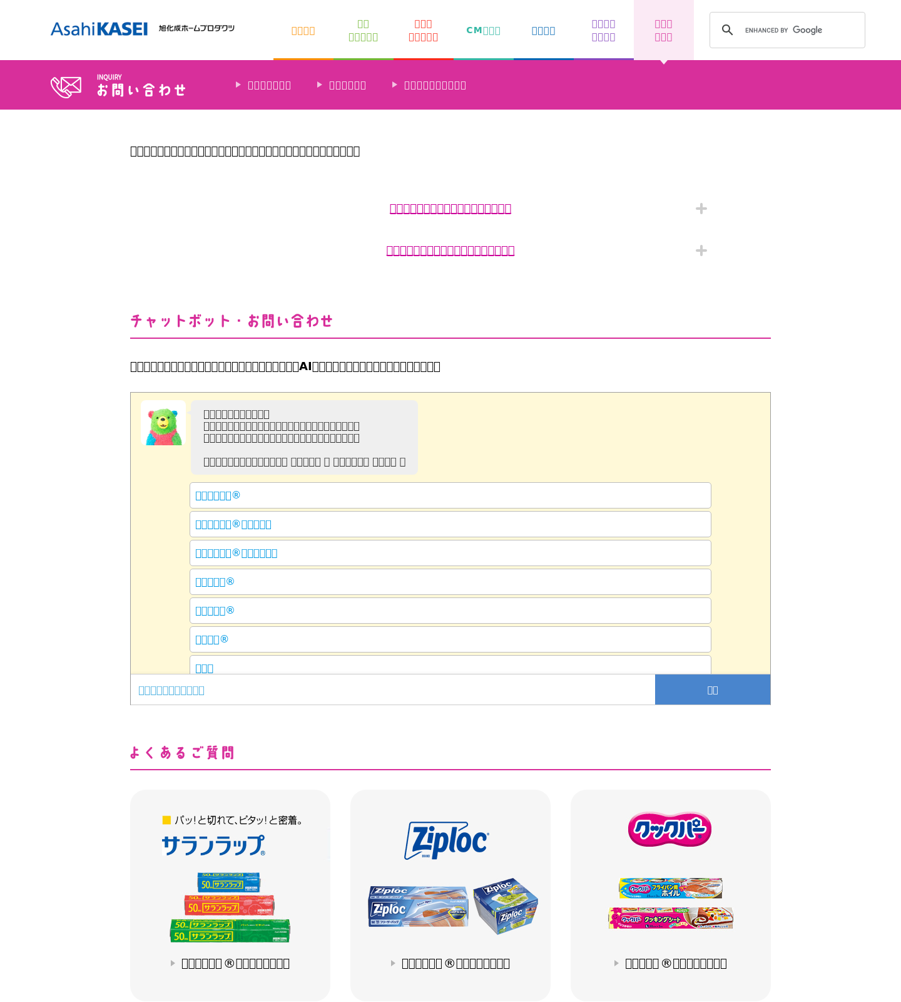
Contact / FAQ — FAQ cards + chatbot + contact blocks
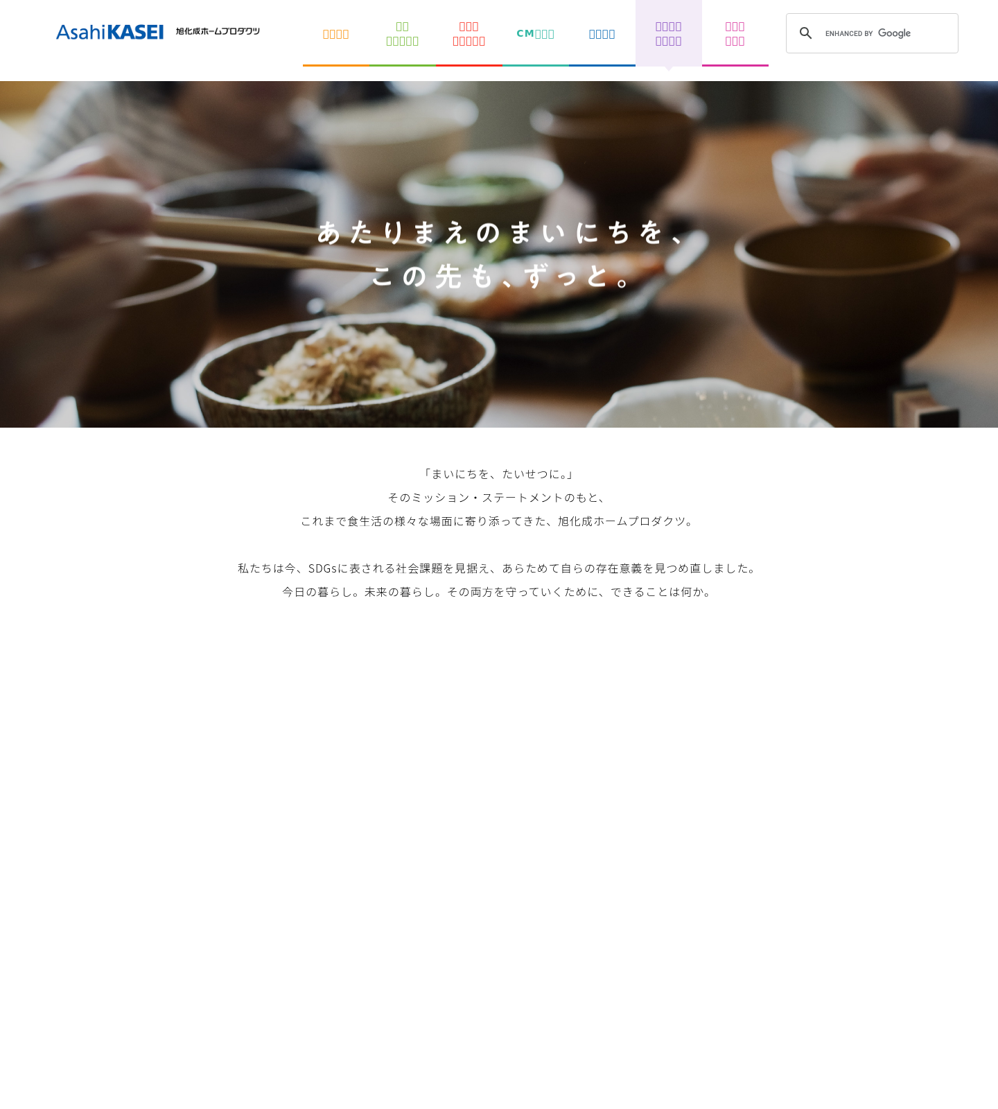
Sustainability — editorial / SDGs
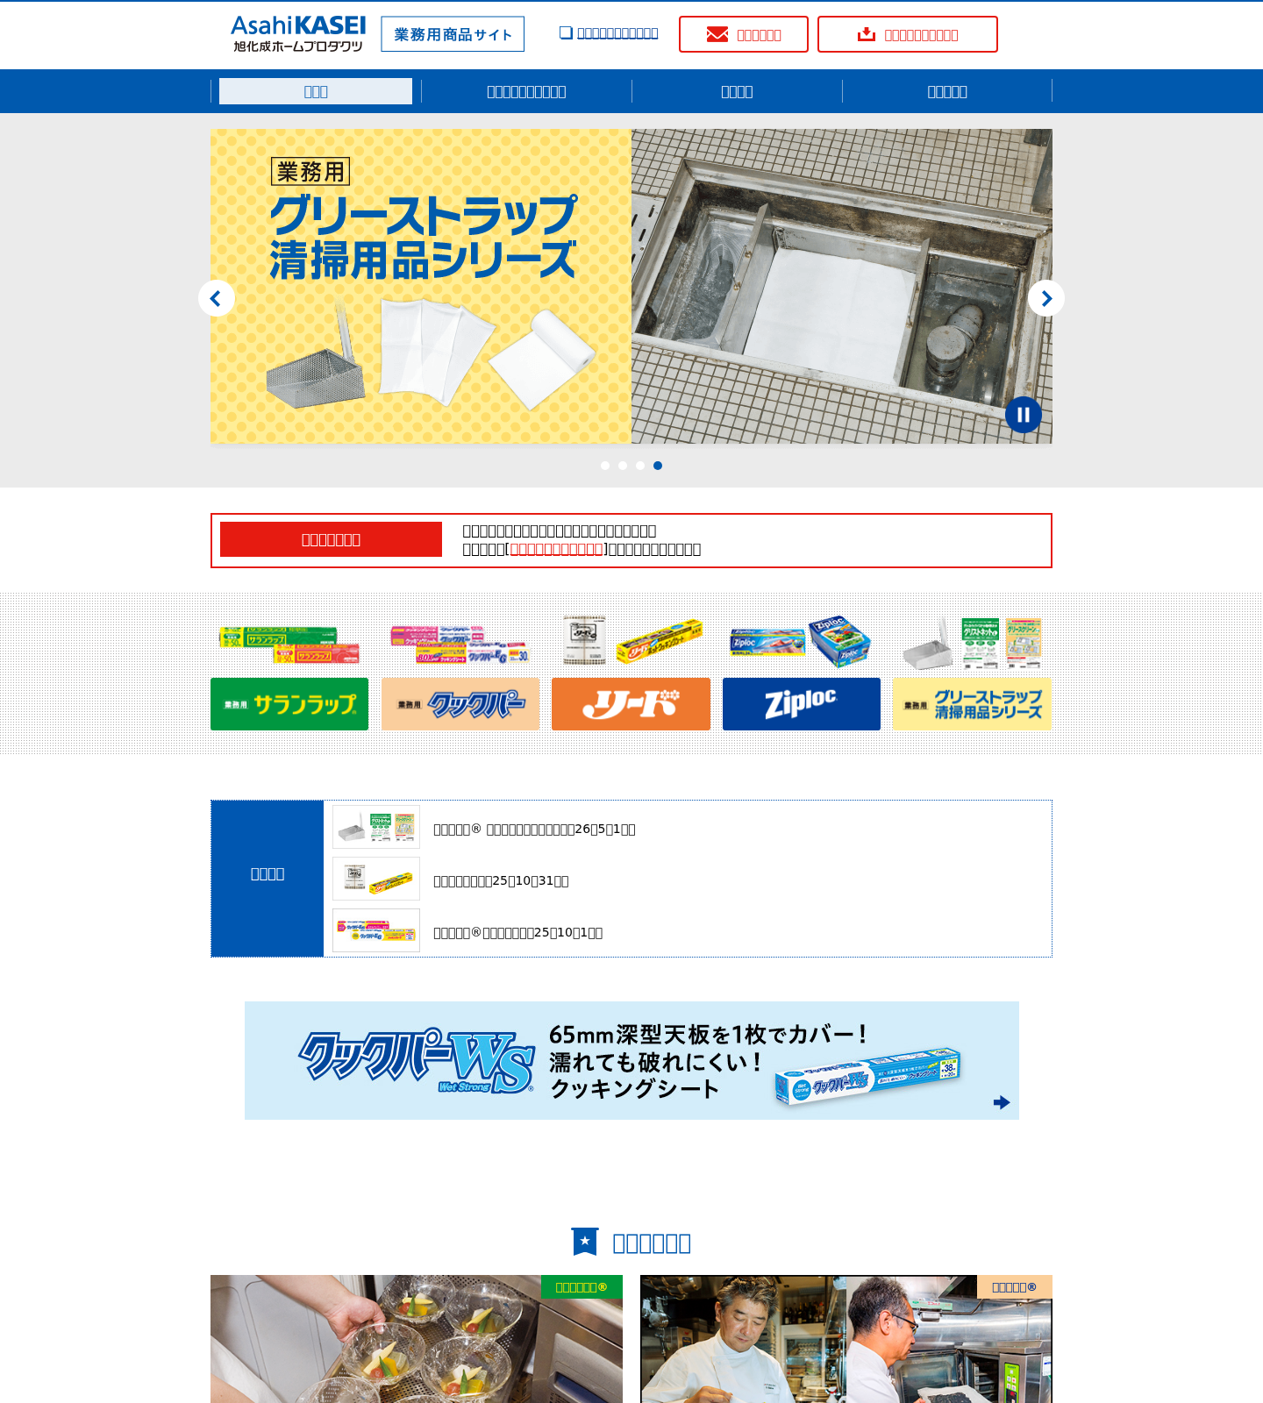
B2B business sub-site — distinct template

3. Page Counts by Template
Page volume per template and migration approach (Auto = standardized/low-logic; Manual = dynamic/custom/heavy-logic).
Template | Pages | Live (200) | Migration approach
Preservation food detail | 159 | 159 | Automatic — uniform structure, standardized data
Recipe / kitchen-idea content | 86 | 86 | Manual/semi — editorial + external recipe links
B2B business sub-site | 83 | 58 | Manual — separate template & nav, many 404s
Product brand page | 50 | 45 | Semi — templated but per-brand variation
Corporate info | 9 | 9 | Semi — list + table are standardized
Editorial / sustainability | 9 | 9 | Manual — custom layout + animations
Global landing | 9 | 9 | Semi — small, simple pages
Utility (sitemap/about/cookie/recycle) | 7 | 7 | Semi — static one-offs
Contact / FAQ | 6 | 3 | Manual — chatbot + contact logic
CM / video | 3 | 3 | Semi — video embeds
Contact form | 3 | 0* | Manual — form logic (see note)
Homepage | 1 | 1 | Manual — bespoke one-off
External corporate (/jp) | 9 | 2 | Exclude — belongs to parent corporate site
TOTAL (in-scope /saran) | 425 | — | ≈159 auto / ≈266 semi-manual

* The bb-form pages returned 404 when crawled without a trailing slash; the working URLs use a trailing slash (/saran/bb-form/q144/). They are live interactive forms.

4. Integrations Analysis
Third-party integrations and embedded services, with page counts measured across all 391 live pages.
Integration | Type | Complexity | Pages | Where used / reference
Google Tag Manager | JS tag container | Medium | 373 (95%) | Sitewide; runtime loader for analytics, consent & search
Web analytics (GA via GTM, _ga linker) | JS tag | Medium | 373 (95%) | Sitewide; outbound links carry _ga linker params
External recipe platform (ahp-recipe.jp) | API / external app | Complex | 236 (60%) | Recipe search & detail links; 142 preservation + 83 recipe pages (content_list.php, sheet.php)
YouTube video embeds | Embed (iframe) | Simple | 24 (77 embeds) | https://www.asahi-kasei.co.jp/saran/cm/ ; https://www.asahi-kasei.co.jp/saran/products/business/ ; product pages
E-commerce retail links (Amazon/LOHACO/Rakuten24) | Affiliate / deep-link | Simple | ~18 | Product lineup & retailer strip
B2B reseller links (Askul/Kaunet/Monotaro/…) | Deep-link | Simple | 18 | https://www.asahi-kasei.co.jp/saran/products/business/
Cookie-consent manager (GTM-injected iframe) | Embed / plugin | Medium | Sitewide (runtime) | All pages, first visit (ul-banner-main-window iframe)
Google Custom Search Engine (GTM-injected) | Embed / JS | Medium | Sitewide (runtime) | Header search on consumer pages (#gsc.tab fragment)
Campaign microsites (ahp-web.jp, yomiuri.co.jp) | External link | Simple | 8 | Product/topic promo tiles
AI FAQ chatbot (faq.asahi-kasei.co.jp) | Embed (iframe) | Complex | 4 | https://www.asahi-kasei.co.jp/saran/customer/
FAQ knowledge base (faq.asahi-kasei.co.jp) | External app | Medium | 4+ | Per-brand 'よくあるご質問' links on product & customer pages
Store locator (asahi-kasei.storelocator.jp) | External app | Simple | ~7 | Retailer strip (Frosch store search)
Social share / X account | Social link | Simple | 10 | Content-detail share; preservation follow button
PDF news releases / catalogs | Document downloads | Simple | 32 files | /corporate_info, /assets, /products/business/download

Measured finding: the external recipe platform is the single most pervasive integration (236 pages / 60%), reaching well beyond the recipe section into 142 preservation pages via 'related recipe' links. GTM (95%) is the runtime delivery mechanism for analytics, the cookie-consent manager and Google Custom Search — which is why those appear in static markup on only ~9 pages. No enterprise REST/SOAP back-office integration (payment, CRM, auth/login) was observed, and only two real HTML <form> tags exist sitewide; commerce is entirely outbound deep-links to third-party retailers.

5. Complex Use Cases & Observations
Behaviours and edge cases needing special attention during migration, quantified.
Use case / observation | Instances | Where found | Why it's complex
Two separate design systems (consumer vs B2B) | 83 B2B pages | /saran/products/business/* | B2B sub-site has its own header/footer/nav/theme — effectively a second site to template.
Externalized recipe library (site-wide dependency) | 236 pages (60%) | /saran/recipe/* (83) + /saran/preservation/* (142) + cm, ahp-recipe.jp | Recipe data & search live off-site on a dynamic PHP platform; measured on 236 pages — every preservation detail cross-links it, so it is a sitewide dependency, not a recipe-only one.
GTM-delivered analytics / consent / search | 373 pages (95%) | Sitewide (GTM container) | Analytics, cookie-consent overlay and Google CSE are injected at runtime via GTM, so they are invisible in static HTML and must be reconstituted, not copied from markup.
Recipe filter form (7 dependent dropdowns) | 1 (high traffic) | /saran/recipe/ | Client-side faceted search posting to external system; not static content.
AI chatbot widget | 4 | /saran/customer/ + linked FAQ pages | Dynamic, session-based iframe app; cannot be statically migrated.
Autoplay hero carousels | 3 variations | home, product detail, B2B | JS sliders with autoplay/pause/tabs; behaviour + timing must be reproduced.
Scroll-reveal animations | 1 template (9 pages) | /saran/sustainability/* | Content hidden until scroll; affects rendering, capture and accessibility.
Cookie-consent gating | Sitewide | All pages, first visit | Regulatory consent manager overlays content and blocks interaction until dismissed.
Broken cookper newsletter series | 24 pages | /products/business/cookper/vol01–vol24.html | Entire numbered archive 404s; decide restore vs redirect vs drop.
Broken parent-corporate links | 7 pages | /jp/privacy, /jp/security, /jp/cookie, /jp/contact-us … | Point to parent site paths that 404 (privacy now at asahi-kasei.com/jp/privacy/).
Discontinued-product & old-contact links | 7 pages | /products/ziploc/*, /zubizuba/grill, /customer/contact/* | Stale links to removed pages; content decisions required.
PDF-based news/catalogs | 32 PDFs (2 broken) | /corporate_info, /assets, /products/business/download | Downloads, not pages; must be re-hosted and re-linked.
Google CSE search dependency | Sitewide | Header on all consumer pages | Search is delegated to Google CSE; replacement/equivalent needed post-migration.
Multi-locale seam (global + external /jp) | 18 pages | /saran/global/*, /jp/* | Mix of in-scope global pages and out-of-scope parent-corporate pages complicates scope.

Appendix — Source Files & Method
Method: all 434 URLs were crawled for status and grouping; all 391 live (HTTP 200) pages were then fetched and their DOM parsed for block markup, embeds and integration signatures (27 feature detectors). Percentages in sections 2, 4 and 5 are of the 391 live pages.
Files: urls-all.json (all 434 pages + 32 PDFs with HTTP status) · urls-grouped.json (43 directory templates) · page-features.json (per-page structural feature matrix, 391 pages) · Saran-URL-Analysis-Report.xlsx (8 sheets, incl. Feature Prevalence) · screenshots/ (10 full-page + cropped). All under .migration/saran-url-analysis/.

