Site Analysis Report
www.shareholdereducation.com
AEM Edge Delivery Services Migration Assessment
Generated: March 6, 2026
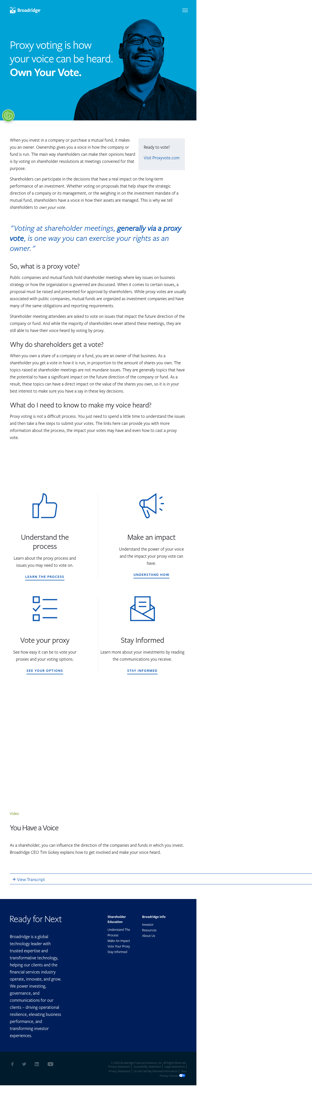

Executive Summary
ShareholderEducation.com is a Broadridge-owned educational website currently hosted on CrownPeak DXM CMS with Amazon CloudFront CDN. The site consists of 13 pages across 7 distinct page templates, serving content related to shareholder education, proxy voting, and corporate governance.
The site is relatively small in page count but has moderate complexity due to interactive components (animated counters, search/filtering, stock widgets) and multiple third-party integrations (15+ services). The primary technical challenge is replacing CrownPeak SearchG2 for the Resources page and removing jQuery dependencies.

Metric | Value
Total Pages | 13
Page Templates | 7
Unique Blocks/Components | 17
Third-Party Integrations | 15 (11 active, 2 dormant, 2 libraries)
PDF Assets | 2
Current CMS | CrownPeak DXM
CDN | Amazon CloudFront
Estimated Migration Effort | 6-8 weeks (1 developer)

1. Templates Inventory
The site uses 7 distinct page templates. Each template is described below with complexity level, page count, and reference URL.

# | Template Name | Complexity | Pages | Reference URL
1 | Homepage | High | 1 | https://www.shareholdereducation.com/
2 | Content Page with Hero + Sidebar CTA | Medium | 3 | https://www.shareholdereducation.com/understand-the-proxy-process
3 | Content Page with Hero (no sidebar) | Low | 1 | https://www.shareholdereducation.com/make-an-impact
4 | Blog/Article Template | Medium | 5 | https://www.shareholdereducation.com/five-reasons-to-vote-your-next-proxy
5 | Product/Landing Page (ProxyVote App) | Medium | 1 | https://www.shareholdereducation.com/proxyvote-app
6 | Resources / Listing Page | Medium-High | 1 | https://www.shareholdereducation.com/resources
7 | Interactive Guide (TSR) | High | 1 | https://www.shareholdereducation.com/tsr

Homepage (High Complexity)
Full-width hero with video background, animated stats ticker, multi-section layout with cards, featured content, and stock widget. Heavy JavaScript interactivity.
Reference: https://www.shareholdereducation.com/


Content Page with Hero + Sidebar CTA (Medium Complexity)
Hero banner with background image, main content area with rich text, sidebar call-to-action panel. Standard corporate content layout.
Reference: https://www.shareholdereducation.com/understand-the-proxy-process
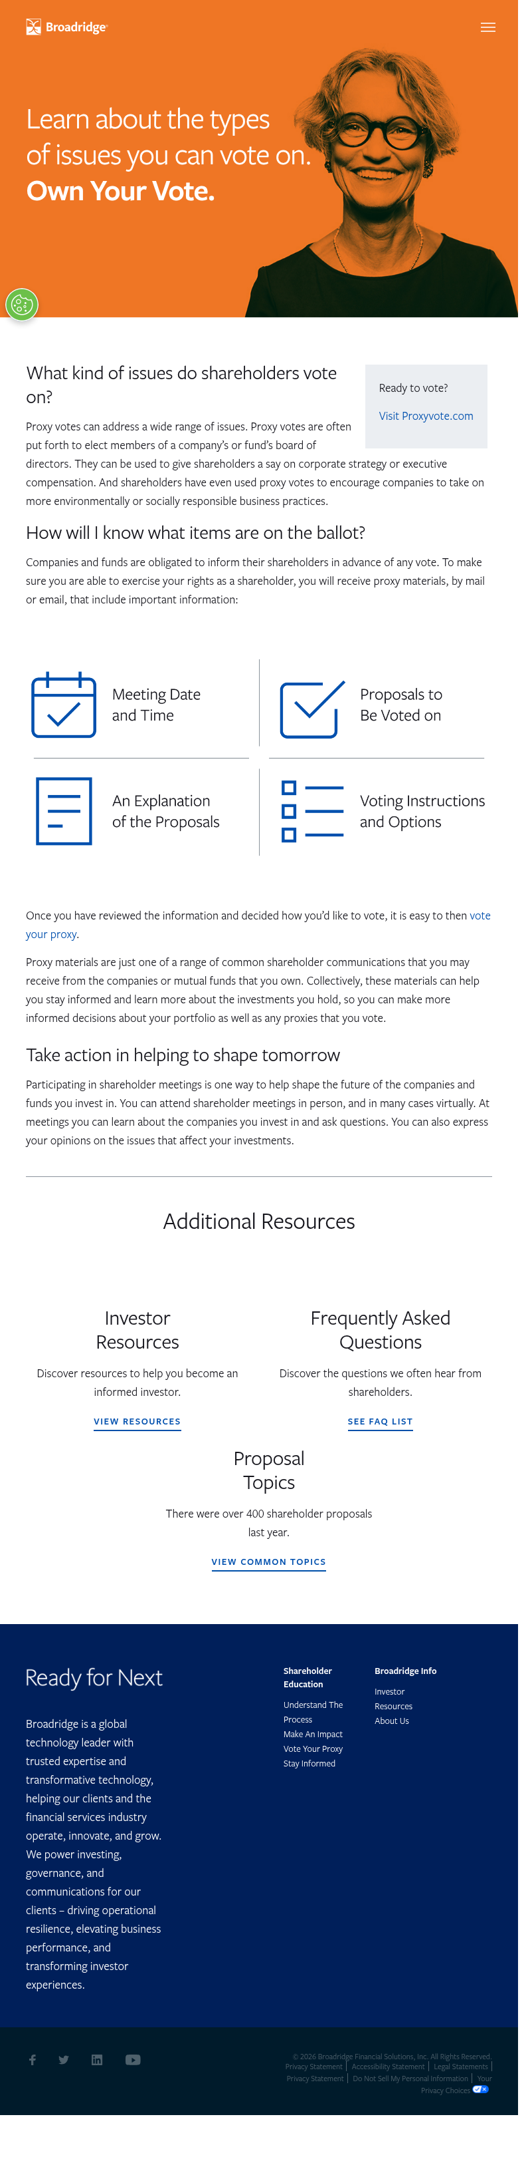

Content Page with Hero (no sidebar) (Low Complexity)
Simplified content page with hero banner and full-width body content. No sidebar elements.
Reference: https://www.shareholdereducation.com/make-an-impact
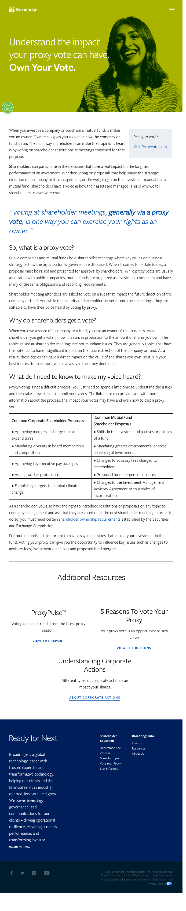

Blog/Article Template (Medium Complexity)
Article-style pages with hero image/banner, body content with headings, images, and ordered/unordered lists. Some include infographics and call-out boxes.
Reference: https://www.shareholdereducation.com/five-reasons-to-vote-your-next-proxy
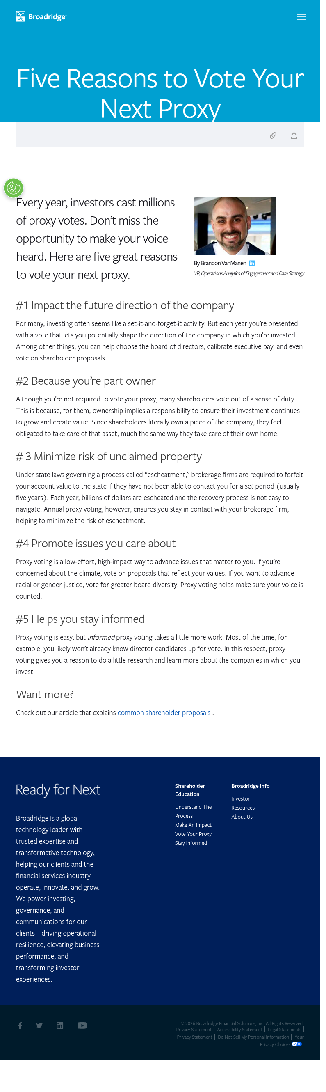

Product/Landing Page (ProxyVote App) (Medium Complexity)
App promotion landing page with app store badges, feature showcase with device mockups, step-by-step instructions, and download CTAs.
Reference: https://www.shareholdereducation.com/proxyvote-app
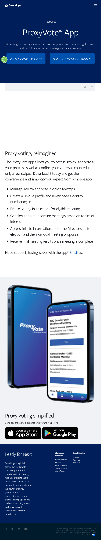

Resources / Listing Page (Medium-High Complexity)
Filterable resource listing with category tabs, search functionality powered by CrownPeak SearchG2, card-based resource grid with pagination.
Reference: https://www.shareholdereducation.com/resources
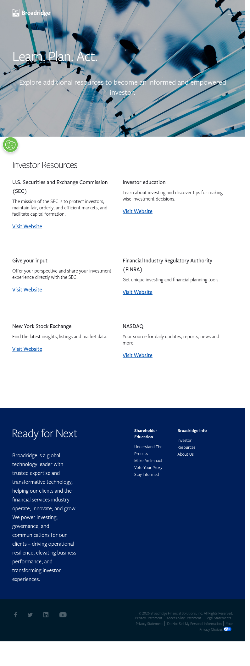

Interactive Guide (TSR) (High Complexity)
Multi-section interactive guide with tabbed navigation, accordion FAQ sections, animated scroll effects, and rich media. Heaviest JavaScript usage.
Reference: https://www.shareholdereducation.com/tsr
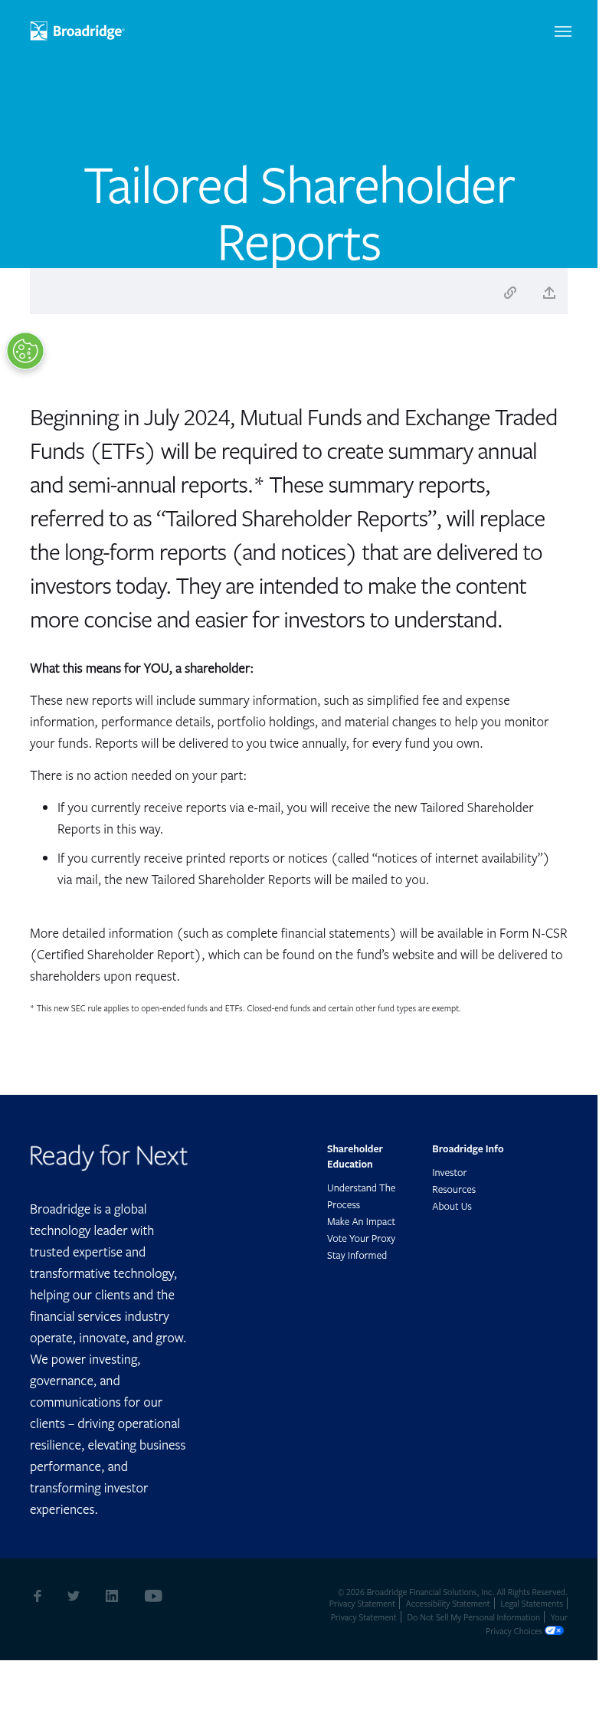

2. Blocks / Components Catalog
The following table catalogs all 17 reusable blocks and components identified across the site, including their complexity, behavior, and where they appear.

# | Block Name | Complexity | Template(s) | Behavior
1 | Hero Banner (Video) | High | Homepage | Full-width hero with looping background video, overlay text, and CTA button. Video autoplays on desktop, falls back to static image on mobile.
2 | Hero Banner (Static Image) | Low | Content/Article Pages | Full-width banner with background image, heading text overlay, and optional breadcrumb navigation.
3 | Stats Ticker / Counter | High | Homepage | Animated number counters that increment on scroll into view. Displays key statistics (e.g., "250M+ shares voted"). Uses JavaScript IntersectionObserver and requestAnimationFrame.
4 | Content Cards Grid | Medium | Homepage, Resources | Responsive grid of cards with image, title, excerpt, and link. 3-column on desktop, stacks on mobile. Used for featured content sections.
5 | Sidebar CTA Panel | Low | Content Pages | Right-aligned sticky sidebar with call-to-action content, heading, description, and button. Scrolls with page content.
6 | Tabbed Content | Medium | TSR, Resources | Horizontal tab navigation that switches between content panels. Used for category filtering on Resources page and section navigation on TSR guide.
7 | Accordion / FAQ | Medium | FAQ, TSR | Expandable/collapsible content sections with question/answer pairs. Click to toggle visibility with smooth animation.
8 | Vimeo Video Embed | Low | Homepage | Embedded Vimeo player with responsive iframe. Loads lazily after page render to avoid blocking LCP.
9 | Stock Quote Widget | High | Homepage | Real-time stock price display powered by StockPR API. Shows BR ticker price, change, and volume. Requires external API integration.
10 | Search Results / Filterable List | High | Resources | CrownPeak SearchG2-powered search with faceted filtering, keyword search, and paginated results. Complex JavaScript integration.
11 | App Store Badges | Low | ProxyVote App | Apple App Store and Google Play download buttons linking to native app listings. Simple image links.
12 | Step-by-Step Instructions | Low | ProxyVote App | Numbered steps with device mockup images showing app usage flow. Responsive image + text layout.
13 | Cookie Consent Banner | Medium | All Pages | OneTrust-powered cookie consent modal with category toggles and accept/reject buttons. Must be integrated or replaced in EDS.
14 | Header / Navigation | Medium | All Pages | Global header with Broadridge logo, primary navigation links, hamburger menu on mobile. Consistent across all pages.
15 | Footer | Medium | All Pages | Multi-column footer with links, copyright, social media icons. Contains bug: links reference dev URLs in production.
16 | Infographic / Rich Image | Low | Blog/Articles | Full-width or inline infographic images with alt text. Some are complex SVGs or large PNGs.
17 | Breadcrumb Navigation | Low | Content/Article Pages | Simple breadcrumb trail showing page hierarchy (Home > Section > Page). Text-based with separator characters.

Block Complexity Summary
Complexity | Count
High | 4
Medium | 6
Low | 7

3. Page Counts by Template
This section breaks down total pages per template type and assesses whether each template can be auto-migrated or requires manual migration.

Template | Pages | Auto-Migrate? | Manual? | Notes
Homepage | 1 | No | Yes | Complex interactive components require custom block development. Video hero, animated counters, stock widget all need manual implementation.
Content Page with Hero + Sidebar CTA | 3 | Partial | Partial | Content can be auto-imported. Sidebar CTA needs manual block setup. Pages: /understand-the-proxy-process, /vote-your-proxy, /stay-informed
Content Page with Hero (no sidebar) | 1 | Yes | No | Simple content page. Hero + body text can be fully auto-imported. Page: /make-an-impact
Blog/Article Template | 5 | Partial | Partial | Body content auto-imports well. Some articles have inline infographics and special call-out formatting that needs manual review. Pages: /five-reasons-to-vote, /understanding-corporate-actions, /how-to-read-an-annual-report, /proxy-voting-frequently-asked-questions, /shareholder-proposals-common-topics-and-issues
Product/Landing Page (ProxyVote) | 1 | No | Yes | App store badges, device mockups, and step-by-step layout need custom block development. Page: /proxyvote-app
Resources / Listing Page | 1 | No | Yes | Search-powered listing requires full replacement of CrownPeak SearchG2. Custom search block needed. Page: /resources
Interactive Guide (TSR) | 1 | No | Yes | Complex interactive guide with tabs, accordions, and scroll animations. Needs decomposition into multiple EDS blocks. Page: /tsr

Migration Approach Summary
Category | Pages
Fully Auto-Migratable | 1
Partially Auto-Migratable | 8
Requires Manual Migration | 4
Total | 13

Complete Page Inventory
# | URL Path | Template
1 | / | Homepage
2 | /understand-the-proxy-process | Content + Sidebar CTA
3 | /vote-your-proxy | Content + Sidebar CTA
4 | /stay-informed | Content + Sidebar CTA
5 | /make-an-impact | Content (no sidebar)
6 | /five-reasons-to-vote-your-next-proxy | Blog/Article
7 | /understanding-corporate-actions | Blog/Article
8 | /how-to-read-an-annual-report | Blog/Article
9 | /proxy-voting-frequently-asked-questions | Blog/Article
10 | /shareholder-proposals-common-topics-and-issues | Blog/Article
11 | /proxyvote-app | Product/Landing
12 | /resources | Resources/Listing
13 | /tsr | Interactive Guide

4. Integrations Analysis
The site integrates with 15 third-party services. Most are tracking pixels that can be re-added via GTM or delayed.js. Two integrations (SearchG2 and StockPR) require significant custom development.

# | Integration | Type | Migration Complexity | Notes
1 | CrownPeak DXM CMS | CMS Platform | N/A (Replaced by AEM) | Current CMS. Fully replaced by AEM EDS. No migration of CMS logic needed - content only.
2 | Google Tag Manager (GTM) | Tag Management | Low | Container ID: GTM-N699NJH. Can be re-added to EDS via delayed.js or head.html. Standard integration.
3 | Google Analytics 4 (GA4) | Analytics | Low | Measurement ID: G-M73R8MV4P7. Loaded via GTM. May also use EDS built-in RUM analytics as supplement.
4 | OneTrust Cookie Consent | Privacy / Compliance | Medium | Domain script with category-based consent. Needs integration in delayed.js. Must maintain consent categories and cookie classifications.
5 | Vimeo Video Player | Media / Video | Low | Single embedded video on homepage. Standard iframe embed. Can use EDS embed block.
6 | StockPR Stock Widget | Financial Data API | High | Real-time stock quote for Broadridge (BR). External JavaScript + API calls. Requires custom block development or iframe approach.
7 | CrownPeak SearchG2 | Site Search | High | Powers the Resources page search/filtering. Requires replacement with EDS-compatible search (e.g., custom index + query builder or third-party search service).
8 | ZoomInfo WebSights | Visitor Intelligence | Low | B2B visitor tracking pixel. Re-add via GTM or delayed.js. No content impact.
9 | Clickagy | Intent Data | Low | Behavioral tracking pixel. Re-add via GTM or delayed.js. No content impact.
10 | The Trade Desk (TTD) | Advertising / DSP | Low | Advertising pixel for retargeting. Re-add via GTM or delayed.js. No content impact.
11 | OpenX | Advertising | Low | Ad exchange pixel. Re-add via GTM or delayed.js. No content impact.
12 | jQuery 3.1.1 + Migrate 3.0.0 | JavaScript Library | Medium | Legacy dependency. Must be removed. All jQuery-dependent code must be rewritten in vanilla JS for EDS.
13 | Handlebars 4.0.5 | Templating Library | Medium | Client-side templating for dynamic content. Must be removed. Replace with vanilla JS DOM manipulation.
14 | LivePerson Chat (Dormant) | Live Chat | N/A | Code present but commented out. Do not migrate unless client wants to reactivate.
15 | Demandbase ABM (Dormant) | ABM Platform | N/A | Code present but commented out. Do not migrate unless client wants to reactivate.

Integration Migration Approach
Tag-based integrations (GTM, GA4, ZoomInfo, Clickagy, TTD, OpenX): Re-add via GTM container or EDS delayed.js. No content impact. Estimated effort: 0.5 days.
OneTrust Cookie Consent: Integrate via delayed.js with domain-specific script ID. Requires testing consent flow. Estimated effort: 1 day.
CrownPeak SearchG2: Full replacement needed. Build custom search using AEM query index or third-party service. Estimated effort: 3-5 days.
StockPR Stock Widget: Custom block development or iframe embed. Estimated effort: 1-2 days.
jQuery/Handlebars Removal: All interactive code must be rewritten in vanilla JS. Effort included in block development estimates.

5. Complex Use Cases & Observations
The following items require special attention during migration due to their complexity, integration dependencies, or potential impact on the migration timeline.

# | Use Case | Severity | Description | Recommendation
1 | Resources Page Search & Filtering | Critical | The Resources page relies entirely on CrownPeak SearchG2 for content discovery, faceted filtering, and paginated results. This is a full search application that cannot be directly migrated. | Build a custom EDS search solution using AEM query index (JSON endpoint) with client-side filtering, or integrate a third-party search service (Algolia, Coveo). Requires custom block development.
2 | Animated Stats Counter | Medium | Homepage features animated number counters that increment when scrolled into view. Uses IntersectionObserver + requestAnimationFrame with jQuery. | Rewrite as a custom EDS block using vanilla JavaScript. IntersectionObserver pattern is well-supported. Estimated 1-2 days for custom block development.
3 | Stock Quote Widget (StockPR) | High | Live stock price for Broadridge (BR) displayed on homepage. Relies on external StockPR JavaScript and API. Data must be real-time or near-real-time. | Option A: Embed via iframe (quick but less control). Option B: Build custom EDS block that calls StockPR or financial data API directly. Option C: Use a static snapshot with periodic refresh via worker.
4 | Interactive TSR Guide | Medium-High | The Tailored Shareholder Reports page is a complex interactive guide with tabbed sections, accordion FAQs, scroll-triggered animations, and rich media throughout. | Decompose into multiple EDS blocks (tabs, accordion, columns). May require a custom "guide" block for scroll-based interactions. Test thoroughly for mobile responsiveness.
5 | Video Background Hero | Medium | Homepage hero uses a looping background video with text overlay. Must handle mobile fallback (static image) and performance implications. | Use EDS hero block with background video support. Implement lazy video loading. Provide poster image for LCP. Consider autoplay policies on mobile browsers.
6 | Dev URL References in Production | Low | Footer links on the live site reference development/staging URLs (e.g., links pointing to dev domain). This is a pre-existing bug in the source site. | Correct URLs during migration. Ensure all links point to production domains in the migrated content.
7 | jQuery Dependency Removal | Medium | Multiple interactive components depend on jQuery 3.1.1 and Handlebars 4.0.5. EDS requires vanilla JavaScript with no library dependencies. | All interactive functionality must be rewritten in vanilla ES6+ JavaScript. This affects: animated counters, tab switchers, accordion toggles, search UI, and mobile navigation.
8 | PDF Assets | Low | Site includes at least 2 PDF documents linked from content pages. PDFs need to be migrated to DAM or hosted alongside EDS content. | Upload PDFs to AEM DAM or include in the EDS project repository. Update download links in migrated content.

6. Migration Estimates
Below are effort estimates for migrating shareholdereducation.com to AEM Edge Delivery Services. Estimates assume 1 developer working full-time with access to content authors for review.

Phase 1: Automated Content Migration
Task | Effort | Notes
Project setup & configuration | 0.5 days | EDS boilerplate, fstab.yaml, head.html
Site analysis & template creation | 0.5 days | 7 templates, page-templates.json
Import infrastructure (parsers, transformers) | 1-2 days | 13 pages across 7 templates
Content import & verification | 1 day | Run bulk import, verify output
Phase 1 Subtotal | 3-4 days

Phase 2: Manual Development & Customization
Task | Effort | Notes
Design system migration (CSS tokens, fonts) | 1-2 days | Colors, typography, spacing, buttons
Header & footer development | 1 day | Navigation, footer links, mobile menu
Hero block variants (video + static) | 1-2 days | Video background hero, static image hero
Cards / content grid blocks | 1 day | Reusable card grid for homepage and articles
Tabs & accordion blocks | 1 day | For TSR guide and FAQ pages
Sidebar CTA block | 0.5 days | Sticky sidebar for content pages
Animated stats counter block | 1 day | Custom JS with IntersectionObserver
Stock quote widget block | 1-2 days | StockPR API integration or iframe
Search/resources page | 3-5 days | Replace CrownPeak SearchG2 with EDS search
ProxyVote app landing page | 1 day | App badges, step-by-step layout
TSR interactive guide refinement | 2 days | Scroll animations, multi-block layout
Phase 2 Subtotal | 13-18 days

Phase 3: Integration & QA
Task | Effort | Notes
GTM / analytics re-integration | 0.5 days | GTM container, GA4 verification
OneTrust cookie consent | 1 day | Integration + consent flow testing
Tracking pixels (ZoomInfo, TTD, etc.) | 0.5 days | Re-add via GTM or delayed.js
Cross-browser testing | 1-2 days | Chrome, Safari, Firefox, Edge, mobile
Accessibility audit (WCAG 2.1 AA) | 1-2 days | Screen reader, keyboard nav, color contrast
Performance testing (Lighthouse 100) | 1 day | LCP, CLS, TBT optimization
Content review & link verification | 1-2 days | All 13 pages + PDF links
Phase 3 Subtotal | 6-9 days

Total Estimate Summary
Phase | Effort (days) | Effort (weeks)
Phase 1: Automated Migration | 3-4 | ~1
Phase 2: Manual Development | 13-18 | 2.5-3.5
Phase 3: Integration & QA | 6-9 | 1-2
TOTAL | 22-31 days | 5-7 weeks

Key Assumptions
1. Single developer working full-time on migration
2. Content authors available for review within 1 business day
3. No new content creation required (migration of existing content only)
4. Design system provided or extracted from existing site
5. SearchG2 replacement uses AEM query index (not a paid third-party service)
6. StockPR API access maintained or alternative financial data source provided
7. Dormant integrations (LivePerson, Demandbase) are NOT migrated

Risk Factors
Risk | Impact | Mitigation
SearchG2 replacement complexity | High - could add 2-3 days | Start search block development early. Consider Algolia/Coveo as fallback.
StockPR API compatibility | Medium - could add 1-2 days | Test API access early. Have iframe fallback ready.
TSR guide interactivity | Medium - could add 1-2 days | Prototype scroll animations early. Simplify if needed.
Content author availability | Low-Medium | Schedule review sessions in advance. Provide preview URLs.

