Western Sydney University
Website Migration Analysis
AEM → Adobe Edge Delivery Services

https://www.westernsydney.edu.au/
9,925 pages analysed · August 2026

Contents
1. Executive Summary
2. Templates Inventory
3. Blocks / Components Catalog
4. Page Counts by Template
5. Integrations Analysis
6. Complex Use Cases & Observations
Appendix: Template Screenshots

1. Executive Summary
This document analyses the Western Sydney University (WSU) website for migration to Adobe Edge Delivery Services (EDS / aem.live). Analysis is based on the site's XML sitemap (9,925 pages), programmatic URL-pattern analysis, live inspection of representative pages across every template family, and rendered-DOM component extraction.
Headline finding — the migration is already substantially underway.
WSU runs two platforms in parallel behind one domain, and the direction of travel is clear from the evidence. The deep content estate — research-institute and centre microsites, schools, the entire News Centre, events and people pages (the ~9,900 sitemap URLs) — is ALREADY on Edge Delivery: pages declare a meta tag cms_type=EDS, load the EDS boilerplate (/scripts/aem.js, /scripts/scripts.js), serve EDS block tables via the .plain.html endpoint, and emit EDS RUM telemetry (rum.hlx.page). A random sample of 40 sitemap URLs returned 40/40 EDS. The residual classic-AEM surface is the corporate marketing shell — the homepage and top-level pages such as /future and /research (cms_type=AEM, ~109 /etc.clientlibs/ references, cmp-* Core Components), the corporate navigation and footer experience fragments, the bespoke news-events widget, the Algolia search integration, and AEM Adaptive Forms.

Key Findings
- Platform: Adobe Experience Manager, mid-transition to Edge Delivery Services. Confirmed via clientlibs, cmp-* components, EDS boilerplate scripts, .plain.html block tables, and cms_type meta tags.
- 9,925 pages in the sitemap — effectively all already rendered by Edge Delivery. The classic-AEM corporate pages are largely NOT in the sitemap and form a separate, much smaller set.
- ~11 template archetypes, dominated by research-institute/centre microsites (40+ centres sharing a common sub-page pattern: about-us, our-people, research, projects, publications, events, news).
- ~1,870 News-story detail pages and ~884 event pages — highly standardised, ideal for automated handling.
- ~15 reusable blocks. The EDS target vocabulary (hero, cards, carousel, columns, table, accordions, dynamic news-list, nav/footer fragments) already exists and is proven in production across thousands of pages — this de-risks the remaining work.
- Navigation and footer on EDS pages are authored as content fragments (per-microsite nav pages + a shared /footer), rather than hard-coded — a clean, maintainable pattern.
- Extensive martech: a single Adobe DTM/Launch library orchestrates two GTM containers, Adobe Audience Manager, and an unusually large ad-pixel farm (Meta ×5 IDs, TikTok ×4, Snapchat, LinkedIn, Google Ads ×3, Floodlight, Spotify) aimed at student recruitment. Consent via OneTrust.
- Higher-effort integrations to re-engineer: Algolia search (5 production indices incl. courses), AEM Adaptive Forms, Genesys PureCloud live chat, and Qualtrics intercepts.
- Enterprise systems on separate subdomains (handbook, apply, library→LibCal, login→Okta, goglobal, careers) are out of CMS scope; the site only links to them.
- Access note: the site returns HTTP 406 to non-browser agents; all analysis used browser headers.

2. Templates Inventory
Template archetypes observed across the estate. 'Stack' notes whether the template is already on Edge Delivery (EDS) or remains on classic AEM. Complexity reflects effort to (re)build/verify the template in the EDS target state.
Template | Stack | Complexity | Reasoning | Example URL(s)
T01 Corporate Homepage | AEM | Complex | Only page still on classic AEM Core Components; bespoke news-events widget (news+events+calendar+gallery), promo bands, embedded Adaptive Forms, Algolia. | https://www.westernsydney.edu.au/
T02 Corporate Marketing Page | AEM | Complex | Top-level recruitment pages on classic AEM; rich hero/promo layouts + Algolia course search + pixels. | https://www.westernsydney.edu.au/future  https://www.westernsydney.edu.au/research
T03 Microsite Landing | EDS | Medium | Institute/centre/school landing: per-microsite nav fragment + hero + carousel + cards + dynamic news list. Repeats across 40+ centres. | https://www.westernsydney.edu.au/ics  https://www.westernsydney.edu.au/schools/grs
T04 Generic Content / Rich-Text | EDS | Simple | Default content (headings, paragraphs, links) + occasional cards/columns/table. The long tail (about-us, policy, scholarships, info pages). | https://www.westernsydney.edu.au/ics/about-us
T05 News Centre Hub | EDS | Medium | Combines dynamic news-list (query/limit/pagination) with curated table-based story lists. | https://www.westernsydney.edu.au/news-centre
T06 News Story Detail | EDS | Simple-Medium | Rich-text body + inline images + optional accordions. ~1,870 pages, highly uniform. | https://www.westernsydney.edu.au/news-centre/stories/2025/
T07 News Listing by Year | EDS | Simple | Single dynamic news-list block bound to a year index. | https://www.westernsydney.edu.au/news-centre/stories/2026
T08 Expert Opinion / Student Spotlight | EDS | Simple-Medium | Article variant of the news story template. ~134 pages. | https://www.westernsydney.edu.au/news-centre/expert-opinion/
T09 Events Listing / Archive | EDS | Medium | Table-based (and index-driven) event lists per microsite. ~884 pages. | https://www.westernsydney.edu.au/babylab/events/previous-events
T10 People / Team Listing | EDS | Simple-Medium | Grid/cards of people and leadership. ~250+ pages. | https://www.westernsydney.edu.au/challenging-racism-project/our-people
T11 Nav & Footer Fragments | EDS | Medium | Navigation authored per-microsite as a page (header-fragment meta); shared /footer fragment. Not a visitor page type but a reusable authored template. | https://www.westernsydney.edu.au/ics/nav  https://www.westernsydney.edu.au/footer
T12 AEM Adaptive Form | AEM | Complex | fd/af runtime clientlibs; multi-step wizard + accordion forms. No native EDS equivalent. | (embedded on homepage / enquiry pages)

3. Blocks / Components Catalog
Reusable blocks, grouping visual variants of one content model as a single block with variants noted. The EDS blocks below are already live in production; the AEM Core Components are the residual homepage/corporate set to be reproduced as EDS blocks.

3.1 Edge Delivery Blocks (interior estate — already live)
Block | Complexity | Behaviour & Functionality | Example URL
Hero (variants: tint-low, title-secondary, white title/description) | Medium | Full-width banner image + heading + intro + CTA. | https://www.westernsydney.edu.au/schools/grs
Carousel | Medium | Rotating slides: image link + heading + sub-heading + 'Find out more' link. | https://www.westernsydney.edu.au/ics
Cards (variants: light-grey, off-white, crimson; btn-outline) | Medium | Responsive grid of image + heading + text + optional button. Colour variants are the main design lever. | https://www.westernsydney.edu.au/schools/grs
Columns (incl. button-list variant) | Simple-Medium | Multi-column layout; button-list renders a row of CTAs; section background via section-metadata. | https://www.westernsydney.edu.au/schools/grs
Table (variants: dynamic-width, no-header, no-border, two-column-table) | Simple-Medium | Flexible table used for data AND as a curated media-list layout (image % + text %). Heavily reused for story lists. | https://www.westernsydney.edu.au/news-centre
News-list (dynamic) | Complex | Index/query-driven feed: config rows for query, limit, pagination; renders latest stories automatically. | https://www.westernsydney.edu.au/news-centre
Accordions | Medium | Expand/collapse panels, each title + rich content (images, paragraphs). Used within news stories. | https://www.westernsydney.edu.au/news-centre/stories/2025/
Global Navigation (fragment block) | Medium | Nested mega-menu authored as a page + section-metadata config (search link, sign-in label, red CTA, logo). Per-microsite. | https://www.westernsydney.edu.au/ics/nav
Global Footer (fragment block) | Simple-Medium | Shared columns layout + social/contact icons (facebook, instagram, linkedin, tiktok, phone, location). | https://www.westernsydney.edu.au/footer
Default content (headings, paragraphs, links, picture, buttons) | Simple | Standard EDS auto-decorated content; images auto-optimised (webp/jpg srcset via the aem.live pipeline). | https://www.westernsydney.edu.au/ics/about-us
Section metadata (styling primitive) | Simple | Sets section background/name and carries block config (not a visual block). | https://www.westernsydney.edu.au/schools/grs
Video embed (YouTube) | Simple | Embedded YouTube player. | https://www.westernsydney.edu.au/

3.2 Classic AEM Core Components (homepage / corporate — to be rebuilt as EDS blocks)
Component | Complexity | Behaviour & Functionality | Example URL
News & Events (cmp-news-events) | Complex | Bespoke composite: news + events cards, image gallery, and a calendar. Closest EDS analog = dynamic news-list + table. | https://www.westernsydney.edu.au/
Promo Band (cmp-promo-block--band) | Medium | Full-width promotional band (multiple instances). | https://www.westernsydney.edu.au/
Button (cmp-button ×6 variants) | Simple | solid / outline / text / black / white / red variants. | https://www.westernsydney.edu.au/
Container / Title / Text / Image | Simple | Standard AEM Core WCM building blocks. | https://www.westernsydney.edu.au/
Experience Fragment (corporate nav & footer) | Medium | Classic AEM XF for the corporate shell — to be re-expressed as EDS nav/footer fragments (already done for microsites). | https://www.westernsydney.edu.au/
Algolia Search (custom web components) | Complex | algolia-autocomplete / -configure / -hit-template reading 5 indices incl. courses. | https://www.westernsydney.edu.au/future

3.3 Illustrative Screenshots
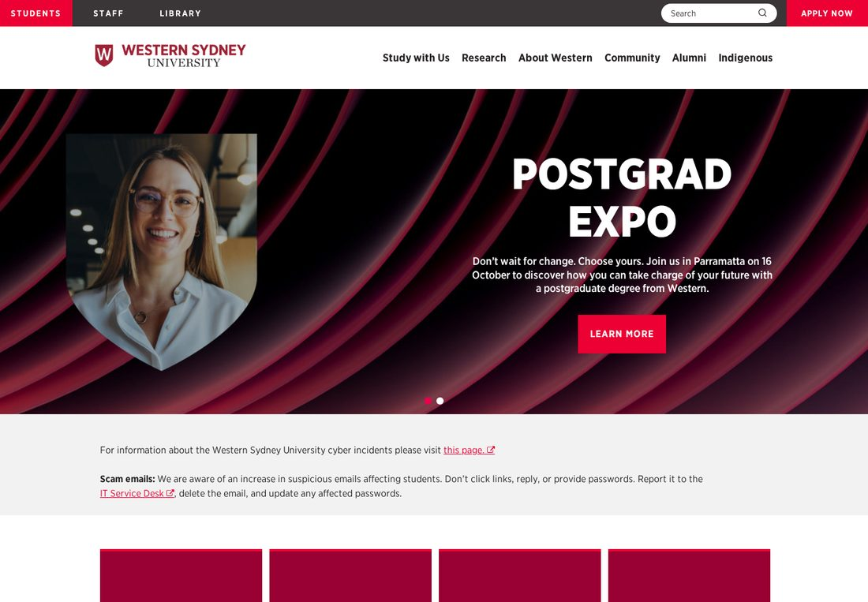
Figure 1: Corporate Homepage (T01) — classic AEM, cmp-news-events, promo bands.
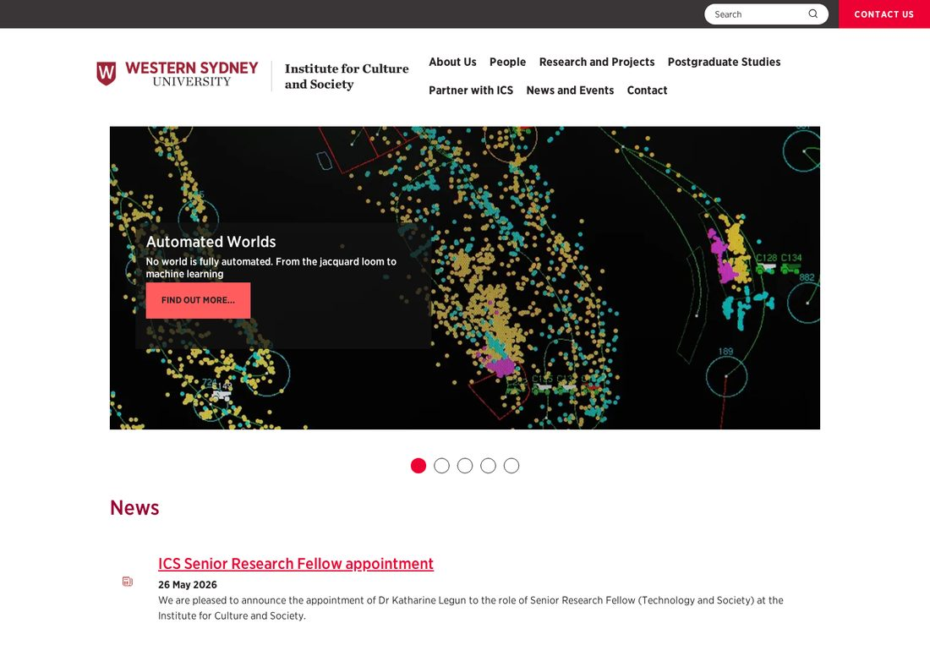
Figure 2: Research-institute microsite landing /ics (T03) — EDS hero, carousel, cards.

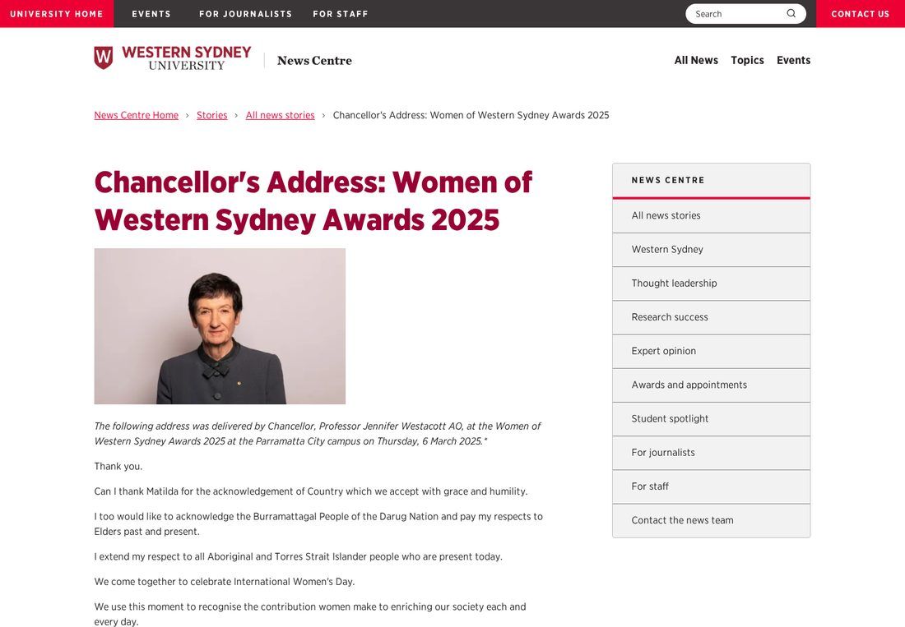
Figure 3: News story detail (T06) — EDS rich-text + accordions.
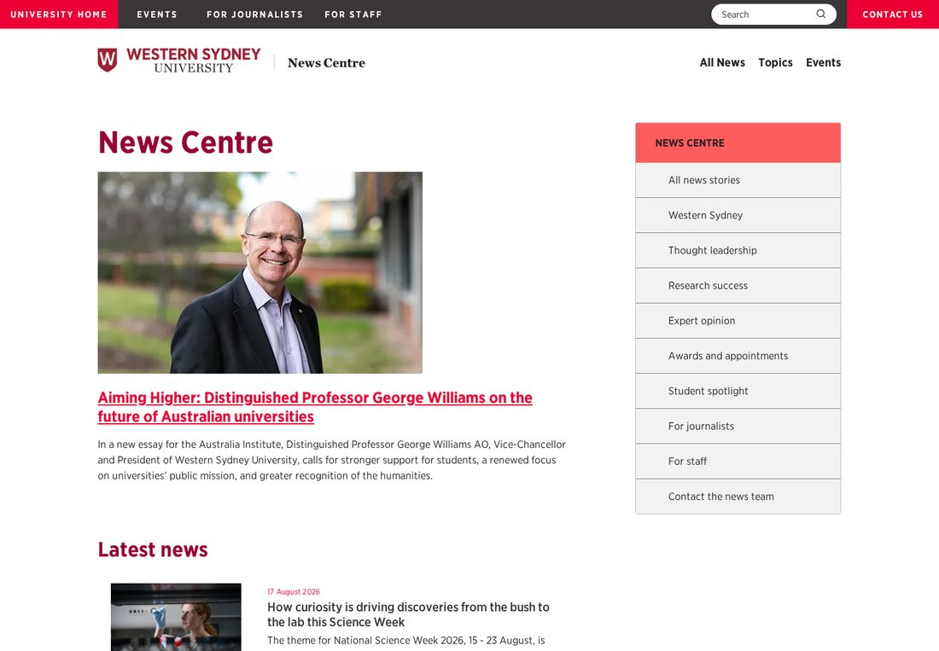
Figure 4: News Centre hub (T05) — EDS dynamic news-list + curated tables.

4. Page Counts by Template
Counts derive from URL-pattern analysis of the 9,925-page sitemap. Because the interior estate is already on Edge Delivery, 'migration type' below reflects the residual effort: RE-PLATFORM for the classic-AEM corporate pages, and VALIDATE/RE-HOST for pages already on EDS (confirm block fidelity, metadata, redirects — largely automatable).
Template | Stack | Est. Pages | Migration Type | Notes / Rationale
T06 News Story Detail | EDS | ~1,870 | Automatic (validate) | Uniform rich-text + images; already EDS. Bulk-verify.
T09 Events Listing / Archive | EDS | ~884 | Automatic (validate) | Table/index-driven lists; already EDS.
T10 People / Team Listing | EDS | ~250+ | Automatic (validate) | Card/grid people lists; already EDS.
T08 Expert Opinion / Spotlight | EDS | ~134 | Automatic (validate) | Article variant; already EDS.
T05 News Centre Hub | EDS | ~15 | Semi-Automatic | Dynamic news-list config to verify.
T07 News Listing by Year | EDS | ~7 | Automatic (validate) | Single dynamic block per year.
T03 Microsite Landing | EDS | ~300-400 | Semi-Automatic | 40+ centres; hero/carousel/cards + nav fragment per site; verify config.
T04 Generic Content / Rich-Text | EDS | ~6,300 | Automatic (validate) | Long tail of about/policy/info/publication pages; already EDS default content.
T11 Nav & Footer Fragments | EDS | ~40+ | Semi-Automatic | One nav fragment per microsite + shared footer.
T01/T02 Corporate Homepage & Marketing | AEM | ~10-40 | Manual (re-platform) | Classic AEM; bespoke widgets, promo bands, Algolia. Not in sitemap.
T12 AEM Adaptive Forms | AEM | ~10-30 | Manual (re-build) | Adaptive Forms have no native EDS equivalent.
TOTAL (sitemap, EDS) | EDS | 9,925 | - | Overwhelmingly already on Edge Delivery.

4.1 Migration Automatability Summary
Category | Est. Pages | Includes
Already on EDS — validate/re-host (largely automatic) | ~9,800 | News, events, people, microsite content, generic pages. Confirm block fidelity, metadata, redirects.
Semi-automatic (config verification) | ~350-450 | Microsite landings, news-centre hub, nav/footer fragments.
Manual re-platform / re-build | ~20-70 | Classic-AEM corporate homepage & marketing pages, Adaptive Forms, Algolia search block.
Because ~99% of sitemap pages already render on Edge Delivery, the dominant activity is validation and cut-over rather than content re-authoring. The concentrated manual effort is the small but complex corporate/marketing shell, forms, and search.

5. Integrations Analysis
Integrations confirmed from rendered DOM, inline scripts, and the Adobe DTM library. Actual IDs captured where visible. Enterprise systems on separate subdomains are noted as out-of-scope links.
Integration | Type | Complexity | Evidence (ID / domain) | Where
Adobe DTM / Launch | Tag manager | Medium | assets.adobedtm.com/…satelliteLib…; injected by EDS delayed.js | All pages
Adobe Audience Manager | Analytics / DMP | Medium | demdex; org 864008A3573B47607F000101@AdobeOrg | via DTM
Google Tag Manager | Tag manager | Simple | GTM-KDSCL5, GTM-NCPWGGZR | via DTM
Google Ads / Floodlight | Ad pixel | Simple | AW-11286271048, AW-937284738, AW-18181713940; dc-432… | via DTM
Microsoft Clarity | Analytics | Simple | clarity.ms / scripts.clarity.ms | Homepage
Meta / Facebook Pixel | Ad pixel | Simple | fbevents.js; 5 pixel IDs incl. custom CoursePageView event | via DTM
TikTok Pixel | Ad pixel | Simple | analytics.tiktok.com; 4 pixel IDs | via DTM
Snapchat Pixel | Ad pixel | Simple | snaptr init dfe8aba0-… | via DTM
LinkedIn Insight | Ad pixel | Simple | snap.licdn.com; partner_id 9227514 | via DTM
Everest / Conversant | Ad pixel | Simple | everestjs.net last-event-tag | via DTM
Spotify Pixel | Ad pixel | Simple | pixel.byspotify.com | Homepage
OneTrust | Consent (CMP) | Complex | cdn-au.onetrust.com/consent/6cfd50d2-…/otSDKStub.js | via DTM
Algolia | Search | Complex | app NY25AYQTZ8; indices wsu_prod_courses/articles/content_library/main_pages; custom web components | Homepage, /future
Genesys PureCloud | Live chat | Complex | apps.mypurecloud.com.au/genesys-bootstrap (region au) | via DTM
Qualtrics | Survey / intercept | Complex | …qualtrics.com/WRSiteInterceptEngine; ZN_* zone IDs | via DTM
AEM Adaptive Forms | Forms | Complex | core/fd/af-clientlibs runtime; wizard + accordion; dompurify | Classic AEM pages
YouTube | Media embed | Simple | youtube.com/embed/… | Homepage
AEM EDS RUM | Telemetry | Native | rum.hlx.page; sampleRUM in scripts.js | All pages
jQuery 3.6.0 | Library | Simple (retire) | ajax.googleapis.com/…jquery-3.6.0 | Homepage, /future
Slick Carousel 1.8.1 | Library | Simple (rebuild) | cdnjs…/slick-carousel/1.8.1 | Homepage
Cloud.typography (Hoefler) | Web fonts | Simple | cloud.typography.com | /future
Okta (SSO) | Auth | Complex (out of scope) | login.westernsydney.edu.au (Okta OIDC/MFA) | login subdomain
Handbook system | Course/handbook | Complex (out of scope) | handbook. / hbook. / studenthandbook.westernsydney.edu.au | Linked
Applications portal | Application | Complex (out of scope) | apply.westernsydney.edu.au | Linked
Library (Springshare LibCal) | Library | Complex (out of scope) | library.westernsydney.edu.au → api3-au.libcal.com | library subdomain
ServiceNow | ITSM | Medium (out of scope) | wsu.service-now.com/it | Footer
GoGlobal / Careers / Online portals | Portals | Medium (out of scope) | goglobal. / careers. / online.westernsydney.edu.au | Linked

5.1 Migration Notes
Trivial to carry across (already proven on EDS): the entire tag/pixel layer — WSU's EDS delayed.js already injects the same Adobe DTM library, so GTM, Audience Manager and all ad pixels transfer for free. YouTube → standard embed block. jQuery, Slick and cloud.typography should be retired/rebuilt natively.
Needs real re-engineering: Algolia search (rebuild custom web components as an EDS search/autocomplete block against app NY25AYQTZ8, repoint indexing at EDS content); AEM Adaptive Forms (no EDS equivalent — rebuild or iframe-embed); Genesys chat & Qualtrics intercepts (load via delayed.js but re-verify page-targeting against the URL structure); OneTrust (re-validate category blocking). Enterprise subdomains (handbook, apply, library, login/Okta, goglobal) are out of CMS scope — preserve links and SSO hand-offs.

6. Complex Use Cases & Observations
Behaviours and edge cases needing special attention during migration, quantified. [C] = confirmed against live pages/sitemap; [E] = estimated.
Use Case | Instances | Where Found | Why It's Complex
Dual-stack site (AEM + EDS in parallel) | Whole estate [C] | Homepage/marketing = AEM (cms_type=AEM); ~9,900 interior pages = EDS (cms_type=EDS) | Two rendering stacks, two component vocabularies, and a live cut-over boundary. Cross-stack nav/consistency and redirect management are the central risk.
Bespoke news-events composite component | 1 (homepage) [C] | cmp-news-events (news + events + calendar + gallery) | Single custom AEM component fuses four content types + a calendar. No 1:1 EDS block; must be rebuilt from news-list + table + gallery.
Dynamic news-list (index-driven feeds) | News-centre + microsites [C] | /news-centre and year listings; config rows for query/limit/pagination | Query/pagination logic bound to content indexes; feeds must be reproduced and re-pointed to EDS-published content, and kept in sync.
Algolia federated search (5 indices) | Site-wide search + course search [C] | app NY25AYQTZ8; wsu_prod_courses/articles/content_library/main_pages | Custom web components and a course index power study discovery. Rebuilding as an EDS block plus re-indexing EDS content is the largest single integration lift.
AEM Adaptive Forms | ~10-30 forms [E] | fd/af runtime; wizard + accordion; homepage enquiry forms | Multi-step conditional forms with validation/submit actions; no native EDS equivalent — each needs rebuild or embed, with backend endpoints re-tested.
Per-microsite navigation fragments | 40+ [C] | /{microsite}/nav pages + section-metadata (search link, sign-in, red CTA) | Each of 40+ centres/schools has its own authored mega-menu fragment; migration must preserve per-site IA, not a single global nav.
Research-institute microsite sprawl | 40+ microsites, ~5,000+ pages [C] | /ics, /marcs, /thri, /nicmhri, /hie, /babylab, … each with about-us/people/research/projects/publications/events/news | Large volume of near-identical sub-structures with local variation; template detection and QA at scale dominate effort.
Large ad-pixel / recruitment martech farm | 15+ trackers [C] | Meta ×5, TikTok ×4, Snapchat, LinkedIn, Google Ads ×3, Floodlight, Spotify; custom CoursePageView | Consent-gated conversion tracking tied to student recruitment; category/zone targeting must be re-validated post cut-over under OneTrust.
Genesys PureCloud live chat + Qualtrics intercepts | Site-wide [C] | apps.mypurecloud.com.au; Qualtrics ZN_* zones | Session/stateful widgets with page-targeting rules held in DTM; behaviour must be re-verified against new URLs.
Enterprise systems on separate subdomains | 6+ systems [C] | handbook, apply, library→LibCal, login→Okta, goglobal, careers, service-now | Out of CMS scope but deeply linked; broken-link/SSO-handoff risk if inbound links and deep links aren't inventoried and preserved.
Bot protection (HTTP 406 to non-browsers) | Whole site [C] | 406 Not Acceptable without browser headers | Automated crawling/import tooling must send browser headers; affects any migration/QA automation and third-party indexing.

Appendix: Template Screenshots
Representative page per template family (captured August 2026, 1440px viewport).
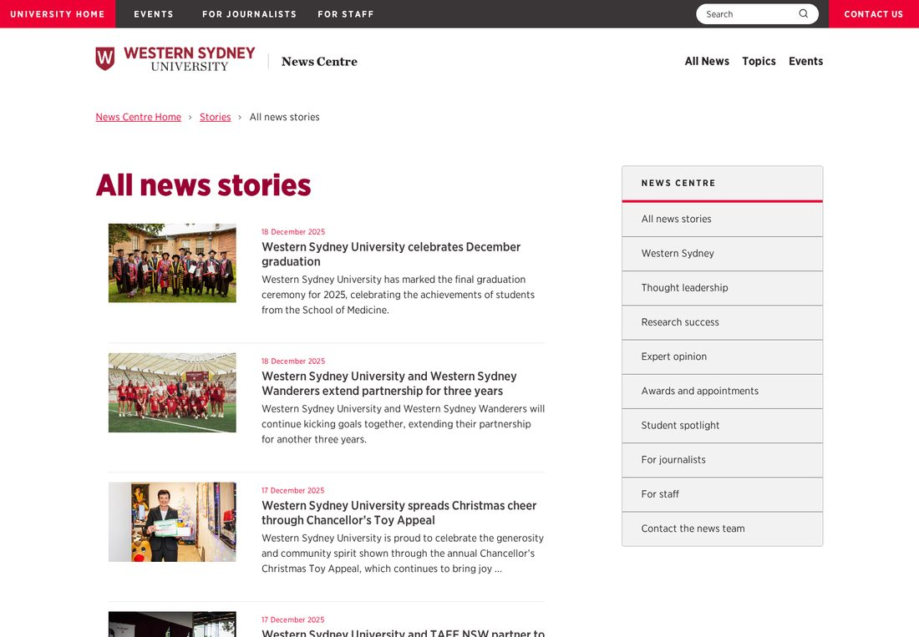
Figure 5: News listing by year (T07).

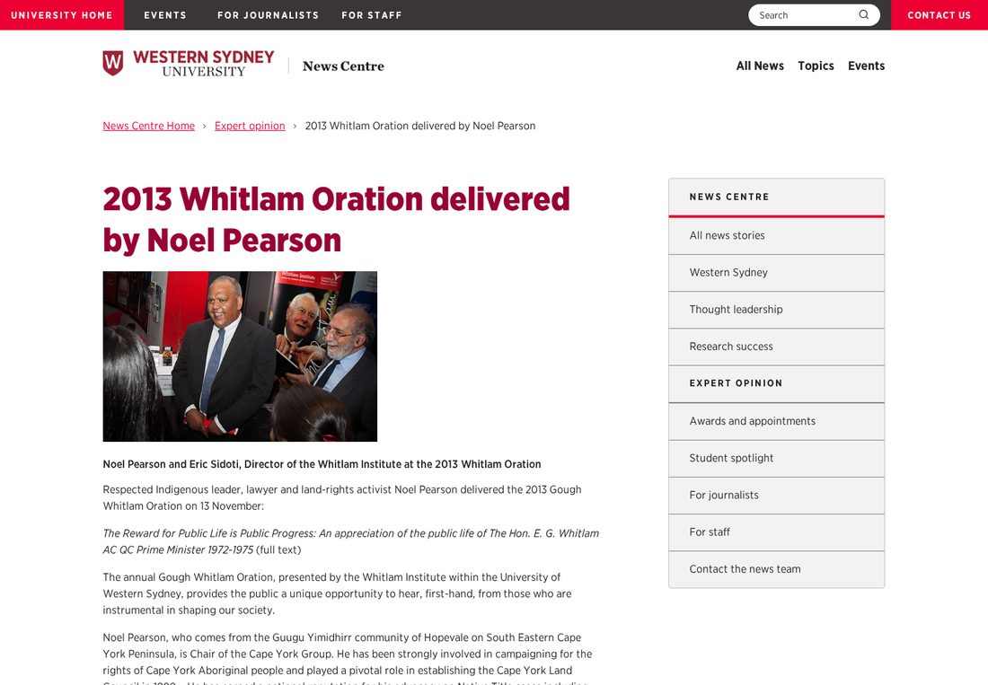
Figure 6: Expert opinion article (T08).

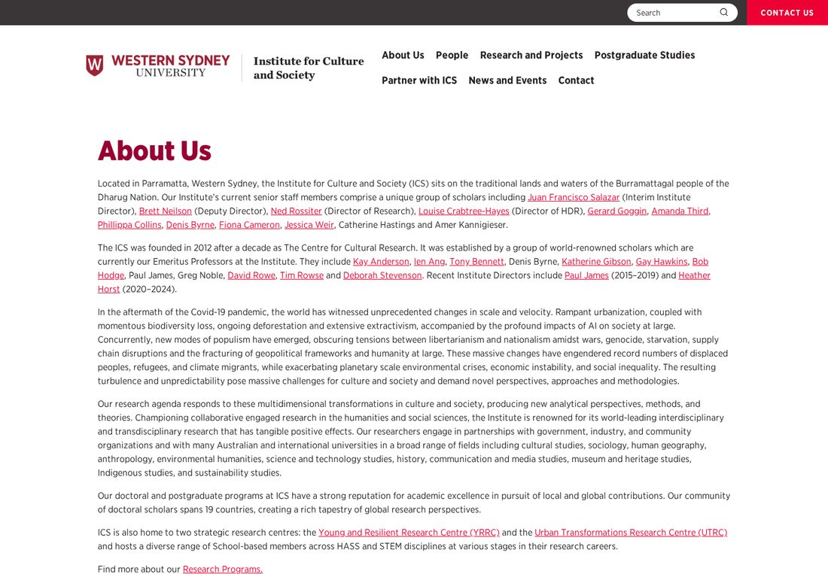
Figure 7: Microsite content / about page (T04).

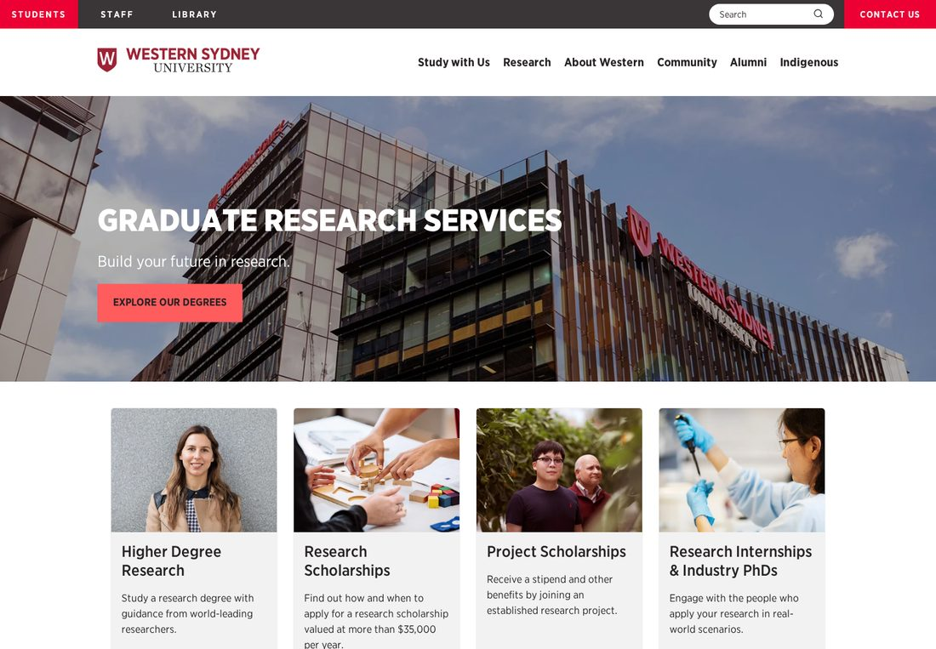
Figure 8: School landing (T03) — hero, cards, button-list.

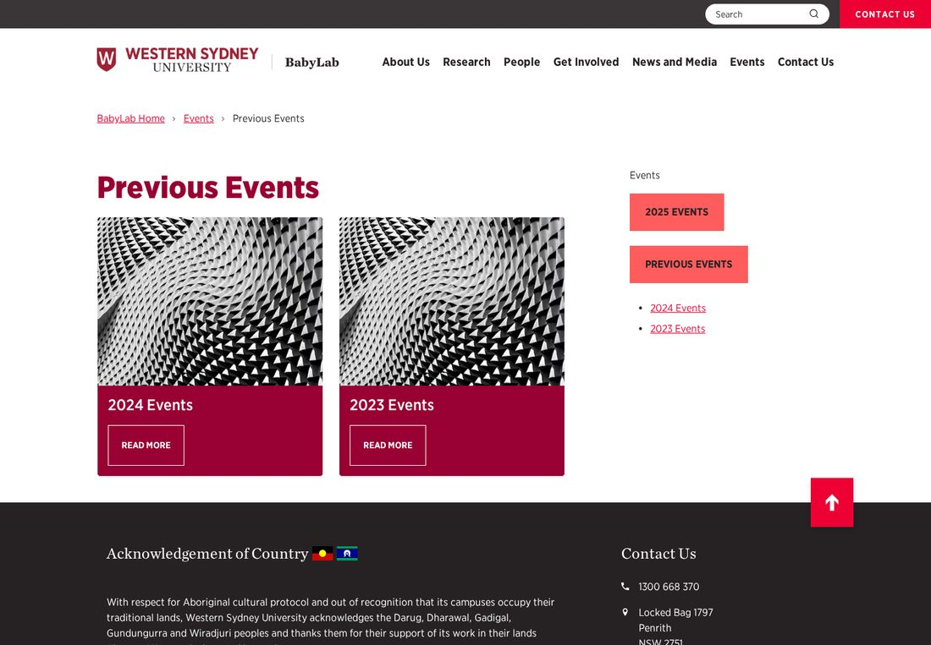
Figure 9: Events archive listing (T09).

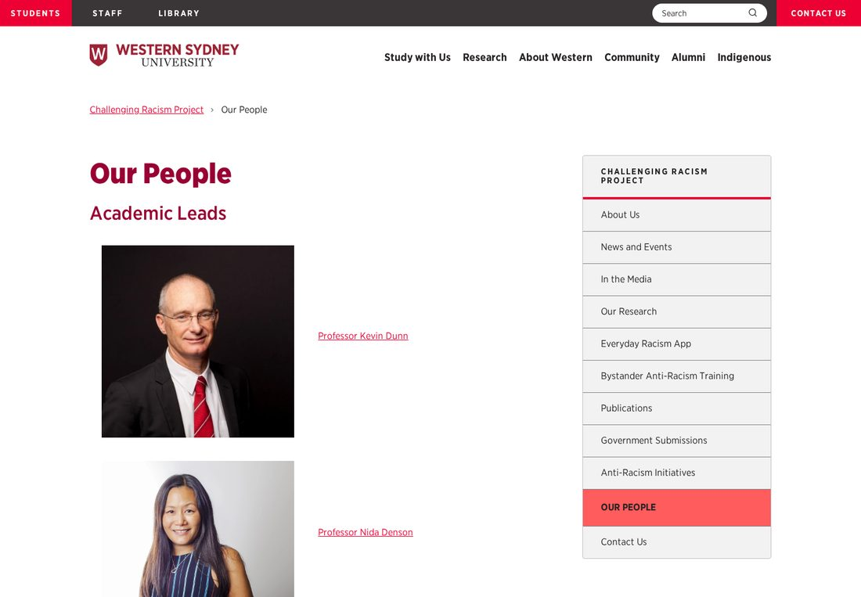
Figure 10: People / team listing (T10).

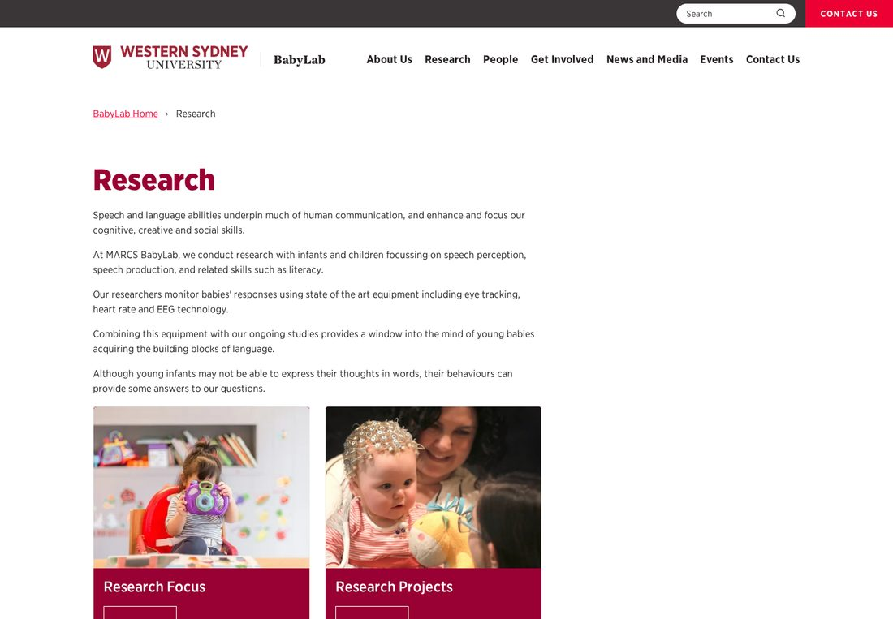
Figure 11: Research/projects listing (T03/T04).

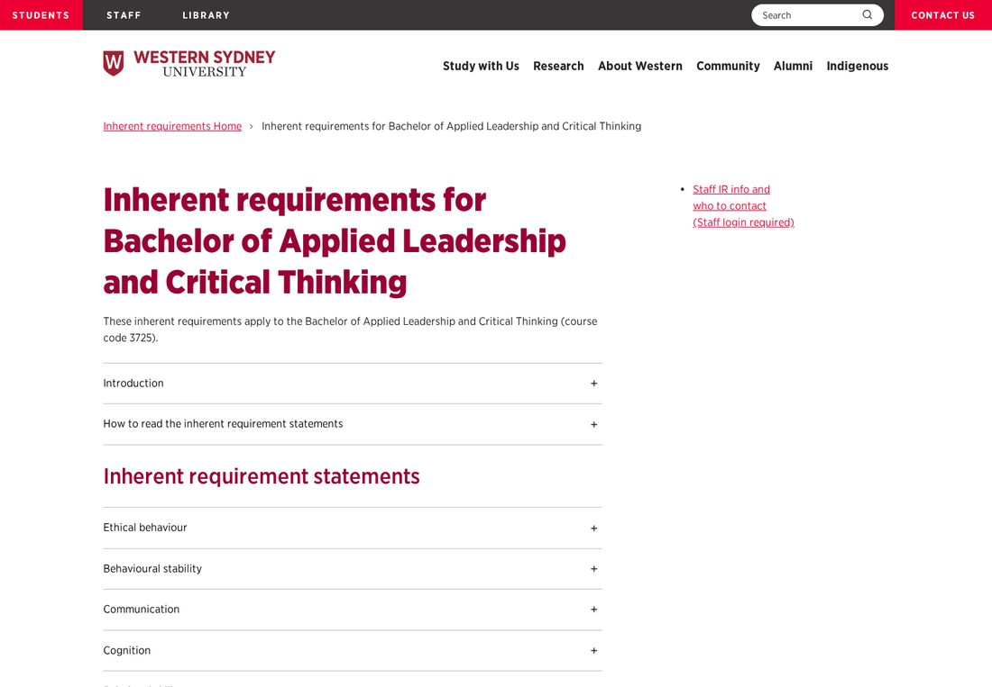
Figure 12: Deep content page — inherent requirements (T04).

Prepared from live inspection of representative pages across both platforms (August 2026). Page counts sourced from the site sitemap. This assessment is a planning document; a fixed migration plan requires a template/block workshop and confirmation of the AEM-vs-EDS cut-over roadmap with WSU.

