Piramal Finance
Website Migration Analysis & Technical Assessment
Templates, Blocks, Page Counts, Integrations & Complex Use Cases

Target URL: https://www.piramalfinance.com/
Analysis Date: 23 June 2026
Destination Platform: Adobe Experience Manager — Edge Delivery Services (EDS)

Executive Summary
This document presents a structured migration analysis of the Piramal Finance website. The analysis is derived from the site's XML sitemaps (1,563 URLs on the main site and 3,160 on the blog), live page inspection, HTTP response headers, the published EDS block markup, and rendered screenshots.
Key finding — the property runs on TWO platforms behind a single domain:
- Main marketing & product site (/, product, calculators, locations, corporate) is already on Adobe Edge Delivery Services (EDS), authored in AEM as a Cloud Service via the Universal Editor.
- The /vidya/ knowledge hub (~3,160 URLs) is a separate legacy WordPress site (jQuery + Bootstrap, wp-content assets). This is the primary content-migration target.
The single biggest volume driver is the programmatic Branch-Locator location hierarchy (1,189 URLs, ~76% of the main site), which is highly templated and well-suited to automated migration. Conversely, the WordPress blog and interactive tools (calculators, application forms, branch map) require manual or assisted migration.
At-a-Glance Metrics
Metric | Value
Main site URLs (sitemap) | 1,563
Blog / Vidya URLs (WordPress) | 3,160
Total addressable URLs | ~4,723
Unique page templates (main site) | 9
Reusable blocks / components | 20+
Third-party integrations | 12+
Current main-site platform | Adobe EDS (AEMaaCS + Universal Editor)
Current blog platform | WordPress (legacy)
CDN / Edge | Fastly (India edge), Brotli, TTFB ~0.75s

1. Templates Inventory
Nine distinct page templates were identified on the main (EDS) site, plus one legacy template family on the WordPress blog. Complexity reflects the variety of blocks, dynamic behaviour, and authoring logic involved per template.
# | Template | Complexity | Reasoning | Reference URL examples
1 | Homepage | High | Hero carousel, multiple teaser bands, live EMI & eligibility calculators, testimonials, app download — many interactive blocks on one page. | https://www.piramalfinance.com/
2 | Loan Product Page | High | Rich content model: hero, key-features, calculators, FAQ schema, apply-form, accordions, comparison tables; multiple SEO/structured-data blocks. | https://www.piramalfinance.com/personal-loan  https://www.piramalfinance.com/home-loan  https://www.piramalfinance.com/business-loan
3 | Calculator Page | High | Client-side interactive financial calculator driven by JSON config + datepicker libs; dynamic computation and charts. | https://www.piramalfinance.com/calculators/personal-loan-emi-calculator  https://www.piramalfinance.com/calculators
4 | Branch-Locator (State) | Medium | Programmatic location landing keyed off branch-locator.json; cascading dropdowns + Google Maps; standardized layout. | https://www.piramalfinance.com/branch-locator  https://www.piramalfinance.com/branch-locator/andhra-pradesh
5 | Branch-Locator (City / Branch Detail) | Low | Highly repetitive SEO location pages (loans-in-city, city/branch) generated from a data source; near-identical structure. | https://www.piramalfinance.com/branch-locator/loans-in-adoni-andhra-pradesh-6002  https://www.piramalfinance.com/branch-locator/andhra-pradesh/adoni
6 | Corporate / Investor / Stakeholder | Medium | Document-heavy: tables, tabbed sections, accordions, PDF disclosures, board-of-director bio sub-pages. | https://www.piramalfinance.com/investor-relations  https://www.piramalfinance.com/stakeholders/interest-rates  https://www.piramalfinance.com/about-us/board-of-director/sunit-madan
7 | Contact / Support Page | Medium | Icon-card grids, WhatsApp QR, embedded maps, multiple CTA blocks and channel links. | https://www.piramalfinance.com/contact-us
8 | FAQ Page | Low | Accordion-driven Q&A with FAQ schema; single primary block. | https://www.piramalfinance.com/faq
9 | Legal / Policy (Static Content) | Low | Long-form rich text, minimal blocks; mostly default content. | https://www.piramalfinance.com/privacy-policy  https://www.piramalfinance.com/terms-and-conditions  https://www.piramalfinance.com/disclaimer
10 | Vidya Blog Article (WordPress — legacy) | Medium | Separate platform; article body + author, breadcrumb, related-link cards, tags; needs cross-platform content extraction. | https://www.piramalfinance.com/vidya  https://www.piramalfinance.com/vidya/loan-against-property-interest-rate-guide

2. Blocks / Components Catalog
Blocks below are the reusable EDS components observed in the published markup across templates. Per the brief, visual differences over the same content model are treated as design VARIANTS of one block (e.g. Teaser vs TeaserV2), not separate blocks.
Block / Component | Cx | Behaviour & Functionality | Reference URL(s)
Header / Navigation | Medium | Sticky top nav, logo, mega-menu, Login CTA, mobile hamburger drawer. Loaded from /nav. | All pages
Footer | Low | Multi-column link groups, social icons, app links, legal row. Loaded from /footer. | All pages
Mobile Nav | Medium | Dedicated mobile navigation source (/mobile-nav). | All pages (mobile)
Hero Carousel | High | Rotating banner slides with image, heading, CTA; auto-rotate; responsive picture sources. | Homepage
Teaser / TeaserV2 (variants) | Medium | Promotional content band: image + heading + copy + CTA. Multiple colour/layout variants (--skyblue, teaser-block-six). | Home, product, contact pages
Key Features | Low | Icon/feature grid listing product benefits; repeated heavily on product pages. | personal-loan, home-loan, business-loan
Columns | Low | Generic multi-column layout container for mixed content. | Most templates
EMI / Eligibility Calculator | High | Interactive calculator (homeloancalculatorv2, emiandeligiblitycalc, eligibilitycalculator) fed by /api/*-calculator.json; sliders, datepicker, live computation. | Home, product, /calculators/*
Apply Loan Form (applyloanform) | High | Lead-capture / loan application form; sticky 'Apply Loan Now' CTA; posts to /api/apply-form-loan.json; routes to /loan/login. | All product pages, homepage
Branch Locator (branchlocator) | High | Cascading State/City/Branch dropdowns + Google Maps embed; data from /api/branch-locator.json. | /branch-locator and children
City List (city-list) / Branches | Medium | Auto-generated list of city/branch links for internal linking & SEO. | product & locator pages
Accordion / Accordion-Group | Low | Expand/collapse FAQ and disclosure content; backs FAQ schema. | product, faq, stakeholders
FAQ Block | Low | Structured Q&A with FAQPage JSON-LD. | /faq, product pages
Tables | Low | Interest-rate / charges / comparison tables. | stakeholders, product pages
Tab-Link (tabbed sections) | Medium | Tabbed navigation between content panels. | /stakeholders/interest-rates
Testimonials (testimonies) | Medium | Customer review carousel/cards. | Homepage
Cards / Icon Cards | Low | Icon + label + link grid (contact channels, services). | contact-us, faq
Image-with-Link / Img-bg (imgwithlink) | Low | Linked image / background-image promo tile. | Home, contact-us
Embed | Medium | Embeds external media (YouTube video, third-party widgets). | product, calculator pages
Breadcrumb | Low | Navigational breadcrumb with BreadcrumbList schema. | All non-home pages
Schema-Tag / Code (schema-tag, code) | Medium | Injects JSON-LD structured data & inline code/scripts per page. | product, calculator, locator pages
Wrapper-Creation (wrappercreation) | Low | Layout grouping/section wrapper utility. | Home, product, contact pages

Representative Screenshots
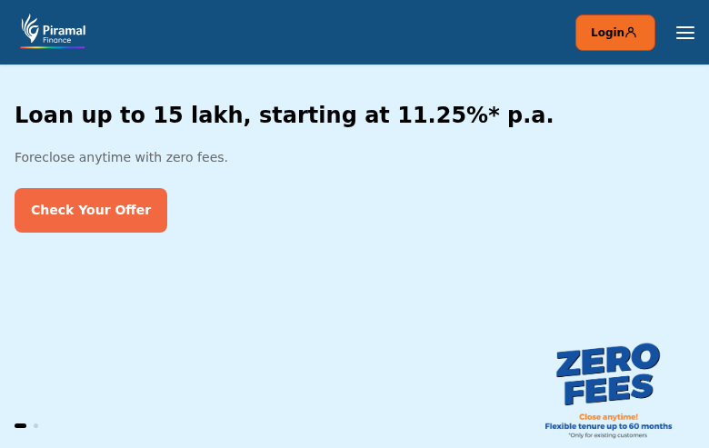
Figure 1 — Homepage: hero carousel + Login CTA (Homepage template)

Figure 2 — Loan Product Page: hero, breadcrumb, Apply CTA, sticky 'Apply Loan Now' bar
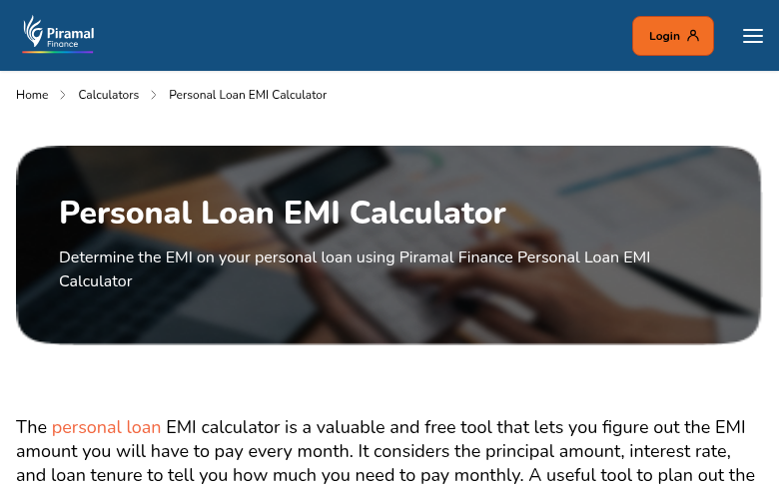
Figure 3 — Calculator Page: interactive EMI calculator template
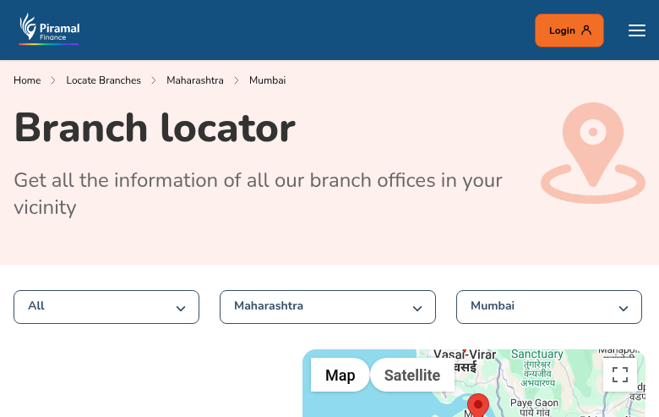
Figure 4 — Branch Locator: cascading State/City dropdowns + Google Maps
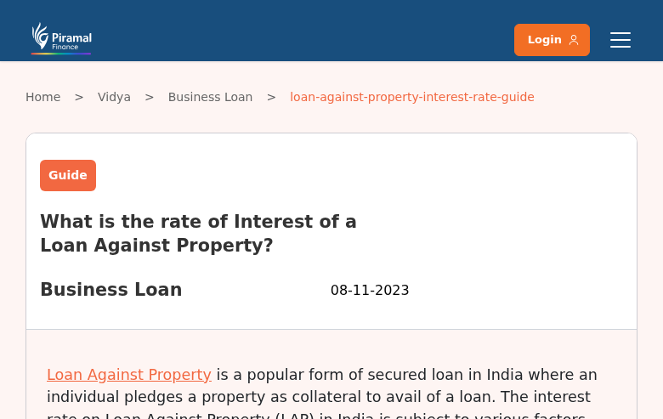
Figure 5 — Vidya Blog article (legacy WordPress) — visually distinct template

3. Page Counts by Template
Counts derived from the XML sitemaps. Migration disposition indicates whether pages can be migrated automatically (standardized, data-driven) or require manual/assisted effort (interactive logic, custom content, or cross-platform extraction).
Template | Pages | Migration Disposition | Rationale
Branch-Locator — City/Branch detail | 1,163 | Automatic | Highly standardized, data-source driven location pages.
Branch-Locator — State landing | 25 | Automatic | Templated, fed by branch-locator.json.
Branch-Locator root (with map) | 1 | Manual | Hosts interactive Google Maps + dropdown logic.
Loan Product Pages | 182 | Manual (assisted) | Rich blocks, calculators, forms, FAQ schema, per-page SEO content.
Calculator Pages | 12 | Manual | Interactive client-side logic + JSON config; functional testing needed.
About-Us (incl. 49 board bios) | 88 | Automatic (assisted) | Mostly structured bio/content pages; bios are templated.
Investor / Stakeholder / Corporate | 57 | Manual (assisted) | Document-heavy, tables, PDFs, tabbed disclosures.
Legal / Policy (static content) | 15 | Automatic | Long-form rich text, minimal interactivity.
Media / News | 5 | Automatic | Standardized content layout.
FAQ / Contact / misc. content | ~15 | Automatic (assisted) | Accordion + icon-card blocks, standardized.
MAIN SITE TOTAL | 1,563 | ~80% Automatic | Volume dominated by templated location pages.
Vidya Blog (WordPress) | 3,160 | Manual (assisted) | Cross-platform extraction from WordPress; map to EDS blog template; preserve SEO/redirects.
GRAND TOTAL | ~4,723 | — | —

Note: category subtotals are approximate where URL patterns overlap; the dominant Branch-Locator family (1,189 URLs) is automation-friendly, which materially de-risks the main-site migration effort.

4. Integrations Analysis
Integrations were identified from the Content-Security-Policy header, delayed.js (martech loader), inline scripts, and API endpoints referenced in the markup.
4.1 Analytics, Marketing & Tag Management
Integration | Type | Cx | Where used / Notes
Google Tag Manager (GTM-T5MTVQ9) | Embed / Script | Low | Site-wide via delayed.js; container ID confirmed.
Google Analytics | Embed / Script | Low | Via GTM; www.google-analytics.com in CSP.
Adobe Experience Cloud (Adobe DTM / Target / Audience) | Script / API | Medium | assets.adobedtm.com, edge.adobedc.net, demdex (Audience Manager) in CSP.
MoEngage | Plugin / SDK | Medium | Customer engagement / push; app_id + SDK loaded in delayed.js; cdn.moengage.com.
Microsoft Clarity | Embed / Script | Low | Session replay / heatmaps; *.clarity.ms in CSP.
Bing Ads (UET) | Embed / Script | Low | bat.bing.com conversion tracking.
Google Ads / DoubleClick / Floodlight | Embed / Script | Low | *.doubleclick.net, googleadservices, fls.doubleclick floodlight.
Facebook Pixel | Embed / Script | Low | connect.facebook.net in CSP.

4.2 Functional & Enterprise Integrations (APIs / Services)
Integration | Type | Cx | Reference / Endpoint
Loan Application / Lead Capture | Custom code / REST API | High | /api/apply-form-loan.json; applyloanform block; routes to /loan/login (customer login app).
EMI & Eligibility Calculators | Custom code / REST API | High | /api/personal-loan-emi-calculator.json, /api/homepage-emi-calculator.json, /api/homepage-eligibility-calculator.json, /api/business-loan-combined-calculator.json.
Branch Locator service | REST API | Medium | /api/branch-locator.json feeds dropdowns + map.
Google Maps Platform | API / Embed | Medium | maps.googleapis.com / maps.gstatic.com on locator & contact pages.
Customer Login / Servicing portal | Embed / External app | High | /loan/login (returns 406 to bots — gated app); existing-customer servicing.
Enterprise backend APIs | REST API | High | mobileapi.pchf.in, apisit.piramal.com, campaignapi.piramalfinance.com (CSP connect-src) — core lending/campaign systems.
AllinCall (call/voice) | API / Embed | Medium | piramal.allincall.in in CSP connect-src.
WhatsApp Business | Embed / Deep link | Low | api.whatsapp.com + WhatsApp QR on contact-us.
YouTube | Embed | Low | Embedded product/brand videos (VideoObject schema).
App Store / Play Store / OneLink | Deep link | Low | App download CTAs (onelink.to).
Universal Editor (authoring) | Platform service | Medium | universal-editor-service.experiencecloud.live; AEMaaCS author author-p133703-e1305981.adobeaemcloud.com.
Font Awesome / Bootstrap CDN (blog) | Embed / Library | Low | kit.fontawesome.com, stackpath.bootstrapcdn.com — legacy WordPress blog.

5. Complex Use Cases & Observations
The following behaviours require special attention, scoping, or functional re-build during migration. Each is quantified by approximate instance count and location.
Use Case | Instances | Where found | Why complex
Dual-platform property (EDS + WordPress) | 1 (3,160 blog URLs) | /vidya/* on WordPress; rest on EDS | Two CMSs, two markup systems; blog content must be extracted from WordPress and re-modelled into EDS blocks with redirect/SEO preservation.
Interactive financial calculators | 12 dedicated + embedded on product/home | /calculators/*, product pages, homepage | Client-side computation, sliders, datepicker libs, JSON-driven config; require functional re-implementation and QA, not just content move.
Loan application / lead-capture forms | On all product pages + homepage | applyloanform; /api/apply-form-loan.json; /loan/login | Multi-step form posting to enterprise APIs, validation, session/login handoff to gated servicing app.
Programmatic location pages | 1,189 | /branch-locator/* (states, cities, branches) | Data-source driven SEO pages with Google Maps + cascading dropdowns; volume + dependency on branch-locator.json and geo data.
Customer login / servicing (session-gated) | 1 app + every Login CTA | /loan/login, header Login | Returns 406 to bots; authenticated, session-dependent area outside the marketing site scope.
Enterprise backend API dependencies | 4+ endpoints | mobileapi.pchf.in, apisit.piramal.com, campaignapi, allincall | Live coupling to core lending/campaign/voice systems; environment config, auth, and CORS must be re-validated post-migration.
Structured-data inconsistency | Multiple | /personal-loan (none), /calculators (partial), /faq (no FAQPage) | Rich JSON-LD on some product pages but missing on peers; risk of losing rich results unless normalized during migration.
Decommissioned regional-language paths | 7 prefixes | /hi /gu /mr /ta /te /kn /ml (404, also robots-blocked) | Listed in robots.txt but return 404 with no content; stale rules to clean up; confirm no SEO equity/redirects needed.
Multiple calculator/eligibility block variants | 3+ block names | homeloancalculatorv2, emiandeligiblitycalc, eligibilitycalculator | Overlapping calculator implementations should be consolidated into one block with variants to reduce maintenance.
Heavy marketing/tracking stack | 8+ tags | Site-wide (GTM, Adobe, MoEngage, Clarity, Bing, FB, DoubleClick) | Tag parity, consent, and dataLayer events must be preserved; risk of analytics gaps during cutover.

6. Recommendations & Migration Notes
- Phase the migration: (1) automate the 1,189 Branch-Locator pages and static legal/content pages first for quick volume wins; (2) manually rebuild product pages, calculators and forms with functional QA; (3) plan the WordPress /vidya blog (3,160 URLs) as a dedicated workstream.
- Consolidate overlapping calculator blocks (homeloancalculatorv2 / emiandeligiblitycalc / eligibilitycalculator) into a single block with design + config variants.
- Normalize structured data: add FinancialService/LoanOrCredit/FAQPage JSON-LD to /personal-loan and other product pages currently missing it.
- Preserve all enterprise API contracts (apply-form, calculators, branch-locator, mobileapi/apisit/campaignapi) and re-validate auth/CORS/env config in the target environment.
- Maintain analytics parity (GTM container GTM-T5MTVQ9, Adobe, MoEngage, Clarity) and dataLayer events through cutover; verify consent management.
- Implement 301 redirects for the WordPress blog URLs and clean up the stale regional-language robots.txt rules.
- Treat the customer login / servicing area (/loan/login) as out-of-scope for content migration — it is a session-gated application.

— End of Report —

