AXA Philippines Website
Migration Analysis & Assessment
Templates, Components, Integrations & Migration Estimates

Target Platform: Adobe Experience Manager (AEM) Cloud Service – Core Components
Source Site: https://www.axa.com.ph/
Scope: 21 representative URLs
Date: June 2026

Table of Contents
1. Executive Summary
2. Templates Inventory
3. Components Catalog (AEM Core Components)
4. Page Counts by Template
5. Integrations Analysis
6. Complex Use Cases & Observations
7. Migration Estimates
8. Appendix: Page Screenshots

1. Executive Summary
This document analyzes 21 representative URLs from the AXA Philippines website (www.axa.com.ph) to assess migration to Adobe Experience Manager (AEM) as a Cloud Service, implemented using the AEM Core Components (WCM) component library. AXA Philippines is a leading life and general insurance provider; the analyzed pages span financial-literacy content, co-branded bancassurance product pages (Metrobank / PSBank), self-service payment facilities, product activation flows, an editorial newsroom, and the "Emma by AXA" customer self-service portal.
The current site is built on a headless/decoupled stack: content and media are served from Prismic (a SaaS headless CMS) and the interactive flows (quote engines, payments, account portal) are AngularJS single-page applications. A migration to AEM CMS therefore involves two distinct efforts: (a) re-platforming editorial/marketing content onto AEM Core Components, which is largely automatable, and (b) re-integrating or rebuilding the transactional SPA experiences, which is predominantly manual, integration-heavy work.

Key Findings
- 6 distinct page templates identified across the 21 URLs (1 URL – /installment-general-insurance – returns HTTP 404 and is excluded from active counts).
- 14 reusable components cataloged, all mappable to standard or extended AEM Core Components; visual differences are best handled as component style variations, not new components.
- Content delivery is currently headless via Prismic CMS; media is served from images.prismic.io and axa-philippines.cdn.prismic.io.
- Transactional pages are AngularJS SPAs with heavy client-side logic (multi-step forms, cascading dropdowns, OTP, premium calculation).
- Extensive third-party integration footprint: 2C2P and PesoPay payment gateways, ion.axa.com.ph payment service, Google reCAPTCHA, LiveChat, and a full martech stack (GA, GTM, Microsoft Clarity, Bing UET, DoubleClick/Google Ads, Innity, Azure Application Insights).
- Co-branded bancassurance pages (Metrobank, PSBank) reuse a single product template with partner-specific branding/credit-card assets – ideal candidates for AEM templating + Experience Fragments.
- The "Emma by AXA" portal (login, register, forgot-password) is an authenticated account application backed by AXA back-end services – out of scope for CMS content migration and should remain a separate application integrated via SSO/links.

Recommended Target Architecture (AEM Core Components)
- Editorial Templates: AEM Editable Templates + Core Components (Title, Text, Image, Teaser, Carousel, Tabs, Accordion, Container, Button, List, Embed).
- Reusable header/footer/partner branding: Experience Fragments referenced across templates and locales.
- Article/Newsroom listing: Core Components List + Content Fragments for article bodies, enabling structured, query-driven listing pages.
- Transactional flows (quote, payment, activation): retain as AngularJS/SPA apps embedded via the Core Components Embed component or AEM SPA Editor, with AEM owning the surrounding chrome and marketing content.
- Emma portal: keep as the existing authenticated application; AEM provides only the marketing/landing shell and deep-links.

2. Templates Inventory
The 21 URLs consolidate into 6 unique page templates. Complexity reflects the effort to reproduce the template on AEM Core Components, including dynamic behavior and integrations.
# | Template | Complexity | Reasoning | Reference URL Examples
T1 | Content / Literacy Hub Landing | Low–Medium | Largely static marketing layout: hero, category nav, card grid, onboarding modal. Content authorable with standard Core Components. Welcome modal and category filtering add minor JS. | https://www.axa.com.ph/finlithub
T2 | Product / Purchase (Bancassurance) Page | High | AngularJS SPA with hero, coverage feature grid, multi-step quote/purchase form, cascading dropdowns, range slider, OTP, premium calculation, FAQ accordion, partner co-branding, payment gateway. Heavy logic + integrations. | https://www.axa.com.ph/products/car-insurance/partners/metrobank ; .../car-insurance/partners/psbank ; .../travel-insurance/partners/metrobank ; .../travel-insurance/partners/psbank ; https://www.axa.com.ph/healthstartlite ; .../health-start-lite/partners/metrobank
T3 | Payment Facility Page | High | Self-service payment forms (one-time, recurring/auto-pay, general insurance). Policy/PRN lookup with real-time validation, currency toggle, reCAPTCHA, OTP, agreement gating, redirect to payment gateway. | https://www.axa.com.ph/payments/premium-onetime ; .../payments/premium-recurring ; .../payments/premium-onetime-general-insurance
T4 | Product Activation Page (PA / Card) | Medium–High | Tabbed layout (Activation / Coverage / Claim) with PIN/PA-code entry, long multi-section application form, cascading PH geography dropdowns, downloadable claim PDFs, validation. | https://www.axa.com.ph/pa ; https://www.axa.com.ph/pa/nba ; https://www.axa.com.ph/pacard
T5 | Article Listing / Newsroom | Medium | Editorial index: hero, category filter tabs, chronological article cards, count badge, read-more. Maps well to Core Components List + Content Fragments; filtering is dynamic. | https://www.axa.com.ph/multimedia/newsroom ; https://www.axa.com.ph/multimedia/articles
T6 | Account Portal / Authentication (Emma) | High | Authenticated SPA: login, multi-step registration, forgot-password, account dashboards (policies, advisors, payments, e-notiXes). Backed by AXA back-end services + email/OTP verification. Not a CMS content template. | https://www.axa.com.ph/emma ; https://www.axa.com.ph/emma/login ; https://www.axa.com.ph/emma/faq ; https://www.axa.com.ph/emma/forgot-password ; https://www.axa.com.ph/axaprime

Note: https://www.axa.com.ph/axaprime is a recruitment/lead-generation landing page with a registration form; it is grouped under the form-driven landing pattern (closest to T6 for estimation, but visually a Content landing). https://www.axa.com.ph/emma/faq is an FAQ page using accordions (T5/Content pattern). One URL (https://www.axa.com.ph/installment-general-insurance) returned HTTP 404.

3. Components Catalog (AEM Core Components)
Reusable UI elements observed across the site, mapped to AEM Core Components. Per the migration guidance, visual differences (e.g., partner co-branding, card layout variants) are implemented as component style/system variations rather than new components, maximizing reuse.
# | Component | AEM Core Component Mapping | Complexity | Behaviour & Functionality | Reference URL(s)
C1 | Global Header / Primary Nav | Header (XF) + Navigation + Language/Utility nav | Medium | Sticky multi-level dropdown nav (Products, Buy Online, Understand Your Needs, Payments, Support, Emma, About Us) + utility links (Funds, Careers, Consult an Advisor). Authored once as Experience Fragment. | All pages
C2 | Global Footer | Footer (XF) + List + Social icons | Low | Social links (FB, X, YouTube, LinkedIn, Instagram), AXA Worldwide link, Site Map / Legal / Privacy, copyright. Reused as Experience Fragment. | All pages
C3 | Cookie Consent Banner | Custom / Embed (martech-managed) | Low | Top-of-page privacy/cookie notice with "I Accept". Typically provided by martech tag, not authored content. | All pages
C4 | Hero Banner | Teaser (with responsive image variations) | Low | Full-width image + headline + supporting copy + CTA button(s). Responsive desktop/tablet/mobile image variants. | finlithub, healthstartlite, car-insurance, pa
C5 | CTA Button / Button Group | Button | Low | Primary (orange) and secondary (outline) actions: Get a Quote, Buy Online, How to Purchase, Consult an Advisor, Learn More. | All product/landing pages
C6 | Card / Teaser Grid | Teaser + Container (style variants) | Low–Medium | Grids of image cards with title, optional text, and Learn More link. Multiple layout variants (2-up, 3-up) handled via style system. | finlithub, emma
C7 | Feature / Coverage Icon Grid | Container + Teaser/Text + Image (icon) | Low | Icon + label + description grid (e.g., Own Damage, Theft, Bodily Injury). Pure content. | car-insurance (metrobank/psbank)
C8 | Category Filter Tabs | Tabs / List with filter (custom JS) | Medium | Tab/segment control filtering content (literacy categories; newsroom ALL/Newsroom/CSR). Client-side filtering. | finlithub, newsroom, articles
C9 | In-page Section Tabs | Tabs | Low–Medium | Anchored content tabs (Activation/Coverage/Claim; Car Insurance/Coverage/Claims/Roadside/Speed/FAQs). | pa, pacard, car-insurance, healthstartlite
C10 | FAQ Accordion | Accordion | Low | Expand/collapse Q&A list. Direct mapping to Core Components Accordion. | car-insurance, emma/faq, healthstartlite
C11 | Article List / Newsroom Feed | List + Content Fragments | Medium | Query-driven chronological list with date, title, excerpt, read-more, category filter, total count badge. | newsroom, articles
C12 | Quote / Purchase Form (multi-step) | Embed (SPA) or AEM Forms (adaptive) | High | Multi-step wizard: PEP question, cascading vehicle dropdowns, range slider, personal info, consent gating, premium calc, OTP, payment hand-off. | car-insurance, travel-insurance (all partners)
C13 | Payment Form | Embed (SPA) or AEM Forms | High | Policy/PRN lookup + real-time status validation, currency toggle, amount range validation, reCAPTCHA, OTP modal, agreement checkbox, gateway redirect. | payments/premium-onetime, premium-recurring, premium-onetime-general-insurance
C14 | Activation / Registration Form | Embed (SPA) or AEM Forms | High | PIN/code entry + long application form, cascading PH province/city/barangay, beneficiary, occupation logic, consent, validation. | pa, pacard, axaprime, emma/login, emma/forgot-password

Representative component screenshots are provided in Section 8 (Appendix).

4. Page Counts by Template
Counts are based on the 21 supplied URLs (20 live + 1 returning 404). "Automated" migration means content/layout can be largely scripted into AEM Core Components with minimal manual rework. "Manual" indicates dynamic SPA logic and integrations that must be rebuilt or re-embedded and tested by hand.
Template | Pages (in scope) | Migration Mode | Rationale
T1 – Content / Literacy Hub Landing | 1 | Automated | Standardized, content-driven layout; minor JS (modal, filter).
T2 – Product / Purchase (Bancassurance) | 6 | Manual | SPA quote engines, payment gateways, OTP, partner branding – custom logic + integrations.
T3 – Payment Facility | 2 live (3 incl. 404) | Manual | Payment SPA, policy validation, reCAPTCHA, gateway hand-off. (premium-onetime-general-insurance is the 404 URL.)
T4 – Product Activation (PA / Card) | 3 | Manual | Long application forms, cascading geography, PIN validation, PDF assets.
T5 – Article Listing / Newsroom | 2 | Automated (semi) | Structured listings via List + Content Fragments; article bodies bulk-importable, filtering reconfigured.
T6 – Account Portal / Auth (Emma) + axaprime | 4 (+axaprime, +emma/faq) | Manual | Authenticated SPA + back-end services; only marketing shell migrated. emma/faq accordion is semi-automated.
TOTAL | 20 live (21 supplied) | — | ~3–4 pages automatable; ~16–17 require manual/custom migration.

Summary
- Automatable (low complexity, standardized): T1 + T5 → ~3–4 pages.
- Manual / custom (dynamic SPA, integrations, auth): T2 + T3 + T4 + T6 → ~16–17 pages.
- Because partner pages (Metrobank/PSBank) share a single template, the manual build effort is per-template, with partner instances created as fast configuration/branding variations.

5. Integrations Analysis
Third-party services and enterprise integrations observed via page behavior, embedded scripts, network/console activity, and content delivery hosts.
# | Integration | Type | Complexity | Purpose | Where Used
I1 | Prismic (headless CMS / image CDN) | API / CDN | Medium | Current content + media source (images.prismic.io, axa-philippines.cdn.prismic.io), PDF hosting. Content must be migrated INTO AEM. | finlithub, product pages, pa, articles
I2 | 2C2P Payment Gateway | API / redirect | High | Installment / card payments for product purchase and premiums. | car-insurance, travel-insurance, payments
I3 | PesoPay Payment Gateway | API / redirect | High | Full one-time payments. | car-insurance, travel-insurance, payments
I4 | ion.axa.com.ph Payment Service | API | High | AXA payment/policy processing endpoint for premium payment flows. | payments/*
I5 | Google reCAPTCHA | Plugin / API | Low–Medium | Bot protection on payment and form submissions (vcRecaptchaApiLoaded). | payments, product/activation forms
I6 | OTP / SMS Verification Service | API | Medium | Mobile OTP (6-digit, 3-attempt limit) for payments and form verification. | payments, product purchase, emma
I7 | LiveChat (livechatinc.com) | Embed (iframe) | Low | Customer support chat widget. | Most pages (global)
I8 | Google Analytics + Google Tag Manager | Embed / tag | Low | Web analytics and tag orchestration. | All pages
I9 | Microsoft Clarity | Embed / tag | Low | Session recording / heatmaps (clarity.ms). | All pages
I10 | Bing UET (bat.bing.com) | Embed / tag | Low | Microsoft Ads conversion tracking. | All pages
I11 | DoubleClick / Google Ads (Floodlight) | Embed / tag | Low | Ad conversion tracking (ad.doubleclick.net, fls.doubleclick.net). | All pages
I12 | Innity (avd.innity.net) | Embed / tag | Low | Ad network / audience tracking. | emma, marketing pages
I13 | Azure Application Insights | API / tag | Low | Front-end telemetry (dc.services.visualstudio.com). | emma portal
I14 | App Store / Google Play Links | Link / embed | Low | Emma mobile app distribution. | emma, emma/login
I15 | AXA Account / Policy Back-end (Emma) | REST API | High | Authentication, policy data, advisors, e-notiXes, fund values – enterprise system integration. | emma, emma/login, emma/forgot-password
I16 | Social Media Platforms | Link / embed | Low | Facebook, X, YouTube, LinkedIn, Instagram brand links. | All pages (footer)
I17 | frossa form validation framework | Custom code | Low–Medium | Client-side validation framework powering AngularJS forms. | axaprime, forms

Enterprise / REST Integration Notes
- Payment flows depend on at least three transaction services (2C2P, PesoPay, ion.axa.com.ph) plus OTP – the highest-risk integration cluster for migration.
- The Emma portal integrates with AXA core policy/account systems via REST APIs; these remain owned by the existing application and are out of scope for CMS content migration.
- Marketing/analytics tags (GA, GTM, Clarity, Bing, DoubleClick, Innity, App Insights) are re-applied through AEM’s page-level tag management / GTM container with minimal effort.
- Prismic is the current content backend; the migration’s automatable effort centers on extracting Prismic content and re-authoring it into AEM Content Fragments / Core Components.

6. Complex Use Cases & Observations
Behaviours and edge cases requiring special attention during migration, quantified by occurrence.
# | Use Case | Instances | Where Found | Why It’s Complex
U1 | Multi-step quote/purchase wizard with premium calculation | 6 pages (1 template) | car-insurance & travel-insurance (Metrobank/PSBank) | Cascading dropdowns (brand→model→variant), range slider, real-time premium computation, conditional coverage (loan triggers AON), payment hand-off.
U2 | Online payment with policy lookup & status logic | 2 live (3 incl. 404) | payments/premium-onetime, premium-recurring, premium-onetime-general-insurance | PRN/policy validation with contextual states (lapsed, paid-up, no loan), currency/forex rules, amount range checks, gateway redirect.
U3 | OTP / SMS verification with retry limiting | Multiple (payments + purchase + emma) | payments, product purchase, emma flows | 6-digit OTP, masked number, 3-attempt cap, resend logic, session-bound state.
U4 | Authenticated account portal | 3+ pages | emma, emma/login, emma/forgot-password | Login (5-attempt lockout), multi-step registration with policy verification + security questions, 15-min email link expiry, role/auth-gated dashboards.
U5 | Long application forms with PH geography cascades | 3 pages | pa, pa/nba, pacard | Province→city→barangay cascades, beneficiary/occupation conditional fields, PIN/PA-code activation, downloadable PDF claim forms.
U6 | Client-side category filtering | 3 pages | finlithub, newsroom, articles | Dynamic filter/sort of content lists; must be reproduced via AEM List query + JS or search.
U7 | Partner co-branding variations | 5+ pages | all /partners/metrobank and /partners/psbank URLs | Same template, partner-specific logos, credit-card art, installment offers, and legal disclaimers – requires templating + Experience Fragments + variation strategy.
U8 | AngularJS SPA rendering | Most transactional pages | product, payment, activation, emma | Content rendered client-side ({\[{ }\]} bindings); not present in initial HTML – blocks naive scraping/auto-import and requires SPA Editor or Embed approach.
U9 | Onboarding / welcome modal | 1 page | finlithub | Multi-slide intro dialog with state; minor but needs reproduction or removal decision.
U10 | Headless content in Prismic | Site-wide | all content pages | Content + assets must be extracted from Prismic and re-modeled into AEM; no direct AEM source exists.

7. Migration Estimates
Estimates assume migration to AEM as a Cloud Service using Core Components, with editable templates, Experience Fragments, and Content Fragments. Transactional SPAs are re-embedded (not rewritten from scratch) unless AXA mandates a full rebuild. Ranges reflect uncertainty around back-end/API access and final design fidelity. Effort is in person-days (1 day = 8 hours); a blended rate of USD 75/hour is used for indicative cost.

7.1 Effort by Work Stream
Work Stream | Description | Effort (person-days)
Foundation & Setup | AEM Cloud project setup, editable templates, design system, header/footer Experience Fragments, tag management. | 8–12
Automated Content Migration | Extract Prismic content; bulk-import T1 + T5 (literacy hub, newsroom, articles) into Core Components / Content Fragments. | 5–8
T2 Product/Purchase template | Build template + embed/rebuild quote SPA, partner variations (6 instances), payment + OTP integration. | 20–28
T3 Payment template | Payment forms, policy lookup, reCAPTCHA, gateway + OTP integration, validation. | 12–18
T4 Activation template | Tabbed activation pages, long forms, geography cascades, PDF assets (3 instances). | 10–14
T6 Emma shell + axaprime | Marketing shell + SSO/deep-links to existing portal; recruitment landing form. | 6–10
Integrations & martech | Re-wire GA/GTM/Clarity/Bing/DoubleClick/Innity/App Insights, LiveChat, payment & OTP services. | 8–12
Component styling & QA-fix | Style variations, responsive parity, co-branding fidelity. | 6–10

7.2 Consolidated Estimate
Category | Effort (person-days) | Indicative Cost (USD @ $75/hr)
Automated migration (T1, T5, content extract, setup) | 13–20 | $7,800–$12,000
Manual / custom migration (T2, T3, T4, T6, integrations) | 56–82 | $33,600–$49,200
QA & Testing (functional, integration, cross-browser, UAT – ~25%) | 17–26 | $10,200–$15,600
Project mgmt / contingency (~15%) | 13–20 | $7,800–$12,000
TOTAL | 99–148 person-days | $59,400–$88,800

7.3 Indicative Schedule
Phase | Activities | Duration
Phase 1 – Foundation | Setup, templates, design system, content extraction strategy. | Weeks 1–2
Phase 2 – Automated content | Literacy hub, newsroom, articles, global header/footer. | Weeks 2–4
Phase 3 – Transactional build | Product/purchase, payment, activation templates + integrations. | Weeks 4–10
Phase 4 – Emma shell & integrations | Portal shell, martech, payment/OTP wiring. | Weeks 9–12
Phase 5 – QA, UAT & launch | Functional/integration testing, UAT, performance, go-live. | Weeks 11–14

Overall timeline: approximately 12–14 weeks with a small dedicated team (1 AEM lead, 1–2 AEM developers, 1 front-end/SPA developer, 1 QA, part-time PM/BA). Assumptions: timely access to AXA payment/OTP/policy APIs and Prismic content export; no full visual redesign; transactional SPAs are embedded rather than rebuilt from scratch. Full SPA rewrites, additional locales, or new design would increase effort materially.

8. Appendix: Page Screenshots
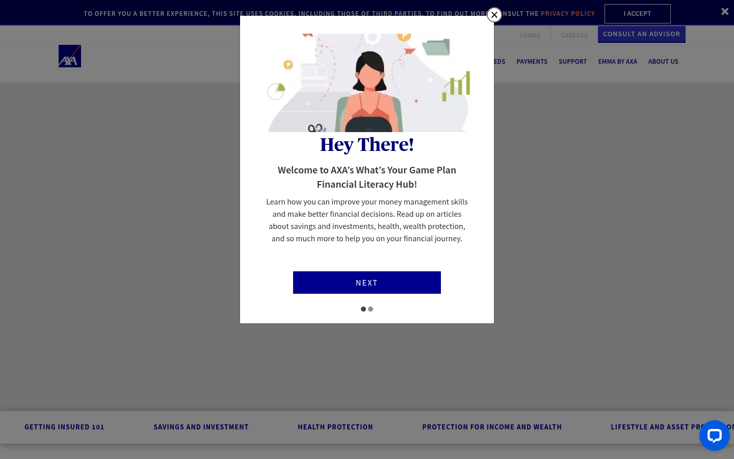
T1 – Content / Literacy Hub Landing (finlithub) with welcome modal

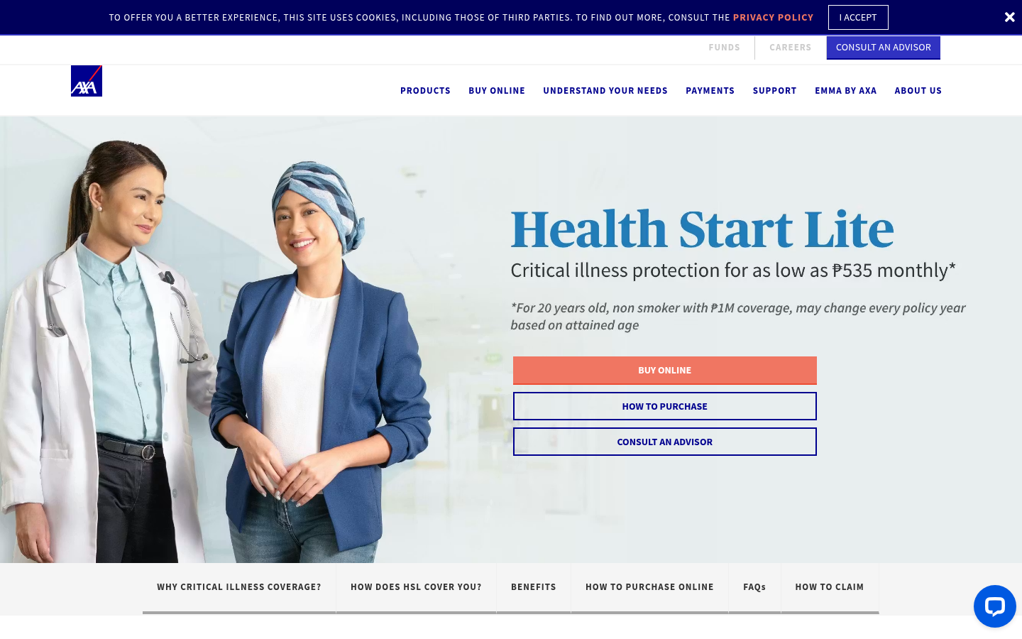
T2 – Product Landing (Health Start Lite) with section tabs

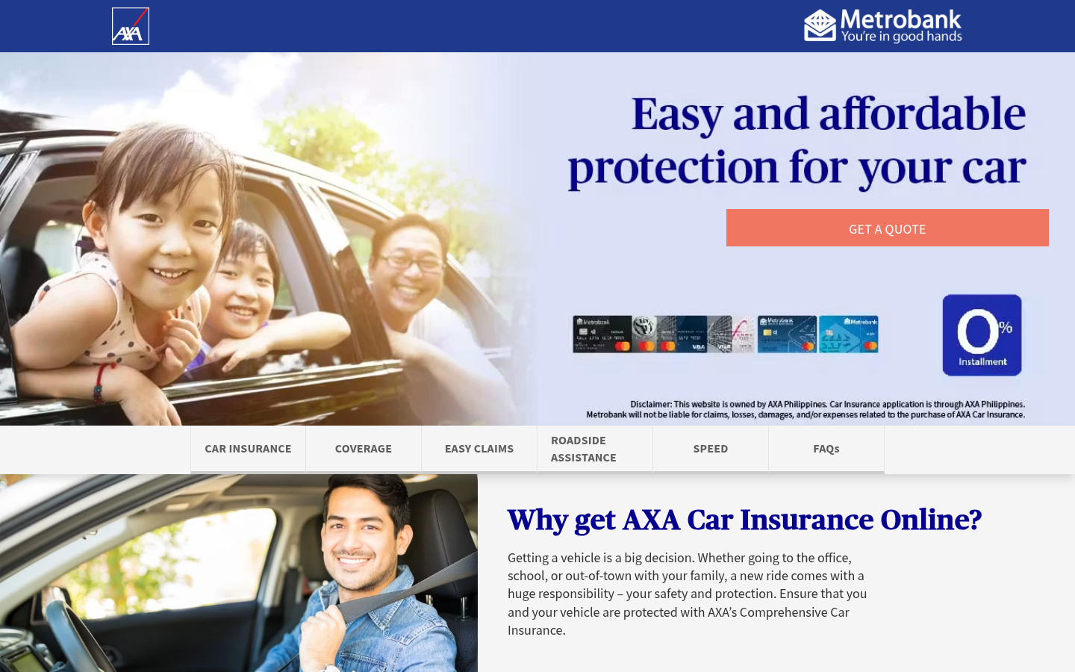
T2 – Product / Purchase Page with Metrobank co-branding & 0% installment

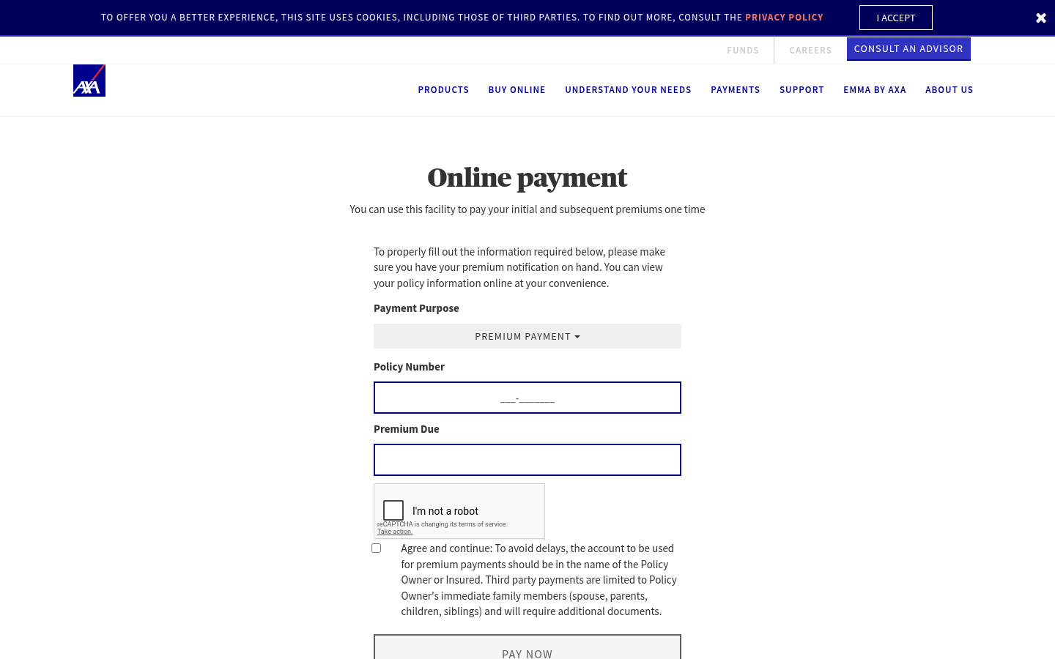
T3 – Payment Facility (one-time premium) with reCAPTCHA

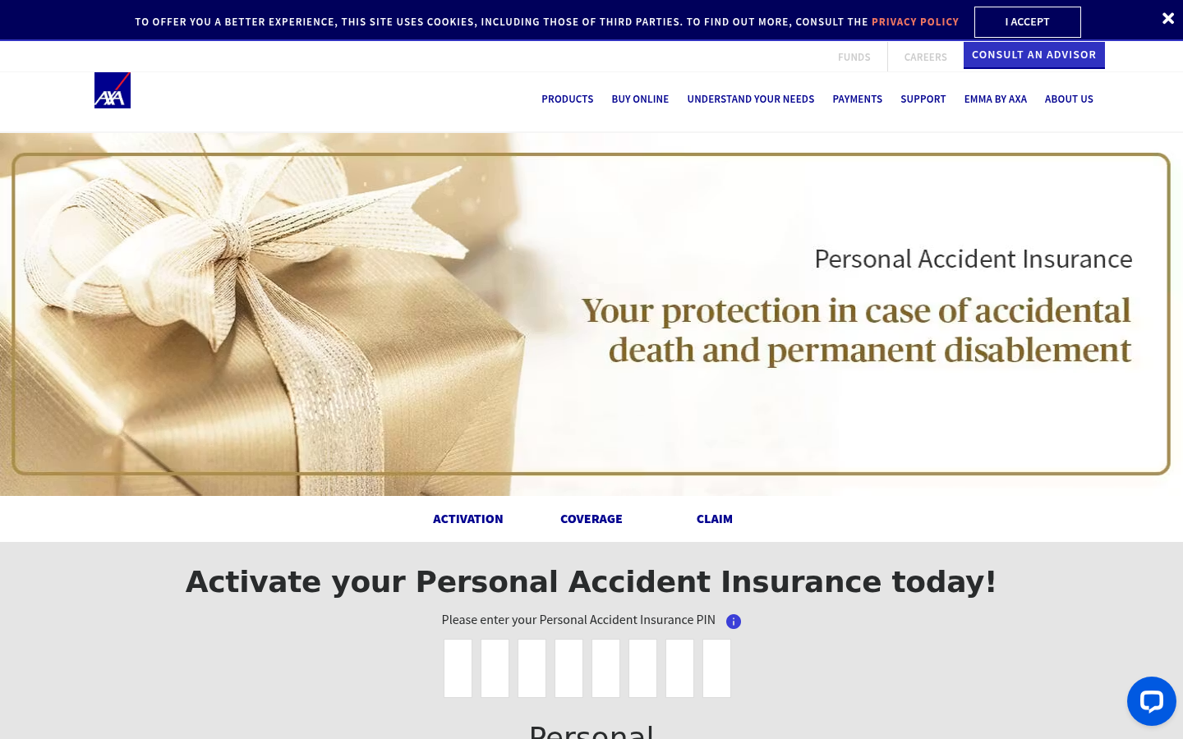
T4 – Personal Accident Activation (tabs + PIN entry)

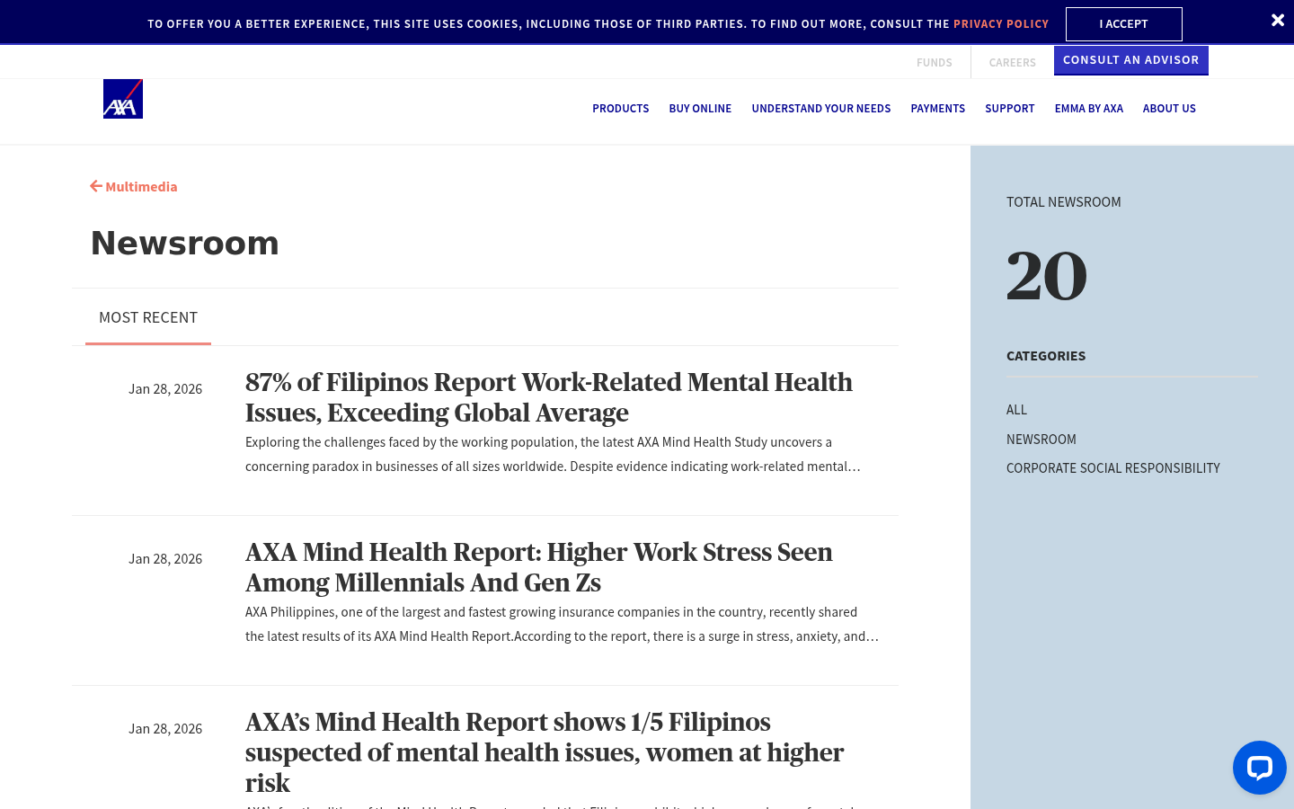
T5 – Newsroom listing with category filter & count badge

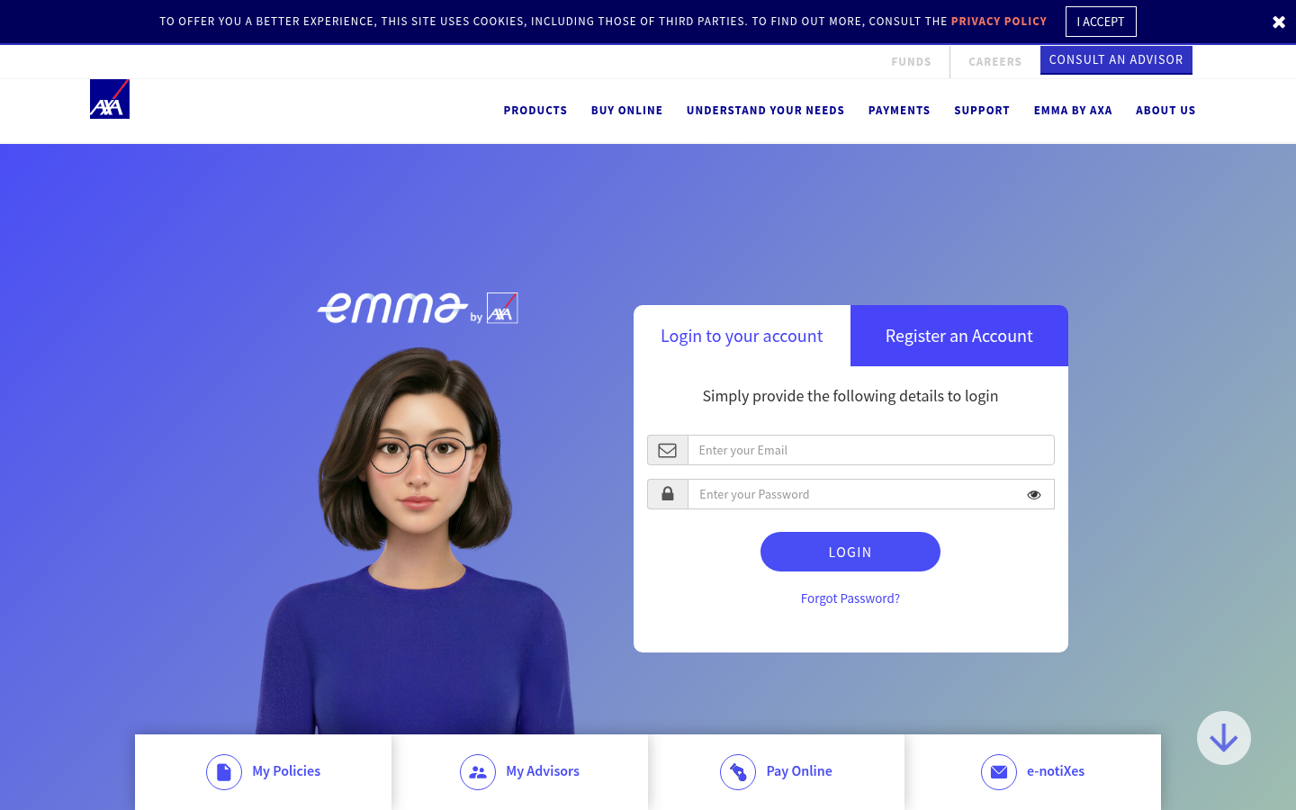
T6 – Emma by AXA login / register portal

