SEG3503 Devoir 3

Partie1:

Q1.1:

Title: Connect

Precondition: Terminal is ON and Terminal is not ready for transactions

Postcondition: Employee is connected and Terminal is ready for transactions

1. Employee enters her code and password

2. System validates employee

3. System enable Terminal for transactions Alternatives

Alternatives

2.a. Wrong code or password

2.a.1 System displays error message

2.a.1 Resume step 1

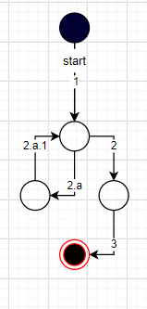 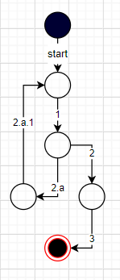

Graph1: connect

Title: Disconnect

Precondition: Terminal is ready for transactions and Employee is connected

Postcondition: Employee is disconnected and Terminal is not ready for transactions

1. Employee disconnects from system

2. System disconnects Employee

3. System disable Terminal for transactions

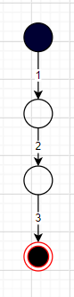

Graph2: Disconnect

Title: Acquisition

Precondition: Terminal is ready for transactions and a Customer is at counter with products items to buy

Postcondition: Terminal is ready for transactions

1. Employee enters Customer's code

2. System displays Customer's name on Terminal

3. Employee selects a product and enters the product code

4. System displays product name and price

5. System updates bill total

6. System updates product stock quantity

7. If there are no more product items, Employee signals end of transaction

8. System computes total and produces bill

Alternatives

1.a. Customer doesn't have a code and doesn't want to be registered

1a.1. GOTO step 3

1.b. Customer doesn't have a code and want to be registered

1.b.1. Employee enters a new code for Customer

1.b.2. Employee enters Customer's name

1.b.3. System registers Customer

1.b.4. GOTO step 2

3.a. There are more than 1 item of the product

3.a.1. Employee enters product quantity

3.a.2. GOTO step 4

7b. There are more product items

7b.1. GOTO step 3

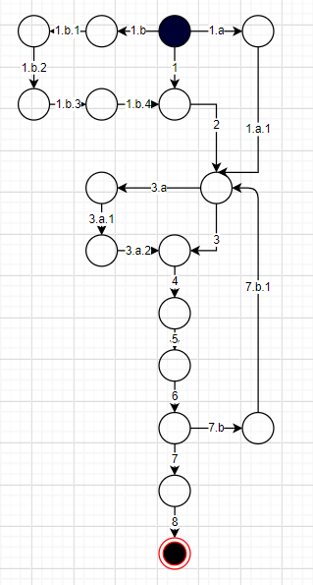

Graph 3: Acquisition.

Q1.2:

|  |  |  |
| --- | --- | --- |
| Id du scénario | Evènements | Description |
| 1: connect2 | 1-2.a-2.a.1-1-2-3 | 1. Employee enters her code and password  2.a. Wrong code or password  2.a.1 System displays error message  2.a.1 Resume step 1  1. Employee enters her code and password  2. System validates employee  3. System enable Terminal for transactions Alternatives |
| 2: disconnect | 1-2-3 | 1. Employee disconnects from system  2. System disconnects Employee  3. System disable Terminal for transactions |
| 3: Acquisition1 | 1.b-1.b.1-1.b.2-1.b.3-1.b.4-2-3-4-5-6-7-8 | 1.b. Customer doesn't have a code and want to be registered  1.b.1. Employee enters a new code for Customer  1.b.2. Employee enters Customer's name  1.b.3. System registers Customer  1.b.4. GOTO step 2  2. System displays Customer's name on Terminal  3. Employee selects a product and enters the product code  4. System displays product name and price  5. System updates bill total  6. System updates product stock quantity  7. If there are no more product items, Employee signals end of transaction  8. System computes total and produces bill |
| 4: Acquisition2 | 1.a-1.a.1-2-3-4-5-6-7-8 | 1.a. Customer doesn't have a code and doesn't want to be registered  1a.1. GOTO step 3  3. Employee selects a product and enters the product code  4. System displays product name and price  5. System updates bill total  6. System updates product stock quantity  7. If there are no more product items, Employee signals end of transaction  8. System computes total and produces bill |
| 5: Acquisition3 | 1-2-3.a-3.a.1-3.a.2-4-5-6-7-8 | 1. Employee enters Customer's code  2. System displays Customer's name on Terminal  3.a. There are more than 1 item of the product  3.a.1. Employee enters product quantity  3.a.2. GOTO step 4  4. System displays product name and price  5. System updates bill total  6. System updates product stock quantity  7. If there are no more product items, Employee signals end of transaction  8. System computes total and produces bill |
| 6: Acquisition4 | 1-2-3-4-5-6-7.b-7.b.1-3-4-5-6-7-8 | 1. Employee enters Customer's code  2. System displays Customer's name on Terminal  3. Employee selects a product and enters the product code  4. System displays product name and price  5. System updates bill total  6. System updates product stock quantity  7b. There are more product items  7b.1. GOTO step 3  3. Employee selects a product and enters the product code  4. System displays product name and price  5. System updates bill total  6. System updates product stock quantity  7. If there are no more product items, Employee signals end of transaction  8. System computes total and produces bill |

Q1.3:

|  |  |  |  |  |
| --- | --- | --- | --- | --- |
| ID du test | ID du scénario | Préparation | Séquence des événements et réponses attendues | Résultat final attendu |
| 1 | 1 | Une instance de CounterFrame et le stub | 1-2.a-2.a.1-1-2-3 | Employee is connected and Terminal is ready for transactions |
| 2 | 2 | Une instance de CounterFrame et le stub.  Etat de la machine est connecte. | 1-2-3 | Employee is disconnected and Terminal is not ready for transactions |
| 3 | 3 |  | 1.b-1.b.1-1.b.2-1.b.3-1.b.4-2-3-4-5-6-7-8 | Bill updated  Product stock quantity updated  Total returned  Terminal is ready for transactions |
| 4 | 4 |  | 1.a-1.a.1-2-3-4-5-6-7-8 | Bill updated  Product stock quantity updated  Total returned  Terminal is ready for transactions |
| 5 | 5 |  | 1-2-3.a-3.a.1-3.a.2-4-5-6-7-8 | Bill updated  Product stock quantity updated  Total returned  Terminal is ready for transactions |
| 6 | 6 |  | 1-2-3-4-5-6-7.b-7.b.1-3-4-5-6-7-8 | Bill updated  Product stock quantity updated  Total returned  Terminal is ready for transactions |

Q2:

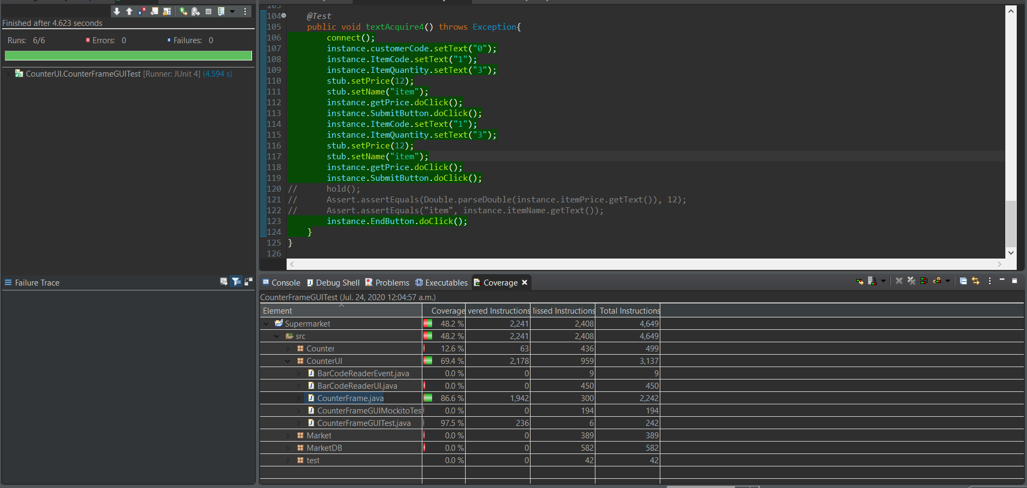

Q3: