ITB431

Data Wrangling

|  |  |
| --- | --- |
| Submitted By: | **Chee Bo Yu (214322H)** |
| PEM Group: | BA2102 |
| Tutor: | Mr Heng Rui Jie |
| Deadline: | 13 June 2022 |

Assignment

Report Title: Data Wrangling Report

**Table of Contents**

Task 1: Steps taken to mashup, clean and transform the data 2-10

Task 2: Challenges 10

**Task 1: Steps taken to mashup, clean and transform the data**

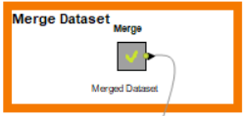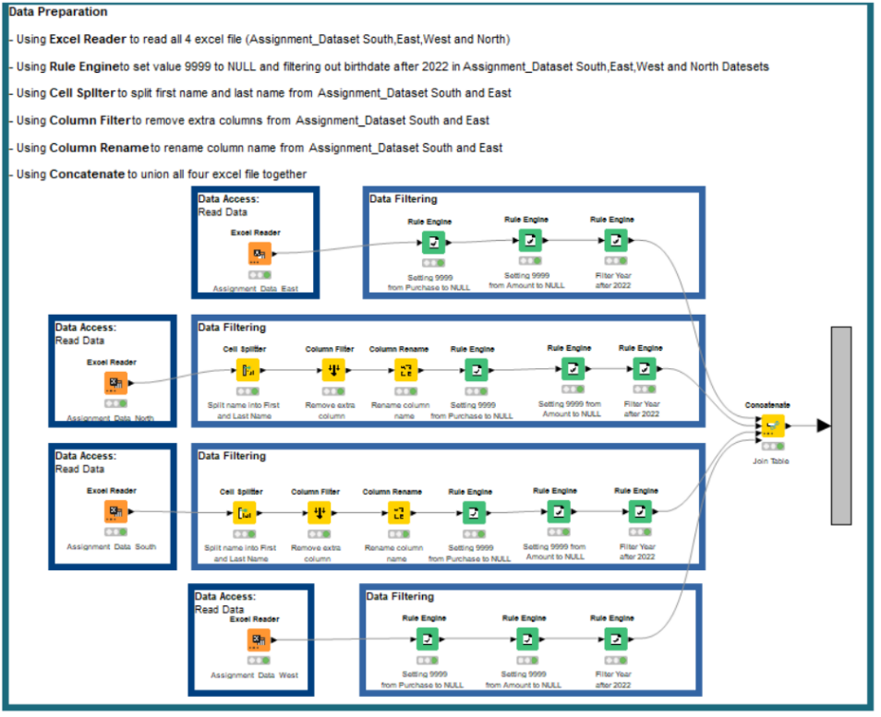

**Metanode**

Using **Metanode** in my assignment is a useful component to make my workflows neater for people to view.

By using **New Workflow Annotation,** I can describe what is the node about and the purpose of using the node for my workflows.

**

**Excel Reader Transformation Tab**

By using **Excel Reader**, I can load the excel file to my workflow and use **Transformation Tab** to check the column would like to view.

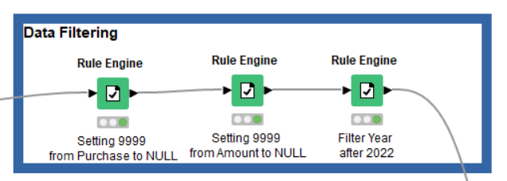 **Rule Engine**

**Result Expression Command**

By using **Rule Engine**, I can set the column values with 9999 to NULL by using the command above and using the same method I can set the amount with 9999 to NULL, BirthDate after 2022 to NULL.

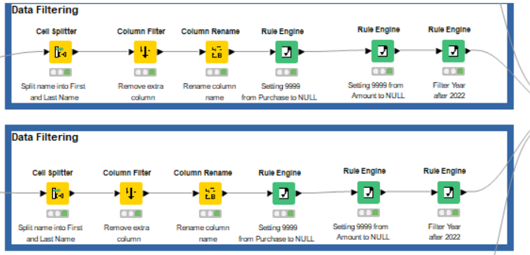

By using **Cell Splitter**, I can split First and Last Name into two columns from the original column name called Name.

**Cell Splitter**

**Before Splitting Columns**

**After Splitting Columns**

By using **Column Filter**, I can remove the extra column called Name_Arr[0] in the table.

**Column Filter**

**Results**

By using **Column Rename**, I can change the column name from Name_Arr[1] and [2] to First and Last Name respectively.

**Results**

**Concatenate**

By using **Concatenate**, I can put all 4 excel files (Assignment_Dataset South, East, West and North) together to union.

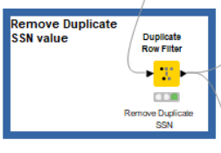

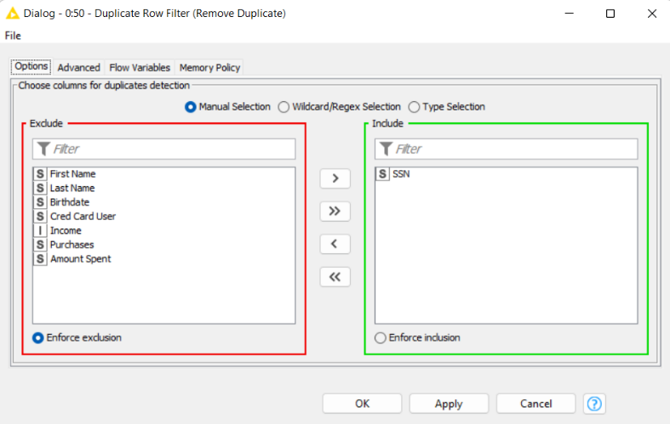 **Duplicate Row Filter**

By using **Duplicate Row Filter**, I can remove the SSN Duplicate to create anonymize stage

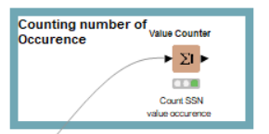

**Value Counter Results**

By using **Value Counter**, I can check whether there is any duplicate for the Row ID by looking at the count column.

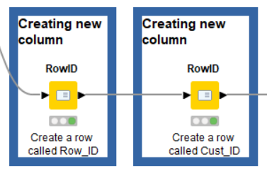

**RowID**

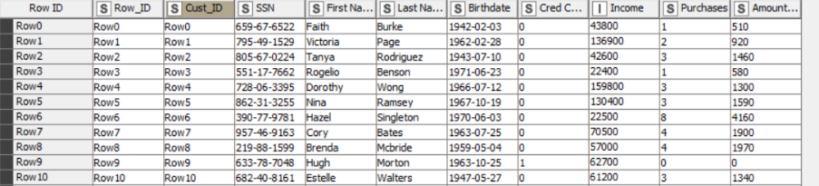

**Results**

By using **Row ID**, I can have a unique column on my dataset for anonymization, by creating two Row ID, this will remove _dup in the Cust_ID column after exporting to excel

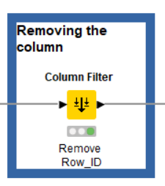

**Results**

By using **Column Filter**, I can remove the column with the same name in my dataset.

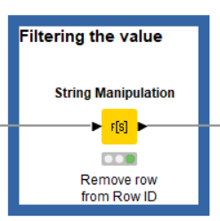

**Results**



By using **String Manipulation**, I can filter out the row from Cust_ID which will only have the number of the ID.

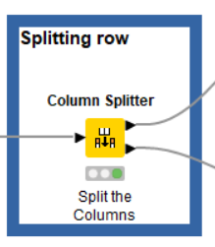 **Column Splitter**

**Results**

By using **Column Splitter**, I can drop the highest priority, which is the SSN, First and Last Name to complete anonymization.

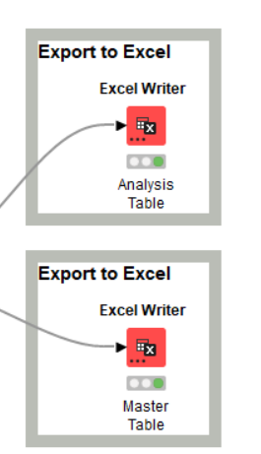

By using **Excel Writer,** I can have two excel

file called Analysis Table and Master Table which

containing the lowest priority and highest priority.

**Task 2: Challenges**

The challenges that I face will be **Uncertain about each node in the Node Repository** and **whether my method of doing anonymising is correct or not.**

For my first challenge faced, with my determination and curiosity to find out what each node does by watching YouTube video, I can learn what each node works like Rule Engine, Column Filter, Column Rename, Cell Splitter and New Workflow Annotation.

For my second challenge faced, by checking with my lectures about my method of using anonymization, I can learn more about using Duplicate Row Filter, RowID, Value Counter, String Manipulation and Column Splitter for Anonymization rather than just using Anonymization Node to anonymize.

(493 Words)