**Create Repository**

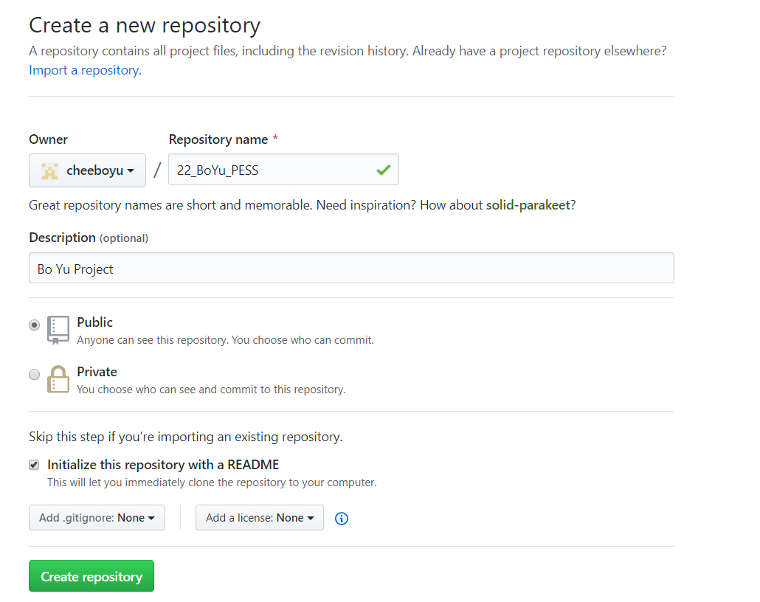

**Clone or Download Button**

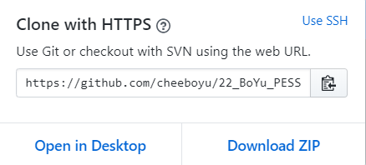

**Open GitHubDesktop.exe**

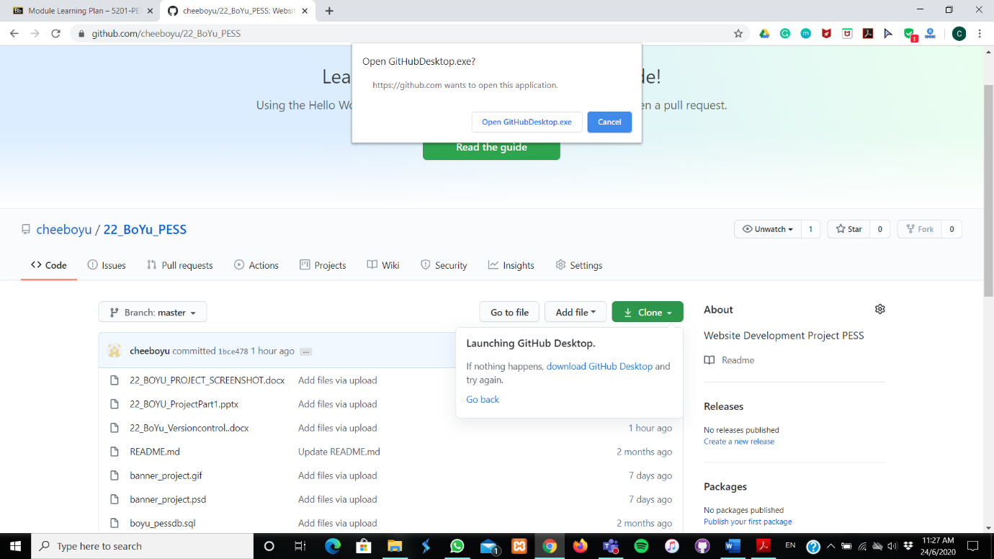

**Repository URL**

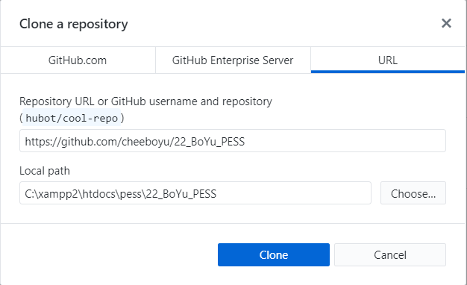

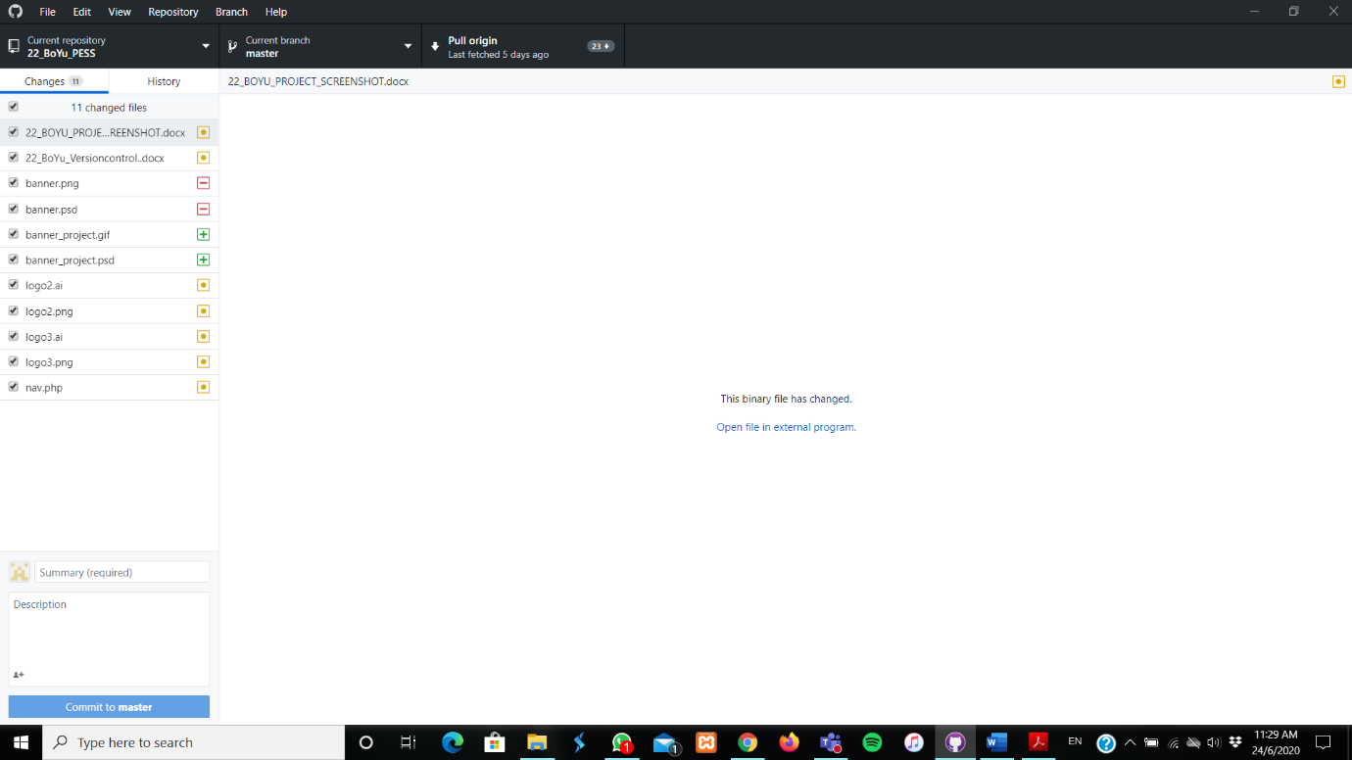**Click commit to master after you have made changes**

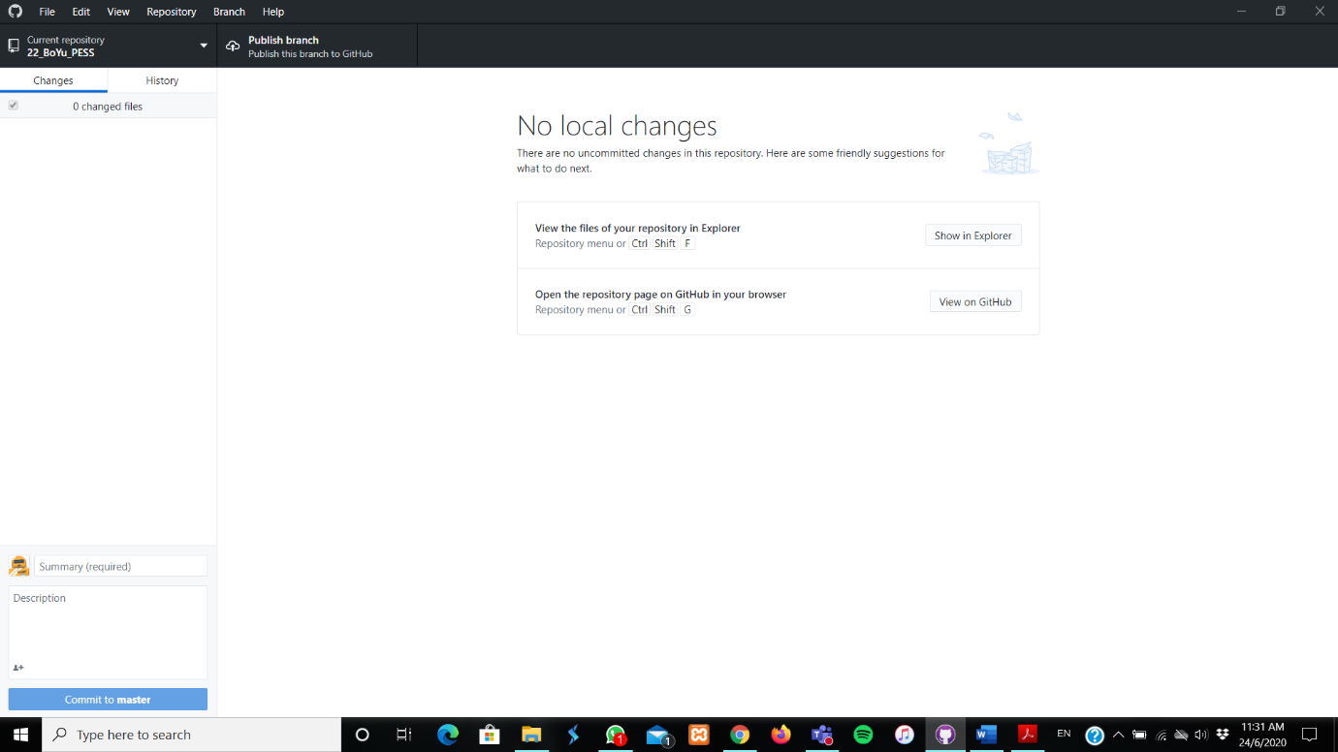**After clicking the Commit to master**

**A folder is added in the pess**

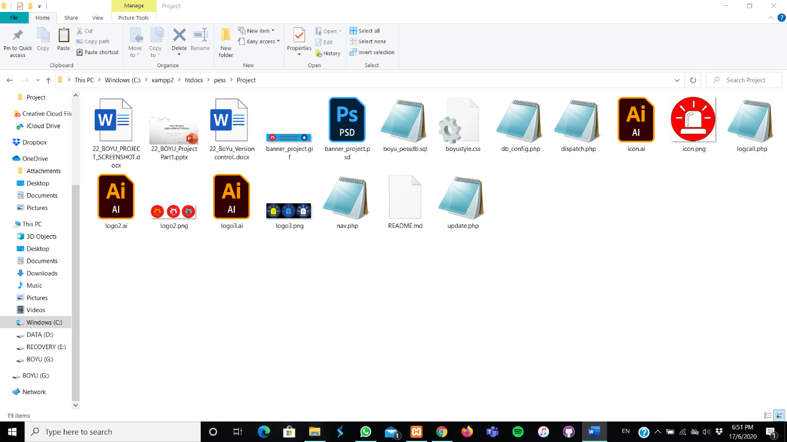

**All file are uploaded in my GitHub**

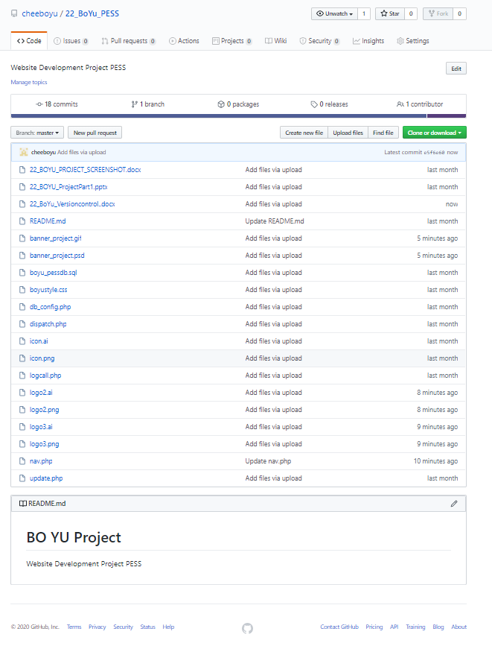

**Invite a collaborator.**

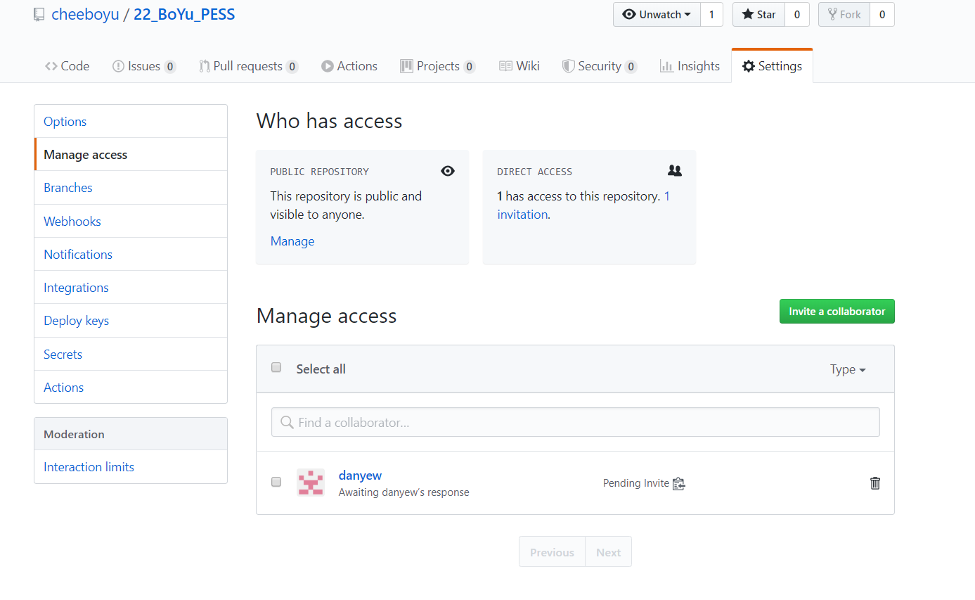**Link:** <https://github.com/cheeboyu/22_BoYu_PESS.git>