CAFETERIA

# wpf application for Cafeteria reservations

## Assumptions

1. The user can make reservations of varying durations.
2. The minimum duration for a reservation is 1 minute. (Warning: shorter duration reservations are easy to miss on the Dashboard view)
3. The user can make a reservation for any time between 10:00 am to 10:00 pm even if that reservation is for already elapsed time of the day. (Only for convenience of testing while developing late in the night)
4. The input file is in the solution at “Cafeteria\Cafeteria.Wpf\Data\Tables.xml”.

## design decisions

1. The input folder, the input file name and the datastore file name are configurable by the user. They are stored as AppSettings in the App.config file. The current defaults are shown in the below image. So, the valid input file should be placed in “C:\Data” folder with name “Tables.xml”.

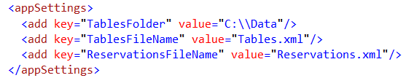

1. The application does not delete the datastore file for the previous day (Applications current scope is to manage reservations for a single day only). It is upto the user to delete the file before running it the next day.
2. The application gives suggestion on the next best available reservation time if the requested duration is not available. It will always suggest the best duration available after the requested reservation start time only. It does not suggest a duration that starts earlier even though that duration occurs in future with respect to the time the reservation was being tried to be made. In short, it is assumed that the requested reservation time is the earliest time possible for the customer to reach the restaurant.
3. To make sure the reservations are not lost in the event of an application crash, all the transactions are atomic and are immediately persisted.

## DEMO RUN

Before running the application a well-formed valid xml input file name Tables.xml is placed in folder C:\Data.

When the application is run, the user is presented with the below screen. It has two tabs, a Reservations tab that lists the reservations made sorted by table Id and then by the From time of the reservations and a Dashboard tab that shows the Gantt chart view for all the tables.

On the first run, since, there are no reservations made yet, a “No reservations made.” message is shown on the Reservations tab.

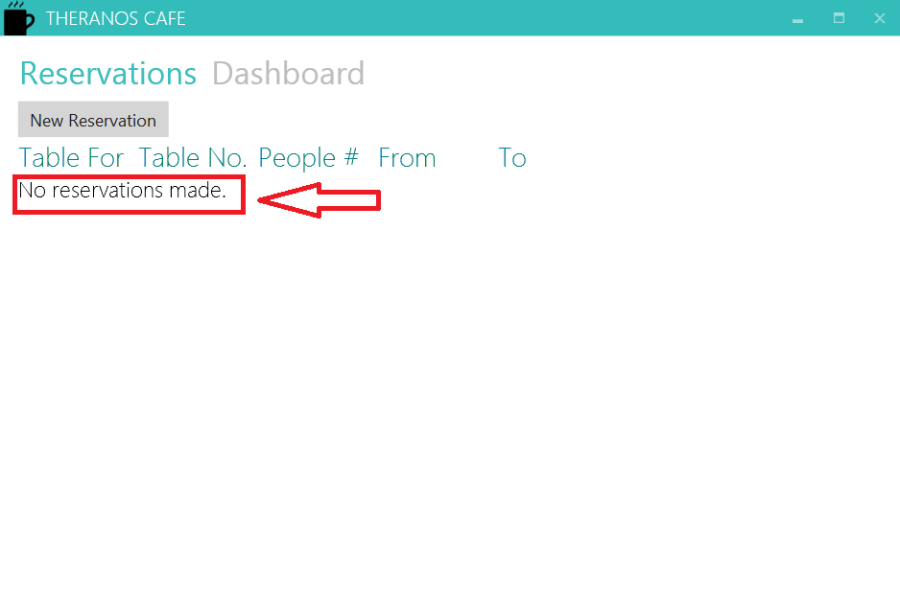

The Dashboard shows all the tables that are read from the input file with the MaxOccupancy value in the parenthesis. The Dashboard is a read-only. No actions can be done on this screen.

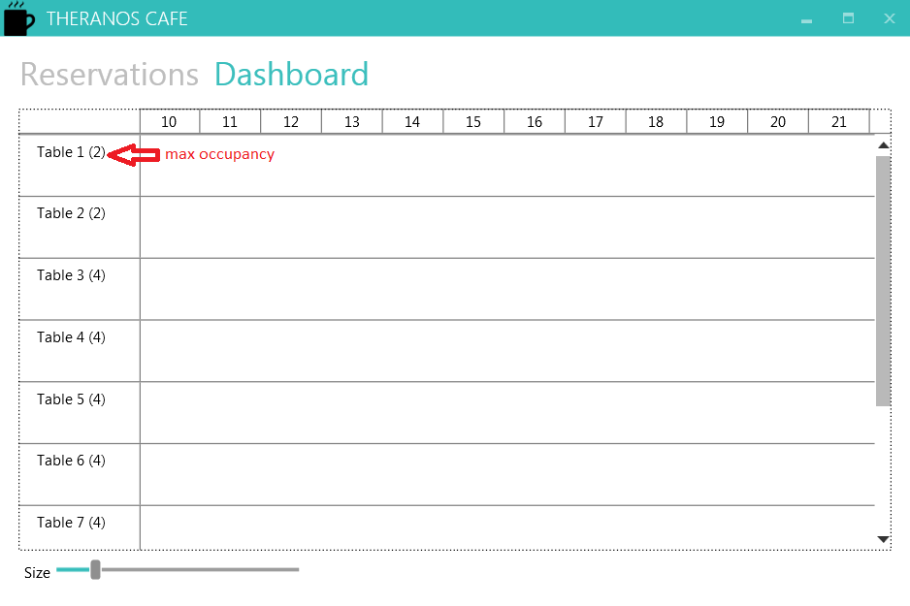

##### Add Reservation

Go to the reservations tab and click on the “New Reservation” button to add a new reservation. This will bring up a New Reservation dialog.

The “For” and “People#” fields are required on this dialog. The “From” and “To” fields are automatically initialized and the bindings are made to ensure that the user cannot pick a “To” time less than the “From” time.

As soon as the “People#” field is entered, the application notifies back with a success message or suggestion or a failure message. Below are the three examples

1. Success – message shown in green, Save button enabled.

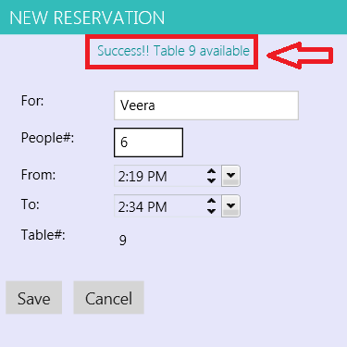

1. Suggestion – message shown in orange color, Save button disabled.

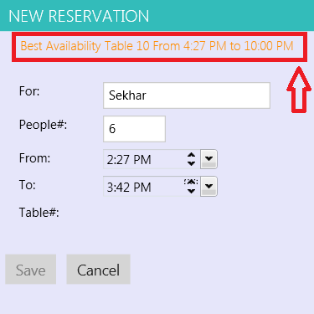

1. Failure – message shown in red color, Save button enabled.

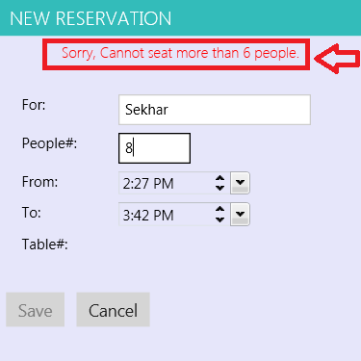

When a valid reservation is found, the Save button is enabled and the Reservation is added to both the Reservations view and Dashboard view.

##### Edit Reservation

The reservation can be edited by clicking on the edit link on the Reservations view next to the reservation. It will bring up the Edit Reservation dialog and the same rules apply as when adding a reservation except the editing reservations time is also accounted as available time.

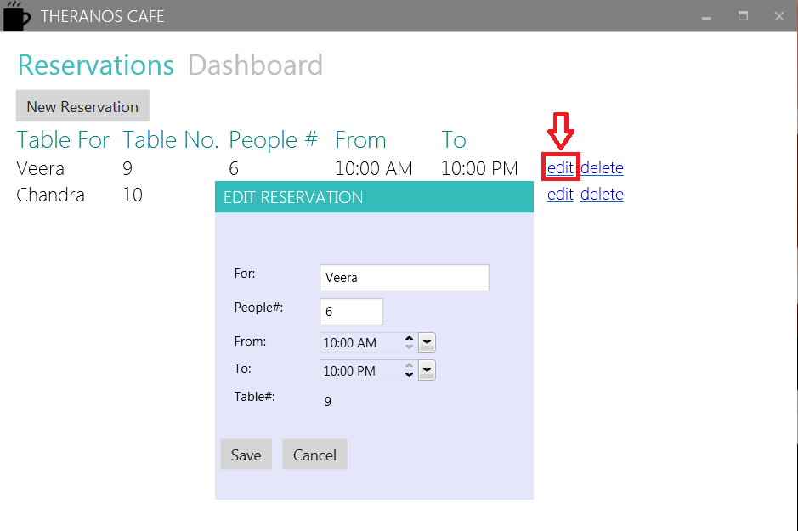

After clicking save, the changes are reflected in both the tabs. If cancel button is clicked the changes are discarded.

##### Delete Reservation

The reservation can be deleted by clicking on the delete link. A confirmation dialog is shown and if the user clicks yes, the reservation is deleted.

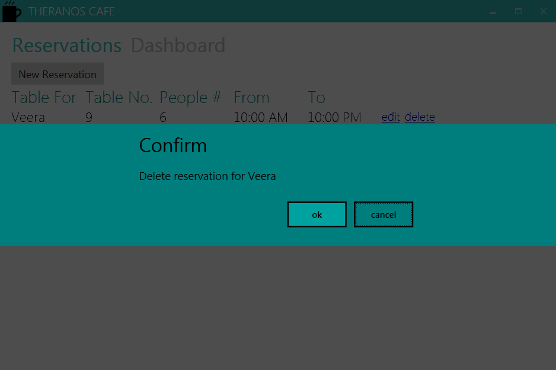

##### Miscellaneous

The end Dashboard view looks like below. Hovering over the mouse shows the Name on the reservation, the number of people on the reservation and the From and To times in the hover caption.

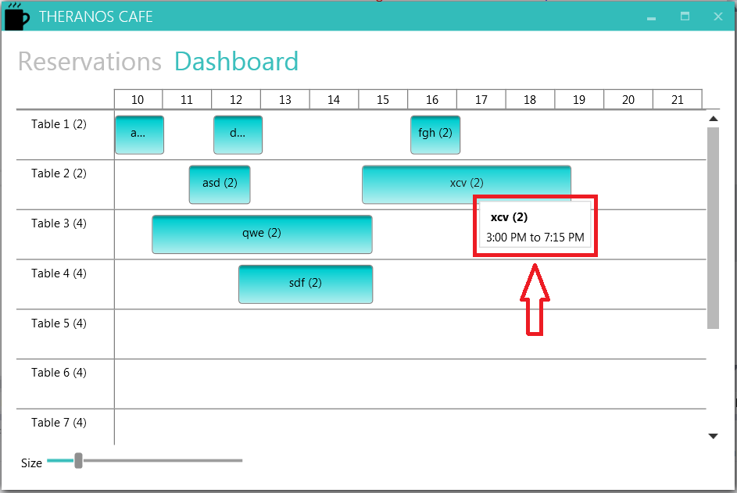

The reservations are saved in a file named Reservations.xml that is saved in the same location as the input file.

