How to: QM-FIR Digital Filter Core – Ethernet UDP Implementation (EDK Project)

Hardware setup
- Connect an Ethernet cable from iBoard to the host machine.
- Configure the eth port to have IP address: 192.168.1.104
- Refer to /documentation/DemoSpec.pdf for more detailed information about setting up the network connection.
- If you are using an iBoard 3 prototype, you may need a jumper cable for two pins on J45. Connect the lower two of the three pins, if the iBoard is oriented to have the power connector at the top.
- Make sure your iBoard's DDR memory is working.
- Connect power and JTAG cables.

Synthesizing and Implementing the Design in EDK
- Open EDK from a terminal. $ xps
- Create a new project using the Base System Builder.
- Choose a directory for your project file and click 'OK'.
- Choose the following options for iBoard 3:
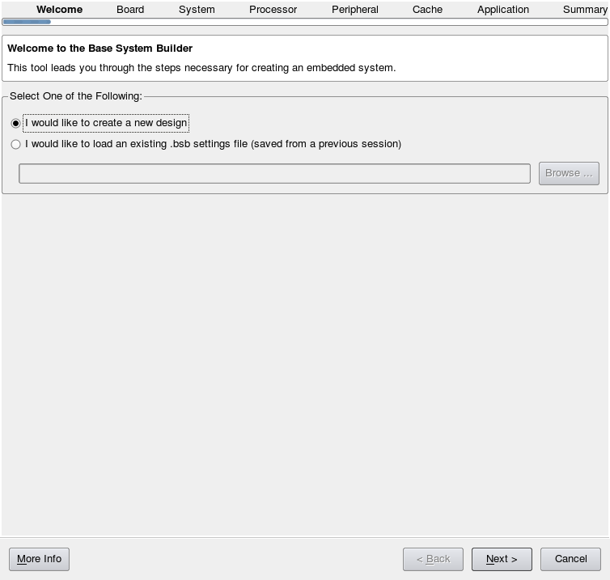
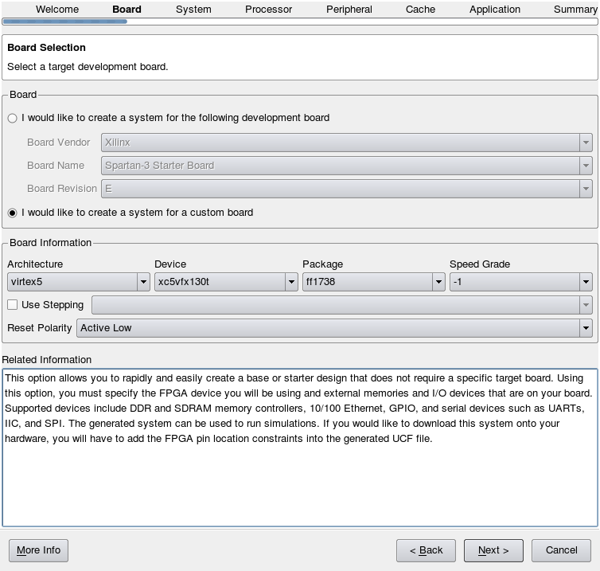

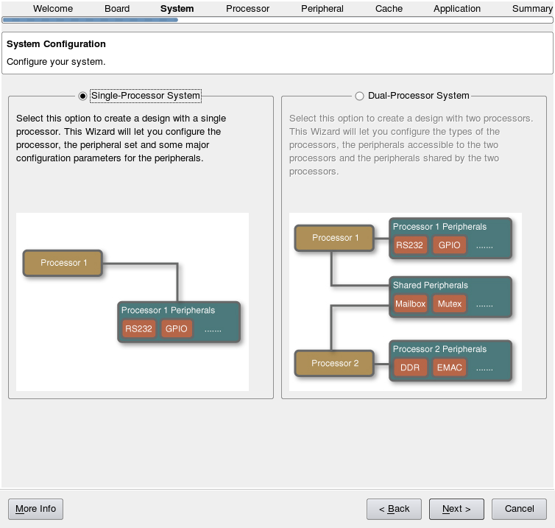
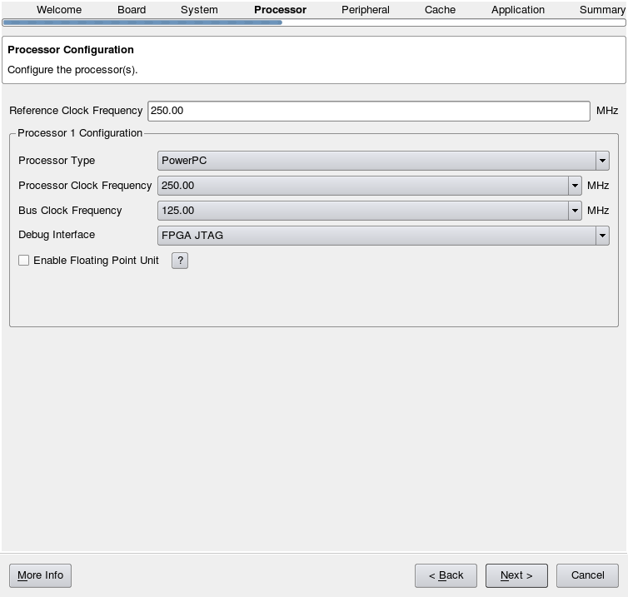

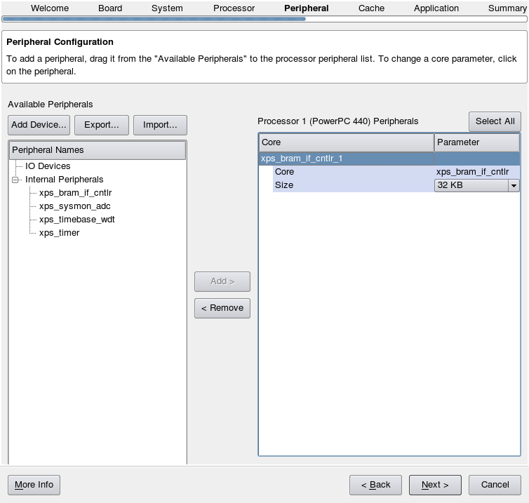
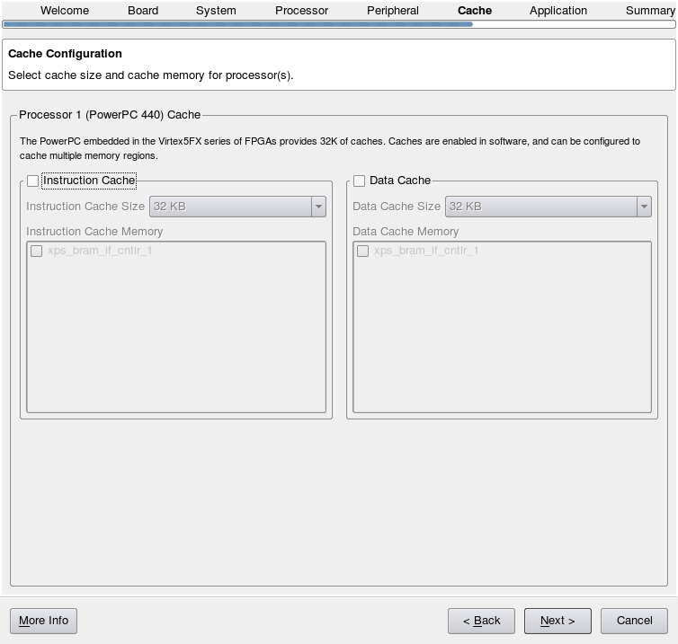

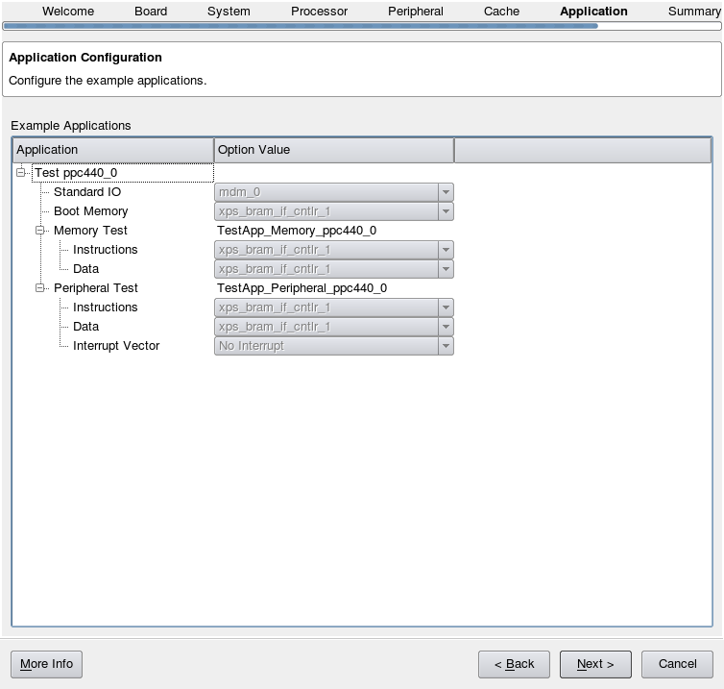

- Continue to click 'Next' through the setup pages and click 'Finish'.
- Start using Xilinx Platform Studio.
- Copy and replace the system.mhs and system.mss files from /qmfir/qmfir_eth/qmfir_udp/EDK_project/ into your project directory.
- Copy and replace the system.ucf file from /qmfir/qmfir_eth/qmfir_udp/EDK_project/data into your project/data directory.

The following italicized steps are for creating the custom IP core for qmfir. This will generate the files included in “pcores” and “drivers”, so you also have the option to perform step 20 instead of performing steps 9 – 19.
- Hardware >> Create or Import Peripheral...
- Follow the wizard to create templates for a new peripheral.
- Attach the peripheral to the Processor Local Bus (PLB).
- Indicate using Interrupt control and Read/Write FIFO slave service.
- Just include a Write FIFO with 1024 entries.
- Choose 4 software accessible registers.
- Choose to Generate stub 'user_logic' template in Verilog instead of VHDL.
- Choose to Generate ISE and XST project files to help you implement the peripheral.
- Chose to Generate template driver files to help you implement software interface.
- Click 'Finish'.
- Copy the HDL (BRAM.v, user_logic.v, qmfir.vhd)

- If you choose not to create a custom IP core, copy and merge the “sw_services”, “pcores”, and “drivers” directories into your project directory.
- Edit lines 4 and 5 of the etc/download.cmd file to include
assignfile -p 1 -file implementation/download.bit
program -p 1
- Software >> Add Software Application Project... and click 'Next' to continue.
- Name your software application.
- In the Applications window, right-click 'Sources' under your software application. Click 'Add Existing Files...', browse to /qmfir/qmfir_eth/qmfir_udp/EDK_project/sw_src/demo_udp, and open all four c-files.
- Do the same thing for 'Headers' and add the three header files.
- Replace the /ppc40_0/include/xparameters.h with /qmfir/qmfir_eth/qmfir_udp/EDK_project//ppc40_0/include/xparameters.h
- Right-click the software application and click 'Set Compiler Options...”.
- Enter in the following compiler options.
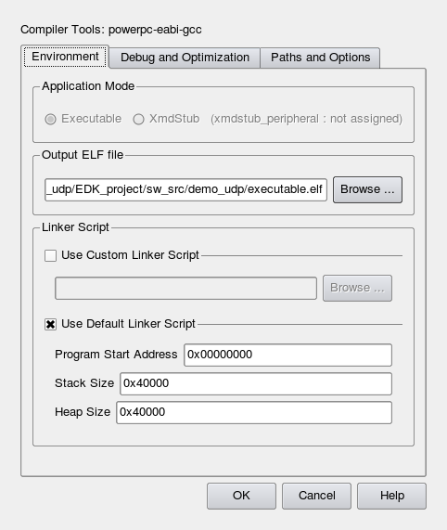
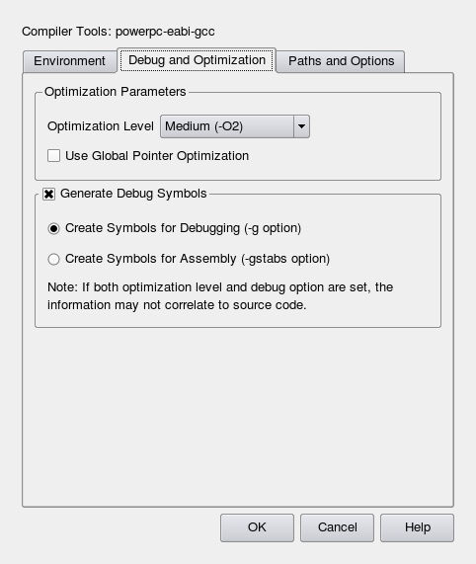
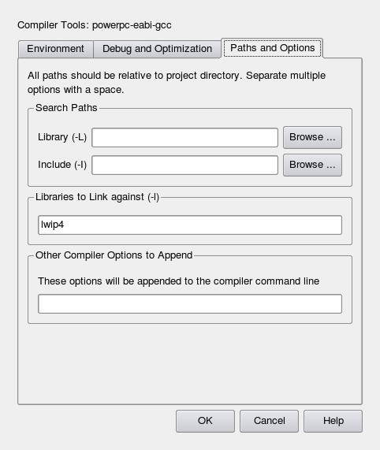

- Right-click on the Default: ppc440_bootloop and 'Mark to Initialize BRAMs'
- Device Configuration >> Update Bitstream. This will synthesize the project.
- If your software application does not build, you may need to link gmake to make:
# ln -s /usr/bin/make /usr/bin/gmake
- Device Configuration >> Download Bitstream. This will download the bitstream to the iBoard.

Using XMD to Download and Run the Software Application
- In a terminal, navigate to the directory where the executable.elf file was outputted (as specified in the compiler options).
- In the same terminal window, open XMD. $ xmd
- In the XMD environment, enter the following to run your application on the iBoard:
XMD% connect ppc hw
XMD% dow executable.elf
XMD% run
- To stop running your software application, enter XMD% stop

Using Kermit to Monitor the Serial Connection
The serial connection is set as the standard input and output. It is useful for debugging. When running the software application, the output will be displayed on the Kermit terminal.
- Copy the following lines of code into a new file called transmit.kt
kermit
set line /dev/ttyS0
set speed 9600
set parity none
set flow-control none
set carrier-watch off
c
- Run Kermit with the specified parameters. $ ./transmit.kt

Using the Matlab GUI for Testing
- Open Matlab from a terminal. $ matlab
- Set your working directory to /qmfir/qmfir_eth/qmfir_udp/matlab_gui
- In the command window, enter >> isaacdemogui
- Make sure the host machine IP address matches.
- Click the 'START' button to start the demo.

Using WireShark to Monitor Packet Transactions
- Open WireShark from a terminal. $ sudo wireshark
- In the “Capture” section, choose the eth device connected to the iBoard from the Interface List.
- Wireshark will begin a live capture of the device, displaying information about packets sent over the ethernet connection.
- This is a useful tool for debugging.

Notes:
- Currently, the filter only works the first time upon downloading elf file. Successive iterations are offset with big error (core is not resetting?).
- Creating a softlink to compile pnet.c
# ln -s /usr/lib/libstdc++.so.5.0.7 /usr/lib/libstdc++.so
<in Matlab command window>> mex -O pnet.c

