JPL RTD Flight System Avionics

qmfir Digital Filter Core for ISAAC FPGA-Based Avionics

Design and Implementation Document

RTD Document Number: XXXX-XXX
JPL Document Number: X-XXXXX

Revision: 1.0

Date: 05/06/2011

Author: Hieu Nguyen
Contributors: (Alphabetically) Yutao He, Hieu Nguyen.
Custodian: Hieu Nguyen
Summary: This document serves as the design documentation of the QM-FIR digital filter core for FPGA-based flight system avionics.

Paper copies of this document may not be current and should not be relied on for official purposes.



Jet Propulsion Laboratory
4800 Oak Grove Drive
Pasadena, CA 91109-8099

Signature Sheet

Prepared By:

_______________________________________
Yutao He
Advanced Mobility Avionics Design Engineer

Reviewed By:

_______________________________________
Kevin Watson
Advanced Mobility Avionics Co-PI

Reviewed By:

_______________________________________
Gary Bolotin
Advanced Mobility Avionics PI

Revision History
Rev. | Description | Author | Date | Approval
0.9 | Initial draft | Hieu Nguyen | 03/04/11
1.0 | Release | Hieu Nguyen | 05/06/11

Table of Contents

1.1 Purpose of this Document 3
1.2 Overview 3
1.3 Features 3
1.4 Implementation Details 3

Table of Figures

Figure 1A Sample Application with smCore 19

Table of Tables

Table 1 qmfir Interface Signals 9
Table 2 qmfir Registers for Ethernet Implementation 16
Table 3 Memory Map of a Simple Application 19

Introduction

Purpose of this Document
This document serves as the ISAAC Newton Quadrature Modulation with Polyphase Decimation Filter (QMFIR) FPGA design specifcation. This has suffcient details for future ISAAC FPGA review and usage of the core.

Overview
The ISAAC—Instrument ShAred Artifact for Computing—project aims to provide a highly capable, highly reusable, modular, and integrated FPGA-based common instrument control and computing platform that can be shared by multiple Earth-Science and planetary-exploration instruments. Essentially, ISAAC allows instrument electronics designers to configure a complete instrument control and computing system by using its integrated framework. The motivation for ISAAC technology is to provide a platform that can be shared by a wide range of instruments, introducing a common spacecraft bus interface with on-board processing for systemic missions. ISAAC’s reusable framework offers a combination of adaptability, computation power, I/O bandwidth, digital interface standards, and data processing capability in a single common low mass/power and small form factor platform with significantly reduced non-recurring cost and risk to Earth Science instruments. As future instruments require more demanding on-board processing capabilities, ISAAC will allow new instrumentation developments to meet performance requirements in a cost-efficient manner.

By focusing on sharable components for instruments, ISAAC technology allows JPL to compete in a host of instrument missions in which it was previously unable to compete competitively. Its use has been recommended for a wide range of future NASA/JPL missions, where it will be integral in data acquisition from digital electronics instruments such as GPS, radars, radiometers, interferometers, lasers, spectrometers, altimeters, and more. The QM-FIR digital filter core is part of a subtask called ISAAC Newton that focuses on the radar application, specically, the on-board processing power which will eventually support the SMAP (Soil Moisture Active-Passive) project.

Features
qmfir provides the following features:
- Implement the quadrature demodulation and polyphase decimation digital filters
- Provide a testbed with multiple connection interfaces (UART, Ethernet, SerDes)
- Provide software interface

Implementation Details
This implementation of the QM-FIR digital filter core was developed using the Xilinx Emebedded Development Kit (EDK). In the EDK project hardware confuguration, the custom IP core qmfir is implemented as a PLB slave device to allow software-accessible registers. The testbed utilizes a Malab GUI to visualize filtered data output and verify the digital filter core's functionality. The iBoard uses its Ethernet interface to communicate with a host machine using the UDP protocol for transmitting packets.

Resource Utilization
Slices | Slice Flip-flops | 4-input LUTs | Block RAMs

QM-FIR Background Information

2.1 Filter Architecture
The QM-FIR digital filter core is a logic design that performs a common DSP function for telecommunication applications. The digital filter turns high-rate samples into data ready to be downlinked for further ground processing. QM-FIR is a combination of two modules, quadrature modulation (QM) and the finite impulse response polyphase decimation (FIRDEC). The QM module takes in an input signal and demodulates it to recover the original signal. Together with the Firdecim modules, they act as a demodulation decimating band-pass channelizer, which removes the out-of-band interference and decimates the high-rate samples to yield a complex output data rate at a lower frequency. This implementation for the SMAP L-band radar uses a three-stage decimation filter to effectively decimate a signal by 50 times, turning a 60MHz input into a 1.2MHz output.
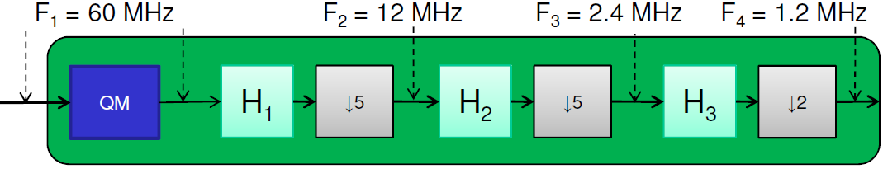

Figure 2.1 QM-FIR Digital Filter Block Diagram

There is one module called “QM” which will take the incoming signal and demodulate it down to baseband. In the process, it will create 6 streams of data at its output. The data are the real and imaginary part of what we call Band 1, Band 2, and Noise band. The 6 streams are then passed through a series of polyphase decimation filters called “FIRDecim.” The incoming data rate is 60MHz, the output data rate is 1.2MHz, thus, the data rate has been decimated 50 times after passing through the series of FIRDecim.
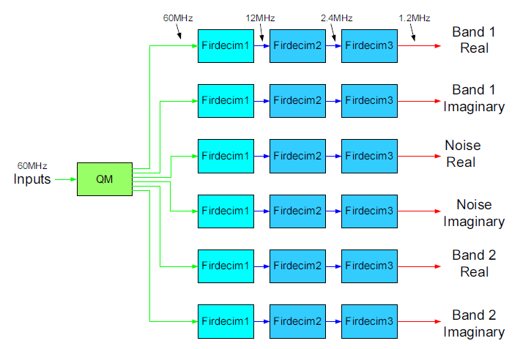
Figure 2.2 QM-FIR Digital Filter Block Diagram for HDL Modules

3.0 Hardware Overview
The QM-FIR digital filter core has been implemented on the ISAAC iBoard platform based upon the Xilinx Virtex-5 FPGA device XC5VFX130T in the EDK-based design envrionment. In particular, the QM-FIR is implemented as a custom IP core, called qmfir, that contains modules for performing quadrature demodulation and polyphase decimation. The demo system was demonstrated using a direct Ethernet connection with the UDP transfer protocol from the iBoard to the host computer.
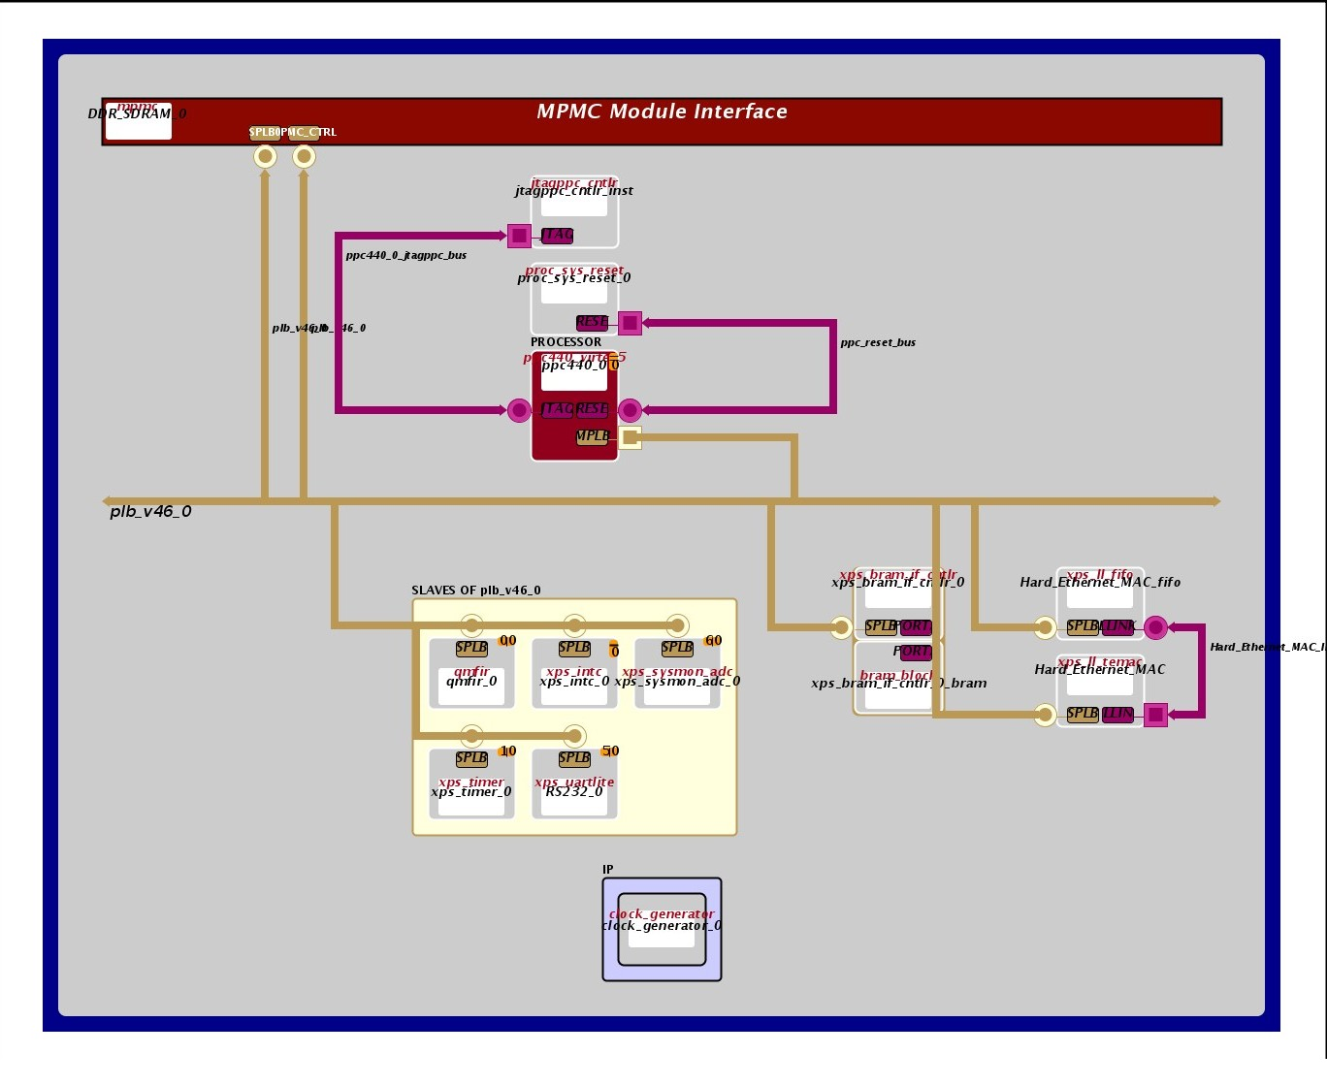
Figure 3.1 Block Diagram Showing Hardware Configuration for QM-FIR Digital Filter Core

3.1 Block Diagram
Generated by EDK, the block diagram in Fig. 3.1 illustrates the project hardware confiugration and shows how each IP core is connected to the processor in the FPGA design. In this example, the qmfir IP core is a slave device on the Processor Local Bus (PLB).
3.2 MHS
The MHS is the hardware specification project file created in EDK. It includes the details for each IP core included in the embedded design defining their parameters in relation to the overall hardware configuration. The following is an excerpt from the MHS project file:
BEGIN qmfir
PARAMETER INSTANCE = qmfir_0
PARAMETER HW_VER = 1.00.a
PARAMETER c_family = virtex5
PARAMETER C_BASEADDR = 0xcea00000
PARAMETER C_HIGHADDR = 0xcea0ffff
PARAMETER C_MEM0_BASEADDR = 0xc1a20000
PARAMETER C_MEM0_HIGHADDR = 0xc1a2ffff
PARAMETER C_MEM1_BASEADDR = 0xc1a00000
PARAMETER C_MEM1_HIGHADDR = 0xc1a0ffff
PARAMETER C_MEM2_BASEADDR = 0xc1a40000
PARAMETER C_MEM2_HIGHADDR = 0xc1a4ffff
BUS_INTERFACE SPLB = plb_v46_0
PORT IP2INTC_Irpt = qmfir_0_IP2INTC_Irpt
END
As you can see, this part of the MHS file specifies an instance of the qmfir IP core called “qmfir_0.” This core runs on a Virtex-5 FPGA and has three defined segments of memory-mapped I/O, each of size 64KB. The qmfir is interfaced to the processor via the SPLB, and has an interrupt port that maps to an interrupt controller. Other IP cores in this design include the PLB, PowerPC processor, BRAM, BRAM interface controller, timer, ADC, processor system reset, clock generator, UART, Ethernet, Ethernet FIFO, and a memory module for SDRAM.

3.3 HDL
Although the qmfir Ethernet implementation uses software applications to transfer data between a host machine and the iBoard, it is the HDL that performs all of the data processing and filtering in hardware. The qmfir digital filter core is written in Verilog (user_logic.v), with low-level digital logic written in VHDL (qmfir.vhd).
The qmfir digital filter core (and all of its modules) is connected to the processor via the SPLB. At the top level, the digital filter core has three modules: iReg, BRAM, and QMFIR. iReg is used for interrupt control and for configuring settings in software. BRAM is used to store input-data to be processed and also output-data ready to be transferred to a host machine. QMFIR performs all of the quadrature demodulation and multi-stage decimation with sine/cosine look-up tables and coefficient rotation for the finite impulse response. These modules operate in parallel to communicate digital filter data between an Ethernet-connected host machine and iBoard.
The following illustrates the hierarchy and stucture of the Verilog modules in the user_logic.v file.
    - user_logic.v
      - iReg
      - QM_FIR
        - QM
          - LkupTbl1
          - LkupTbl2
          - LkupTbl3
        - firdecim (firdecimR1, firdecimI1, firdecimR2, firdecimI2, firdecimR3, firdecimI3)
          - firdecim_m5_n15
            - MAC1 (MAC1_a, MAC1_b, MAC1_c)
          - firdecim_m5_n20
          - firdecim_m5_n15
      - BRAM (BRAM0, BRAM1, BRAM2)
        - BLKMEMDP_V6_3 (blackbox)
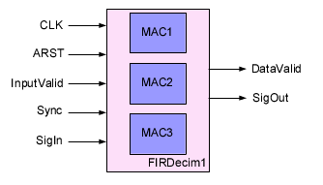
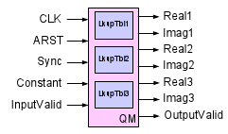

Figure 3.2 Interface Blocks for QM and FIRDecim1 Modules
The QM module uses a lookup table with specialized values for the sine and cosine base on the central frequency. The FIR uses a rotating coefficient bank to perform the finite impulse response. For more detailed information on the HDL modules and their structure, please refer to the “firdecim.pdf” and “Newton_QMFIR_Spec.pdf” which is located in the documentation folder.

3.4 Interface Signals
Table 1 lists the qmfir interface signals.
Name | I/O | Width | Description
CPU_Interrupt_Pulse | O | 1 | Generated interrupt signal
CPU_Reset_Pulse | O | 1 | Generated CPU reset signal
System_Reset_Pulse | O | 1 | Generated system reset signal
FPGA_Reconfig_Pulse | O | 1 | Generated FPGA reconfiguration signal
Type1_Error_Notif | O | 1 | Notification signal of occurrence of an EG1 error
Type2_Error_Notif | O | 1 | Notification signal of occurrence of an EG2 error
Type3_Error_Notif | O | 1 | Notification signal of occurrence of an EG3 error
Type4_Error_Notif | O | 1 | Notification signal of occurrence of an EG4 error
CPU_comparison_enable | O | 1 | Enable the dual-processor comparison function
BRAM_comparison_enable | O | 1 | Enable the dual BRAM comparison function
OCMBRAM_SB_Error | I | 1 | Signal occurrence of an OCM BRAM single-bit error
PLBBRAM_SB_Error | I | 1 | Signal occurrence of an PLB BRAM single-bit error
DDRSDRAM_SB_Error | I | 1 | Signal occurrence of an external SDBRAM single-bit error
CPU_mismatch | I | 1 | Dual-processor comparison mismatch
CPU_WDT_Error | I | 1 | Processor watchdog timer timeout signal
OCMEDC_DB_Error | I | 1 | OCM BRAM double-bit error
OPBBUS_Error | I | 1 | Signal occurrence of an OPB bus error
PLBBUS_Error | I | 1 | Signal occurrence of an PLB bus error
ConfigMem_Error | I | 1 | Signal occurrence of a configuration memory error
PLBEDC_DB_Error | I | 1 | Signal occurrence of an PLB BRAM double-bit error
DDRSDRAM_DB_Error | I | 1 | Signal occurrence of an external SDBRAM double-bit error
ConfigMem_WDT_Error | I | 1 | Signal a configuration memory watchdog timer timout
CPU_Reset_Ext | I | 1 | CPU reset signal from outside the smCore
Sys_Reset_Ext | I | 1 | System reset signal from outside the smCore
Sys_Clk | I | 1 | System clock
Bus2IP_Clk | I | 1 | OPB bus to user IP core clock
Bus2IP_Reset | I | 1 | OPB bus to user IP core reset
Bus2IP_Data | I | 32 | OPB bus to user IP core data bus
Bus2IP_BE | I | 4 | OPB bus to user IP core byte enable
Bus2IP_RdCE | I | 4 | OPB bus to user IP core read chip enable
Bus2IP_WrCE | I | 4 | OPB bus to user IP write chip enable
IP2Bus_Data | O | 1 | User IP core to OPB bus data bus
IP2Bus_Ack | O | 1 | User IP core to OPB bus transfer acknowledgement
IP2Bus_Retry | O | 1 | User IP core to OPB bus cycle retry
IP2Bus_Error | O | 1 | User IP core to OPB bus transfer error
IP2Bus_ToutSup | O | 1 | User IP core to OPB bus slave time-out suppress
IP2WFIFO_RdReq | O | 1 | IP to WFIFO : IP read request
IP2WFIFO_RdMark | O | 1 | IP to WFIFO : read mark
IP2WFIFO_RdRelease | O | 1 | IP to WFIFO : read release
IP2WFIFO_RdRestore | O | 1 | IP to WFIFO : read restore
WFIFO2IP_Data | I | 32 | WFIFO to IP : WFIFO read data
WFIFO2IP_RdAck | I | 1 | WFIFO to IP : WFIFO read acknowledg
WFIFO2IP_AlmostEmpty | I | 1 | WFIFO to IP : WFIFO almost empty
WFIFO2IP_Empty | I | 1 | WFIFO to IP : WFIFO empty
WFIFO2IP_Occupancy | I | 10 | WFIFO to IP : occupancy
FIR_WE | I | 1 | FIR write enable
IP2Bus_IntrEvent | I | 1 | IP to OPB bus interrupt event
iReg2IP_RdAck |  | 1 | iReg to IP: read acknowledge
iReg2IP_WrAck |  | 1 | iReg to IP: write acknowledge
iReg2IP_Data | O | 32 | IReg to IP: data
RealOut1 | O | 16 | Real output 1 from QM_FIR
ImagOut1 | O | 16 | Imaginary output 1 from QM_FIR
RealOut2 | O | 16 | Real output 2 from QM_FIR
ImagOut2 | O | 16 | Imaginary output 2 from QM_FIR
RealOut3 | O | 16 | Real output 3 from QM_FIR
ImagOut3 | O | 16 | Imaginary output 3 from QM_FIR
DataValid_R | O | 1 | Real data valid
DataValid_I | O | 1 | Imaginary data valid
RAM_WE | I | 3 | RAM write enable
RAM2IP_Data_int0 | O | 32 | RAM0 to IP data
RAM2IP_Data_int1 | O | 32 | RAM1 to IP data
RAM2IP_Data_int2 | O | 32 | RAM2 to IP data
sine1 | O | 16 | Sine output from lookup table 1
cosine1 | O | 16 | Cosine output from lookup table 1
sine2 | O | 16 | Sine output from lookup table 2
cosine2 | O | 16 | Cosine output from lookup table 2
sine3 | O | 16 | Sine output from lookup table 3
cosine3 | O | 16 | Cosine output from lookup table 3
Real1 | O |  | Channel1 Real
Imag1 | O |  | Channel1Imag
Real2 | O |  | Noise Channel Real
Imag2 | O |  | Noise Channel Imag
Real2 | O |  | Channel2 Real
Imag2 | O |  | Channel2 Imag
Table 1. qmfir Interface Signals
3.5 Parameters
3.6 Port Definitions
3.7 Registers
In the Ethernet implementation, qmfir has four 32-bit registers that can be accessed by software via the PLB bus. The registers for the Ethernet implementations are listed in Table 2.
Register | Symbol | Address Offset | Bit Width | Access Type
Error, Status, Control | ESCR | 0x1 | 32 | RW
Write Pointer | WPTR | 0x2 | 32 | RW
Input Counter | ICNT | 0x3 | 32 | RW
Output Counter | OCNT | 0x4 | 32 | RW
Table 2. qmfir Registers for Ethernet Implementation

3.7.1 ESCR Register
The ESCR Register keeps track of the error, status, and control of the overall digital filter core. It also stores the module version number for configration management.
Address offset: 0x0000
Reset value: 0x8000

ESCR Register
31 | 30 | 29 | 28 | 27 | 26 | 25 | 24 | 23 | 22 | 21 | 20 | 19 | 18 | 17 | 16 | 15 | 14 | 13 | 12 | 11 | 10 | 9 | 8 | 7 | 6 | 5 | 4 | 3 | 2 | 1 | 0
setclr | Spare |  |  |  |  |  |  |  |  |  |  |  | OVFL_MSK | WMI_MSK | Spare | VERSION[7:0] |  |  |  |  |  |  |  | Spare |  |  |  |  | OVFL | WMI | Spare

Bits | Type | Name | Description
0 | Spare
1 | R/W | WMI | Automatically asserted when OCNT (output counter) overflows  Default value is “0”
2 | R/W | OVFL | Automatically asserted when CPTR (BRAM pointer) overflows  Default value is “0”
[3 : 7] | Spare
[8 : 15] | R/W | VERSION[7:0] | Module version number  Default value is “0”
16 | Spare
17 | R/W | WMI_MSK | WMI interrupt mask bit  “1” - disables WMI interrupt  “0” - enables WMI interrupt  Default value is “0”
18 | R/W | OVFL_MSK | OVFL interrupt mask bit  “1” - disables WMI interrupt  “0” - enables WMI interrupt  Default value is “0”
[19 : 30] | Spare
31 | R/W | setclr | “1” - SYNCs modules upon receiving Bus2IP_Data_int[0]  “0” - resets register  Default value is “0”

3.7.2 WPTR Register
The WPTR Register stores the current BRAM write pointer.
Address offset: 0x0004
Reset value: 0x0000

WPTR Register
31 | 30 | 29 | 28 | 27 | 26 | 25 | 24 | 23 | 22 | 21 | 20 | 19 | 18 | 17 | 16 | 15 | 14 | 13 | 12 | 11 | 10 | 9 | 8 | 7 | 6 | 5 | 4 | 3 | 2 | 1 | 0
Spare |  |  |  |  |  | SPTR[9:0] |  |  |  |  |  |  |  |  |  | Spare |  |  |  |  |  | CPTR[9:0]

Bits | Type | Name | Description
[0 : 9] | R | CPTR[9:0] | Current BRAM pointer, data from IP to bus  Default value is “0”
[10 : 15] | Spare
[16 : 25] | R/W | SPTR[9:0] | Load data to CPTR when SYNC is asserted  Default value is “0”
[26 : 31] | Spare

3.7.3 ICNT Register
The ICNT Register stores the input counter...
Address offset: 0x0008
Reset value: 0x0000

ICNT Register
31 | 30 | 29 | 28 | 27 | 26 | 25 | 24 | 23 | 22 | 21 | 20 | 19 | 18 | 17 | 16 | 15 | 14 | 13 | 12 | 11 | 10 | 9 | 8 | 7 | 6 | 5 | 4 | 3 | 2 | 1 | 0
ICNT[31:0]

Bits | Type | Name | Description
[0 : 31] | R | ICNT[31:0] | Input counter, increments after every write to WFIFO  Default value is “0”

3.7.4 OCNT Register
The OCNT Register stores the output counter...
Address Offset: 0x000c
Reset Value: 0x0000

OCNT Register
31 | 30 | 29 | 28 | 27 | 26 | 25 | 24 | 23 | 22 | 21 | 20 | 19 | 18 | 17 | 16 | 15 | 14 | 13 | 12 | 11 | 10 | 9 | 8 | 7 | 6 | 5 | 4 | 3 | 2 | 1 | 0
OCNT_WM[15:0] |  |  |  |  |  |  |  |  |  |  |  |  |  |  |  | OCNT_int[15:0]

Bits | Type | Name | Description
[0 : 15] | R/W | OCNT_WM[15:0] | Output counter watermark, increments after every write to WFIFO  Default value is initWM, the initial watermark value (set to 0xffff)
[15 : 31] | R/W | OCNT_int[15:0] | Counts the number of outputs, increments every FIR write  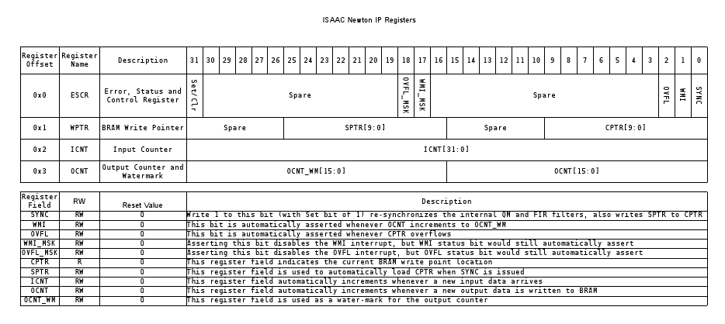  Default value is “0”
3.8 Interrupts
In addition to the hardware interrupts specified in the MHS that are linked to the interrupt controller, the qmfir also generates interrupts based on the register values. An interrupt is generated whenever there is overflow, or when a watermark value is reached. As data is written into a FIFO on the iBoard, the OCNT register increments each time a filter output is written. When the OCNT counter reaches a specifed watermark value, an interrupt is sent to the processor to send the data over the Ethernet connection. If the FIFO gets overrun with data, another interrupt is generated to send out the current payload and clear the FIFO. These interrupts are set up in software by enabling the interrupts and writing a set value to the QMFIR_INTR_IPIER, QMFIR_INTR_DGIER, and QMFIR_INTR_IPISR registers.

3.9 Overall System Data Flow
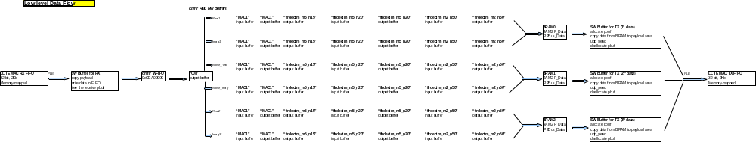Please refer to “qmfir_diagram.xls”, located in the documentation folder, to view the low-level data flow diagram.
Figure 3.3 Overall System Data Flow

4.0 Software Overview
The software to run the UDP demonstration is written in C and is located in the /EDK_project/sw_src/demo_udp directory. The software is responsible for managing the network connection , enabling and setting up interrupts, providing callback functions, and facilitating the communication over UDP between the iBoard and host machine.

4.1 Testbed Data Flow
The testbed system is designed to demonstrate the capabilities of the Newton QM-FIR digital filter core. The testbed setup is shown in Fig. 4.1. Data is first transferred from the host machine through Ethernet to the iBoard. The data gets temporarily stored in the DDR memory. When all the data has been stored, the PPC will transfer the data to the FIFO into the QMFIR DSP core. The data gets processed and the result will be written into 3 local Block RAM inside the DSP core. When all the data has been written, there will be an interrupt to let the PPC know that it can then grab the data from the BRAM and transfer it back through ethernet to the host machine.
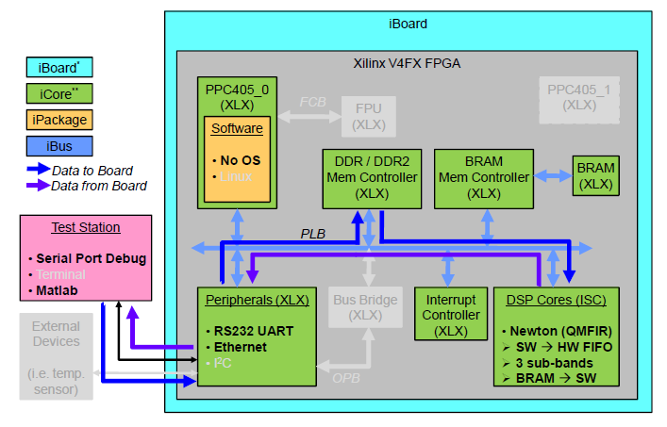
Figure 4.1 Testbed Setup

4.2 Matlab Data Flow
This demo uses floating-point algorithms in Matlab to generate synthetic filter input data. That data is sent to the iBoard for processing, but also sent through Matlab functions to perform the same filtering on the host machine. This calculates the expected output of the filter, to be compared with the actual output of the QM-FIR digital filter core. Figure 4.2 provides a block diagram to illustrate the data flow.
The figure shows 2 scenarios in which the demo system can run. These are not the only 2 scenarios but are chosen for their contrast. Scenario 1 demonstrates that the demo system is able to process data on the y with unknown, new data generated in real-time by Matlab. This is the most accurate scenario because on a flight mission the data will be unknown and will be processed in real-time. This scenario will also plots the pulse compression from the data that has been processed by the FPGA. Scenario 2 will attempt to depict the speed of the DSP core. This scenario will use previously generated data and will depict a moving target. This scenario will not plot the pulse compression.

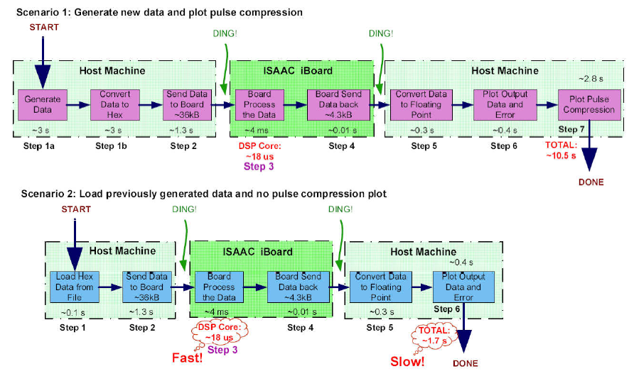
Figure 4.2 Matlab Data Flow

The figure breaks down which steps are computed by the host machine (Matlab, data movement to the board, etc.), and which steps are computed by the iBoard (DSP core, data movement on the board, etc.). The figure links what each step is doing to a step number, which will then be depicted on the Matlab GUI. The figure gives an approximate time each step takes to execute, either in Matlab or on the iBoard. The figure gives a total amount of time that can be expected for each scenario to play out.

4.3 Matlab GUI
The Matlab GUI is used to visualize data output from the iBoard and compare it with expected data generated on the host machine through Matlab algorithms. There are a variety of options to choose from in the GUI interface. Figure 4.3 shows the options that are available on the interface.

- On the top on the GUI is the ethernet transfer information. Users can choose the Host IP, the Host Port number, the Remote IP, and the Remote Port number. The Host information is the information of the computer which is running the MATLAB GUI. The Remote information is the information of the board that is running the FPGA. To change the information of the Host and Remote, just simply click on white box and type in a new IP or port number. Make sure that this matches with the C script that is programmed into the Power PC running on the FPGA. Default values: Host IP is 192.168.0.1, Host Port is 61557, Remote IP is 192.168.0.15, Remote Port is 61557.
- This is the 'Do not generate new data' option. If this option is clicked, input data to the FPGA will be loaded from a series of previously generated data. This option will provide a quicker demo time because loading data from a file is much faster than generate the chirp data from a MATLAB algorithm. Default value is Unselected.
- This is the 'Do not generate pulse compression' option. If this option is clicked, the data that is transferred from the board will not be generated into pulse compression. This option will provide a quicker demo time because generating the pulse compression demands running the long MATLAB program. Default value is Unselected.
- This is the button to start the demo run. This will first either generated data or load data from file, transfer to board, wait and receive the processed data from board, and plot the data and error, and could plot the pulse compression. This button should be the last to press after all of the options have been looked at and chosen.
- This is the 'Starting point for rotation 3100 to 14000' option. This allows the user to choose the starting position of the rotation of the input data. This will dictate the first the first rotation point for the input data. From algorithm design, this number should be between 3100 and 14000. This is only valid if option 2 is UNclicked (meaning that new data is generated). Default value is 3100.
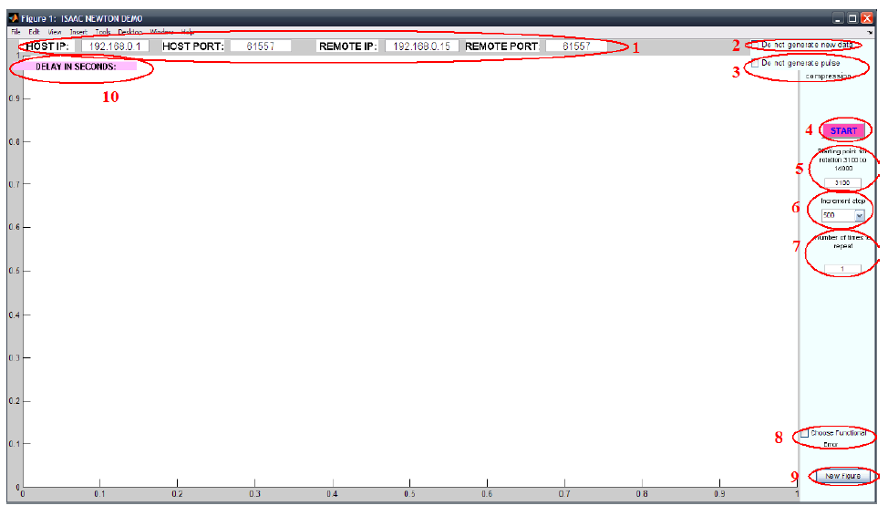
Figure 4.3 Matlab GUI

- This option allows user to choose the increment step to be taken between rotation. Starting from the value in option 5, subsequent rotation will be incremented by the number chosen in this step. Default value for this is 500 points.
- This option allows user to repeat the demo run (sending data and receiving data) more than one time. User than input the number of times to send data to be processed and receive the data to plot. There are currently 23 data points on file if option 2 is clicked. And the maximum number for this step if option 2 is UNclicked depends on option 5 and 6. If option 5 and 6 combined is larger than 14000, the demo system will stop. The default value is 1. The default value is Unselected.
- This option allows user to see the function error between the FPGA implementation and MATLAB algorithm simulation. The default is UNclicked, which means that the error that is plotted is the quantization error from the MATLAB representation of the RTL code.
- This option allows user to generate a new GUI figure to clean up current figure.
- This is the real-time "how long does each step take" portion of the demo. This demonstration system is able to display in real-time the amount of time each step in the demonstration system takes.

Figure 4.4 shows what the GUI is expected to look like after running the demo system. On the left side of the GUI, there is a list of Steps and time corresponding to each step. The steps are explained in Fig. 4.2. The corresponding time is the amount of time it takes for each steps to be processed. The top figure shows the data that is sent to the board to be processed. This data is sampled at 60MHz. The 2nd line shows the real data from Band 1, Band 2, and noise band from left to right. The 3rd line shows the imaginary data from Band 1, Band 2, and noise band from left to right. Line 4 shows the error between the real data of the FPGA processed data versus the data from simulation (Band 1 and Band 2 from left to right), and line 5 shows the error between the imaginary data. The last plot of lines 4 and 5 shows the pulse compression plots of the FPGA processed data.
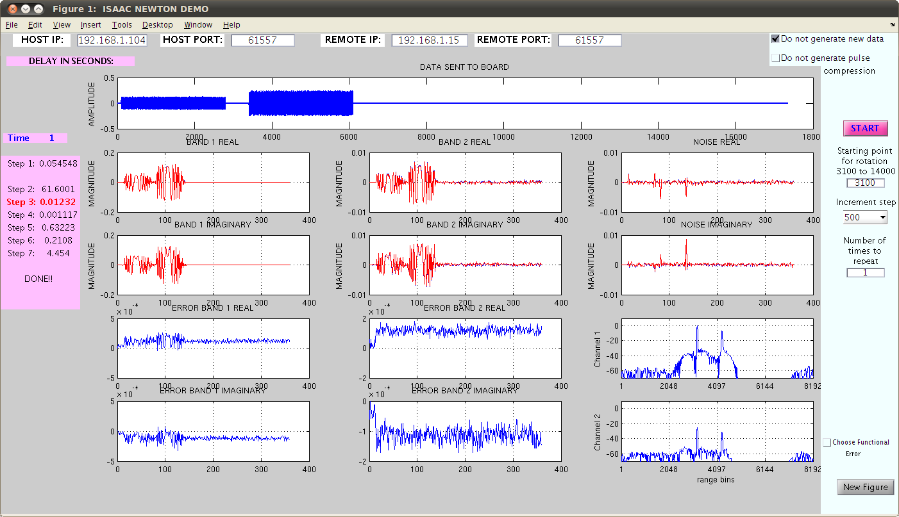
Figure 4.4 Matlab GUI Displaying Output

Please refer to “qmfir_eth_from_scratch.doc”, located in the documentation directory, for instructions on how to setup the project, download the bitstream, and run the demonstration.

5.0 Power, Mass and Volume

5.1 Power Consumption
The primary power to the AMA-SM board is TBD V. However, a TBD V is produced for FPGA consumption.
Supply | Typical | Max | Unit
P3.3V | 3.3 (Tentative) | TBD | W
P1.5V | 2.5 (Tentative) | TBD | W
Overall | 5.8 (Tentative) | TBD | W

5.2 Order of Power Application
P3.3V, P1.5V may be powered up or powered down in any sequence.

5.3 Mass
The weight of the AMA-SM, including connectors, wedge locks, stiffeners, and heat spreaders, will be TBD grams.

5.4 Volume
All grades of AMA-SM shall conform to the outlines of the slice as defined by TBD.

6.0 Operating Conditions
The following table summarizes the AMA-SM operating conditions including Temperature. AMA-SM operation is not guaranteed after exposure to conditions outside these limits.
Symbol | Parameter | Absolute Maximum | Recommended Operating Conditions | Unit
P3.3V | +3.3V Primary Supply Voltage | -0.3 to +3.6 | 3.0 to 3.6 | V
P1.5V | +1.5V FPGA Supply Voltage | -0.3 to +1.6 | 1.425 to 1.575 | V
T_{A} | Ambient Temperature | -55 to +125 | -55 to +75 | °C

7.0 FPGA Port Definitions
Note: this is not yet complete
FUNCTION | SIGNAL NAME | I/O | DESCRIPTION | COMMENTS
OPB | OPB_CLK | IN | OPB System Clock | 100MHz
OPB | OPB_RST | IN | OPB System Reset
OPB | OPB_ABUS[0] | IN | OPB Address Bus 0
OPB | OPB_ABUS[1] | IN | OPB Address Bus 1
OPB | OPB_ABUS[2] | IN | OPB Address Bus 2
OPB | OPB_ABUS[3] | IN | OPB Address Bus 3
OPB | OPB_ABUS[4] | IN | OPB Address Bus 4
OPB | OPB_ABUS[5] | IN | OPB Address Bus 5
OPB | OPB_ABUS[6] | IN | OPB Address Bus 6
OPB | OPB_ABUS[7] | IN | OPB Address Bus 7
OPB | OPB_ABUS[8] | IN | OPB Address Bus 8
OPB | OPB_ABUS[9] | IN | OPB Address Bus 9
OPB | OPB_ABUS[10] | IN | OPB Address Bus 10
OPB | OPB_ABUS[11] | IN | OPB Address Bus 11
OPB | OPB_ABUS[12] | IN | OPB Address Bus 12
OPB | OPB_ABUS[13] | IN | OPB Address Bus 13
OPB | OPB_ABUS[14] | IN | OPB Address Bus 14
OPB | OPB_ABUS[15] | IN | OPB Address Bus 15
OPB | OPB_ABUS[16] | IN | OPB Address Bus 16
OPB | OPB_ABUS[17] | IN | OPB Address Bus 17
OPB | OPB_ABUS[18] | IN | OPB Address Bus 18
OPB | OPB_ABUS[19] | IN | OPB Address Bus 19
OPB | OPB_ABUS[20] | IN | OPB Address Bus 20
OPB | OPB_ABUS[21] | IN | OPB Address Bus 21
OPB | OPB_ABUS[22] | IN | OPB Address Bus 22
OPB | OPB_ABUS[23] | IN | OPB Address Bus 23
OPB | OPB_ABUS[24] | IN | OPB Address Bus 24

8.0 Board Level Pin Outs
CONN | COL | ROW | SIGNAL NAME | I/O | FUNC | ENDPOINT | I/O
 |  |  | Connector pins used: |  |  | TBD
 |  |  | Connector pins available |  |  | TBD
 |  |  | Percent Spare |  |  | TBD

9.0 Acronyms
FIR Finite Impulse Response
FPGA Field Programmable Gate Array
FPGA Field Programmable Gate Array
IP Intellectual Property
LSB Least Significant Bit
MAC Media Access Control
MSB Most Significant Bit
OPB On-chip Peripheral Bus
POR Power On Reset
QM Quadrature Modulation
R Read Only
RAM Random-Access Memory
RW Read/Write
SEU Single Event Upset
SPLB Slave Processor Local Bus
SRAM Static Random-Access Memory
UART Universal Asynchronous Receiver/Transmitter
UDP User Data Protocol
W Write Only

10.0 Applicable Documents

10.1 Data Sheets

10.2 JPL Documents
Document Title | Project Document No. | JPL D-#
 | R&TD Mobility Avionics

