How to: QM-FIR Digital Filter Core – UART Implementation (ISE Project)

Hardware Setup
- Connect a serial cable from iBoard's UART port to the S0 port on the host machine.
- Connect power and JTAG cables.

Synthesizing and Implementing the Design in ISE
- Open Xilinx ISE from a terminal. $ ise
- Open the New Project Wizard. File >> New Project...
- Enter a project name, location, and working directory. Click 'Next'.
- Choose your desired device and design flow. Click 'Next'. Note: this How-to uses the iBoard 3
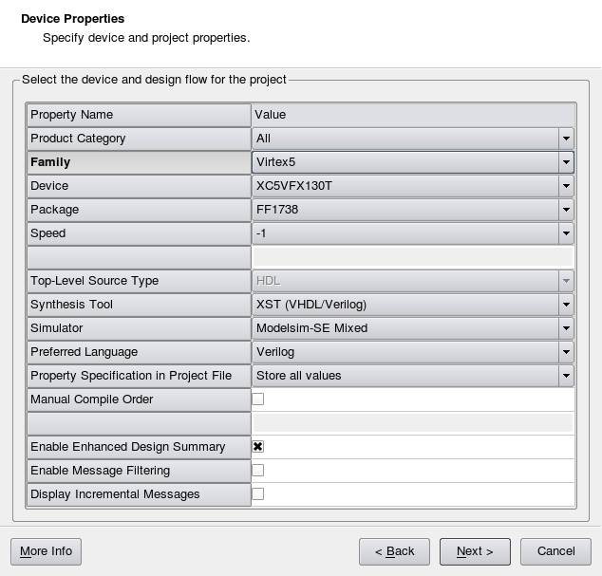

- Because we have existing source files, click 'Next' on the Create New Source screen.
- In the Add Existing Sources screen, click 'Add Source'. Browse to /qmfir/qmfir_uart/qmfir_240MHz/ISE_project and select the following files.

FIR0QM.v
firdecim_m2_n50.v
firdecim_m4_n12_freqcalc.v
firdecim_m4_n12_wrap.v
firdecim_m4_n12.v
firdecim_m5_n15.v
firdecim_m5_n25.v
firdecim.v
iReg.v
MAC1.v
QM_FIR.v
QM.v
QMFIR_uart_if.v
QMFIR_uart_top.v
sasc_brg.v
sasc_fifo4.v
sasc_top.v
QMFIR_uart_top.ucf

- Also add the BRAM.xco and BRAM_larg.xco files, which are located in /qmfir/qmfir_uart/qmfir_240MHz/ISE_project/ipcore_dir, and click 'Next'.
- Click 'Finish'. And then click 'OK'.
- Click on the QMFIR_uart_top source file in the Hierarchy window and make sure it is highlighted.
- In the Processes window below, double-click on 'Generate Programming File'. The ISE project will begin to Synthesize. This procedure may take time to finish (about 20 minutes).
Downloading the Bitstream to iBoard (refer to iStart.doc for a more detailed way to do this)
- In the Processes window, double-click 'Configure Target Device' to open iMPACT.
- In iMPACT, double-click 'Boundary Scan' under IMPACT Flows.
- Make sure the iBoard is powered on and connected to the computer with a JTAG cable.
- File >> Initialize Chain
- Browse to the *.bit file in your project directory and click 'Open'.
- Click 'No' to programming the Flash, and click 'OK' at the next pop up.
- Click on the 'Program' icon to program the iBoard.
- Wait for the “Program Succeeded” notification.

Running the QM-FIR Digital Filter Core with the Python GUI
- In a terminal, browse to the iPanel.py code.
$ cd /qmfir/qmfir_uart/qmfir_240MHz/python_gui
- Run the iPanel.
$ python iPanel.py
- Click the 'Start' button to start the core.

Notes:
- To run the iPanel, make sure to have these Python modules installed: wx, Numeric, matplotlib
  - They are available in the synaptic package manager
    - python-wxversion, python-wxgtk2.8, python-wxgtk2.8-dbg
    - python-numeric
    - python-matplotlib-data, python-matplotlib

Including ChipScope In Your Design
ChipScope is a very useful debugging tool for looking at internal signals.
- Open CORE Generator from a terminal. $ coregen
- Create a new project. File >> New Project
- Enter in the device details for iBoard 3 in the Project Options.

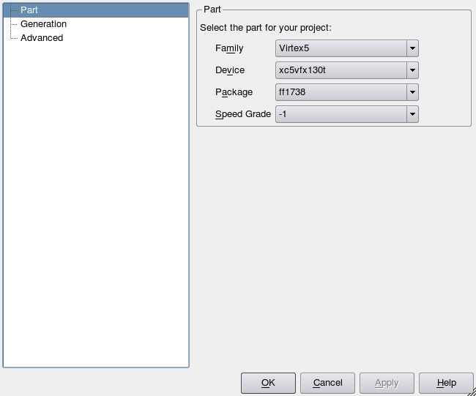
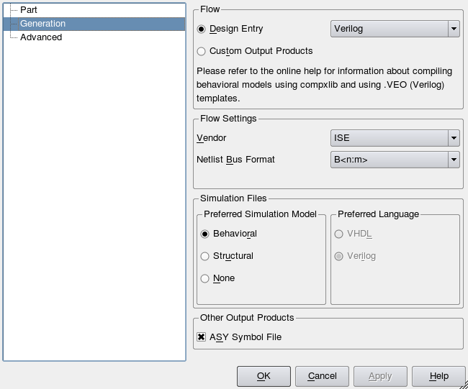

- In the IP Catalog window, under Debug & Verification >> ChipScope Pro, double-click on ICON and enter in the following parameters. Then click 'Generate'.

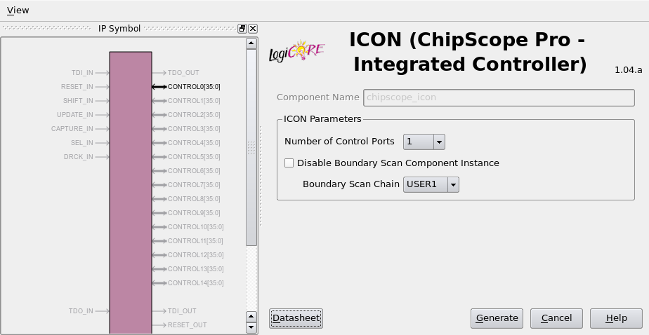

- In the IP Catalog window, under Debug & Verification >> ChipScope Pro, double-click on ILA and enter in the following parameters. Then click 'Generate'.
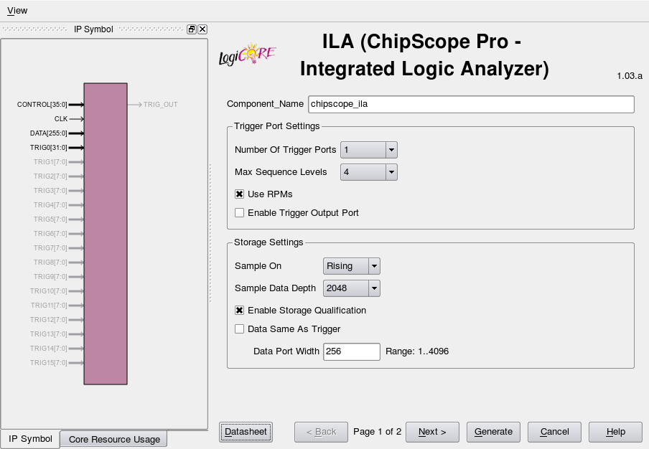

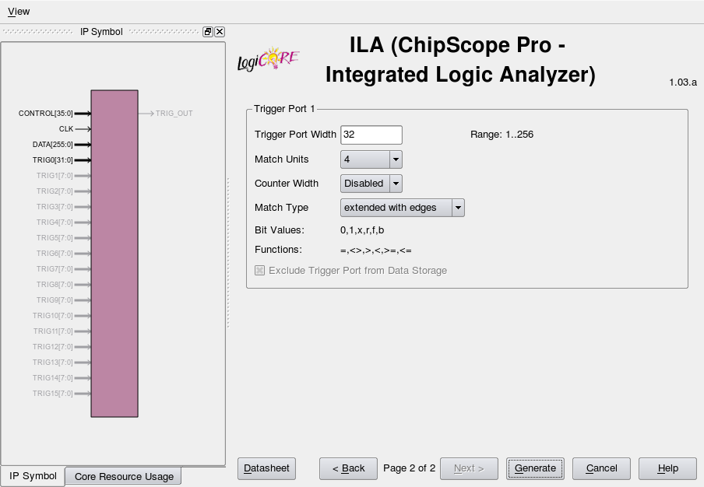

- By generating these cores, CORE Generator creates chipscope_icon.xco and chipscope_ila.xco files into your coregen project directory, which you will need for your ISE project.
- In ISE, add the following to your top file to instantiate the ChipScope ICON and ILA:
wire [35:0] control1;
chipscope_icon myIcon(control1);
chipscope_ila myChipScope(
.CONTROL(control1),
.CLK(clk),
.DATA({/*your 256-bit data*/}),
.TRIG0({31'b0,clk})
);
- Add the chipscope_icon.xco and chipscope_ila.xco files to your project. Project >> Add Copy of Source... (these files should be located in your COREgen project directory)
- Re-synthesize the design.
- Download the bitstream to the iBoard.
- Open the ChipScope Analyzer from a terminal. $ analyzer.sh
- Click the 'Open Cable/Search JTAG Chain' icon.
- Click the Play button or 'Trigger Setup' → 'Run' to take a new sample.

