JPL RTD Flight System Avionics

Instrument ShAred Artifact for Computing (ISAAC)

QM-FIR Digital Filter Core – for UART

Design and Implementation Document

RTD Document Number: XXXX-XXX
JPL Document Number: X-XXXXX

Revision: 1.0

Date: 05/06/2011

Author: Hieu Nguyen
Contributors: (Alphabetically) Yutao He, Hieu Nguyen.
Custodian: Hieu Nguyen
Summary: This document serves as the design documentation for the QM-FIR digital filter core for ISAAC FPGA-based flight system avionics.

Paper copies of this document may not be current and should not be relied on for official purposes.



Jet Propulsion Laboratory
4800 Oak Grove Drive
Pasadena, CA 91109-8099

Signature Sheet

Prepared By:

_______________________________________

Advanced Mobility Avionics Design Engineer

Reviewed By:

_______________________________________
Kevin Watson
Advanced Mobility Avionics Co-PI

Reviewed By:

_______________________________________
Gary Bolotin
Advanced Mobility Avionics PI

Revision History
Rev. | Description | Author | Date | Approval
0.9 | Initial draft | Hieu Nguyen | 03/04/11
1.0 | Release | Hieu Nguyen | 05/06/11

Table of Contents

1.1 Purpose 3
1.2 ISAAC Background 3
1.3 Overview 3
4.4.7 Additional UART Register Information 11
1.3.1 Resource Utilization 15
1.4 Power Consumption 17

Table of Figures

Figure 1A Sample Application with smCore 16

Table of Tables

Table 1 QM-FIR Registers for UART Implementation 6
Table 2 Memory Map of a Simple Application 16

Introduction

Purpose
This document serves as the ISAAC Newton Quadrature Modulation with Polyphase Decimation Filter (QM-FIR) FPGA design specification. This has sufficient details for future ISAAC FPGA review and usage of the core.

ISAAC Background
The ISAAC—Instrument ShAred Artifact for Computing—project aims to provide a highly capable, highly reusable, modular, and integrated FPGA-based common instrument control and computing platform that can be shared by multiple Earth-Science and planetary-exploration instruments. Essentially, ISAAC allows instrument electronics designers to configure a complete instrument control and computing system by using its integrated framework. The motivation for ISAAC technology is to provide a platform that can be shared by a wide range of instruments, introducing a common spacecraft bus interface with on-board processing for systemic missions. ISAAC’s reusable framework offers a combination of adaptability, computation power, I/O bandwidth, digital interface standards, and data processing capability in a single common low mass/power and small form factor platform with significantly reduced non-recurring cost and risk to Earth Science instruments. As future instruments require more demanding on-board processing capabilities, ISAAC will allow new instrumentation developments to meet performance requirements in a cost-efficient manner.

By focusing on sharable components for instruments, ISAAC technology allows JPL to compete in a host of instrument missions in which it was previously unable to compete competitively. Its use has been recommended for a wide range of future NASA/JPL missions, where it will be integral in data acquisition from digital electronics instruments such as GPS, radars, radiometers, interferometers, lasers, spectrometers, altimeters, and more. The QM-FIR digital filter core is part of a subtask called ISAAC Newton that focuses on the radar application, specically, the on-board processing power which will eventually support the SMAP (Soil Moister Active/Passive) project.

Overview
This implementation of the QM-FIR digital filter core was developed by Kayla Nguyen, Jason Zheng, Charles Le, Jason Chu, Yutao He in April 2009. The filter was designed to meet the radar onboard processor requirements of the Soil Moisture Active/Passive (SMAP) mission, which operates at L-band (and has 240MHz ADC sampling rate). Because of ISAAC's modularity, the QM-FIR team was able to inherit the previous 60MHz digital filter design and extend it for a 240MHz application. Algorithm development and simulation was based on the ISAAC 60MHz digital filter design, FPGA design and implementation was based on the ISAAC 60MHz digital filter core, and testbed construction and demonstration was based on the ISAAC iBench. The originally design was implemented on the Xilinx Virtex-II FPGA. In April 2011, the digital filter core was ported over to the ISAAC iBoard 3, which featured a more computationally powerful Xilinx Virtex-5 FPGA.

2.0 Background
Details of QM and FIR, filter design/functionality
The 240MHz input signal is slowed down to 60MHz with a 1:4 DMUX, and followed by a 4-stage decimation-by-200 to bring the output signal to 1.2MHz. The following diagrams illustrate the flow of the QM-FIR filter components.

Figure … Multi-stage Decimation Filter Design
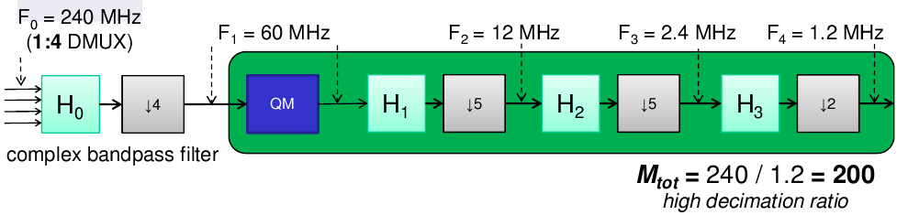
Figure … QM & Polyphase Decimation Filter Design
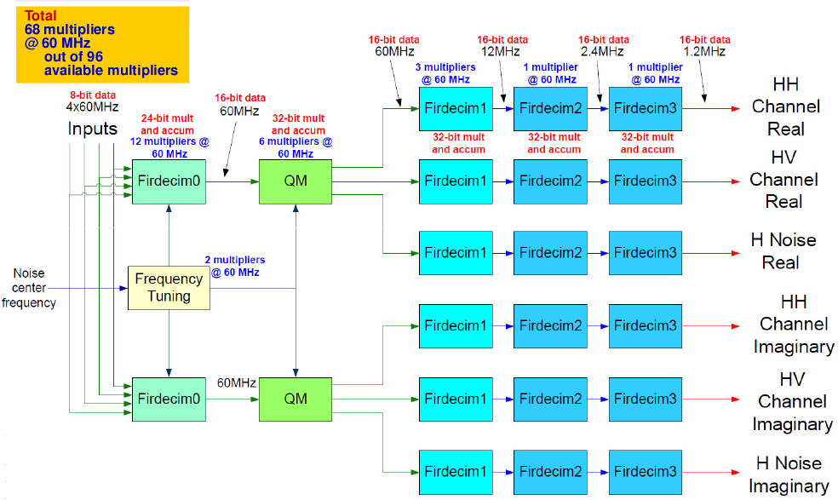

3.0 QM-FIR FPGA Modules Description

Describe all HDL modules (inputs, outputs, customized parameters, hierarchy)
QMFIR_uart_top →

4.0 Hardware Overview

4.1 Asynchronous Reset (ARST)
An asynchronous reset switch, which resets the core when pressed, is located on SW5.

4.2 Block Random Access Memory (BRAM)
This QM-FIR digital filter core runs on the ISAAC iBoard 3, utilizing its UART port for communication with a Host Machine and its internal BRAM for filter input/output data storage. The core utilizes the Block Memory Generator (v. 3.3), created with COREgen, to configure and initialize the size of BRAM regions for the memory modules. The input BRAM module (called “BRAM_larg”) is a 64KB region of BRAM that holds input data from address 0x0000 to 0x0A8C (containing 2700 4-byte words). This region holds the input data from the Host Machine until the digital filter core is ready to process that data. This is illustrated in Figure ___, (a).
The digital filter core produces 6 streams of output data at 1.2MHz into a 16KB output BRAM module (called “BRAM”). There are three regions of output BRAM that hold the processed data until the Test Station is ready to retrieve the data. This BRAM module has a 32-bit output containing the concatenation of the 16-bit Real and 16-bit Imaginary part of a particular channel. Each channel takes up a total of 164 address spaces, as illustrated in Figure ___, (b).
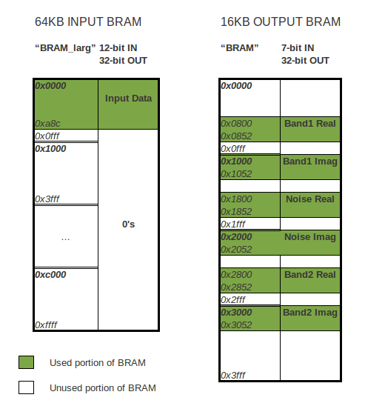

4.3 Digital Clock Manager (DCM)
This core features a DCM to divide the 100MHz onboard clock down to the specified 60MHz UART speed. The DCM is instantiated in the “QMFIR_uart_top.v”, taking in the 100MHz 'clk' and outputting a 60MHz 'core_clk' to feed to the rest of the UART-based modules and always blocks. By setting the DCM's .CLKFX_DIVIDE and .CLKFX_MULTIPLY parameters, one can alter the clock frequency to his/her specifications.

For example, the following parameters will multiply the input clock by 3 and divide it by 5, yielding a clock signal that has been reduced to 60%.

.CLKFX_DIVIDE(5), // Can be any integer from 1 to 32
.CLKFX_MULTIPLY(3), // Can be any integer from 2 to 32

4.4 Registers
In the UART implementation, the QM-FIR digital filter core has six 16-bit registers that store additional information to specify unique filter parameters such as the a specified center noise frequency. The registers for the UART implementation are listed in Table ___.

Register | Symbol | Address Offset | Bit Width | Access Type
Error, Status, Control | ESCR | 0x1 | 16 | RW
Write Pointer | WPTR | 0x2 | 16 | R
Input Counter | ICNT | 0x3 | 16 | RW
Frequency | FREQ | 0x4 | 16 | RW
Output Counter | OCNT | 0x5 | 16 | RW
Filter Counter | FCNT | 0x6 | 16 | RW
Table 1 QM-FIR Registers for UART Implementation
4.4.1 ESCR Register
The ESCR Register is the Error, Status, and Control Register. It keeps track of interrurpt control due to overflow and the water mark interrupt.
Address offset: 0x1
Reset value: 0x0
Reset by: ARST

ESCR Register
15 | 14 | 13 | 12 | 11 | 10 | 9 | 8 | 7 | 6 | 5 | 4 | 3 | 2 | 1 | 0
setclr | Spare |  |  |  | OVFL_MSK | WMI_MSK | Spare |  |  |  |  | START | OVFL | WMI | Spare

Bits | Type | Name | Reset Value | Description
0 | Spare
1 | RW | WMI | 0 | Watermark interupt is asserted when OCNT increments to OCNT_WM  Default value is “0”
2 | RW | OVFL | 0 | Overflow is automatically asserted when CPTR overflows  Default value is “0”
3 | RW | START | 0 | Indicates that interface is done transferring data and filter can start processing  Default value is “0”
[4 : 8] | Spare
9 | RW | WMI_MSK | 0 | Watermark interrupt mask disables WMI interrupt  Default value is “0”
10 | RW | OVFL_MSK | 0 | Overflow mask disables OVFL interrupt  Default value is “0”
[11 : 14] | Spare
15 | RW | setclr | 0 | Used to set and clear ESCR register, assigned to ( reg0w & idata[15] )  Default value is “0”

4.4.2 WPTR Register
The WPTR Register is used to store the current BRAM write point location.
Address offset: 0x02
Reset value: 0x0
Reset by: SYNC

WPTR Register
15 | 14 | 13 | 12 | 11 | 10 | 9 | 8 | 7 | 6 | 5 | 4 | 3 | 2 | 1 | 0
Spare |  |  |  |  |  | CPTR[9:0]

Bits | Type | Name | Reset Value | Description
[0 : 9] | R | CPTR | 0 | Current BRAM write point location  Default value is “0”
[10 : 15] | Spare

4.4.3 ICNT Register
The ICNT Register keeps track of the input counter and stores the address pointer for incoming BRAM.
Address offset: 0x3
Reset value: 0x0
Reset by: ARST

ICNT Register
15 | 14 | 13 | 12 | 11 | 10 | 9 | 8 | 7 | 6 | 5 | 4 | 3 | 2 | 1 | 0
ICNT[15:0]

Bits | Type | Name | Reset Value | Description
[0 : 15] | RW | ICNT | 0 | Counts the number of inputs, and holds the address pointer for incoming BRAM  Default value is “0”

4.4.4 FREQ Register
The FREQ Register specifies the frequency parameters for the QM-FIR digital filter core.
Address offset: 0x4
Reset value: 0x41
Reset by: ARST

FREQ Register
15 | 14 | 13 | 12 | 11 | 10 | 9 | 8 | 7 | 6 | 5 | 4 | 3 | 2 | 1 | 0
setclr3 | NEWFREQ | Spare |  |  |  |  |  | setclrf | FREQ_int[6:0]

Bits | Type | Name | Reset Value | Description
[0 : 6] | RW | FREQ_int | 0 | Indicates the center noise frequency  Default value is 0x41, which is 65MHz
7 | RW | setclrf | 0 | Used to set/clr new frequency  Assigned to (reg3w & idata[7])
[8 : 13] | Spare
14 | RW | NEWFREQ | d65 | Indicates that a new frequency is to be set  Default value is “0”
15 | RW | setclr3 | 0 | Used to set and clear the FREQ register  Assigned to (reg3w & idata[15])

4.4.5 OCNT Register
The OCNT Register stores the output BRAM write counter.
Address offset: 0x5
Reset value: 0x6000
Reset by: ARST

OCNT Register
15 | 14 | 13 | 12 | 11 | 10 | 9 | 8 | 7 | 6 | 5 | 4 | 3 | 2 | 1 | 0
OCNT_WM[7:0] |  |  |  |  |  |  |  | OCNT_int[7:0]

Bits | Type | Name | Reset Value | Description
[0 : 7] | RW | OCNT_int | 0 | Counts # of outputs, increments whenever a new output data is written to BRAM  Default value is “0”
[8 : 15] | RW | OCNT_WM | d96 | Output counter watermark. Stops writing into the BRAM when OCNT==WM  Default value is 0xff

4.4.6 FCNT Register
The FCNT Register stores the input BRAM write counter.
Address offset: 0x6
Reset value: 0x0
Reset by: ARST

FCNT Register
15 | 14 | 13 | 12 | 11 | 10 | 9 | 8 | 7 | 6 | 5 | 4 | 3 | 2 | 1 | 0
FCNT[15:0]

Bits | Type | Name | Reset Value | Description
[0 : 15] | RW | FCNT | 0 | Input BRAM counter to pass data into filter  Default value is “0”

4.4.7 Additional UART Register Information
UART Read from BRAM
First 8 bit: 01xxxxxx (upper bits of address) to choose which BRAM
Second 8 bit: xxxxxxxx (lower bits of address) address inside BRAM

To read from BRAM1 (Real1): address needs to start with 0x1 ex 0x4800
To read from BRAM2 (Imag1: address needs to start with 0x2 ex 0x5000
To read from BRAM3 (Real2): address needs to start with 0x3 ex 0x5800
To read from BRAM4 (Imag2): address needs to start with 0x4
To read from BRAM5 (Real3): address needs to start with 0x5
To read from BRAM6 (Imag3): address needs to start with 0x6

UART Read from Register
First 8 bit: 00xxxxxx address
Second 8 bit: xxxxxxxx address

ESCR: addr = 0x1
WPTR: addr = 0x2
ICNT: addr = 0x3
FREQ: addr = 0x4
OCNT: addr = 0x5
FCNT: addr = 0x6

UART Write to Core BRAM
First 8 bit: 11xxxxxx address
Second 8 bit: xxxxxxxx address

UART Write to Register
First 8 bit: 10xxxxxx address
Second 8 bit: xxxxxxxx address
ex: write to register 4 to update frequency
0x8004 write to register 4
0x0000 this is ignored
0x00c6 this is written into register

4.5 UART Interface
The UART interface serves to collect commands and data from the test station. The UART has a baud rate of 57600 and operates on a 60MHz clock. Reading and writing over UART is done 4 bytes at a time. Refer to UART read and write commands in section ___ Software Overview for more detailed information.

The HDL for the UART read and write functions is described using a state machine. Upon power up, the UART FIFO's are empty and the core reads in two bytes of data to initialize the 16-bit command word. This causes the state to change from Idle to Cmd1, which is fine for reading and writing, but not for starting the core for the first time. Thus, at the top level, a soft UART reset is asserted every time the START command is issued. This puts the UART back into the Idle state, allowing the UART to initialize correctly.

5.0 Software Overview
One of the main objectives of this UART implementation was to avoid the software overhead incurred when transmitting data using a complex protocol. Thus, the only software used in this implementation is on the Host Machine side for functional verification. A graphical user interface (GUI) was written in Python to take in user input, track the digital filter core through its various cycles, and plot filter output. Matlab software algorithms were also used to generate synthetic data for filter input, and to calculate the expeceted filter output for comparison.

5.1 Matlab Code
Matlab files to generate filter input data and save those values to a text file called '___'. Those 10,800 values are run though a series of Matlab algorithms, converting from binary to hex to decimal, and the output is saved in text files respective of channel.
Test Data: synthetic data generated by Matlab, Max 0dB, Min -25dB, Thermal Noise -34dB, ADC scaling .25, 10,800 8-bit samples stores and read from input BRAM

5.2 Python Code
The Python code consists of a GUI (the “iPanel”) and several backend function calls to run Matlab and communicate with the QM-FIR digital filter core on the iBoard. The iPanel uses some numeric computing functions from the Numeric Python module, available in the Synaptic Package Manager. Using its serial connection through UART, the iPanel reads and writes to memory and registers in the BRAM. When communicating over UART, a command word is sent to specify an operation and a target.

cmd[15:0]
15 | 14 | 13 | 12 | 11 | 10 | 9 | 8 | 7 | 6 | 5 | 4 | 3 | 2 | 1 | 0
cmdRd | cmdMem | uart_addr[13:0]

Bits | Type | Name | Reset Value | Description
[0 : 13] | RW | uart_addr | 0 | Specifies the UART address for BRAM
[14] | RW | cmdMem | 0 | Specifies an operation on memory when bit is set to '0', otherwise on register.
[15] | RW | cmdRd | 0 | Specifies a read operation when bit is set to '0', otherwise it is a write operation.

The command word is masked with an opcode corresponding to its software function. Following the command word, four bytes of data are processed.

rdMem() is masked with 0x4000.
rdReg() is masked with 0x0000.
wrMem() is masked with 0xC000.
wrReg() is masked with 0x8000).

Note: When transferring input data over UART to the iBoard, a time.sleep(.01) function was used to add a 10ms delay between write transactions. This was necessary to avoid UART FIFO overflow.

The main purpose of the iPanel GUI is to visually interpret the functionality of the QM-FIR digital filter core through useful Matlab plots. In Figure ___, we can verify the core output (red) matches the expected output (blue) with very little error. This means that the digital filter core is working as expected and the error meets expectation of fixed-point error analysis. The iPanel also provides useful debugging information by keeping track of the overall state. It also takes in user input to tune to different center frequencies with 1MHz spacing.

iPanel demo flow operations
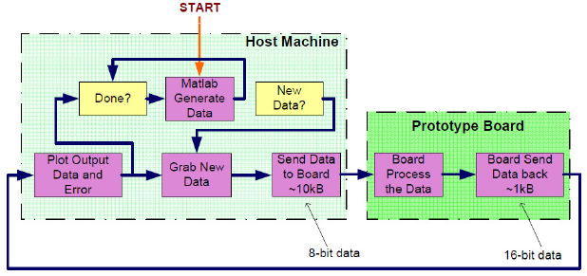

iPanel steps screenshot

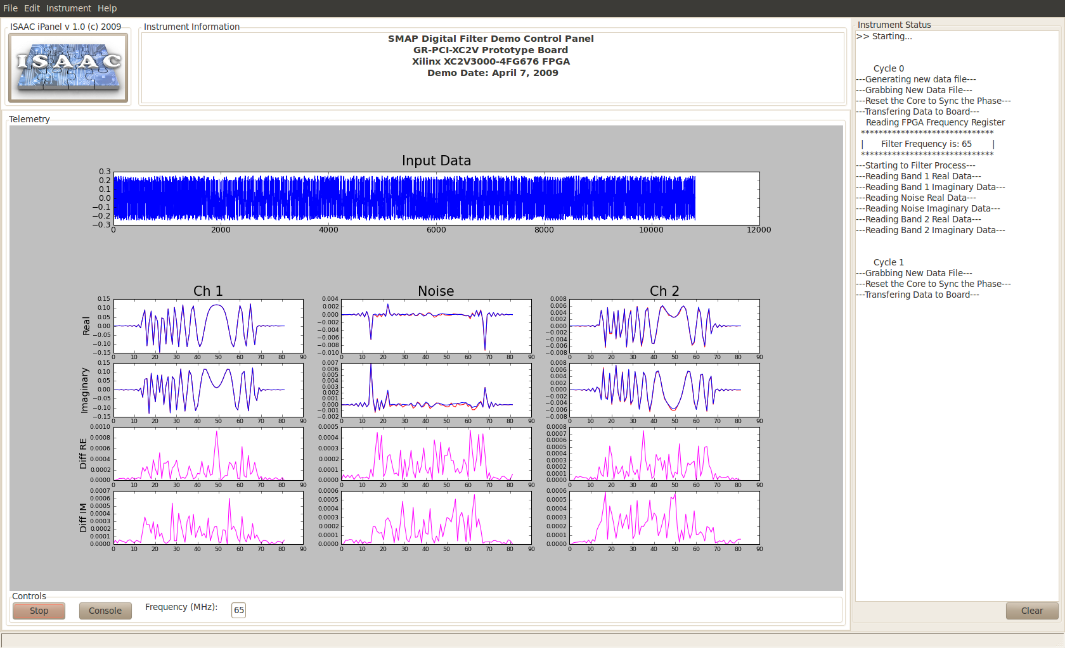
Figure ___: A screenshot of the iPanel after completing one cycle at a 65MHz center frequency. (zoom in???)

6.0 Testbed Demo Flow
Signal, direction, size, active level, description
Interface block diagram for each module, along with tunable inputs
Module signals, parameters
Testbed setup and diagram
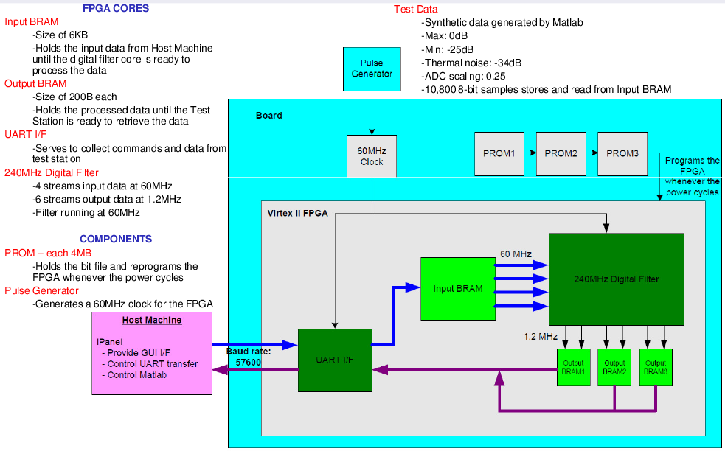

Demo flow:
Host Machine
  - runs on linux with the iPanel in Python
  - calls Matlab to generate synthetic data
  - sends data to the board over UART to be stored on the input BRAM in FPGA
  - starts DFC by writing to register wrReg(4, 0x8008)
iBoard
  - when the register is written, it sends a signal to the DFC to grab data from input BRAM to process
  - DFC processes all data and stores the outputs in Output BRAM
Host Machine
  - grabs data from Output BRAM through UART, converts hex to decimal and stores data in files
  - plots output data vs expected data generated by Matlab
  - plots error between the output data and expected data

TESTBED OPERATION INSTRUCTIONS
- use iMPACT to download the bitstream to the iBoard
- run the iPanel by entering >> python iPanel.py
- click 'Start'
- watch the status bar on the right side of the iPanel for current operation
- after plotting the filter output, the core will re-sync and write the next cycle of input data, running the core again
- clicking 'Stop' will signal abortion of the core, and it will stop drawing at the end of the current cycle
- one can choose the center frequency by inputting a value in the text box, and then restarting the core

    - Resource Utilization
Slices | Slice Flip-flops | 4-input LUTs | Block RAMs
9915 | 9890 | 11660 | 128 Bits

A Sample Application with smCore Integrated
A simple application platform is described in this section to illustrate use of smCore. It is shown in Figure 1 and can be generated using EDK. In addition to smCore components, it contains UART core, and PLB BRAM Controller core, PLB/OPB Bridge core. This minimalist hardware platform allows a software application to take the inputs from serial ports, and to write to the screen. In the meantime, all functions provided the smCore can be demonstrated.
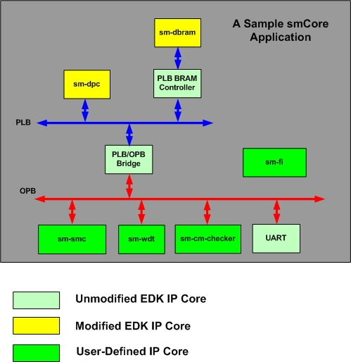
Figure 1A Sample Application with smCore
The memory map is shown in Table 2. Note that the application does not contain an external memory. All data and instructions are loaded into BRAM.
Address |  | Size (Bytes) | Module Name
Start | End | Size (Bytes) | Module Name
0xFFFFC000 | 0xFFFFFFFF | 16K | PLBBRAM
0x80000000 | 0x8000FFFF | 64K | PLB2OPB
0x80000000 | 0x80001FFF | 8K | RS232
0x80002000 | 0x80003FFF | 8K | sm-smc
0x80004000 | 0x80005FFF | 8K | sm-wdt
0x80006000 | 0x800060FF | 256 | sm-cm-checker
Table 2 Memory Map of a Simple Application

Power, Mass and Volume

Power Consumption
The primary power to the AMA-SM board is TBD V. However, a TBD V is produced for FPGA consumption.
Supply | Typical | Max | Unit
P3.3V | 3.3 (Tentative) | TBD | W
P1.5V | 2.5 (Tentative) | TBD | W
Overall | 5.8 (Tentative) | TBD | W

Order of Power Application
P3.3V, P1.5V may be powered up or powered down in any sequence.

Mass
The weight of the AMA-SM, including connectors, wedge locks, stiffeners, and heat spreaders, will be TBD grams.

Volume
All grades of AMA-SM shall conform to the outlines of the slice as defined by TBD.

Operating Conditions
The following table summarizes the AMA-SM operating conditions including Temperature. AMA-SM operation is not guaranteed after exposure to conditions outside these limits.
Symbol | Parameter | Absolute Maximum | Recommended Operating Conditions | Unit
P3.3V | +3.3V Primary Supply Voltage | -0.3 to +3.6 | 3.0 to 3.6 | V
P1.5V | +1.5V FPGA Supply Voltage | -0.3 to +1.6 | 1.425 to 1.575 | V
T_{A} | Ambient Temperature | -55 to +125 | -55 to +75 | °C

FPGA Port Definitions
FUNCTION | SIGNAL NAME | I/O | DESCRIPTION | COMMENTS
OPB | OPB_CLK | IN | OPB System Clock | 100MHz
OPB | OPB_RST | IN | OPB System Reset
OPB | OPB_ABUS[0] | IN | OPB Address Bus 0
OPB | OPB_ABUS[1] | IN | OPB Address Bus 1
OPB | OPB_ABUS[2] | IN | OPB Address Bus 2
OPB | OPB_ABUS[3] | IN | OPB Address Bus 3
OPB | OPB_ABUS[4] | IN | OPB Address Bus 4
OPB | OPB_ABUS[5] | IN | OPB Address Bus 5
OPB | OPB_ABUS[6] | IN | OPB Address Bus 6
OPB | OPB_ABUS[7] | IN | OPB Address Bus 7
OPB | OPB_ABUS[8] | IN | OPB Address Bus 8
OPB | OPB_ABUS[9] | IN | OPB Address Bus 9
OPB | OPB_ABUS[10] | IN | OPB Address Bus 10
OPB | OPB_ABUS[11] | IN | OPB Address Bus 11
OPB | OPB_ABUS[12] | IN | OPB Address Bus 12
OPB | OPB_ABUS[13] | IN | OPB Address Bus 13
OPB | OPB_ABUS[14] | IN | OPB Address Bus 14
OPB | OPB_ABUS[15] | IN | OPB Address Bus 15
OPB | OPB_ABUS[16] | IN | OPB Address Bus 16
OPB | OPB_ABUS[17] | IN | OPB Address Bus 17
OPB | OPB_ABUS[18] | IN | OPB Address Bus 18
OPB | OPB_ABUS[19] | IN | OPB Address Bus 19
OPB | OPB_ABUS[20] | IN | OPB Address Bus 20
OPB | OPB_ABUS[21] | IN | OPB Address Bus 21
OPB | OPB_ABUS[22] | IN | OPB Address Bus 22
OPB | OPB_ABUS[23] | IN | OPB Address Bus 23
OPB | OPB_ABUS[24] | IN | OPB Address Bus 24
OPB | OPB_ABUS[25] | IN | OPB Address Bus 25
OPB | OPB_ABUS[26] | IN | OPB Address Bus 26
OPB | OPB_ABUS[27] | IN | OPB Address Bus 27
OPB | OPB_ABUS[28] | IN | OPB Address Bus 28
OPB | OPB_ABUS[29] | IN | OPB Address Bus 29
OPB | OPB_ABUS[30] | IN | OPB Address Bus 30
OPB | OPB_ABUS[31] | IN | OPB Address Bus 31
OPB | OPB_BE[0] | IN | OPB Byte Enable 0

Board Level Pin Outs
CONN | COL | ROW | SIGNAL NAME | I/O | FUNC | ENDPOINT | I/O
 |  |  | Connector pins used: |  |  | TBD
 |  |  | Connector pins available |  |  | TBD
 |  |  | Percent Spare |  |  | TBD

Acronyms
FIR Finite Impulse Response
FPGA Field Programmable Gate Array
FPGA Field Programmable Gate Array
IP Intellectual Property
LSB Least Significant Bit
MAC Media Access Control
MSB Most Significant Bit
OPB On-chip Peripheral Bus
POR Power On Reset
QM Quadrature Modulation
R Read Only
RAM Random-Access Memory
RW Read/Write
SPLB Slave Processor Local Bus
SRAM Static Random-Access Memory
UART Universal Asynchronous Receiver/Transmitter
UDP User Data Protocol
W Write Only

Applicable Documents

Data Sheets

JPL Documents
Document Title | Project Document No. | JPL D-#
SEU Mitigation Design Specifications (Simple Strategy), Mandy Wang, Jan 7, 2005 | R&TD Mobility Avionics
Configuration Memory, Mandy Wang and Ryan Stern, August 8, 2005

