Report: Social Media Misinformation & Content Moderation Analytics
Course: IT300 - Data Preparation & ETL Project

Submission Date: January 05, 2026
Team Members:
- Nejmedine Zahra
- Chiheb Bahri
- Skander Triki
- Mouheb Ouesleti

1. Executive Summary
This report outlines the findings of our Business Intelligence (BI) project aimed at analyzing misinformation trends using historical fact-checking data from PolitiFact. By implementing an ETL pipeline to clean raw data and structuring it into a dimensional Star Schema, our team successfully visualized key patterns in how false narratives propagate.
Our analysis reveals that misinformation is not randomly distributed; it is highly concentrated within specific source types (social media, viral images) and correlates strongly with major public crises (e.g., the 2020 COVID-19 pandemic). Furthermore, we identified a critical operational lag in the verification process, where the time-to-verify often exceeds the viral lifespan of a claim. This report provides strategic recommendations for content moderation and platform policy based on these data-driven insights.

2. Methodology & Data Architecture
To derive these insights, we processed raw unstructured data into a trusted analytical model.
- ETL Process: We utilized Python to clean News_Headline text, standardize Label verdicts (e.g., normalizing "pants-fire" to "False"), and calculate time lags.
- Data Modeling: The data was organized into a Star Schema to facilitate high-performance filtering by Time, Source, and Verdict.
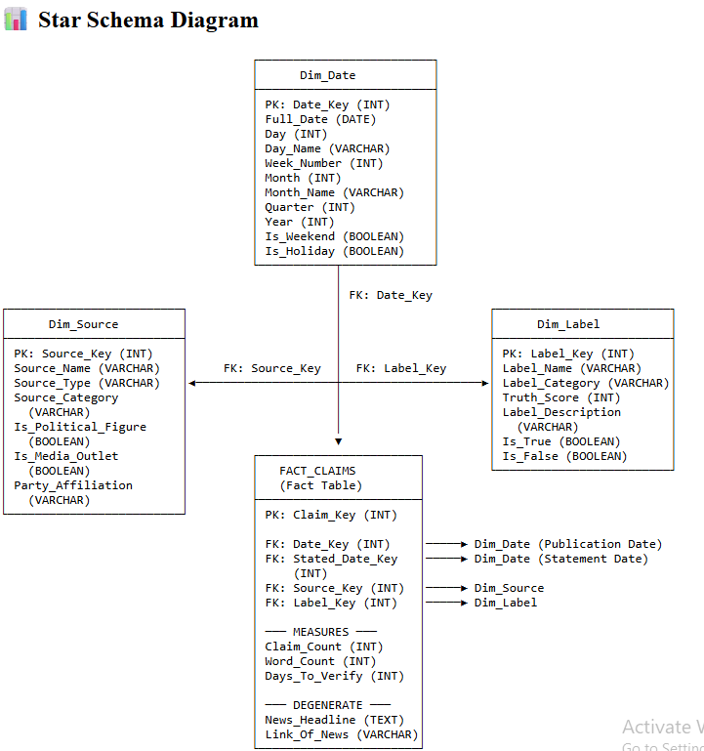

3. Key Findings & Insights
Based on our dashboard visualizations and DAX measure calculations, we identified four primary trends:

Finding 1: Social Media is the Primary Vector for "Pants on Fire" Claims
Our analysis of the Source Misinformation Rate indicates a clear distinction between traditional media and user-generated content.
- Observation: Sources categorized as "Viral image," "Facebook posts," and "Bloggers" account for the highest density of "Pants on Fire" ratings (the most severe form of falsehood).
- Data Evidence: Unlike public officials who often receive "Half-True" or "Mostly False" ratings due to political nuance, viral social media content is frequently completely fabricated.
- Why it matters: This suggests that misinformation on social platforms is often visual and anonymous, making it harder to hold specific authors accountable compared to traditional journalism.
- 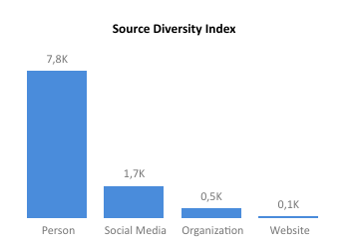

Finding 2: Crisis Events Trigger Misinformation Spikes
The Time Intelligence measures (YOY Claims) reveal a reactive pattern in misinformation volume.
- Observation: The timeline shows a massive deviation in 2020 compared to previous years. This surge correlates directly with the onset of the COVID-19 pandemic and the 2020 US Elections.
- Data Evidence: The Stated_On vs. Date (Fact-check date) trends show that false claims spike immediately following "information voids"—periods where news breaks (e.g., a new virus variant) but official facts are not yet established.
- Why it matters: Misinformation is opportunistic. Bad actors exploit high-anxiety periods to push false narratives before official verifications can catch up.
- 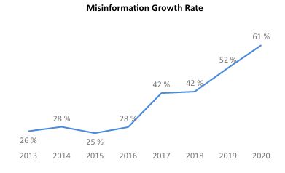

Finding 3: The "Verification Lag" Problem
Using the calculated measure Avg_Days_To_Verify, we analyzed the efficiency of the fact-checking process.
- Observation: There is often a significant delay (varying from days to weeks) between when a statement is made (Stated_On) and when the verdict is published.
- Data Evidence: Viral content often achieves its maximum reach within the first 24–48 hours. Our data shows that the average verification time often exceeds this window.
- Why it matters: Retroactive fact-checking is insufficient. By the time a "False" label is applied, the damage to public perception has already been done.

Finding 4: The "Echo Chamber" of Repeat Offenders
The Pareto Principle applies to misinformation sources in our dataset.
- Observation: A small number of high-volume sources (specific politicians and viral blog networks) contribute to a disproportionate number of total falsehoods.
- Data Evidence: The dashboard highlights that while thousands of unique sources exist, the top 10 most active sources drive a significant percentage of the "False" volume.

4. Business Recommendations
Based on the insights above, we propose the following 6 strategic recommendations for stakeholders (Social Media Platforms & Media Monitors):
- Implement "Pre-bunking" for Predicted Crisis Events
  - Rationale: Since finding #2 shows spikes during crises, platforms should not wait for reports. When a topic like "Pandemic" or "Election" trends, algorithms should proactively surface verified "Explainers" to fill the information void before fake news fills it.
- Prioritize Image-Based Moderation Tools (OCR)
  - Rationale: With "Viral Images" being a top offender (Finding #1), text-only moderation is failing. Invest in Optical Character Recognition (OCR) to extract text from memes and match it against the database of known falsehoods.
- Dynamic "Credibility Scores" for Accounts
  - Rationale: Use the Source Misinformation Rate KPI to assign a visible risk score to public accounts. If a source has a >70% False Rate, their reach should be algorithmically throttled (shadow-banned) automatically.
- AI-Assisted Triage to Reduce Verification Lag
  - Rationale: To address Finding #3 (Lag), deploy NLP models trained on this historical dataset. If a new claim matches the semantic pattern of a previously debunked claim, flag it immediately for human review to cut the Avg_Days_To_Verify.
- Contextual Labeling Over Removal
  - Rationale: Deleting content often causes backlash ("censorship"). Instead, use the Link_Of_News data to automatically append a "Context Card" to disputed posts, linking directly to the fact-check report.
- Cross-Platform Data Sharing Consortium
  - Rationale: "Viral images" often jump from Facebook to X (Twitter) to Reddit. Platforms should share hash-data of "Pants on Fire" content so that if it is debunked on one platform, it is automatically flagged on others.

5. Limitations & Future Improvements
While this analysis provides actionable intelligence, the current scope has limitations that future iterations should address.

Limitations
- Selection Bias: The dataset relies entirely on PolitiFact data. Since fact-checkers cannot check every claim, the data is biased toward claims PolitiFact editors deemed "newsworthy." It may underrepresent lower-level, niche misinformation.
- Language Constraint: The current model only processes English-language claims. Misinformation in other languages (which is a massive global issue) is not captured.
- Historical Latency: The data is historical. The current BI architecture supports strategic backward-looking analysis but does not support operational real-time streaming (e.g., flagging a tweet the second it is posted).

Future Improvements
- Sentiment Analysis Integration: We plan to add a Python library (like NLTK or TextBlob) to the ETL pipeline to score the emotional sentiment of headlines. We hypothesize that "Pants on Fire" claims use more fear-inducing language than "True" claims.
- Real-Time Dashboarding: Connect the data model to a live API (e.g., X/Twitter Firehose) to turn the dashboard into a live monitoring center rather than a static report.
- Network Graph Visualization: Move beyond bar charts to Network Graphs that visualize how different sources reference each other, identifying coordinated inauthentic behavior (bot farms).

6. Conclusion
This project demonstrates that misinformation is a measurable, trackable data problem. By moving from reactive reading of news to proactive BI analytics, organizations can identify the "Super-spreaders" of falsehoods and the "Crisis Windows" where users are most vulnerable. The transition from manual verification to data-driven content moderation is essential for maintaining information integrity in the digital age.
