Chee M. Lee

ICS 311 – Database Management Systems

Term Project Project Step 4

Graphical User Interface

**Read Me**

**Starting the Application:**

1. Import the project “MinnestarDatabase” into Eclipse
2. Locate the config.xml file in the properties folder
3. Insure that the credentials under the node <Users> are correct
4. Note that the program does require some 3rd party dependencies, see dependencies-readme file inside the lib folder. All required dependencies should already be included.
5. To build the database locate the file “projectStepThree_queries.sql” in the sql folder of the project
   * 1. From terminal/cmd login to mysql
     2. Run the command “Source <absolute-path-to-file>”
6. Run the Driver.java file

**Using the Application:**

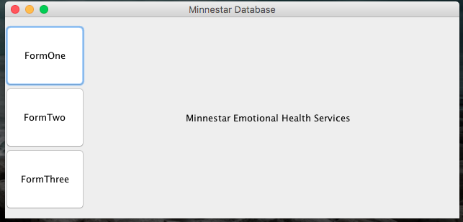

After the application has started you will see an introduction screen as the one shown above. From here you can select any of the three options to the left of the screen.

**Form One:**

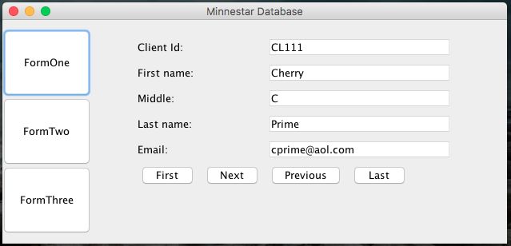

Form one will allow you to browse information on clients. You have the ability to use the buttons “First”, “Next”, “Previous”, and “Last” to iterate through an available client view for limited information.

**Form Two:**

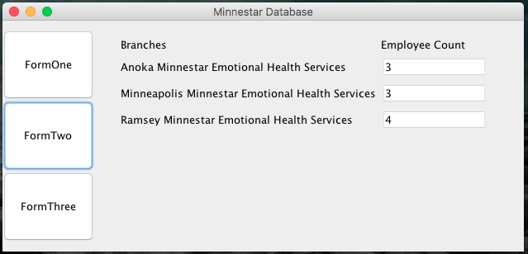

Form Two will allow you see the number of employees per branch.

**Form Three:**

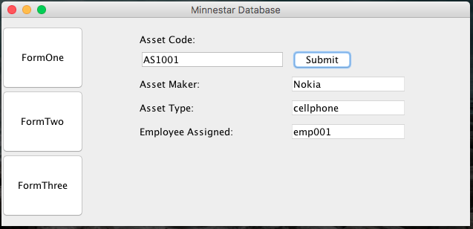

FormThree will allow you to perform a database query of the asset table using a valid asset_id. I you try to query using an invalid asset_id all the fields will display “null”.

**Closing the application:**

Simply press the “x” button to close the application. Alternatively, if you started the project from eclipse you can press the stop button in the IDE.