# Introduction

Components involved in setting up JobApply system in general.

*JABackendService*

This is a backend web service to facilitate the data storage and retrieval.

*JAFrontendWeb*

This is a web application to interface user. It displays typical ASPX page for user to insert and retrieve applicant data.

*SQL Server*

This is the repository used in JA System. It comprised several table and stored procedures.

# Screenshots

Index.aspx

The landing page

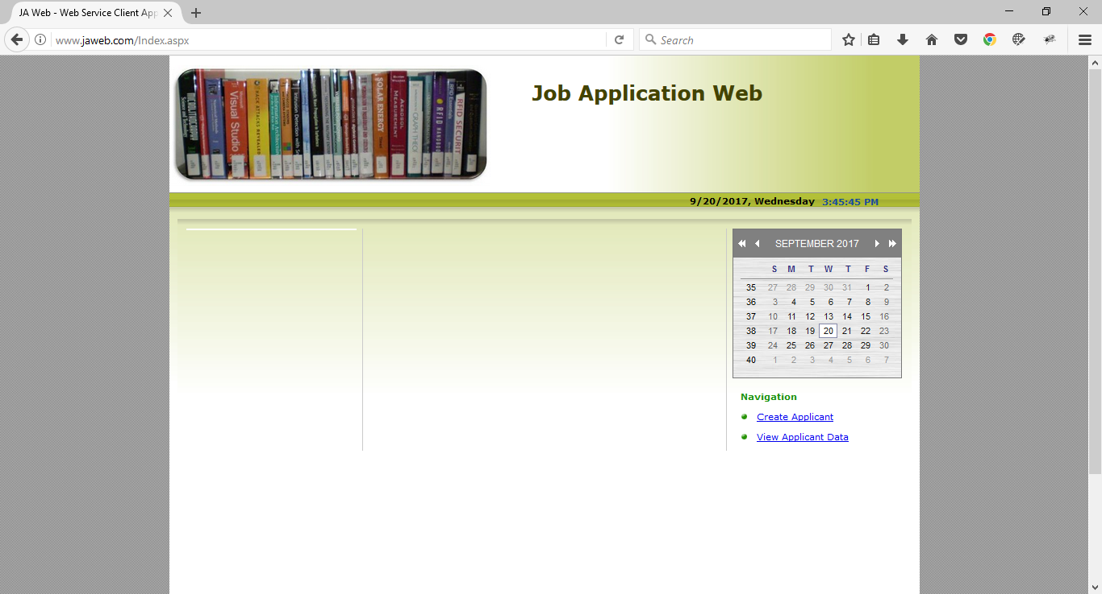

ApplicantCreation.aspx

Data input page

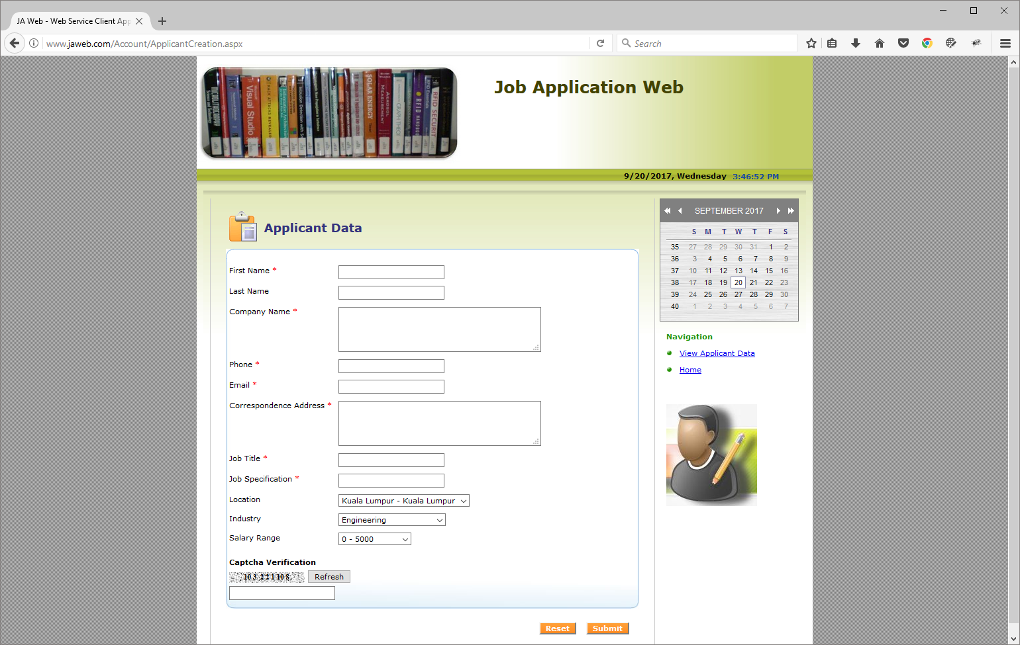

Notification on data successfully save

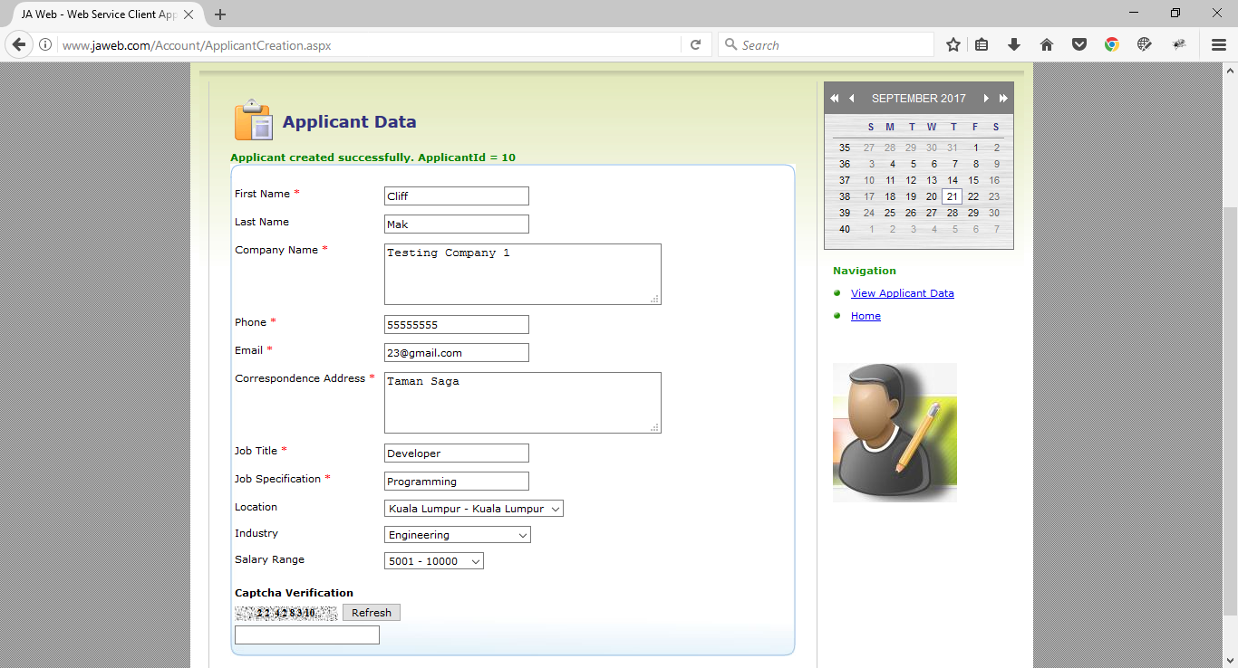

Captcha validation

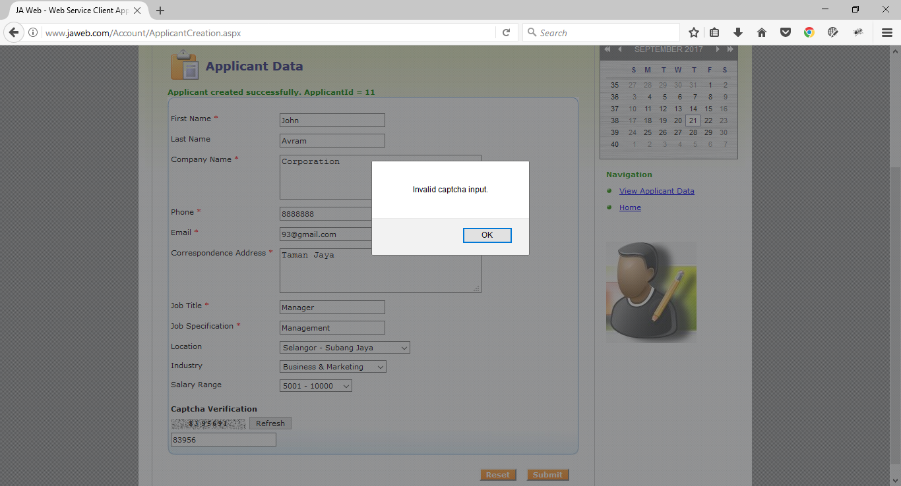

Validation summary on input page

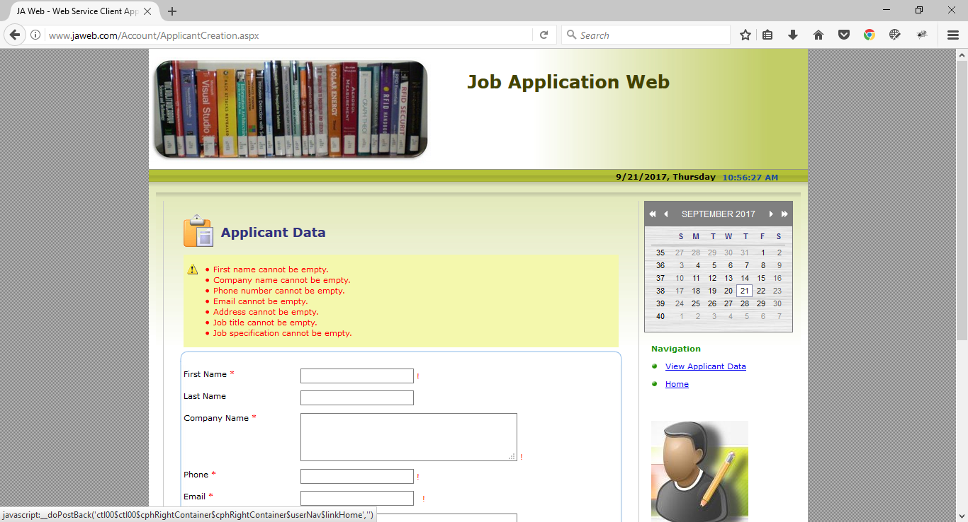

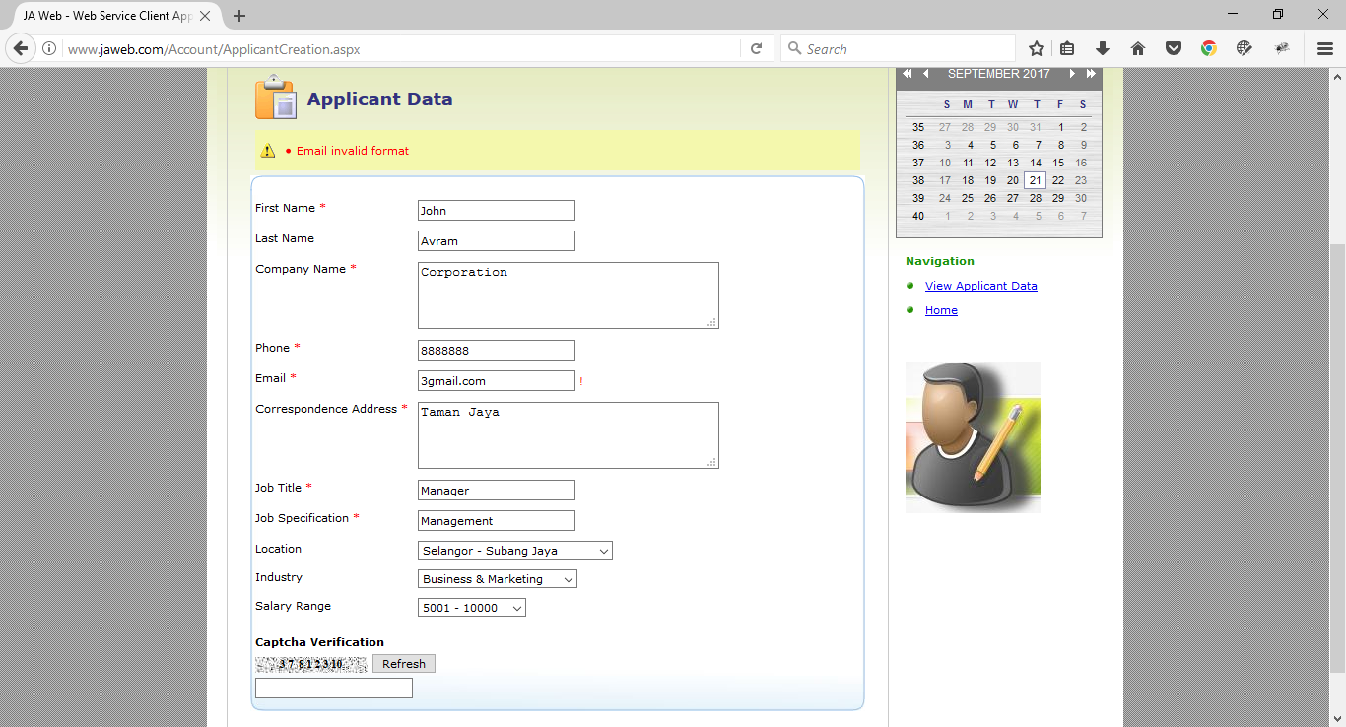

ViewApplicant.aspx

No record screen

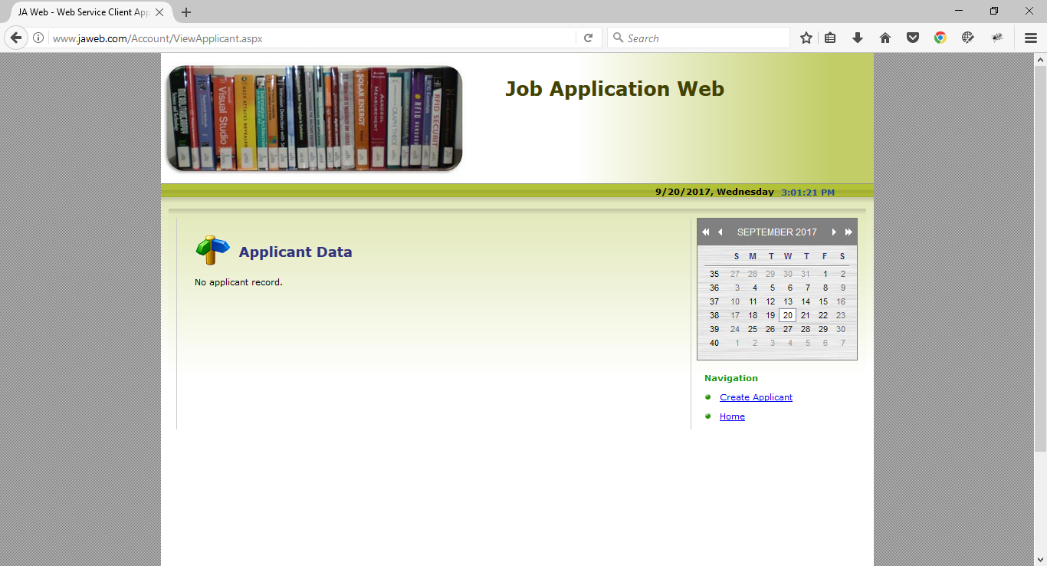

Grid view screen

