用户数据库：

用户名，密码，邮箱，评分，等级，胜局，负局，平局

//胜一局10分，平一局7分，负一局-7分，等级=[评分/10]

create table if not exists chess_player (

name varchar(50) not null,

password varchar(50) not null,

email char(40) not null,

score int not null,

grade int unsigned not null,

victory int unsigned not null,

defeat int unsigned not null,

draw int unsigned not null,

primary key(name,password,email)

);

jdbc:mysql://localhost:3306/chess?useSSL=false&serverTimezone=UTC

// serverTimezone=UTC 这是保证数据库时间一致，不然会出错

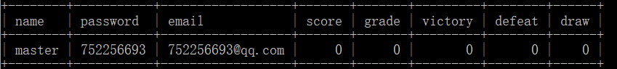

create table if not exists chess_game(

red_player VARCHAR(50) NOT NULL,

black_player VARCHAR(50),

next_step int,

now_player VARCHAR(50),

isregret int,

PRIMARY KEY (red_player)

);

insert into chess_game (red_player,black_player,next_step,now_player,isregret) values ('master',null,null,null,null);

delete from chess_game where red_player=’master’;

localhost:8080/match?name=master&&next_step=-1&&isregret=0&&me=3