A
Project Report
On
SWIGGY SALES DASHBOARD
Using Power BI
By
CHEERLA VANITHA
AF05262683
Batch Code: ANP-D6582

- AIM

The aim of this project is to analyze Swiggy food-delivery transaction data and develop an interactive Power BI dashboard.
The project transforms raw order-level information into meaningful business information about revenue, orders, customers, food categories, cuisines, payment methods, restaurants, cities, delivery performance, and customer ratings.

Purpose of the Project
- Provide a single interactive view of overall sales and operational performance.
- Reduce the need to manually inspect thousands of individual transactions.
- Allow users to filter information by City, Cuisines, Year, Order Status, and Restaurant.
- Support comparison of revenue, order volume, customer activity, delivery time, and ratings.
- Identify patterns that require further business investigation.

Overall, the project aims to convert raw transactional data into an easy-to-understand, interactive, and business-oriented dashboard.

2. OBJECTIVE

The project objectives cover the complete data-analysis lifecycle, from understanding the raw dataset to generating insights and recommendations.
- Understand the structure, fields, and business meaning of the Swiggy dataset.
- Check for missing values, duplicate records, inconsistent categories, invalid values, and unsuitable data types.
- Clean and prepare the dataset for reliable Power BI analysis.
- Create key performance indicators such as Total Revenue, Total Orders, Total Customers, Average Delivery Time, and Average Customer Rating.
- Analyze revenue and order performance across cities and restaurants.
- Study food-category demand using quantity-based analysis.
- Compare cuisines using Order Value.
- Analyze revenue contribution from UPI, Card, Wallet, and Cash.
- Compare average delivery time between cities.
- Analyze monthly revenue trends.
- Build an interactive single-page Power BI dashboard.
- Generate meaningful business insights from the completed visuals.
- Provide detailed recommendations based on the observed patterns.

3. DESCRIPTION OF DATASET

The project uses a structured Swiggy food-delivery transaction dataset containing 50,000 records and 21 columns. It covers orders from 01 Jan 2025 to 31 Aug 2026. The dataset includes 14,479 unique customers, 900 restaurants, 8 cities, and 15 cuisine groups.
The dataset contains information about customers, restaurants, cities, cuisines, food categories, quantities, order values, discounts, delivery charges, revenue, payment methods, order status, delivery performance, and customer ratings.
Dataset Attribute | Description
Number of records | 50,000
Number of columns | 21
File format | CSV
Data type | Structured tabular transaction data
Unique orders | 50,000
Unique customers | 14,479
Cities | 8
Restaurants | 900
Cuisines | 15
Food categories | 20
Payment methods | 4
Order statuses | 3
Date range | 2025-01-01 to 2026-08-31

Dataset Link: https://www.kaggle.com/datasets/vanithacheerla/swiggy-food-delivery-dataset

4. DATA CLEANING
Before Cleaning:
Check | What is examined | Why it matters
Missing values | Blank cells and incomplete fields | Prevents incorrect calculations
Duplicate records | Repeated rows or repeated transaction identifiers | Prevents inflated order/revenue totals
Data types | Date, time, numeric and text fields | Ensures correct Power BI calculations
City values | Spelling and naming consistency | Ensures correct geographic grouping
Cuisine values | Category consistency | Avoids duplicate category groups
Food categories | Consistent category labels | Supports accurate demand comparison
Payment methods | UPI, Card, Wallet, Cash | Supports reliable payment comparison
Order status | Delivered, Delayed, Cancelled | Supports operational analysis
Ratings | Expected rating scale | Prevents invalid averages
Revenue fields | Order Value, charges, tax, Net Revenue | Ensures valid financial analysis
Date fields | Order and delivery dates | Supports monthly/yearly trends
Before cleaning, the dataset was inspected to understand its structure and identify possible data-quality issues.
The main missing-value issue is 3,487 Customer_Rating values. These records correspond to cancelled orders, where a customer rating is not applicable. Therefore, these values should not be replaced with an artificial rating.

After Cleaning:
The dataset was cleaned and validated before being used for dashboard development.
- Converted Order_Date and Delivery_Date into proper date fields.
- Checked numeric columns for invalid or negative values.
- Checked Order_ID for duplicate transactions.
- Validated Customer_Rating values to ensure ratings are within the expected 1–5 range.
- Reviewed missing ratings and retained them as not applicable for cancelled orders.
- Standardized categorical fields for consistent Power BI grouping.
- Verified Payment_Method and Order_Status categories.
- Confirmed that no transaction rows needed to be removed because duplicate and invalid-row checks returned zero issues.
After cleaning, all 50,000 transaction records were retained. The resulting dataset was suitable for analysis and Power BI visualization.

Cleaning Workflow:

Raw CSV Data
Data Inspection
Missing-Value Check
Duplicate Check
Data-Type Correction
Category Validation
Numerical Validation
Final Prepared Dataset
Power BI Analysis

6. ANALYSIS STEPS

1. Import the CSV dataset into the analysis environment.
2. Understand the dataset structure, columns, data types, and business meaning.
3. Perform missing-value and duplicate checks.
4. Validate dates, numerical values, ratings, payment methods, and order statuses.
5. Create calculated measures in Power BI.
6. Calculate Total Revenue, Total Orders, Total Customers, Average Delivery Time, and Average Customer Rating.
7. Group data by City, Cuisines, Food_Category, Payment_Method, Order_Status, Restaurant, and Month.
8. Compare city-wise revenue and delivery time.
9. Analyze food-category demand and cuisine-level order value.
10. Analyze monthly revenue trends.
11. Create interactive slicers and dashboard visuals.
12. Interpret the visual results and prepare key insights.

7. DATA VISUALIZATION
The dashboard uses different visualizations according to the business question. The objective is to make large amounts of transactional data understandable at a glance.
Visualization | Purpose
KPI Cards | Display major business metrics immediately
Slicers | Filter the report interactively
Column Chart | Compare Top 10 Food Categories by quantity
Donut Chart | Compare payment methods by revenue
Line/Area Chart | Compare average delivery time by city
Bar Chart | Compare Order Value by cuisine
Monthly Column Chart | Show monthly revenue trend
Table | Show restaurant-level detail
Treemap | Compare total revenue contribution by city

Visualization Details:

KPI Cards – Provide the fastest view of Total Revenue, Average Delivery Time, Average Customer Rating, Total Customers, and Total Orders.
Top 10 Food Category – Uses quantity to compare food demand and highlight leading categories.
Payment Method by Revenue – Uses a donut chart to compare UPI, Card, Wallet, and Cash revenue contribution.
Average Delivery Time by City – Compares delivery performance across locations.
Order Value by Cuisines – Shows which cuisine groups contribute larger order values.
Monthly Revenue Trend – Shows revenue variation over the months.
Restaurant Detail Table – Provides detailed Restaurant Name, City, and Net Revenue information.
Total Revenue by City – Uses a treemap to show relative city-level revenue contribution.
8. DASHBOARD

The Swiggy Sales Dashboard combines KPIs, filters, charts, and detailed data into one interactive report. The left-side slicers allow users to filter the entire dashboard, while the central and right-side visuals provide sales and operational analysis.
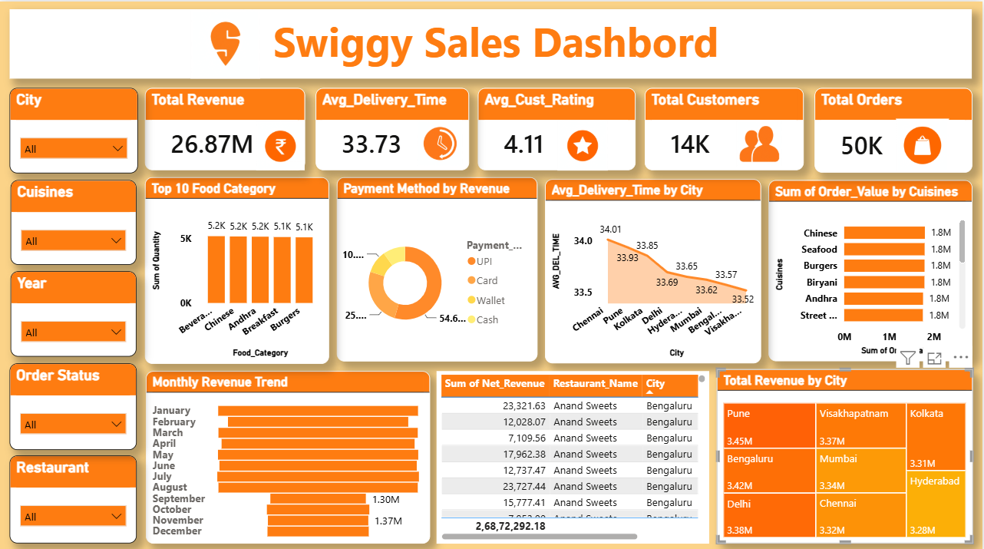
Figure: Swiggy Sales Dashboard
The dashboard is designed for quick business review. Users can select a city, cuisine, year, order status, or restaurant and immediately observe how the KPIs and visualizations change.

9. KEY INSIGHTS

- The dataset contains 50,000 orders with approximately ₹2.69 crore in Net Revenue.
- There are 14,479 unique customers in the dataset.
- Average delivery time is 33.73 minutes.
- Average customer rating is 4.11 out of 5 among rated orders.
- UPI contributes the highest revenue among the payment methods, at approximately ₹1.47 crore.
- UPI contributes the largest revenue share at approximately 54.67%, followed by Card at approximately 25.33%.
- Pune is the highest-revenue city in the supplied data at approximately ₹3,447,414.25. Bengaluru and Delhi are also among the higher-revenue cities
- Beverages is the highest-quantity food category with approximately 5,213 items.
- Chinese has the highest Order Value among the cuisine groups, at approximately ₹18.02 lakh, followed by Seafood, Burgers, Biryani, and Andhra.
- Order status counts are 43,953 Delivered, 2,560 Delayed, and 3,487 Cancelled.
- Average city delivery time ranges from approximately 33.52 to 34.01 minutes.
These observations describe the dataset represented in the dashboard and can be explored further using the slicers.

10. RECOMMENDATIONS

1. Focus on High-Revenue Cities
Monitor high-revenue cities closely and compare revenue with order volume, customer activity, restaurant availability, and delivery performance before making resource decisions.

2. Improve Delivery Performance
Cities with relatively higher delivery times should be investigated using Delivery Distance, Order Status, restaurant-level data, and peak-demand periods. Possible factors include distance, preparation time, delivery capacity, and traffic conditions.

3. Maintain a Strong Digital-Payment Experience
UPI and Card contribute strongly to revenue in the dashboard. Payment reliability, transaction success, and customer convenience should therefore be monitored.

4. Support High-Demand Food Categories
Categories with high quantities should be monitored for availability during high-demand periods. Restaurants can use category-level demand information for inventory and preparation planning.

5. Use Cuisine-Based Analysis
Cuisine performance can be compared by city and month. This can support more targeted campaigns instead of applying the same strategy to every location.

6. Investigate Lower-Revenue Months
Lower monthly values should be investigated using filters for city, restaurant, cuisine, and order status. The analysis should determine whether the change is related to order volume, cancellations, delays, or specific locations.

7. Monitor Cancelled and Delayed Orders
Order Status should be analyzed by city, restaurant, month, and cuisine. Locations with unusually high cancelled or delayed orders can be examined for operational causes.

8. Monitor Customer Experience
Customer ratings should be considered together with delivery time. Locations with longer delivery times and weaker ratings may require further investigation.

9. Analyze Restaurant Performance
The restaurant table can be used to identify high-revenue and lower-revenue restaurants and compare their performance by city.

10. Refresh and Monitor Regularly
The dashboard should be refreshed periodically so that changes in revenue, order volume, customer experience, delivery performance, and payment behavior can be identified early.

10. CONCLUSION

The Swiggy Sales Dashboard successfully transforms a 50,000-record food-delivery dataset into an interactive business-analysis report. The project covers the complete workflow from data understanding and cleaning to analysis, visualization, dashboard development, and insight generation.
The dashboard provides a clear view of revenue, orders, customers, food demand, payment methods, delivery performance, restaurants, and city-level performance. Interactive slicers make it possible to examine the same metrics from different business perspectives.
Overall, the project demonstrates practical skills in data cleaning, exploratory analysis, KPI development, Power BI visualization, dashboard design, and communicating analytical findings.

11. REFERENCES AND LINKS

Data set Link: “https://www.kaggle.com/datasets/vanithacheerla/swiggy-food-delivery-dataset ”
Github Link:
“https://github.com/cheerlavanitha/Swiggy-Dashboard”

