- Random diceValue exсludes Spade
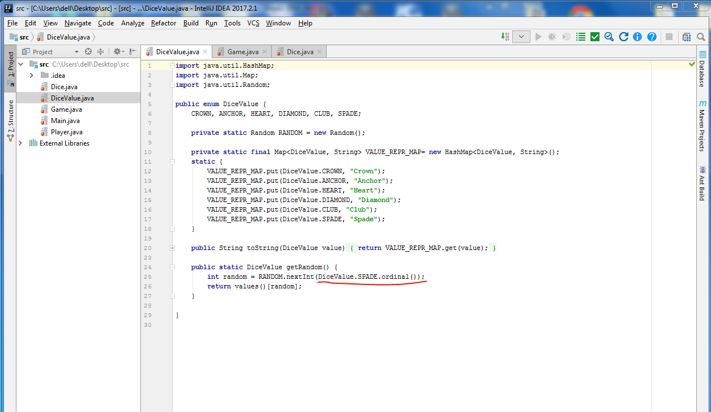
- Same 3 starting cards after each game
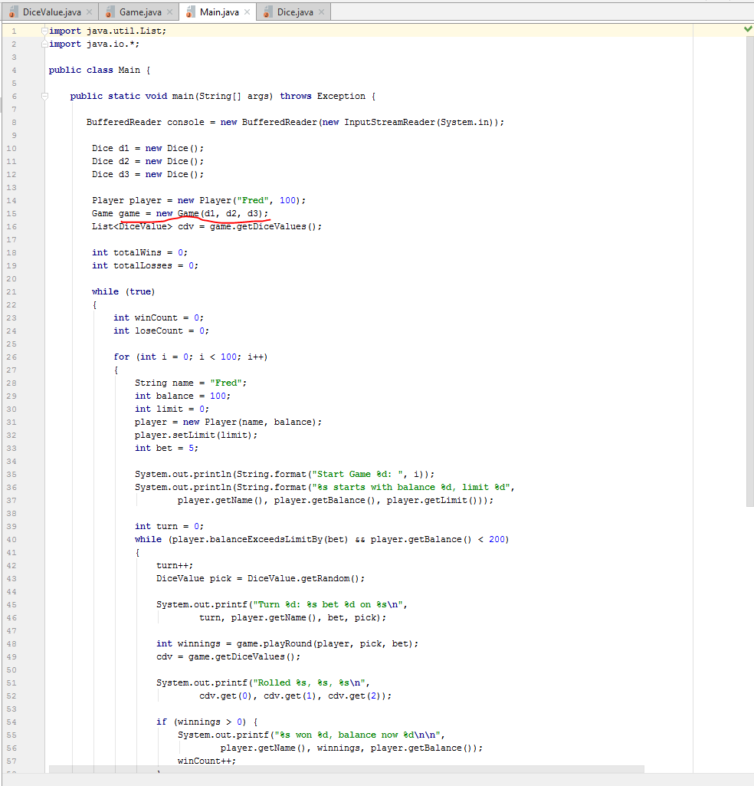
- If player wins, bet amount doesnt take into account
