1. **Index page (Homepage)**

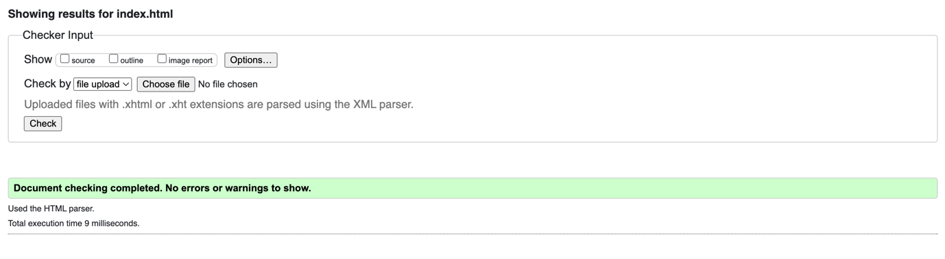

1. **About Me page**

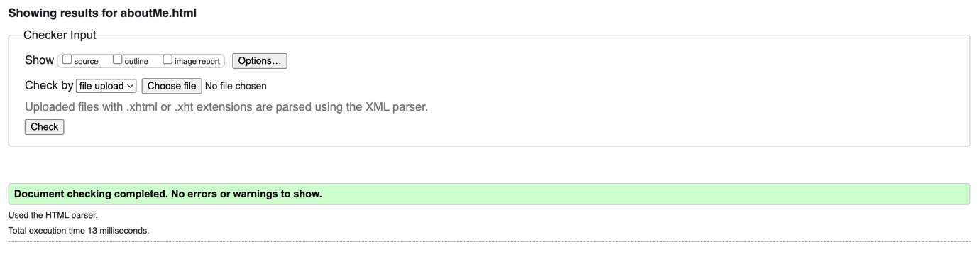

1. **Sitemap page**

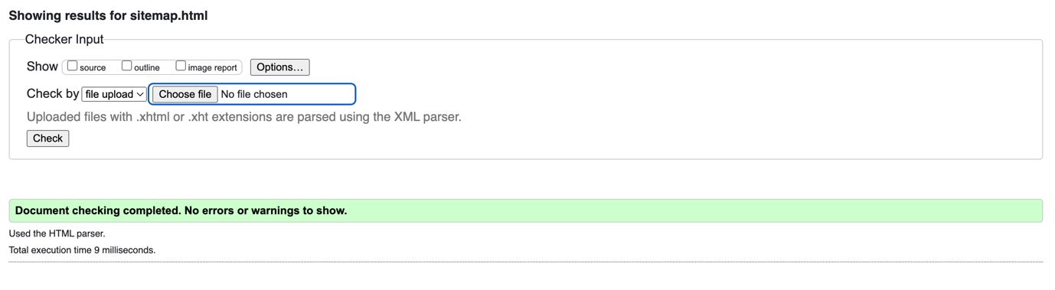

1. **Source Log page**

1. **Feedback page**

1. **Image Map page**

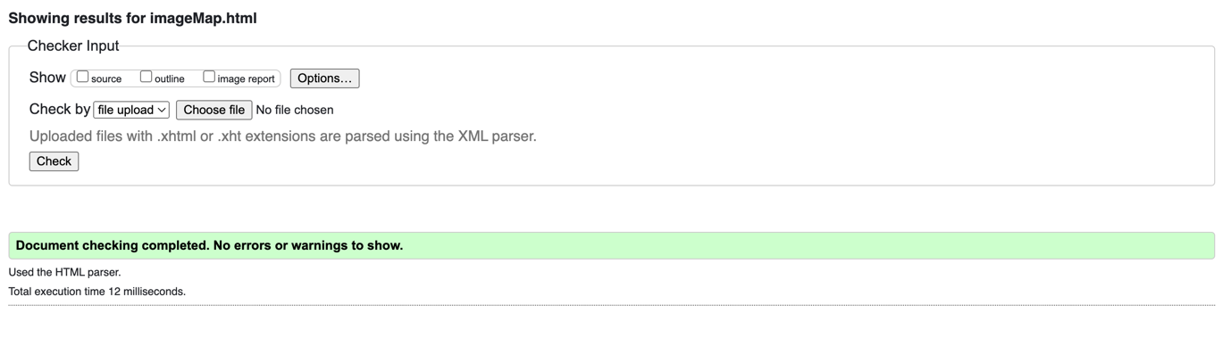

1. **Photo Gallery page**

1. **About My Site page**

1. **Original Recipe page**

1. **Inspiration pageA screenshot of a computer

   Description automatically generated with low confidence**