Project 1b Flight Data Manipulation

The purpose of this project is to prepare and process the data collected from part a.

1. Take any CSV file from Project1a. Make sure you are taking a long simulation (you can always re-run and speed up using the –S flag). About 8 minutes with the –S 5 flag should be sufficient. It is important that you are familiar with the headers, the order they are in, the units (ms/usec, rads/deg). More information on the header data types can be found here:

<https://mavlink.io/en/messages/common.html>

2. Import the csv file into matlab. There are number of commands you can use but I recommend the *importdata* command.

3. Write/use functions to normalize the data. For example NAV_CONTROLLER_OUTPUT messages are in degrees, while ATTITUDE messages are in radians.

4. Some data may come in difficult to work with ranges i.e. 1100-1900 (Servo PWM). You may want to normalize it between 0 and 1. This step will not affect your results, but may make your data easier to visualize and understand.

$z_{i}=\frac{x_{i}-min⁡(x)}{\max\left(x\right)-min⁡(x)}$

$x=(x_{1},x_{2},…,x_{i})$

WARNING: Do not add/subtract columns after they have been normalized. For example do not do normalized(degrees)-normalized(radians), make sure you do normalized(radians-converted(degrees)), or another equivalent function.

5.There may be certain rows which contain nans. Having non-values in your data array will negatively affect your later results. These should be removed and “filled in” by values. I recommend using the inpaint_nans function (uploaded to gdrive). Make sure that you run inpaint_nans over the columns (of the same data type), and not the rows.

In general matlab works using row major order. This means that if you had the following

x=[ 1 5 100;

     nan 6 101;

    3     nan  102;

    4    8     nan;]

and you just run inpant_nans it will give you

    1.0000    5.0000  100.0000

  -16.0198    6.0000  101.0000

    3.0000   24.1188  102.0000

    4.0000    8.0000   57.5000

rather than

x=[

1 5 100

2 6 101

3 7 102

4 8 103]

Check out the documentation within the inpaint_nans function.

6.Verify “semi” constant timestamp. The first column should contain the timestamp, plot the time delta between each data point to ensure your timestamp is relatively constant. If you don’t think your time is “steady” enough you should try to either re-run your data collection, or clip your data to where the time constant is steady. Make sure you have at least 10,000 samples of good data, if not, re-run your data collection.

The delta between samples should look something like this:

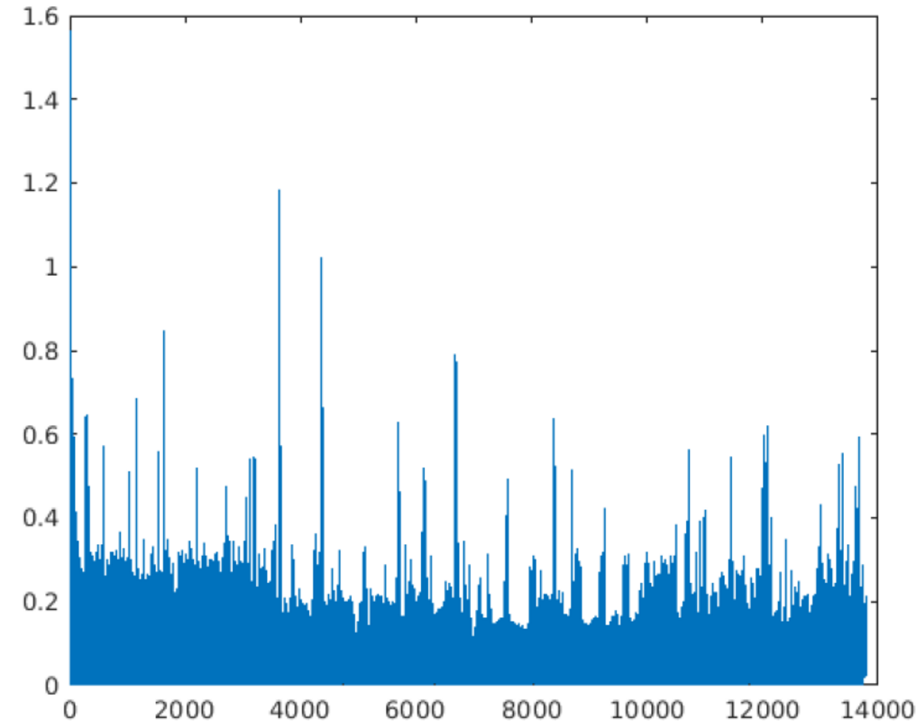

Submission directions:

Attach your submission as a compressed file with the following name “<lastname>_project_1b”.

Submit the following in a zip file:

1. The original flight tlog file.
2. The command used to generate the csv file.
3. The csv file
4. Your matlab code