Contents

**I.** **Setting firebase** 2

**1.** **Create table Firestore Database** 2

**2.** **Setting “Rules”** 2

**3.** **Add index in “Indexes”** 2

**II.** **Khởi tạo database Period** 3

1. **Setting firebase**
2. **Create table Firestore Database**

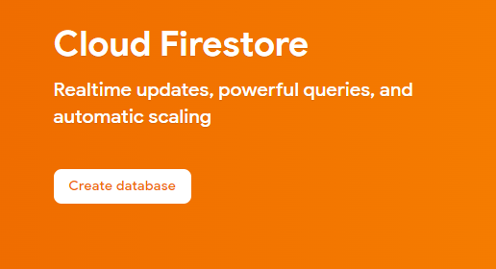

1. **Setting “Rules”**

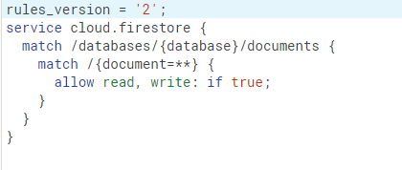

1. **Add index in “Indexes”**

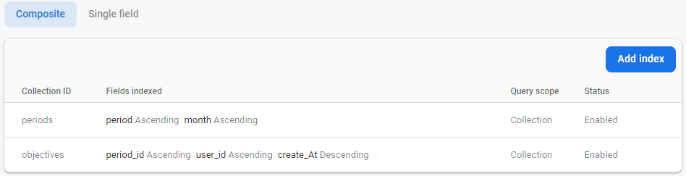

1. **Khởi tạo database Period**

Mở file homepage.dart chạy createPeriod() 1 lần 